- Disrepair Issues and Bad Management by My Housing Team!
- Disrepair Issues
- Start Date 11/08/2006.
- End Date 14/11/2022!
- The Enfield Council alongside with the Enfield Homes & the Safer neighbourhood watch teams failed their obligations to the Now Claimant a Mr. S. P. Cordell when guaranteeing his Security of tenure while managing his housing affairs, but most recently.
- Maintenance failures meant that necessary works did not finish in his home to a high standard or time limit through the years of 2006 till date 30/09/2022.
- The history of my living circumstances is: -
- Years have faded away and without the qualifying repairs taking a place since the Now Claimant signed his tenancy and the problems still protest today.

- 2006
- The flat rented to the Now Claimant a M. S. P. Cordell on the date of 11/08/2006 and by December 2006, the Now Claimant was already complaining about Disrepair Issues.
- When the Now Claimant first moved into his rented flat issued by the Enfield Council the flat never seemed to be in a bad state of a living condition due to the Enfield Council recently having it painted so, to be ready for the Now Claimant to move into it.
- Straight away of moving inside of the flat the Now Claimant realised that there was an extraordinarily strong damp smell but thought it was normal and that the flat just needed airing out aloe he could also smell fresh paint.
- Within the first few months of living inside of the flat the Now Claimant became use to the extraordinary overpowering smell and soon after started to notice the walls and ceilings were getting covered in a toxic mould and this meant that his rented property suffered with damages alongside with himself and private property.
- The Now Claimant decided that he had had enough after one too many things of his were destroyed causing him to suffer and at no fault of his own and this is what forced him to start acting on top of any extra cleaning chores caused by the damp. These actions of the Now Claimant involved: = “taking picture evidence” “Contacting the relevant People,” about his sufferings caused from the: - “Rented Flat.”
- “These pictures are in the Table at The Bottom of This Document Exhibited as ****.”

- As soon as they could the Now Claimant and his support network notified the Enfield Council and the relevant corresponding companies by way of telephone calls about the really bad damp growing inside of the rented flat and they all talked about his spoiled belongings & the damp causing him bad health.
- Enfield Council at first sent different surveyors out to the Address of 109 Burncroft Avenue and the surveyors explained that the damp and mould existed because of a bad air flow through circulation within the premise but while on the telephone the Enfield Councils employees were saying that the disrepair was caused by condensation being created as the windows needed to be opened more.
- The Now Claimant could not keep his windows opened all year around as in the winter it became too cold.
- The windows fitted into the property are double glazed and have an air flow system built within their design and these vents were always keep open as well as the windows as much as they could, but the damp keep growing and this meant that the window vents were not adequate and even aloe the Now claimant done what was requested by the Council of him by keeping them open.
- The Now Claimant done what the Enfield Council asked of him but as day by day went past the damp continued to flourish.
- The now Claimant was washing his walls as well as ceilings and he done this at least once a week, but the damp keep coming back and washing of the building become a regime for him and this happened until the Enfield Council closed the on his bedroom giving him less rooms to wash but the damage was already caused to him and his belongings and by the Council just closing the bedroom door they left the damp to only get worse.
- The Now Claimant lost the Complete use of the bedroom and had no choice but to sleep in the front room even when it was a one-bedroom flat.
- The damp was not contained in just the bedroom, but the bedroom was the most effected room.
- No matter what room the now claimant tried to keep safe in the damp keep making him ill and, in more ways, than just one but no matter what was explained to the Enfield Council they blamed the problem to be because of bad condensation and tried to make the Now Claimant feel responsible and all while still refusing to help him.
- Throughout this time the main mother board in my boiler kept blowing up, which the Enfield Council had to keep replacing.
- When the Councils engineers came to the flat to start works on the Boiler, they would always explain that the boiler was showing low in water pressure and gave a guide on how to keep it toped up. The Now Claimant always listened to their advice and made filling up the boiler to the correct limits a standard practice.

- Sound Proofing 2006 till 2022
- Whin weeks of living inside 109 Burncroft Avenue the Now Claimant also kept noticing the soundproofing issues with the premises were extensively bad.
- The impulsive sounds of neighbors’ personal conversations become an intrusion of his and their privacy causing any chance of a private family life to become a non.
- The intrusive Soundproofing issues within 109 Burncroft Avenue sustains itself at an inadequate to fair standard of living and
- The Private Conversations that occupiers or guests can hear when inside a Burncroft Avenue flat are too clear to be private.
- Quite a couple of the Enfield councils’ rented homes within the Burncroft Avenue Housing estate are not up to the correct ISO standards, and the Enfield Council housing estate manager also agreed to this fact in writing when she took out an inspection of the homes
- We also herein induce Exhibit 000 as documented below: -

04 May 2015 13:22
Sent: 10/06/2015 - 21: 13
Sent: 03 November 2015 14:39
Sent: 06 February 2017 13:33 flooring
Sent: 07/02/2017 - 17:02 flooring
06/02/2017 :08/02/2017:
Sent: 08/02/2017 - 16:08

- We entered the property so that Steve Stirk could test the water taps in the kitchen and bathroom.
- There was no flooring laid except for a rug in the living room (the kitchen was accessed through here) and the floorboards made a significant amount of noise as we stepped on them.
- The resident from the property underneath, Mr Simon Cordell, heard us in the property and came upstairs.
- Steve Stirk and I were outside the property at this point as the locksmith started to undertake the work to install new locks on to the door (he was inside the hallway).

- 2007
- By the year of 2007, the Enfield Council was still sending out a different surveyor every time we contacted them and without starting any works to complete the rid of the High-Risk damp disrepair issue that persisted to isolate rooms and grow in its own dormancies.
- The flat of 109 Burncroft Avenue had become in less than a year a: - “Toxic Hell” and the Enfield Council staff left the Now Claimant to live inside of it and the Exhibits evidence these claims.
- The smell created within the humidity of the damp & mouldy flat cannot be smelt by the presented Exhibits, but as any person who has suffered from extremely bad damp and/or mould and/or may have an occupational interest in these positions would know the smell caused by these hazards is extremely awful and awful to an extent that the allergen fragments floating in the air that are created from the spores that cause the Damp & Mouldy smells, actually makes a person become ill from its toxic substances, but still the official persons just left the Now Claimant to live and coupe on his own in his exhibited rented hell of a living home.
- The different surveyors who had all repeatedly stated the obvious that the flat suffered from: -
- Bad air circulation in the flat caused the flat to have bad ventilation and therefore created a perfect living condition for fungal spores to grow.
- The days finally turned into what we thought would be one of the last times we saw an Enfield Council surveyors at 109 Burncroft Avenue and on his attendance he agreed to replace the order for the works to start so that the workers could start fixing the walls and the work would include stripped them back to the bricks and then treating the walls to be re plastered again.
- The surveyors stated that the workers would install an air ventilation system into every room via the windows and walls in the flat.
- He continued by explaining that they would need to place a large industrial humidifier in the bedroom as this was the worse room suffering with the damp and mould, for them to be able to remove any unwanted water out of the flat and this would happen before the walls could be treated.
- The Now Claimant agreed with the survivor and the needed works were scheduled to take place.
- After a few more days passing by the Enfield Council staff arrived at the Now Claimants front door of 109 Burncroft Avenue with an industrial humidifier and they were allowed to install it in the bedroom but before the staff left they gave the Now Claimant instructions on how to maintain the industrial machine until works concluded and when he asked how long this would be for the staff explained for about three months.
- In the meantime, the large industrial humidifiers operated to remove the water that had built up in the internal and external walls of the flat and this also included the flats grounds that laid underneath.
- The damp flat meant that the only time the Now Claimant could enter into his bedroom was to empty a bucket of water that the humidifier “machine” collected.
- He can remember that in the beginning of the machine getting placed inside of his bedroom that the water bucket for the humidifier used to fill up many times a day, on an average of three times a day and he also, remembers that as the months did continue to pass by the amount of unneeded stored water in the machine became less and less the Now Claimant states the chore took up a lot of his time.
- The Now Claimant had to manage to maintain the machine himself and found this hard to achieve for such a lengthy time aloe he did not have any major incidents, this meant that he had to always be present at certain times of the day to complete this job in hand and this was right up until the council and the Enfield homes reasonable persons where able to finally start their works.

Sound Proofing 2006 till 2022

- 2008
- In the early months of the year of 2008 the machine and the Now Claimant were still collecting water, when on one of the trips to empty the bucket, something knew happened.
- The Now Claimants foot disappeared as he and his foot sunk into the ground, he had been walking out of his bedroom door with the bucket full of water in his hands and as he walked into his front hallway heading for the bathroom with the need of emptying the water away, the floor had given away.
- This caused the Now Claimant a sharp pain that almost made him throw the bucket onto the floor and scream for help, but he knew if he had done this, he would have had to clean up the mess. Before the Now Claimant knew what had happened, he placed the bucket safely on the floor and look down at his foot to see the damage the floor had caused.
- Drawn blood from grazes and bruised skin from the chipboard was the result but if it had not been for the concreate underneath being so shallow the injuries would have been worse.
- After inspecting the wounds and analysing the damage to the property the Now Claimant knew he was not to blame and decided to phone his mother for help and advice.
- The Now Claimant mother advised him to call the Enfield council right away as floors giving away means that there is something very wrong as 109 Burncroft Avenue had become a hazarded place to be as it was a work site and not a safe home.
- The Now Clamant then after his call to his mother spoke to the Enfield Council by way of a telephone call about the floor giving away and to his and his mother’s shock a surveyor arrived within 1 hour.
- The surveyor took one glimpse with his eyes at the sinking floor and sharply agreed to the Now Claimant that he immediately needed to place an order for disrepair works to be instated and as he said so, he walked towards the door and left the flat while on his telephone, the telephone call he made was to order the emergency works to be completed.
- Later the same day a different worker arrived at the flat and proceeded to lift the hazarded floorboards away from the bedroom, bathroom, and the hallway of the Now Claimants flat.
- While the worker was removing the hazarded floorboards away, he came across an issue, he realised that the heating system had fractured the cooper pipe that lays under the floorboards and between the bedroom and bathroom that joins causing a sprung water leak.
- It became obvious that the sprung water leak had just got worse over the years and concealing itself until this point of time.
- The Now Claimant and the Workman spoke and conclude that this is why the damp had been taking over the flat in part and that the fractured water pipe was more than likely leaking before the Now Claimant moved into the property due to the damage it had caused.
- The worker immediately shut down the heating system and made the leek stop while explain to the Now Claimant that he could no longer use the heating system until it was fixed.
- Whin a few hours passing by the worker had completed what he said he could do by lifting up all the hazardous floorboards in the three rooms and shutting the heating system of.
- The Now Claimants floors were left with no floorboards and he had to walk along or in between the wood beams to be able to empty the bucket of water produced by the industrial humidifier and while the bedroom was sealed as unstable due to mould and mushrooms growing the rest of the rooms in the flat were also suffering as they were also covered in different coloured moulds growing and not to forget that the heating was non-existent, while an air ventilation system still needed to be installed for a better air quality to exist.
- Temporary floor was necessary to be laid but this was not provided by the Enfield Council staff.
- The flat of 109 Burncroft Avenue stayed in such a state of disrepair that the Now Claimant mother had to attend the premisses a few days afterwards to be able to inspect the situation for herself and she found herself so upset when she saw the condition the Enfield Council had left her son to live withinside and the damage caused to him and his goods.
- The now Claimants mother knew it to be best to contact the Enfield Council and question them in regard to their decision of leaving her son or any person for these facts to have to deal with such dangerous conditions and their staff replied by arranged for another workman to attend the flat on the day of this telephone call but just to fix the floors..
- Another worker arrived very soon after the telephone call had finished and laid some temporary chipboard down so the floor could be walked on till the heating system and our other mentioned disrepair issues could be fixed but this became the permanent floor in the end.
- While the flat continued to dry out the Now Claimant did not have a home fit for use for more reasons than one and the Enfield Council did not seem at all bothered.
- Late in the last months of 2008 and after many more telephone calls to the Enfield Council they agreed that the flat had dried out enough for the needed disrepair works to be completed and the Enfield Council worker started to strip the walls back to brick treat them and then re plaster them. But this still left damaged floorboards and no wooden flooring, No Heating System, and an air ventilation system still to be installed as well as damage caused by the disrepair issues caused to the Now Claimant and his belongings.
- At the same time as the walls being completed more workers arrived at 109 Burncroft Avenue and they had with them two new double glassed panes of glass ready to fit into their places and with holes cut into them ready for the air system to be fitted, one glass pane was for the bathroom and the second one was for the kitchen.
- After the work man had fitted the windows, they said that another company that may have the named of: - “Air Flow,” will shortly arrive and fit the Ventilation System.”
- The Now Claimant waited in doors and no other person came to his home to fit the system into the holes in the windows and this led to more problems because the flat had become unsafe due to the considerable risk of trespassers easily detecting one of the holes.
- The reason a trespasser could easily detect the holes is because the flat the Now Claimant bathroom window leads straight into the main street for all visiting the Housing estate to see as the now Claimants flat is directly opposite the main entrance into the Estate for traffic and pedestrians and is one of the first thing they see, while the kitchen widow is only accessible from the back garden.
- It came to the Now Claimant and his mother of no surprise when they contacted the Enfield Council, and they said that the air ventilation systems equipment that was needed for the installation had faced delays.
- The needed works the Enfield Council needed to complete for the Air Ventilation System to be fitted shockingly took them until the year of 2010 to complete as they explained to the now Claimant and his mother that the lack in work has occurred due to a shortage of supplies of the needed equipment.

Sound Proofing 2006 till 2022

- 2009
- Into the year of 2009 the issues would not stop, and this was with the: -
- Flooring: As the Enfield Council still had not fixed the flooring still correctly due to the leak.
- Heating System: Was still Non-existent.
- Large Holes Cut into The Windows: The Enfield council had left holes in the windows so the now claimant or someone from his support network had to occupy the premises for security reasons and this all went on for around another 6 months, or more until the year of 2010.
- The Air Ventilation System Installation: The air ventilation system for the flat was still a nightmare to get hold of.
- Damp Smell:
- and this was even aloe the Council had just plastered the bedroom.
- The Now Claimant still did not feel comfortable in the bedroom as he had never been able to use it other than the first 2 months of moving into the flat a due to the damage the damp had caused alongside other issues with his next-door neighbour Hazzan Ozman renting the room out beside.
- The Enfield Council acted with no care towards the Now Claimant and any other contact made to themselves by his mother and this was no matter how many times they both contacted the Endfield Councils Repair teams the air vent workers just never showed up.
- Telephone calls after calls were also, made in regard to having no heating system, and only surveyor after surveyors attended 109 Burncroft Avenue and when they arrived, they had no worker or replacement heating system with them and tended to say the work would be conducted soon afterwards but the disrepair woks were never done.
- The Enfield Council just left the Now Claimant freezing in his unsatisfactory rented flat with holes in the windows and no heating system.

- 2010
- Years was just going by with no heating system within the flat it was freezing and making the Now Claimant extremely ill the Now Claimants rented flat was so cold it would never go fully warm, and the damp smell was so horrendous guest could not be invited around.
- Contacting the Enfield Council sent the Now Claimant and his mother on a non-joyous adventure of get the Disrepair issues fixed to be able to live a fair standard of life.
- Eventually the Now Claimant and his mother were so sick of calling and putting in complains over the telephone phone that the Now Claimant felt that he might as well live in a squat, when one day the Enfield Council made contact and said that the ventilation system was final ready to be installed, A date was arranged and a workman attended the flat to then afterwards installed the system into the holes in the windows and then finally this disrepair job was completed.
- The flat of 109 still continued to suffer with more knock-on effect issues and as an example we will start with

Sound Proofing 2006 till 2022

- 2011, 2012
- The following years slowly went by 2010, 2011, 2012: -- The Enfield Council changed the Now Claimants life as they turned it for him into a living hell with the mentioned disrepair issues still presiding as abandoned.

Flooring Sinking: 2008 till 0000 and then till 2022
Heating System Pipes 2008 till 2015
Smell 2006 till 2016
Kitchen Cupboards 0000 till 2021
Electrics 2006 till 2014
Sound Proofing 2006 till 2022

The Now Claimant
The Now Claimant His Belongings

- 2013
- The now claimant had to live inside of 109 Burncroft avenue more than he usually would because the police wrongfully accused him of an offence that he later won at court, and this meant that the disrepair within the flat became a problem that he wanted to solve.

Flooring Sinking: 2008 till 0000 and then till 2022
Heating System Pipes 2008 till 2015
Smell 2006 till 2016
Kitchen Cupboards 0000 till 2021
Electrics 2006 till 2014
Sound Proofing 2006 till 2022

The Now Claimant
The Now Claimant His Belongings

- 2014
- We herein introduce Exhibit: - “The Now Claimants Diary”
- The Now Claimants Diary exhibits a large multitude of correspondences that are mostly emails, video, and Audio recordings that the Enfield Council and Metropolitan Police Force himself and his mother were all sending backwards and forwards amongst each other.

- In reference to the Emails contained in the diary quite a few of the emails sent by any person deal with more than one subject E.g. An email sent to the Enfield Council on the 00/00/2014 to a case handler named as Dawn Alan raises the concerns of disrepair but in the same email the complaint also ask the Enfield Council to manage the Now Claimants members of Neighbours who were wound up by the Enfield Council and Metropolitan Police Force when they publicised information about the Now Claimant that the Government Officials had gained by setting him up fraudulently and by manipulating the law causing members of his neighbours to vigorously try and make him move away from them at any cost out of his life.

- On the 00/00/0014 The Enfield Council and the Metropolitan police took out a frauded attack on the now claimant’s life and this enrolled member of his neighbours to join in as Exhibited as ****

- Then came the water pressure issue

- Disrepair work was also, conducted on the Now Claimants rented flat re replacing the complete electrical system, they wired in fire alarms and a Carbon Monoxide alarm incorrectly,
- I made mutable calls to the Enfield Council to say to them that the Safety Alarms Systems had not been installed correctly, and due to this the Now Claimant suffered with carbon monoxide poisoning as there was a fault with the boiler and the Carbon Monoxide alarm not working. when they did come out in Nov 2014 I was left with no boiler for weeks until parts could be ordered

- EXHIBIT D6
This Exhibit D6 referrers to a letter of evidence made on behalf of the Now Claimant a Mr. S. P. Cordell.
Access as national grid have shut down the heating system because the CO2 Alarm Kept Sounding.
Gas defect to domestic gas central Heating appliance.
Fault Log: 28/11/2014
Est. Complete Date: 28/11/2014

- EXHIBIT D7
This Exhibit D7 referrers to a letter of evidence made on behalf of the Now Claimant a Mr. S. P. Cordell.
Supply and fit Graphite Seal
Gas defect to domestic gas central Heating appliance.
Fault Log: 01/12/2014
Est. Complete Date: 03/12/2014

- We also herein induce Exhibit G42 as documented below
- EXHIBIT G42 Is photographic evidence Dated the 06/10/2022 of the Now Claimant rented Flat 109 Burncroft Avenue of the Enfield Council. The picture displays the flats front room main display wall and a leak running down the wall making the flat undecorate able while an undesiring place to be. The external side of the wall is open to air and has a drain guttering that runs on top and down its side that is leaking wastewater down the side of the wall. The Now Claimant request that of the Enfield Councils teams to repair the damage to the wall while fixing the Cause of Problem to make the flat a sustainable living place in the years of 2014. Once the Enfield Councils Staff turned up, they overview the disrepair issue but never looked outside and

the Enfield Council treated and re skimmed the walls inside of the flat of 109 Burncroft Avenue due to the works that took a place in the years of 2006 till 2009.

The walls inside of the flat of 109 Burncroft Avenue

The now claimant never realised at this stage the wall in the flat overside was an external wall open to air. The now claimant can remember talking to the different surveyors and workers trying to work out where the water was coming from. They all talked about the four flats above and the possibility of them having a water leak under their floorboards like had prior happened to the now Claimant. The repair teams said that they would order an inspection into the possibility of a leak coming from above. Within the month a plaster arrived at the Now Claimants Flat

Walls Damp Mould 2006 Till End Of 2008 then 2014 till 20022
Flooring Sinking: 2008 till 0000 and then till 2022
Heating System Pipes 2008 till 2015
Co2 Alarm System November 2014 till January 2015
Smell 2006 till 2016
Water Pressure 2014 till 0000
Banging On the Walls and Using Drills 2014 till 2022
Kitchen Cupboards 0000 till 2021
Electrics 2006 till 2014
Sound Proofing 2006 till 2022

The Now Claimant
The Now Claimant His Belongings

- 2015
- The year of 2015 suddenly appeared, and the Now Claimant was still suffering from their being no heating system in the flat, causing the Summers to stay cold of the nights and the winters become freezing.

- Disrepair jobs needed completing, and the Council had now created two frauded Court Order applications with the seconds one being to get away from the first and all while the first frauded court application the Enfield Council and Metropolitan Police Force used to cause the Claimants Neighbours to act in a hatred frenzy way against him as documented as

- which was no one would deal with and in the end the Now Claimants mother and I was so sick of what was going on my mother started sending emails of complaints.

- The 1st email sent was 02/03/2015 it was a Complaint, my mother did get a call back but it was not for everything nor the heating system, on the 04/03/2015 emails and complaints were also now being sent to the housing officer Dawn Allan regarding issues with neighbours and also repairs to the flat but no reply was forthcoming at all from Dawn Allan when at least 2 or more emails were being sent a month, it took until 21 Sep 2015 for Dawn Allan to finally reply. Due to emails being sent a few jobs to the flat was starting to get done but not the heating system.

- Around the end of April 2015 my mother got a call from Enfield Council regarding the heating system she was horrified and angry at the lies being told to her by the Enfield Council worker, the Enfield Council worker told my mother the reason the heating system had not been replaced was due to Mr. S Cordell taking all the pipework from the flat and causing the damage that the cost to replace it would be nearly £4000.00 stating my son would need to pay, at that my mother went mad on the phone told the person she wanted a manger and surveyors to come to her son’s flat within 2 days, and if she needed to she would rip every place of flooring up in the flat to prove all the pipework and everything was still under the flooring that her son had not done what she was saying and she wanted this addressed she was not having lies stated about her son. The women on the phone said there be no need for all that they would replace the heating system. My mother was still horrified and angry at what the Enfield Councils staff had said and then stated she would still like an official person to come to the flat to see the truth for themselves, but the women on the phone stated that would not be needed the heating system will be replaced. My mother said she still wanted someone to come and check this has never happened and would not be the end of what was said.

So, we waited for them to come and do the heating this did not happened until around July 2015, the reason for it taking so long was due to what Enfield Council had told the company that would be doing the work. When a worker did turn up, he stated to Mr S Cordell no one wanted to do the job because of what Enfield Council had told them what you had done taking up all the pipes and doing a great deal of damage to the flat, the workman said he was so happy that he had agreed to do the job and could not wait to go back to the office and tell them everything he was shocked because he could see all the pipes were there they had not been removed like Enfield Council had told them, that his officer and the workers was going to be really shocked. Mr S Cordell then told him the whole history of what really happened and how he had to live and what Enfield Council had done the worker was more than shocked and said how did Enfield Council make you live like this. No one has ever come from Enfield Council to check the pipework was still there and is still there, which I would still like my name has been blackened by Enfield Council and I want a great deal corrected. Which Enfield Council has beached the duty of candour multiple times for things.

Walls Damp Mould 2006 Till End Of 2008 then 2014 till 20022
Flooring Sinking: 2008 till 0000 and then till 2022
Heating System Pipes 2008 till 2015
Co2 Alarm System November 2014 till January 2015
Smell 2006 till 2016
Water Pressure 2014 till 0000
Banging On the Walls and Using Drills 2014 till 2022
Window Seals 2015 till 2021
Kitchen Cupboards 0000 till 2021
Sound Proofing 2006 till 2022

The Now Claimant
The Now Claimant His Belongings

2016
Then water pressure issue I was getting letters after letters blaming me for causing it, I let five council workers in to check my flat all stated the issue was not coming from my flat and I also had low water pressure but because I am based on the ground floor, I would not have noticed it so much. I myself called once after I could take no more of the letters blaming me and was very rude, I allowed Thames Water also in my flat four times to check my flat each time being told the issue is not coming from my flat. The complaints about the water pressure were being made by 117, it did not matter how many times I allowed Enfield Council workmen in to check or Thames Water, or the landlord of 117 plumbers in all saying the issues was not coming from my flat, Enfield council only believed what 117 tenants were telling them I was causing the issues with the water pressure. Enfield Council did not believe all their own workers or Thames Water or the property owner at 117 own plumbers, I just was blamed the letters kept coming this was ongoing for over a year. Then came the disrepair guy Neville Gray from Enfield Council who was rude and that is an understanding, and he lied on more than one occasion.

Walls Damp Mould 2006 Till End Of 2008 then 2014 till 20022
Flooring Sinking: 2008 till 0000 and then till 2022
Smell 2006 till 2016
Water Pressure 2014 till 2016
Banging On the Walls and Using Drills 2014 till 2022
Window Seals 2015 till 2021
Kitchen Cupboards 0000 till 2021
Sound Proofing 2006 till 2022

The Now Claimant
The Now Claimant His Belongings

2017
I was in my flat in Feb 2017 after having really bad family news the day before so was really upset and did not feel well, Neville Gray just banged on my door and demanded I let him in, I called my mother who came to my flat.
Neville Gray lied to her along with her brother that day and it was not just going to stop there, it seemed he had been in contract with 117 and they knew he was coming he also stated that 113 knew he was coming as he had contracted them, the only person who had not been contracted was 109 Mr S Cordell.
In the end there was words said and also 113 was not there, Government staff named as Neville Gray who was employed by the Enfield Council lied in mutable instances to aid in a cover up of the truth.

Walls Damp Mould 2006 Till End Of 2008 then 2014 till 20022
Flooring Sinking: 2008 till 0000 and then till 2022
Banging On the Walls and Using Drills 2014 till 2022
Window Seals 2015 till 2021
Kitchen Cupboards 0000 till 2021
Sound Proofing 2006 till 2022

The Now Claimant
The Now Claimant His Belongings

2018
- A

Walls Damp Mould 2006 Till End Of 2008 then 2014 till 20022
Flooring Sinking: 2008 till 0000 and then till 2022
Banging On the Walls and Using Drills 2014 till 2022
Window Seals 2015 till 2021
Kitchen Cupboards 0000 till 2021
Sound Proofing 2006 till 2022

The Now Claimant
The Now Claimant His Belongings

2019
- A

Walls Damp Mould 2006 Till End Of 2008 then 2014 till 20022
Flooring Sinking: 2008 till 0000 and then till 2022
Banging On the Walls and Using Drills 2014 till 2022
Window Seals 2015 till 2021
Kitchen Cupboards 0000 till 2021
Sound Proofing 2006 till 2022

The Now Claimant
The Now Claimant His Belongings

2020
- A

Walls Damp Mould 2006 Till End Of 2008 then 2014 till 20022
Flooring Sinking: 2008 till 0000 and then till 2022
Banging On the Walls and Using Drills 2014 till 2022
Window Seals 2015 till 2021
Kitchen Cupboards 0000 till 2021
Sound Proofing 2006 till 2022

The Now Claimant
The Now Claimant His Belongings

2021
- A

Walls Damp Mould 2006 Till End Of 2008 then 2014 till 20022
Flooring Sinking: 2008 till 0000 and then till 2022
Banging On the Walls and Using Drills 2014 till 2022
Window Seals 2015 till 2021
Kitchen Cupboards 0000 till 2021
Sound Proofing 2006 till 2022

The Now Claimant
The Now Claimant His Belongings

2022
- A

Walls Damp Mould 2006 Till End Of 2008 then 2014 till 20022
Flooring Sinking: 2008 till 0000 and then till 2022
Banging On the Walls and Using Drills 2014 till 2022
Sound Proofing 2006 till 2022

The Now Claimant
The Now Claimant His Belongings

- What Kind of Mould Grows on Walls?
- Common indoor moulds include: - “Alternaria” This occurs in damp places indoors, such as showers or under leaky sinks.
- “Aspergillus” This often grows indoors on dust, powdery food items, and building materials, such as drywall. 20 Aug 2019.
- Moulds, in the right conditions, produce: - “Mycotoxins," poisonous substances that easily make people sick.
- “Aflatoxins” are: “Amongst the Most Poisonous Mycotoxins” and they produce certain moulds such as: - “Aspergillus Flavus” and: - “Aspergillus Parasiticus…”

- Exhibits D1.
- Exhibit D1 is a letter that the Now Claimant received From the London Borough of Enfield Council on the date of 26th of July 2006.
- This letter shows that the Enfield Council were fully aware that the premises that they had rented out to the Now Claimant suffered with asbestos within the building materials and that it was their job to maintain the asbestos within the premises, to a fair standard of living.
- The Enfield Council Letter addressed to the now claimant, also displays a doctor name printed inside of it and the Now Claimant believes that this is due to the danger asbestos can cause to human life the doctors name is a Donald Graham.

- The Now Claimant suffered through High risks associated to contaminating mould growth due to the Enfield Councils incompetence.

- The Enfield Council understood they were leaving people lives at a servery high risk by leaving them in horrendous inhabitable conditions due to mould being present in a large percentage of their rented home contained in their portfolio of property rented out to become homes and that it was going to be Very Likely that they have a claim put against them for damages caused due to these facts.
- The Now Claimant: - “landlords” must protect him by not charging for any unfair rent.
- Exhibit D2
- Is a letter sent to the Now Claimant from the Enfield Council.
- This exhibited letter has a date of the 22/11/2011.
- The Letter subject is: - “Electrical Air Vent System Due to Be Installed In 2010, Was to Prevent Damp and Mould Issues” – “Windows Have Been Temp Repaired to Cover Holes.” “No Skirting Boards in Bathroom and Bedroom.”
- The Letter shows that the Enfield Council Failed the Now Claimant in their obligation to supply a home fit for purpose.
- The Date of the letter s is the 22/11/2011 and the Enfield Council are openly admitting having failed the Now Claimant prior to 2010.
- The Enfield Council raised the Issue of disrepair for another surveyor to overview the mutable different problems that left the flat in an unsustainable living condition and never substitute property in the meantime.
- The next surveyor was to arrive on the 1st of December 2011.
- Exhibit D3
- This Exhibit D3 referrers to a letter of evidence made on behalf of the Now Claimant a Mr. S. P. Cordell.
- Document Date 01/12/2011
- Damp Skirting Boards: - “I called to see you today at 14:33.”
- Exhibit D4
- This Exhibit D4 referrers to a letter of evidence made on behalf of the Now Claimant a Mr. S. P. Cordell.
- Document Date 15/02/2012
- Heating: - “I called to see you today at 10am.”
- Exhibit D5
- This Exhibit D5 referrers to a letter of evidence made on behalf of the Now Claimant a Mr. S. P. Cordell.
- Total Loss of Gas heating and Hot water in summer 1st May to 31st October.
- Gas defect to domestic gas central Heating appliance.
- Fault Log: 14/05/2009
- Est. Complete Date: 19/05/2009
- Exhibit D6
- This Exhibit D6 referrers to a letter of evidence made on behalf of the Now Claimant a Mr. S. P. Cordell.
- Access as national grid have shut down the heating system because the CO2 Alarm Kept Sounding.
- Gas defect to domestic gas central Heating appliance.
- Fault Log: 28/11/2014
- Est. Complete Date: 28/11/2014
- Exhibit D7
- This Exhibit D6 referrers to a letter of evidence made on behalf of the Now Claimant a Mr. S. P. Cordell.
- Supply and fit Graphite Seal
- Gas defect to domestic gas central Heating appliance.
- Fault Log: 01/12/2014
- Est. Complete Date: 03/12/2014

- Exhibits E.
- Exhibits E. comes with twenty-three pictures that were took in the year of 2007.
- EXHIBIT E2. Bathroom.
- EXHIBIT E3. Bathroom ceiling.
- EXHIBIT E4. Bathroom ceiling.
- EXHIBIT E5. Kitchen vermin issues on top of tumble dryer.
- EXHIBIT E6. Kitchen vermin. Issues on top of microwave.
- EXHIBIT E7. Kitchen vermin Issues on top of sides.
- EXHIBIT E8. Kitchen vermin Issues on top of sides.
- EXHIBIT E9. Kitchen vermin Issues on top of sides.
- EXHIBIT E10. Front room entrance side damp damage to internal and Fixtures.
- Exhibit. E11. Far side front room External window wall ledge damp issues.
- Exhibit. E12. Far side front room External door frame inner wall damp issues based around the windows and back garden door.
- Exhibit. E13. Far side front room wall damp issues.
- Exhibit. E14. Far side front room wall damp issues.
- EXHIBIT E15. Front room entrance side behind the door Vermin issues.
- EXHIBIT E16. Bedroom Mould. Serious High Risk. Unliveable quarters “unable to be lived or unfit to live in” Damage to his property.
- EXHIBIT E17. Bedroom walls mould. Serious High Risk. Unliveable quarters.
- EXHIBIT E18. Bedroom walls mould. Serious High Risk. Unliveable quarters. Damaged bed mattress, tv.
- EXHIBIT E19. Bedroom ceiling mould. Serious High Risk. Unliveable quarters.
- EXHIBIT E20. Bedroom ceiling and wall mould. Serious High Risk. Unliveable quarters. With an ineffective air system.
- EXHIBIT E21. Bedroom. Damage to Personal Property. Serious High Risk. Unliveable quarters.
- EXHIBIT E22. Bedroom. Damage to Personal Property. Serious High Risk. Unliveable quarters.
- EXHIBIT E23. Bedroom. Damage to Personal Property. Serious High Risk. Unliveable quarters.

- Exhibits F.
- Exhibits F. comes with fourteen pictures that were took in the year of 2022.
- The pieces of evidence show how Enfield Council have managed the Damp issues in Burncroft Avenue and the Standards that they are happy to sublet properties out in.
- 117 Burncroft Avenue EXHIBIT F27 referrers to photographic evidence made by the Now Claimant a Mr. S. P. Cordell, A letter of policy for subletting a premisses between the Enfield Council and Ashdale Services Limited. The Policy States: - “
- 117 Burncroft Avenue EXHIBIT F28 referrers to photographic evidence made by the Now Claimant a Mr. S. P. Cordell, A letter of policy
- 117 Burncroft Avenue EXHIBIT F29 referrers to photographic evidence made by the Now Claimant a Mr. S. P. Cordell, Business Card
- 117 Burncroft Avenue EXHIBIT F30 referrers to photographic evidence made by the Now Claimant a Mr. S. P. Cordell, A letter of policy
- 117 Burncroft Avenue EXHIBIT F31 referrers to photographic evidence made by the Now Claimant a Mr. S. P. Cordell, Video Link
- 117 Burncroft Avenue EXHIBIT F32 referrers to photographic evidence made by the Now Claimant a Mr. S. P. Cordell, Video Link
- 117 Burncroft Avenue EXHIBIT F33 referrers to photographic evidence made by the Now Claimant a Mr. S. P. Cordell, Video Link Freeze Frame Picture. A Dirty Bed Mattress 1 OF 5
- 117 Burncroft Avenue EXHIBIT F34 referrers to photographic evidence made by the Now Claimant a Mr. S. P. Cordell, Video Link Freeze Frame Picture. A Dirty Mouldy Bed Mattress 1 OF 5
- 117 Burncroft Avenue EXHIBIT F35 referrers to photographic evidence made by the Now Claimant a Mr. S. P. Cordell, Video Link Freeze Frame Picture. A Dirty Mouldy Bed Mattress 1 OF 5
- 117 Burncroft Avenue EXHIBIT F36 referrers to photographic evidence made by the Now Claimant a Mr. S. P. Cordell, Video Link Freeze Frame Picture. A Dirty Mouldy Bed Mattress 1 OF 5
- 117 Burncroft Avenue EXHIBIT F37 referrers to photographic evidence made by the Now Claimant a Mr. S. P. Cordell, Video Link Freeze Frame Picture. A Dirty Mouldy Bed Mattress 1 OF 5
- 117 Burncroft Avenue EXHIBIT F38 referrers to photographic evidence made by the Now Claimant a Mr. S. P. Cordell, Video Link Freeze Frame Picture. A Dirty Mouldy Bed Mattress 1 OF 5
- 117 Burncroft Avenue EXHIBIT F39 referrers to photographic evidence made by the Now Claimant a Mr. S. P. Cordell, Video Link Freeze Frame Picture. A Dirty Mouldy Bed Mattress 1 OF 5
- 117 Burncroft Avenue EXHIBIT F40 referrers to photographic evidence made by the Now Claimant a Mr. S. P. Cordell, Broken Front Door. Smashed by 117 Slamming it closed as they left.

- Exhibits G.
- Exhibits G.
- EXHIBIT G42 Is photographic evidence Dated the 06/10/2022 of the Now Claimant rented Flat 109 Burncroft Avenue of the Enfield Council. The picture displays the flats front room main display wall and a leak running down the wall making the flat undecorate able while an undesiring place to be. The external side of the wall is open to air and has a drain guttering that runs on top and down its side that is leaking wastewater down the side of the wall. The Now Claimant request that of the Enfield Councils teams to repair the damage to the wall while fixing the Cause of Problem to make the flat a sustainable living place in the years of 2014. Once the Enfield Councils Staff turned up, they overview the disrepair issue but never looked outside and

The walls inside of the flat of 109 Burncroft Avenue were treated and re skimmed with plaster due to the works that took a place in the years of 2006 till 2009.

The now claimant never realised at this stage the wall in the flat overside was an external wall open to air. The now claimant can remember talking to the different surveyors and workers trying to work out where the water was coming from. They all talked about the four flats above and the possibility of them having a water leak under their floorboards like had prior happened to the now Claimant. The repair teams said that they would order an inspection into the possibility of a leak coming from above. Within the month a plaster arrived at the Now Claimants Flat
As is EXHIBIT as G62

- EXHIBIT G43 Front Room Main Wall. There is water Running down the wall.
- EXHIBIT G44 Front Room Main Wall. There is water Running down the wall.
- EXHIBIT G45 Front Room Picture. And this shows that no matter how hard it has been for the Now Claimant he still keeps the flat in an orderly manner and should not have to suffer without being able to decorate of have a home up to a fair living standard.
- EXHIBIT G46 Front Room 2021 main windows hinges replaced due to rusting away. Front Room bottom double glassed window replaced due to blowing a hole inside of it through the seal and also needed new outer seals as the window was causing damp. Front Room Garden door had to be resealed due to bad drafts but was not fixed properly.
- EXHIBIT G47 Front Room Air vent
- EXHIBIT G48 Kitchen
- EXHIBIT G49 Kitchen
- EXHIBIT G50 Kitchen 2021 New Bottom Kitchen Cupboards installed because the plumbing system would not drain as it was blocked causing the main sink not to flow water down it and when the Enfield Council sent a worker around to fix it he realised the damp in the flat had damaged the wood on the Kitchen cupboards and to complete the drainage job they replaced the cupboards and also replaced the customised kitchen window and air vent as they became damaged from ware and tear causing the air flow system to fail.
- EXHIBIT G51 Kitchen
- EXHIBIT G52 Hallway
- EXHIBIT G53 Bathroom
- EXHIBIT G54 Bathroom
- EXHIBIT G55 Bathroom
- EXHIBIT G56 Bedroom
- EXHIBIT G57 The Bedroom Ceiling is suffering with a lack of due care from the Enfield Council due to Asbestos materials fulling into a bad state of disrepair. The Council has left the issue unattended to for the following years 2009, 2010, 2011, 2012, 2013, 2014, 2015, 2016, 2017, 2018, 2019, 2020, 2021, 2022. It was a builder who actually noticed the Asbestos and informed the Now Claimant to report it to the Enfield Council, so, the Now Claimant told the Enfield Council and they refused to listen.
- EXHIBIT G58 Back Garden Picture
- EXHIBIT G59 Back Garden Picture of the Garden fence just replaced by ***** due to orders of the Enfield Council because
- EXHIBIT G60 Back Garden Picture
- EXHIBIT G61 Back Garden Picture displays a nice garden that the Now Claimant has not been able to use due to the Enfield Council allowing
- EXHIBIT G62 Drainpipe Causing flat wall to suffer with damp.

- EXHIBIT G63 is Audio recording of the Enfield Council at the Now Claimants Home in the Year of 2017 and is Exhibited as *****. Whin this recording there is more than one relevant issue of concern.

- Air Quality
- The Now Claimant suffered with low quality air that was Poor fore human consumption withinside his Rented home of the Enfield Council due to fault of theirs.

- The Now Claimants Health
- As the allergens dried out, they become airborne and caused the Now Claimant to suffer with dry eye and irritable breathing irritation as well as irritated skin, Throat irritation, Sinus swelling and irritation.
- The Now Claimants Hair also, becomes dry and split due to the damp conditions in his home.
- Dust mites thrived and multiplied, affecting the Now Claimant asthma and effected his skin due to allergies.
- The evidence he and his support network have supplied clearly show bacteria’s growing inside of his home, that the Enfield Council forced him to live in leading to the Now Claimants illness to date such as the already mentioned and the addition of bad depression, alongside Excessive sweating.

- The Now Claimants Rented Home also, Suffered with
- Wooden furniture and flooring dry out.
- Warp Fixtures and crack walls as the air in the flat became excessively dry.
- Even Houseplants were dying due to low humidity.
- Condensation continually formed due to bad air flow, and this happened even with the windows open and as a result the Now Claimant could not stop the growth of mould alone.
- The higher limit of risks associated to damp the Now Claimant suffered with and at no fault of his own
- The Enfield Council should not have charged the Now Claimants Rent Rates through these periods for a flat not fit for renting purposes, the Now Claimants Tenancy Rent Rates the Council over charged and this fact we prove by the exhibited.
- The Exhibits show an unacceptable standard of life that the Enfield Council charged the Now Claimant to live through.
- The Damp came with a damp smell that covered the complete area of the home and was of a high-risk category, but the Enfield Council did not treat the damp or wellbeing relevantly so.
- The flat of 109 Burncroft Avenue suffered with peeling wallpaper and damaged paint at the Now Claimants cost of repair.
- Mould formed on the Now Claimants clothes and that of his most prided other possessions.
- The Wooden flooring in the Now Claimant rented home that he installed the mouldy damp also damaged and this came at his loss of cost due to overtime lined disrepair issues.
- Fungal decay stated grow poisonous Mushrooms from spores that are so tiny at first no person could see them with their naked eye and these spores are dangerous as the Enfield Council is well aware of.
- Vomiting and diarrhoea became a regular problem for the Now Clamant as the flat stayed to unhygienic to cook food while residing inside of.
- Insect and vermin infestation took over the premises of 109 Burncroft Ave as the conditions the Enfield Council left the Now Claimant to live in was more than just an inviting invitation form them as well.

- The Now Claimant request for the Enfield Council, to pay the sum as totalled below in respect of the Disrepair Damages caused to him.
Civil wrongs
- The Enfield Councils Insurance Covers them as outlined in Material Damages in part A page 14 & page 15 of Section 2 which is – The Cover of your insurance policy document.
- Web Link to Metropolitans Police Insurance Policy Document
- https://serverone.hopto.org/Police%20policy%202012/

Recovery of damages and General Losses
- 2006 The Now Claimant requests a 50% split of: - “Net Rent” paid on his behalf for the following years, day, and Months: -

2005
Numb | Rates | Totals
 | - Proprietors: - London and Quadrant  - Date: 19/05/2005  - Gross Rent: £76.19  - Net Rent: £67.60  - Services: £8.59  - Water Rates: N/a  - Address: 04 Crompton Place Enfield Island Village | N/a
2006
Numb | Rates | Totals
 | - Proprietors: - London and Quadrant / The London Borough of Enfield.  - Date: 24/01/2006  - Gross Rent: £76.19  - Net Rent: £67.60  - Services: £8.59  - Water Rates: N/a  - Address: 04 Crompton Place Enfield Island Village  - Proprietors: - The London Borough of Enfield.  - Date: 11/08/2006  - Gross Rent: £69.13  - Net Rent: £62.04  - Water Rates: £3.96  - Heating Charge: N/a  - Caretaking: £2.47  - Ground Maintenance: £2.47  - Address: 109 Burncroft Avenue Enfield | - Net Rent a Week: £62.04 x4 = £248.16p  - Rent Charged Per Day £62.04 divided by 7 = £8.86p .28571 pence of a penny.  August 31 days – 11 = 2 weeks + 6 days totalling to 20 days =  2 weeks total to £124.08p  6 days total to £53.17p .7142 pence of a penny.  September 30 days = 2 days extra. x 4 = £248.16p  October 31 days = 3 days extra. x 4 = £248.16p  November 30 days = 2 days extra. x 4 = £248.16p  December 31 days = 3 days extra. x 4 = £248.16p  = 992.64  + 1 month 248.16p  = 1,240.8  + 2 days  1 week 3 days extra  1 week = £62.04P  3 days = £26.58p. 8571 pence of a penny.  Two Days  x 2 day = 17.72p. 5711 pence of a penny.  Without Penny’s Points = 1, 258 .51p  Penny’s = 1p .5713 of a penny.  Total Days = 19 week 3 days = 136 days  TOTAL VALUE  £1,258.52.5713.  Example: 62.04 divided by 7 = 8.8628571 then 8.8628571 x by 7 = 62.39999. is not 62.04.  - £. 1,258.52.5713 - £. 1,258.52.5713 =  - 2006 “11/08/2006 till 04/04/2007 and as per my records the amount for the reimbursement comes to £. 1,258.52.5713 pence of a penny.
2007
Numb | Rates | Totals
 | - Proprietors: - The London Borough of Enfield.  - Date: 05/02/2007  - Gross Rent: £72.42  - Net Rent: £62.04  - Water Rates: £3.96  - Heating Charge: N/a  - Caretaking: £2.47  - Ground Maintenance: £2.47  - Address: 109 Burncroft Avenue Enfield | - 2007 Net Rent: £71.50?  January 31 days = 3 days extra. x 4 = £00.00p  February 28 days = x 4 = £00.00p  March 31 days = 3 days extra. x 4 = £00.00p  April 30 days = 2 days extra. x 4 = £00.00p  May 31 days = 3 days extra. x 4 = £00.00p  June 30 days = 2 days extra. x 4 = £00.00p  July 31 days = 3 days extra. x 4 = £00.00p  August 31 days = 3 days extra. x 4 = £00.00p  September 30 days = 2 days extra. x 4 = £00.00p  October 31 days = 3 days extra. x 4 = £00.00p  November 30 days = 2 days extra. x 4 = £00.00p  December 31 days = 3 days extra. x 4 = £00.00p  - 2007 04/04/2007 till 04/04/2008 and as per my records the amount for the reimbursement comes to £. (amount).
2008
Numb | Rates | Totals
 | - Proprietors: - The London Borough of Enfield.  - Date: 04/04/2008  - Gross Rent: £75.94  - Net Rent: £71.50  - Water Rates: £3.96  - Heating Charge: N/a  - Caretaking: £2.47  - Ground Maintenance: £2.47  - Address: 109 Burncroft Avenue Enfield | - 2008 Net Rent: £71.50  29 days = 4 weeks 1 day  12 months x4 = 48 +  4 weeks 1 day  Total  49 weeks + 1 days  --  £71.50 X 49 = £2,033.5p  £71.50 Divided By 7 = £10.21p. 4285 pence of a penny.  --  £2,033.5p  £10.21p. 4285 pence of a penny.  Total  £2,43.26p  + 1 day leap year = £10.21p .4285 pence of a penny.  Total  £2,53.47p .0.857 pence of a penny.  January 31 days = 3 days extra. x 4 = £286  Leap Year February 29 days = x 4 = £286  March 31 days = 3 days extra. x 4 = £286  April 30 days = 2 days extra. x 4 = £286  May 31 days = 3 days extra. x 4 = £286  June 30 days = 2 days extra. x 4 = £286  July 31 days = 3 days extra. x 4 = £286  August 31 days = 3 days extra. x 4 = £286  September 30 days = 2 days extra. x 4 = £286  October 31 days = 3 days extra. x 4 = £286  November 30 days = 2 days extra. x 4 = £286  December 31 days = 3 days extra. x 4 = ££286  - £2,53.47p .0.857 - £2,53.47p .0.857 =  - 2008 04/04/2008 till 04/04/2009 and as per my records the amount for the reimbursement comes to £2,53.47p .0.857 pence of a penny.
2009
Numb | Rates | Totals
 | - Proprietors: - The London Borough of Enfield.  - Date: 04/04/2009  - Gross Rent: £78.37  - Net Rent: £78.37  - Water Rates: £4.75  - Heating Charge: N/a  - Caretaking: £2.67  - Ground Maintenance: £1.05  - Address: 109 Burncroft Avenue Enfield | - 2009 Net Rent: £78.37  29 days = 4 weeks 1 day  12 months x4 = 48 +  4 weeks 1 day  Total  49 weeks + 1 days  --  £78.37 X 49 = £3,840.13p  £78.37 Divided By 7 = £11.19p .5714 pence of a penny.  Total  £3,851.32p .5714 pence of a penny.  January 31 days = 3 days extra. x 4 = £313.48p  February 28 days = x 4 = £313.48p  March 31 days = 3 days extra. x 4 = £313.48p  April 30 days = 2 days extra. x 4 = £313.48p  May 31 days = 3 days extra. x 4 = £313.48p  June 30 days = 2 days extra. x 4 = £313.48p  July 31 days = 3 days extra. x 4 = £313.48p  August 31 days = 3 days extra. x 4 = £313.48p  September 30 days = 2 days extra. x 4 = £313.48p  October 31 days = 3 days extra. x 4 = £313.48p  November 30 days = 2 days extra. x 4 = £313.48p  December 31 days = 3 days extra. x 4 = £313.48p  - £. 3,851.32p .5714 - £. 3,851.32p .5714 =  - 04/04/2009 till 04/04/2010 and as per my records the amount for the reimbursement comes to £. 3,851.32p .5714 pence of a penny.
2010
Numb | Rates | Totals
 | - Proprietors: - The London Borough of Enfield.  - Date: 115/11/2010  - Gross Rent: £79.01  - Net Rent: £72.68  - Water Rates: £3.96  - Heating Charge: N/a  - Caretaking: £2.47  - Ground Maintenance: £2.47  - Address: 109 Burncroft Avenue Enfield | - 2010 Net Rent: £72.68  29 days = 4 weeks 1 day  12 months x4 = 48 +  4 weeks 1 day  Total  49 weeks + 1 days  --  £72.68 X 49 = £3,561.32p  £72.68 Divided By 7 = £10.38p .2857 pence of a penny.  Total  £. 3,571.7p .2857 pence of a penny.  January 31 days = 3 days extra. x 4 = £290.72p  February 28 days = x 4 = £290.72p  March 31 days = 3 days extra. x 4 = £290.72p  April 30 days = 2 days extra. x 4 = £290.72p  May 31 days = 3 days extra. x 4 = £290.72p  June 30 days = 2 days extra. x 4 = £290.72p  July 31 days = 3 days extra. x 4 = £290.72p  August 31 days = 3 days extra. x 4 = £290.72p  September 30 days = 2 days extra. x 4 = £290.72p  October 31 days = 3 days extra. x 4 = £290.72p  November 30 days = 2 days extra. x 4 = £290.72p  December 31 days = 3 days extra. x 4 = £290.72p  - £. 3,571.7p .2857 - £. 3,571.7p .2857 =  - 04/04/2010 till 04/04/2011 and as per my records the amount for the reimbursement comes to £. 3,571.7p .2857 pence of a penny.
2011
Numb | Rates | Totals
 | - Proprietors: - The London Borough of Enfield.  - Date: 04/05/2011  - Gross Rent: £83.46  - Net Rent: £74.61  - Water Rates: £5.02  - Heating Charge: N/a  - Caretaking: £2.73  - Ground Maintenance: £1.10  - Address: 109 Burncroft Avenue Enfield  - Council Tax: £ 1,094.38 | - 2011 Net Rent: £74.61  29 days = 4 weeks 1 day  12 months x4 = 48 +  4 weeks 1 day  Total  49 weeks + 1 days  --  £74.61 X 49 = £3,655.89p  £74.61 Divided By 7 = £10.65p .8571 pence of a penny.  Total  £. 3,666.54p .8571 pence of a penny.  January 31 days = 3 days extra. x 4 = £298.44p  February 28 days = x 4 = £298.44p  March 31 days = 3 days extra. x 4 = £298.44p  April 30 days = 2 days extra. x 4 = £298.44p  May 31 days = 3 days extra. x 4 = £298.44p  June 30 days = 2 days extra. x 4 = £298.44p  July 31 days = 3 days extra. x 4 = £298.44p  August 31 days = 3 days extra. x 4 = £298.44p  September 30 days = 2 days extra. x 4 = £298.44p  October 31 days = 3 days extra. x 4 = £298.44p  November 30 days = 2 days extra. x 4 = £298.44p  December 31 days = 3 days extra. x 4 = £298.44p  - £. 3,666.54p .8571 - £. 3,666.54p .8571 =  - 04/04/2011 till 04/04/2012 and as per my records the amount for the reimbursement comes to £. 3,666.54p .8571 pence of a penny.
2012
Numb | Rates | Totals
 | - Proprietors: - The London Borough of Enfield.  - Date: 04/04/2006  - Gross Rent: £89.13  - Net Rent: £79.70  - Water Rates: £5.40  - Heating Charge: N/a  - Caretaking: £2.87  - Ground Maintenance: £1.16  - Address: 109 Burncroft Avenue Enfield | - 2012 Net Rent: £89.13  29 days = 4 weeks 1 day  12 months x4 = 48 +  4 weeks 1 day  Total  49 weeks + 1 days  --  £89.13 X 49 = £4,367.37p  £89.13 Divided By 7 = £12.73p .2857 of a penny.  Total  £4,380.01p .2857 of pence of a penny.  + 1 day leap year = £12.73p .2857 pence of a penny.  Total  £4,392.74p .5714 pence of a penny.  January 31 days = 3 days extra. x 4 = £356.52p  Leap Year February 29 days = x 4 = £356.52p  March 31 days = 3 days extra. x 4 = £356.52p  April 30 days = 2 days extra. x 4 = £356.52p  May 31 days = 3 days extra. x 4 = £356.52p  June 30 days = 2 days extra. x 4 = £356.52p  July 31 days = 3 days extra. x 4 = £356.52p  August 31 days = 3 days extra. x 4 = £356.52p  September 30 days = 2 days extra. x 4 = £356.52p  October 31 days = 3 days extra. x 4 = £356.52p  November 30 days = 2 days extra. x 4 = £356.52p  December 31 days = 3 days extra. x 4 = £356.52p  - £4,392.74p .5714 - £4,392.74p .5714 =  - 04/04/2012 till 04/04/2013 and as per my records the amount for the reimbursement comes to £4,392.74p .5714 pence of a penny.
2013
Numb | Rates | Totals
 | - Proprietors: - The London Borough of Enfield.  - Date: 14/03/2013  - Gross Rent: £69.13  - Net Rent: £92.49. reduced by £5.65, to £86.84 each week  - Water Rates: £5.65  - Heating Charge: N/a  - Caretaking: £2.47  - Ground Maintenance: £2.47  - Address: 109 Burncroft Avenue Enfield  - Email in diary 14/03/2013 | - 2013 Net Rent: £86.84p  29 days = 4 weeks 1 day  12 months x4 = 48 +  4 weeks 1 day  Total  49 weeks + 1 days  --  £86.84 X 49 = £4,255.16p  £86.84 Divided By 7 = £12.40p .5714 pence of a penny.  Total  £. 4,237.56p .5714 pence of a penny.  January 31 days = 3 days extra. x 4 = £86.84p  February 28 days = x 4 = £86.84p  March 31 days = 3 days extra. x 4 = £86.84p  April 30 days = 2 days extra. x 4 = £86.84p  May 31 days = 3 days extra. x 4 = £86.84p  June 30 days = 2 days extra. x 4 = £86.84p  July 31 days = 3 days extra. x 4 = £86.84p  August 31 days = 3 days extra. x 4 = £86.84p  September 30 days = 2 days extra. x 4 = £86.84p  October 31 days = 3 days extra. x 4 = £86.84p  November 30 days = 2 days extra. x 4 = £86.84p  December 31 days = 3 days extra. x 4 = £86.84p  - £. 4,237.56p .5714 - £. 4,237.56p .5714 =  - 04/04/2013 till 04/04/2014 and as per my records the amount for the reimbursement comes to £. 4,237.56p .5714 pence of a penny.
2014
Numb | Rates | Totals
 | - Proprietors: - The London Borough of Enfield.  - Date: 04/04/2014  - Gross Rent: £96.66  - Net Rent: £86.36  - Water Rates: £3.96  - Heating Charge: N/a  - Caretaking: £3.04  - Ground Maintenance: £1.25  - Address: 109 Burncroft Avenue Enfield | - 2014 Net Rent: £86.36  29 days = 4 weeks 1 day  12 months x4 = 48 +  4 weeks 1 day  Total  49 weeks + 1 days  --  £86.36 X 49 = £4,231.64p  £86.36 Divided By 7 = £11.33p .7142 pence of a penny.  Total  £. 4,242.97p .7142 pence of a penny.  January 31 days = 3 days extra. x 4 = £345.44  February 28 days = x 4 = £345.44  March 31 days = 3 days extra. x 4 = £345.44  April 30 days = 2 days extra. x 4 = £345.44  May 31 days = 3 days extra. x 4 = £345.44  June 30 days = 2 days extra. x 4 = £345.44  July 31 days = 3 days extra. x 4 = £345.44  August 31 days = 3 days extra. x 4 = £345.44  September 30 days = 2 days extra. x 4 = £345.44  October 31 days = 3 days extra. x 4 = £345.44  November 30 days = 2 days extra. x 4 = £345.44  December 31 days = 3 days extra. x 4 = £345.44  - £. 4,242.97p .7142 - £. 4,242.97p .7142 =  - 04/04/2014 till 04/04/2015 and as per my records the amount for the reimbursement comes to £. 4,242.97p .7142 pence of a penny.
2015
Numb | Rates | Totals
 | - Proprietors: - The London Borough of Enfield.  - Date: 11/08/2006  - Gross Rent: £69.13  - Net Rent: £96.66 reduced by £6.01, to £90.65 each week  - Water Rates: £6.01  - Heating Charge: N/a  - Caretaking: £2.47  - Ground Maintenance: £2.47  - Address: 109 Burncroft Avenue Enfield  - Council Tax: £ 1,088.38 | - 2015 Net Rent: £90.65  29 days = 4 weeks 1 day  12 months x4 = 48 +  4 weeks 1 day  Total  49 weeks + 1 days  --  £90.65 X 49 = £4,441.85p  £90.65 Divided By 7 = £12.95p  Total  £. 4,454.08p  January 31 days = 3 days extra. x 4 = £90.65  February 28 days = x 4 = £90.65  March 31 days = 3 days extra. x 4 = £90.65  April 30 days = 2 days extra. x 4 = £90.65  May 31 days = 3 days extra. x 4 = £90.65  June 30 days = 2 days extra. x 4 = £90.65  July 31 days = 3 days extra. x 4 = £90.65  August 31 days = 3 days extra. x 4 = £90.65  September 30 days = 2 days extra. x 4 = £90.65  October 31 days = 3 days extra. x 4 = £90.65  November 30 days = 2 days extra. x 4 = £90.65  December 31 days = 3 days extra. x 4 = £90.65  - £. 4,454.08p - £. 4,454.08p =  - 04/04/2015 till 04/04/2016 and as per my records the amount for the reimbursement comes to £. 4,454.08p
2016
Numb | Rates | Totals
 | - Proprietors: - The London Borough of Enfield.  - Date: 04/04/2016  - Gross Rent: £99.49  - Net Rent: £87.38  - Water Rates: £6.30  - Landlord Communal Service Charge: £0.40  - Heating Charge: N/a  - Caretaking: £3.38  - Ground Maintenance: £1.44  - Entrance Cleaning Charge In: £0.59  - Address: 109 Burncroft Avenue Enfield  - 27/02/2016 | - 2016 Net Rent: £87.38  29 days = 4 weeks 1 day  12 months x4 = 48 +  4 weeks 1 day  Total  49 weeks + 1 days  --  £87.38 X 49 = £4,281.62p  £87.38 Divided By 7 = £12.48p .2857 pence of a penny.  Total  £4,294.01p .2857 of a penny.  + 1 day leap year = £12.48p .2857 pence of a penny.  Total  £4,306.49p .5714 of a penny  January 31 days = 3 days extra. x 4 = £349.52  Leap Year February 29 days = x 4 = £349.52  March 31 days = 3 days extra. x 4 = £349.52  April 30 days = 2 days extra. x 4 = £349.52  May 31 days = 3 days extra. x 4 = £349.52  June 30 days = 2 days extra. x 4 = £349.52  July 31 days = 3 days extra. x 4 = £349.52  August 31 days = 3 days extra. x 4 = £349.52  September 30 days = 2 days extra. x 4 = £349.52  October 31 days = 3 days extra. x 4 = £349.52  November 30 days = 2 days extra. x 4 = £349.52  December 31 days = 3 days extra. x 4 = £349.52  - £4,306.49p .5714 - £4,306.49p .5714 =  - 04/04/2016 till 04/04/2017 and as per my records the amount for the reimbursement comes to £4,306.49p .5714 pence of a penny.
2017
Numb | Rates | Totals
 | - Proprietors: - The London Borough of Enfield.  - Date: 04/04/2006  - Gross Rent: £99.28  - Net Rent: £86.51  - Water Rates: £3.96  - Enhanced Cleaning Charge: £0.59  - Landlord Communal Service Charge: £0.45  - Heating Charge: N/a  - Caretaking: £3.54  - Ground Maintenance: £1.89  - Address: 109 Burncroft Avenue Enfield | - 2017 Net Rent: £86.51  29 days = 4 weeks 1 day  12 months x4 = 48 +  4 weeks 1 day  Total  49 weeks + 1 days  --  £86.51 X 49 = £4,238.99p  £86.51 Divided By 7 = £12.35p .8571 pence of a penny.  Total  £. 4,251.34p. .8571 pence of a penny.  January 31 days = 3 days extra. x 4 = £346.04  February 28 days = x 4 = £346.04  March 31 days = 3 days extra. x 4 = £346.04  April 30 days = 2 days extra. x 4 = £346.04  May 31 days = 3 days extra. x 4 = £346.04  June 30 days = 2 days extra. x 4 = £346.04  July 31 days = 3 days extra. x 4 = £346.04  August 31 days = 3 days extra. x 4 = £346.04  September 30 days = 2 days extra. x 4 = £346.04  October 31 days = 3 days extra. x 4 = £346.04  November 30 days = 2 days extra. x 4 = £346.04  December 31 days = 3 days extra. x 4 = £346.04  - £. 4,251.34p. .8571 - £. 4,251.34p. .8571 =  - 04/04/2017 till 04/04/2018 and as per my records the amount for the reimbursement comes to £. 4,251.34p. .8571 pence of a penny.
2018
Numb | Rates | Totals
 | - Proprietors: - The London Borough of Enfield.  - Date: 03/04/2018  - Gross Rent: £98.24  - Net Rent: £62.04  - Water Rates: £3.96  - Heating Charge: N/a  - Caretaking: £2.47  - Ground Maintenance: £2.47  - Address: 109 Burncroft Avenue Enfield  - Council Tax: £ 1,152.08  - 25.00% Discount - £288.02  - Total: £753.02 | - 2018 Net Rent: £86.36  January 31 days = 3 days extra. x 4 = £00.00p  February 28 days = x 4 = £00.00p  March 31 days = 3 days extra. x 4 = £00.00p  April 30 days = 2 days extra. x 4 = £00.00p  May 31 days = 3 days extra. x 4 = £00.00p  June 30 days = 2 days extra. x 4 = £00.00p  July 31 days = 3 days extra. x 4 = £00.00p  August 31 days = 3 days extra. x 4 = £00.00p  September 30 days = 2 days extra. x 4 = £00.00p  October 31 days = 3 days extra. x 4 = £00.00p  November 30 days = 2 days extra. x 4 = £00.00p  December 31 days = 3 days extra. x 4 = £00.00p  - 04/04/2018 till 04/04/2019 and as per my records the amount for the reimbursement comes to £. (amount).
2019
Numb | Rates | Totals
 | - Proprietors: - The London Borough of Enfield.  - Date: 01/04/2019  - Gross Rent: £98.52  - Net Rent: £84.78  - Water Rates: £7.43  - Heating Charge: N/a  - Caretaking: £3.94  - Ground Maintenance: £1.90  - Address: 109 Burncroft Avenue Enfield | - 2019 Net Rent: £84.78  29 days = 4 weeks 1 day  12 months x4 = 48 +  4 weeks 1 day  Total  49 weeks + 1 days  --  £84.78 X 49 = £4,154.22p  £84.78 Divided By 7 = £12.11p .1428 pence of a penny.  Total  £. 4,166.33p .1428 pence of a penny.  January 31 days = 3 days extra. x 4 = £339.12p  February 28 days = x 4 = £339.12p  March 31 days = 3 days extra. x 4 = £339.12p  April 30 days = 2 days extra. x 4 = £339.12p  May 31 days = 3 days extra. x 4 = £339.12p  June 30 days = 2 days extra. x 4 = £339.12p  July 31 days = 3 days extra. x 4 = £339.12p  August 31 days = 3 days extra. x 4 = £339.12p  September 30 days = 2 days extra. x 4 = £339.12p  October 31 days = 3 days extra. x 4 = £339.12p  November 30 days = 2 days extra. x 4 = £339.12p  December 31 days = 3 days extra. x 4 = £339.12p  - £. 4,166.33p .1428 - £. 4,166.33p .1428 =  - 04/04/2019 till 04/04/2020 and as per my records the amount for the reimbursement comes to £. 4,166.33p .1428 pence of a penny.
2020
Numb | Rates | Totals
 | - Proprietors: - The London Borough of Enfield.  - Date: 06/04/2020  - Gross Rent: £93.59  - Net Rent: £87.07  - Water Rates: N/a water rate will no longer be a part of rent charge.  - Landlord Communal Service Charge: £0.48  - Heating Charge: N/a  - Caretaking: £4.10  - Ground Maintenance: £1.94  - Address: 109 Burncroft Avenue Enfield  - Council Tax: £ 989,24 | - 2020 Net Rent: £87.07  29 days = 4 weeks 1 day  12 months x4 = 48 +  4 weeks 1 day  Total  49 weeks + 1 days  --  £87.07 X 49 = £4,266.43p  £87.07 Divided By 7 = £12.43p .8571 pence of a penny.  Total  £. 4,278.86p .8571 pence of a penny.  + 1 day leap year = £12.43p .8571 pence of a penny.  Total  £4,291.30p .7142 of a penny  January 31 days = 3 days extra. x 4 = £348.28p  Leap Year February 29 days = x 4 = £348.28p  March 31 days = 3 days extra. x 4 = £348.28p  April 30 days = 2 days extra. x 4 = £348.28p  May 31 days = 3 days extra. x 4 = £348.28p  June 30 days = 2 days extra. x 4 = £348.28p  July 31 days = 3 days extra. x 4 = £348.28p  August 31 days = 3 days extra. x 4 = £348.28p  September 30 days = 2 days extra. x 4 = £348.28p  October 31 days = 3 days extra. x 4 = £348.28p  November 30 days = 2 days extra. x 4 = £348.28p  December 31 days = 3 days extra. x 4 = £348.28p  - £. 4,291.30p .7142 - £. 4,291.30p .7142 =  - 04/04/2020 till 04/04/2021 and as per my records the amount for the reimbursement comes to £. 4,291.30p .7142 of a penny
2021
Numb | Rates | Totals
 | - Proprietors: - The London Borough of Enfield.  - Date: 05/04/2021  - Gross Rent: £94.95  - Net Rent: £88.38  - Water Rates: N/a  - Landlord Communal Service Charge: £0.49  - Heating Charge: N/a  - Caretaking: £4.12  - Ground Maintenance: £1.96  - Address: 109 Burncroft Avenue Enfield  - Council Tax: £ 1,047.36 | - 2021 Net Rent: £88.38  29 days = 4 weeks 1 day  12 months x4 = 48 +  4 weeks 1 day  Total  49 weeks + 1 days  --  £88.38 X 49 = £4,330.62p  £88.38 Divided By 7 = £12.62p .5714 pence of a penny.  Total  £. 4,343.24p .5714 pence of a penny.  January 31 days = 3 days extra. x 4 = £353.52  February 28 days = x 4 = £353.52  March 31 days = 3 days extra. x 4 = £353.52  April 30 days = 2 days extra. x 4 = £353.52  May 31 days = 3 days extra. x 4 = £353.52  June 30 days = 2 days extra. x 4 = £353.52  July 31 days = 3 days extra. x 4 = £353.52  August 31 days = 3 days extra. x 4 = £353.52  September 30 days = 2 days extra. x 4 = £353.52  October 31 days = 3 days extra. x 4 = £353.52  November 30 days = 2 days extra. x 4 = £353.52  December 31 days = 3 days extra. x 4 = £353.52  - £. 4,343.24p .5714 - £. 4,343.24p .5714 =  - 04/04/2021 till 04/04/2022 and as per my records the amount for the reimbursement comes to £. 4,343.24p .5714 pence of a penny.
2022
Numb | Rates | Totals
 | - Proprietors: - The London Borough of Enfield.  - Date: 04/04/2022  - Gross Rent: £99.09  - Net Rent: £92.00  - Water Rates: N/a  - Landlord Communal Service Charge: £0.50  - Heating Charge: N/a  - Caretaking: £4.31  - Ground Maintenance: £2.28  - Address: 109 Burncroft Avenue Enfield  - Increase By: 4.1% from April 2022 | - 2022 Net Rent: £92.00  29 days = 4 weeks 1 day  12 months x4 = 48 +  4 weeks 1 day  Total  49 weeks + 1 days  --  £92.00 X 49 = £4,508.00p  £92.00 Divided By 7 = £13.14p .2857 pence of a penny.  Total  £. 4,511.14p .5714 .2857 pence of a penny.  January 31 days = 3 days extra. x 4 = £368.00p  February 28 days = x 4 = £368.00p  March 31 days = 3 days extra. x 4 = £368.00p  April 30 days = 2 days extra. x 4 = £368.00p  May 31 days = 3 days extra. x 4 = £368.00p  June 30 days = 2 days extra. x 4 = £368.00p  July 31 days = 3 days extra. x 4 = £368.00p  August 31 days = 3 days extra. x 4 = £368.00p  September 30 days = 2 days extra. x 4 = £368.00p  October 31 days = 3 days extra. x 4 = £368.00p  November 30 days = 2 days extra. x 4 = £368.00p  December 31 days = 3 days extra. x 4 = £368.00p  - £. 4,511.14 .5714 .2857 - £. 4,511.14 .5714 .2857 =  - 04/04/2022 till 25/11/2022 and as per my records the amount for the reimbursement comes to £. 4,511.14p .5714 .2857 pence of a penny.
2023
Numb | Rates | Totals
- Proprietors: - The London Borough of Enfield.
- Date: 04/04/2022
- Gross Rent: £99.09
- Net Rent: £92.00
- Water Rates: N/a
- Landlord Communal Service Charge: £0.50
- Heating Charge: N/a
- Caretaking: £4.31
- Ground Maintenance: £2.28
- Address: 109 Burncroft Avenue Enfield

- Damage to Personal Property
- The Now Claimant request a complete recovery of product losses due to the damp being left to escalate in such a bad condition for far too long of a lengthy time and his request is for a Like for Like Product Exchange or the Replacement of the Cash Value of the losses of products and the Now Claimant requests for the Enfield Council to also, take into account for the consideration of the Brand & Date of the purchases of products.

ID | Date | Who is Liable  Reason one! | Description of Item |  | Details of Damage / Loss | Cost of  Product  £ | Amount of  Claimed  £ | Total  £
 | 02/06/2012 | - Enfield Council. /  - Proprietors. | Bedroom Net curtains |  | - Damp and Mould over excessive time period. | £ | £ | £
 | 02/06/2012 | - Enfield Council. /  - Proprietors. | Bedroom Main Curtains |  | - Damp and Mould over excessive time period. | £ | £ | £
 | 02/06/2012 | - Enfield Council. /  - Proprietors. | Bedroom Curtin Rail “Oak Wood” |  | - Damp and Mould over excessive time period. | £ | £ | £
 | 02/06/2012 | - Enfield Council. /  - Proprietors. | Bedroom wall Pictures |  | - Damp and Mould over excessive time period. | £ | £ | £
 | 02/06/2012 | - Enfield Council. /  - Proprietors. | Bedroom Side Chester draws set “Solid Oak Wood” |  | - Damp and Mould over excessive time period. | £ | £ | £
 | 02/06/2012 | - Enfield Council. /  - Proprietors. | Bedroom Main Chester draws Unit set “Solid Oak Wood” |  | - Damp and Mould over excessive time period. | £ | £ | £
 | 02/06/2012 | - Enfield Council. /  - Proprietors. | Bedroom Bottom of bed Chester Unit “Solid Oak Wood” |  | - Damp and Mould over excessive time period. | £ | £ | £
 | 02/06/2012 | - Enfield Council. /  - Proprietors. | 52” Sonny Plasma Tv  In Exhibit E18 |  | - Damp and Mould over excessive time period. | £ | £ | £
 | 02/06/2012 | - Enfield Council. /  - Proprietors. | Expensive Metal Gold Nob  Bed Frame |  | - Damp and Mould over excessive time period. | £ | £ | £
 | 02/06/2012 | - Enfield Council. /  - Proprietors. | Computer Console X Box New Out  Xbox 360/Release date  22 November 2005  And  20x Games |  | - Damp and Mould over excessive time period. | £ | £ | £
 | 02/06/2012 | - Enfield Council. /  - Proprietors. | Bed Shits |  | - Damp and Mould over excessive time period. | £ | £ | £
 | 02/06/2012 | - Enfield Council. /  - Proprietors. | Bed Covers |  | - Damp and Mould over excessive time period. | £ | £ | £
 | 02/06/2012 | - Enfield Council. /  - Proprietors. | Cloths |  | - Damp and Mould over excessive time period. | £ | £ | £
 | 02/06/2012 | - Enfield Council. /  - Proprietors. | Ironing Board |  | - Damp and Mould over excessive time period. | £ | £ | £
 | 02/06/2012 | - Enfield Council. /  - Proprietors. | Sound system |  | - Damp and Mould over excessive time period. | £ | £ | £
 | 02/06/2012 | - Enfield Council. /  - Proprietors. | Font room Living room, tv, pc Table set from Argos |  | - Damp and Mould over excessive time period. | £ | £ | £
 | 02/06/2012 | - Enfield Council. /  - Proprietors. | Damage to Italian Three-Piece Leather Sofa  2 x Single  1x 3-Seater |  | - Damp and Mould over excessive time period. | £ | £ | £
 | 02/06/2012 | - Enfield Council. /  - Proprietors. |  |  | - Damp and Mould over excessive time period. | £ | £ | £
 | 02/06/2012 | - Enfield Council. /  - Proprietors. |  |  | - Damp and Mould over excessive time period. | £ | £ | £
 | 02/06/2012 | - Enfield Council. /  - Proprietors. |  |  | - Damp and Mould over excessive time period. | £ | £ | £
 | 02/06/2012 | - Enfield Council. /  - Proprietors. |  |  | - Damp and Mould over excessive time period. | £ | £ | £
GRAND TOTAL CLAIMED FOR |  |  |  | £
- As per my records the amount for the reimbursement comes to £. (amount).

END

- Personal Damages Health
- As per my records the amount for the reimbursement comes to £. (amount).

- Recovery of Expenses and/or Legal Fees
- As per my records the amount for the reimbursement comes to £. (amount).

- The Below listed is the additional miscellaneous expenditure occurred by the Now Claimant caused as loss due to the ongoings within this claim and these specifics include receipts and bank transactions of purchase that are herewith attached and requested as recovered.

- Receipt of Purchase: -

- Bank Transactions: -
- As per my records the amount for the reimbursement comes to £. (amount).
- The Now Claimant Sums of losses Create due to the Enfield Council create a total of the following: -
- Total Amount we requested as paid is. £
- We request the Enfield Council to release the sums of loss as they are legally liable to pay for in respect of the damages caused to the Now Claimant.
- We are looking forward to a prompt response from the Enfield Council so to be able to put right to right and an end to these proceedings.
- Thanking you for your time.
- If you have any questions, please feel free to contact us directly on the details below and we are looking forward to your response.
Yours sincerely,

- An additional Legal Consent Form.
- We have added a legal consent form below for the Now Claimants Mother a Ms Lorraine Cordell to have the legal consent to address these ongoing issues at any time of day.

- Signature: -
- Signature: -

- Formal Name + Title: -
- Mr. Simon Paul Cordell

- Address: -
109 Burncroft Avenue
Enfield
London
EN3 7JQ

- Email: -
- Re_Wired@ymail.com

- Tel Number: -
- This Information is up to date on the Enfield Councils Databases.

Disrepair Issues and Bad Management by My Housing Team Asbestos!
[Exhibit D]

- File Temp Link Location
- https://horrific-corruption-files.webhop.me/Temp/Disrepair%20109%20Burncroft%20Avenue/

Numb | Details of Responsible Authority / Landlords | Exhibits | Photographic Evidence
 | Enfield Civic Centre. Enfield Civic Centre. Silver Street, Enfield, London, EN1 3XA | - EXHIBIT D1  - This Exhibit D1 referrers to a letter of evidence made on behalf of the Now Claimant a Mr. S. P. Cordell.  - Document Date 26/07/2006  - This Date 06/10/2022  Exhibit D1 is a letter that the Now Claimant received From the London Borough of Enfield Council on the date of 26th of July 2006.  This letter shows that the Enfield Council were fully aware that the premises that they had rented out to the Now Claimant suffered with asbestos within its building materials and that it was their job as the proprietors and local Council to maintain the asbestos within the premises, to a fair standard of living.  The Enfield Council Letter addressed to the now claimant, also displays a doctor name printed inside of it and we believe that this is due to the dangers that asbestos can cause to human life. The doctor’s name is a Donald Graham. | 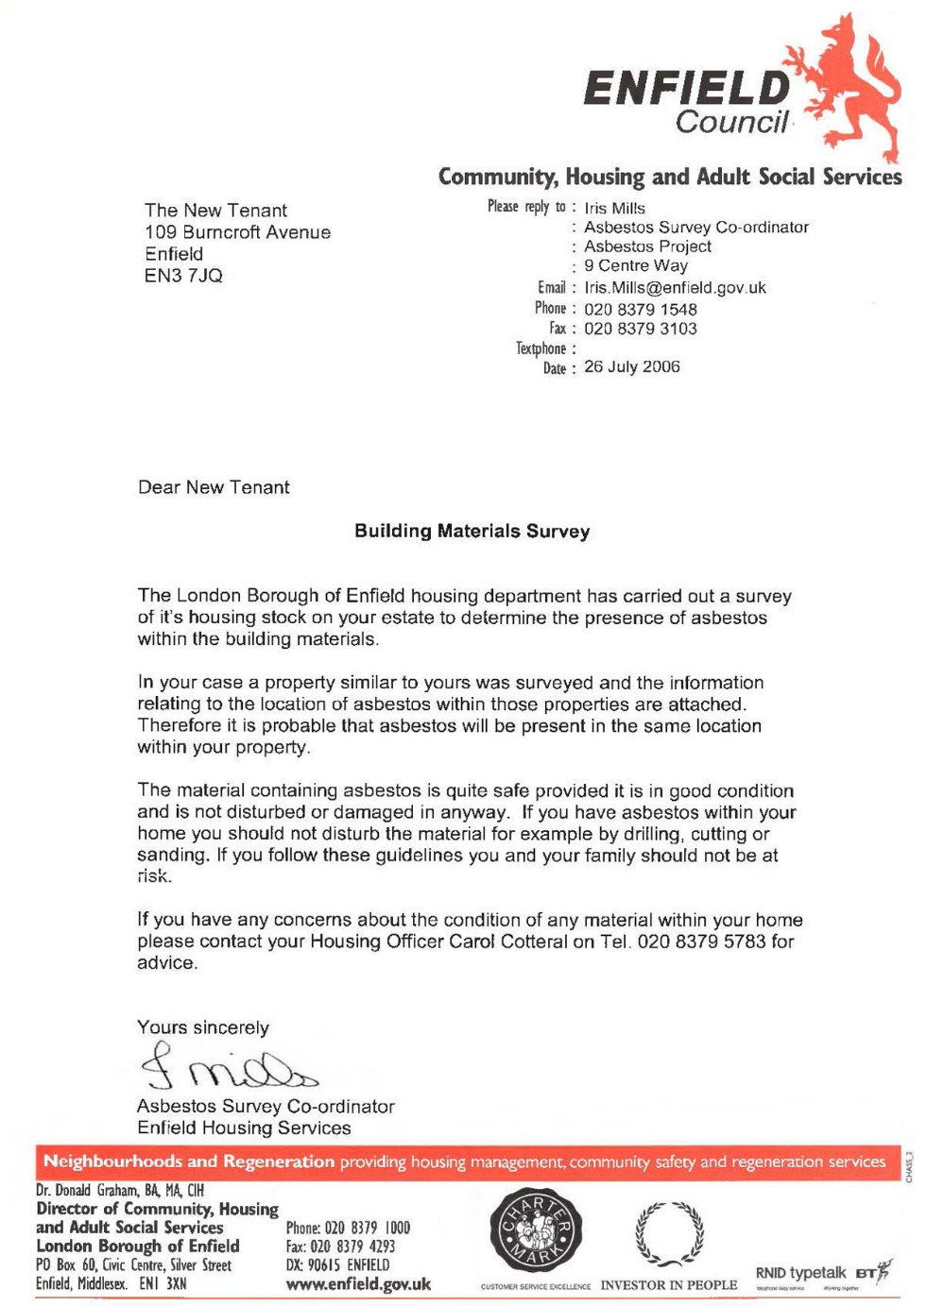
 | Enfield Civic Centre. Enfield Civic Centre. Silver Street, Enfield, London, EN1 3XA | - EXHIBIT D2  - This Exhibit D2 referrers to a letter of evidence made on behalf of the Now Claimant a Mr. S. P. Cordell.  - Document Date 22/11/2011  - This Date 06/10/2022 | 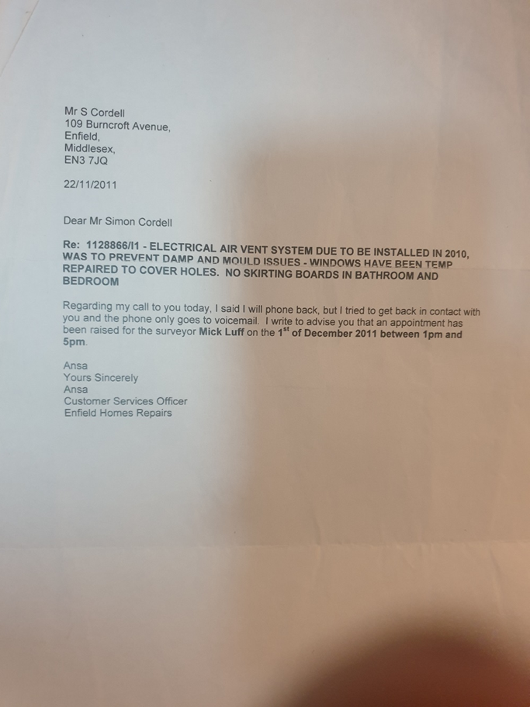
 | Enfield Civic Centre. Enfield Civic Centre. Silver Street, Enfield, London, EN1 3XA | - EXHIBIT D3  - This Exhibit D3 referrers to a letter of evidence made on behalf of the Now Claimant a Mr. S. P. Cordell.  - Document Date 01/12/2011  - This Date 06/10/2022 | 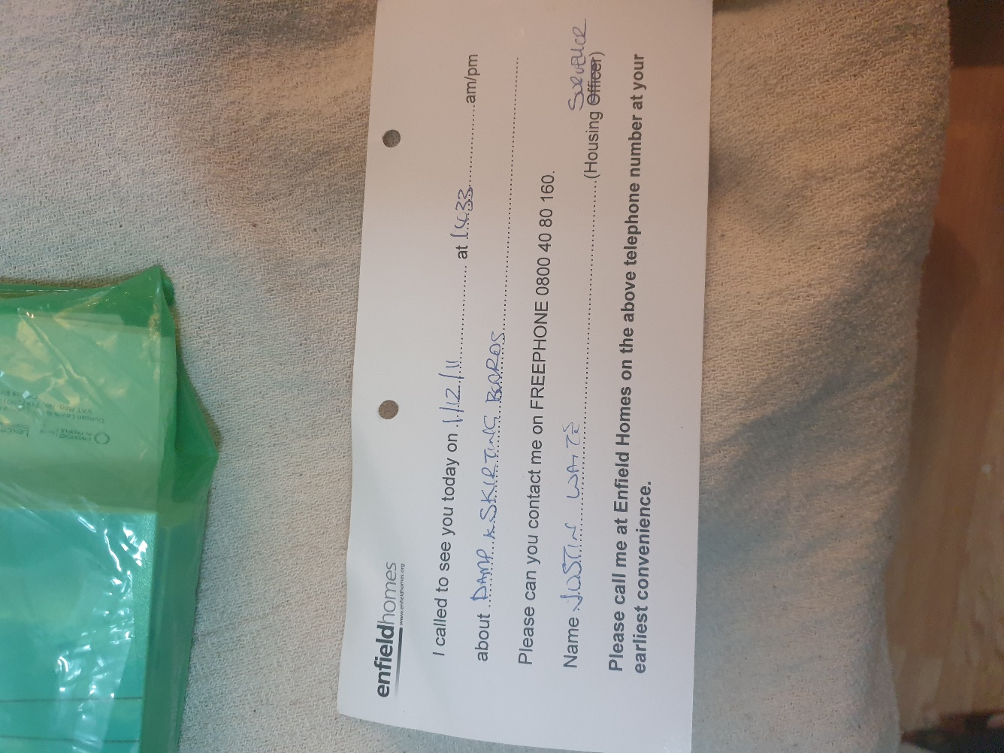
 | Enfield Civic Centre. Enfield Civic Centre. Silver Street, Enfield, London, EN1 3XA | - EXHIBIT D4  - This Exhibit D4 referrers to a letter of evidence made on behalf of the Now Claimant a Mr. S. P. Cordell.  - Document Date 15/02/2012  - This Date 06/10/2022  - Heating | 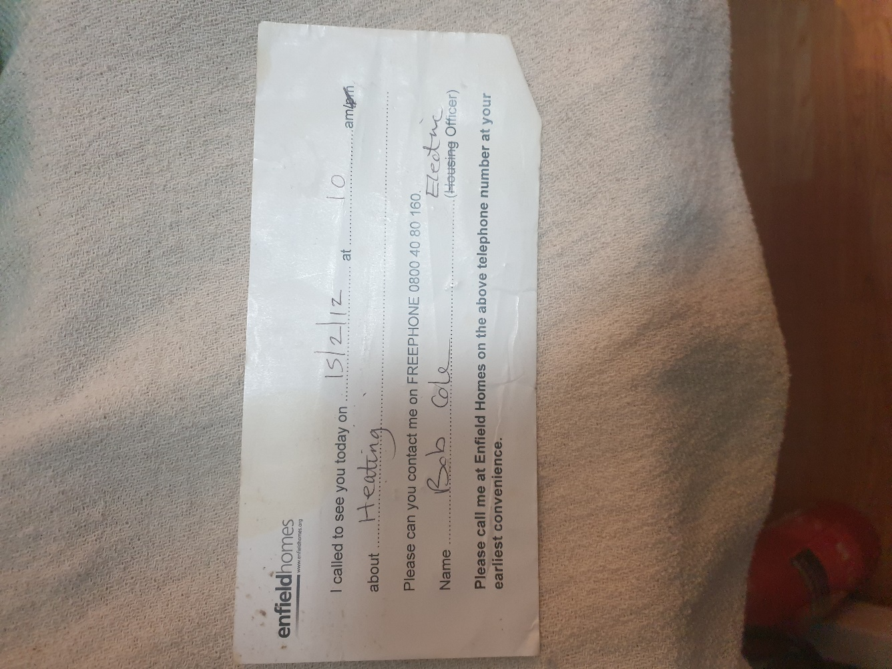
 | Enfield Civic Centre. Enfield Civic Centre. Silver Street, Enfield, London, EN1 3XA | - EXHIBIT D5  - This Exhibit D5 referrers to a letter of evidence made on behalf of the Now Claimant a Mr. S. P. Cordell.  - Total Loss of Gas heating and Hot water in summer 1st May to 31st October.  - Gas defect to domestic gas central Heating appliance.  - Fault Log: 14/05/2009  - Est. Complete Date: 19/05/2009 | 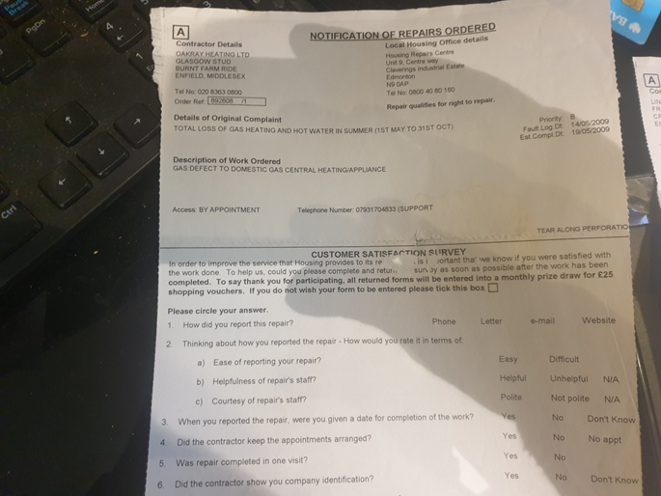
 | Enfield Civic Centre. Enfield Civic Centre. Silver Street, Enfield, London, EN1 3XA | - EXHIBIT D6  - This Exhibit D6 referrers to a letter of evidence made on behalf of the Now Claimant a Mr. S. P. Cordell.  - Access as national grid have shut down the heating system because the CO2 Alarm Kept Sounding.  - Gas defect to domestic gas central Heating appliance.  - Fault Log: 28/11/2014  - Est. Complete Date: 28/11/2014 | 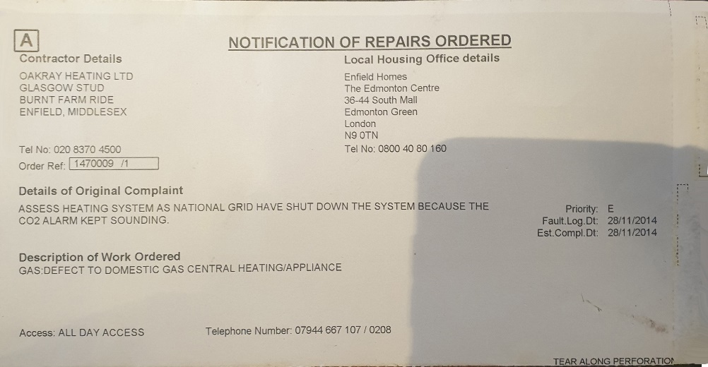
 | Enfield Civic Centre. Enfield Civic Centre. Silver Street, Enfield, London, EN1 3XA | - EXHIBIT D7  - This Exhibit D7 referrers to a letter of evidence made on behalf of the Now Claimant a Mr. S. P. Cordell.  - Supply and fit Graphite Seal  - Gas defect to domestic gas central Heating appliance.  - Fault Log: 01/12/2014  - Est. Complete Date: 03/12/2014 | 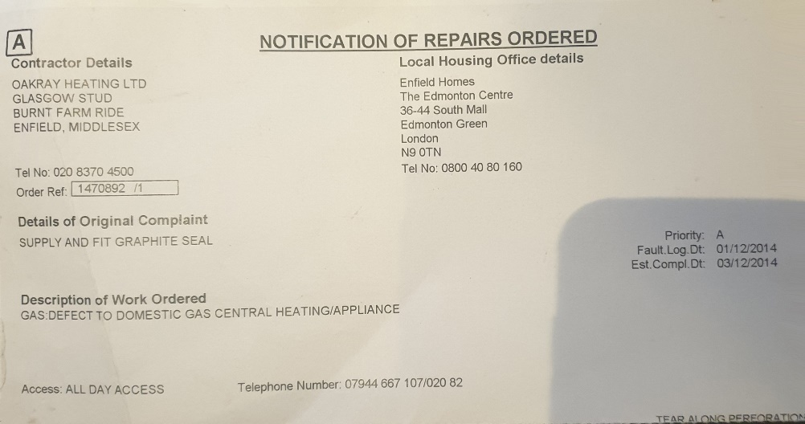
END

Disrepair Issues and Bad Management by My Housing Team Pictures the First Set 109!
[EXHIBIT E]

- File Temp Link Location
- https://horrific-corruption-files.webhop.me/Temp/Disrepair%20109%20Burncroft%20Avenue/

Numb | Details of Responsible Authority / Landlords | Exhibits |  | Photographic Evidence
 | Enfield Civic Centre. Enfield Civic Centre. Silver Street, Enfield, London, EN1 3XA | - EXHIBIT E2  - This EXHIBIT E2 referrers to photographic evidence made on behalf of the Now Claimant a Mr. S. P. Cordell  - This Date 06/10/2022 |  | 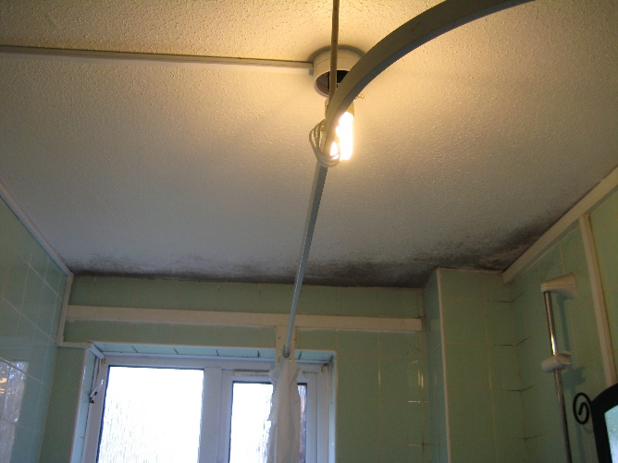
 | Enfield Civic Centre. EN1 3XA | - EXHIBIT E3  - This EXHIBIT E3 referrers to photographic evidence made on behalf of the Now Claimant a Mr. S. P. Cordell  - This Date 06/10/2022 |  | 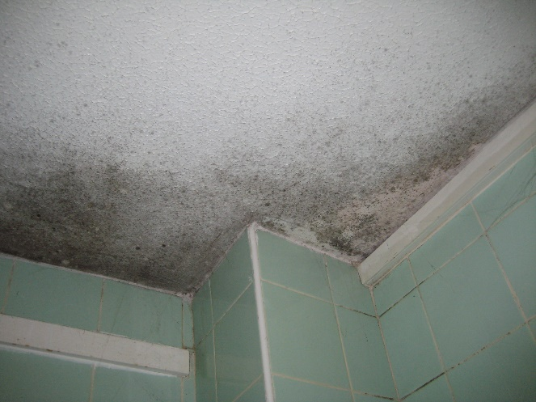
 | Enfield Civic Centre. EN1 3XA | - EXHIBIT E4  - This EXHIBIT E4 referrers to photographic evidence made on behalf of the Now Claimant a Mr. S. P. Cordell  - This Date 06/10/2022 |  | 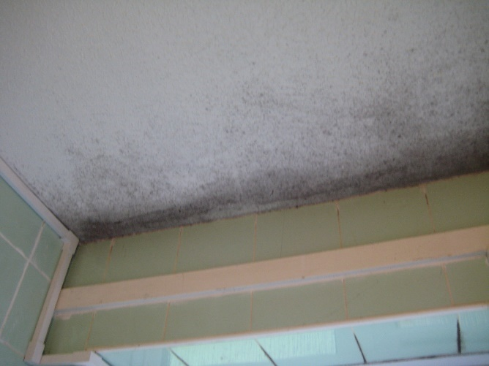
 | Enfield Civic Centre. EN1 3XA | - EXHIBIT E5  - This EXHIBIT E5 referrers to photographic evidence made on behalf of the Now Claimant a Mr. S. P. Cordell  - This Date 06/10/2022 |  | 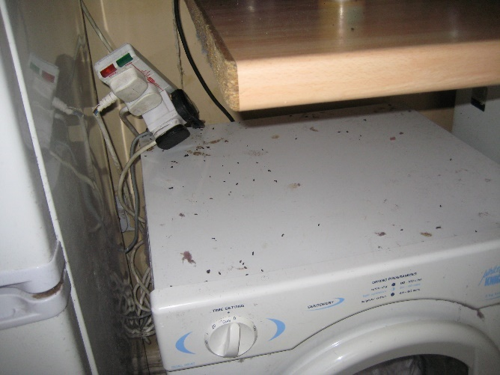
 | Enfield Civic Centre. EN1 3XA | - EXHIBIT E6  - This EXHIBIT E6 referrers to photographic evidence made on behalf of the Now Claimant a Mr. S. P. Cordell  - This Date 06/10/2022 |  | 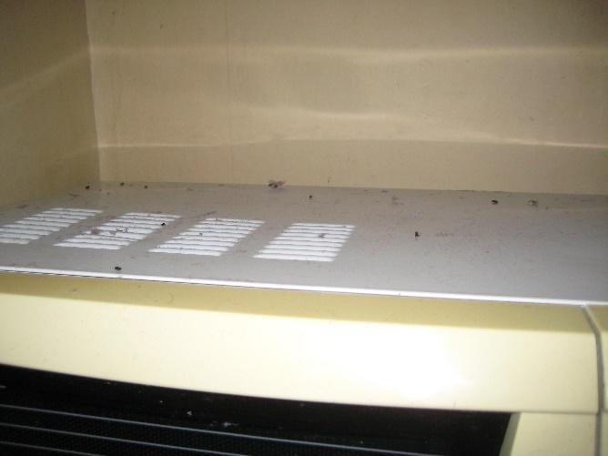
 | Enfield Civic Centre. EN1 3XA | - EXHIBIT E7  - This EXHIBIT E6 referrers to photographic evidence made on behalf of the Now Claimant a Mr. S. P. Cordell  - This Date 06/10/2022 |  | 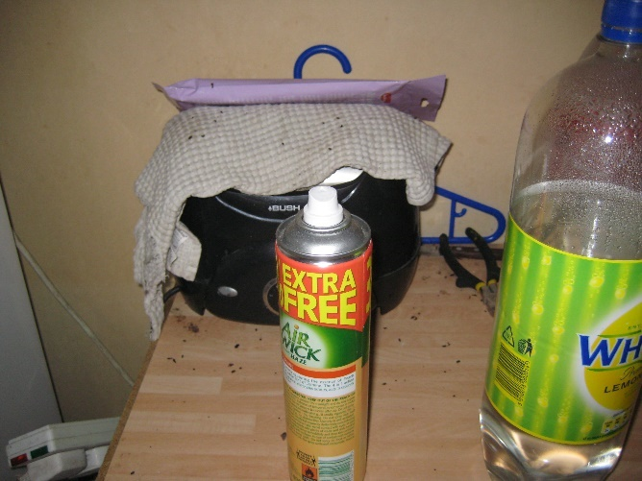
 | Enfield Civic Centre. EN1 3XA | - EXHIBIT E8  - This EXHIBIT E8 referrers to photographic evidence made on behalf of the Now Claimant a Mr. S. P. Cordell  - This Date 06/10/2022 |  | 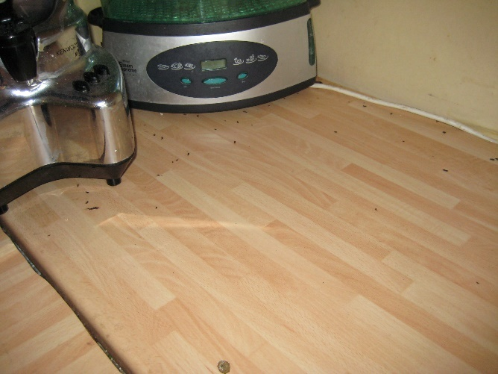
 | Enfield Civic Centre. EN1 3XA | - EXHIBIT E9  - This EXHIBIT E9 referrers to photographic evidence made on behalf of the Now Claimant a Mr. S. P. Cordell  - This Date 06/10/2022 |  | 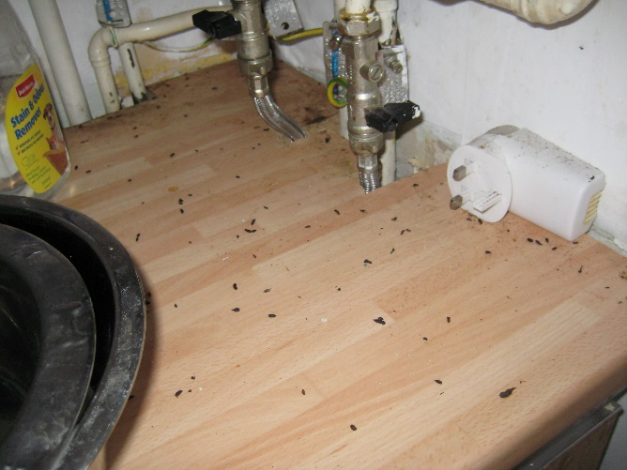
 | Enfield Civic Centre. EN1 3XA | - EXHIBIT E10  - This EXHIBIT E10 referrers to photographic evidence made on behalf of the Now Claimant a Mr. S. P. Cordell  - This Date 06/10/2022 |  | 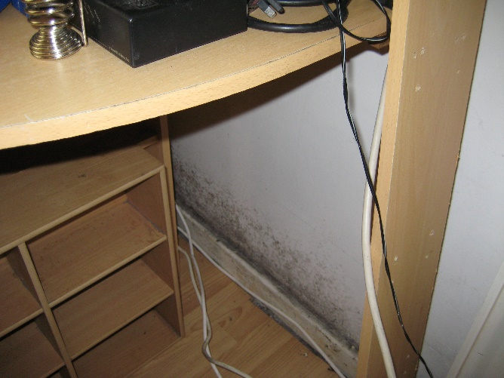
 | Enfield Civic Centre. EN1 3XA | - EXHIBIT E11  - This EXHIBIT E11 referrers to photographic evidence made on behalf of the Now Claimant a Mr. S. P. Cordell  - This Date 06/10/2022 |  | 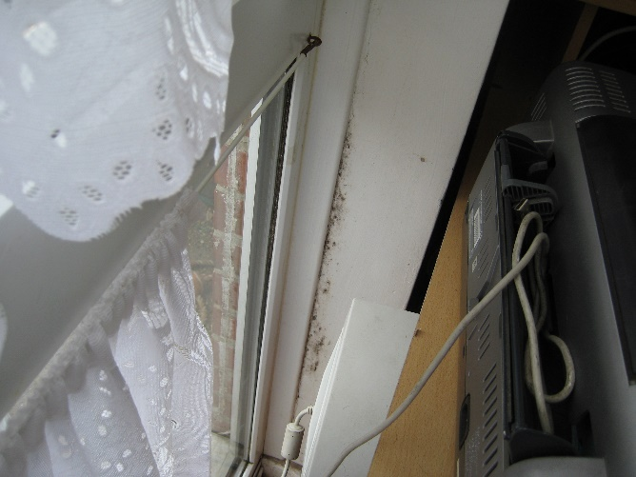
 | Enfield Civic Centre. EN1 3XA | - EXHIBIT E12  - This EXHIBIT E12 referrers to photographic evidence made on behalf of the Now Claimant a Mr. S. P. Cordell  - This Date 06/10/2022 |  | 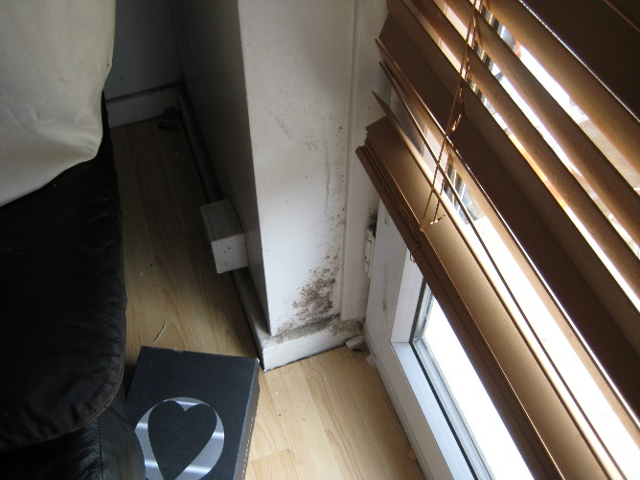
 | Enfield Civic Centre. EN1 3XA | - EXHIBIT E13  - This EXHIBIT E13 referrers to photographic evidence made on behalf of the Now Claimant a Mr. S. P. Cordell  - This Date 06/10/2022 |  | 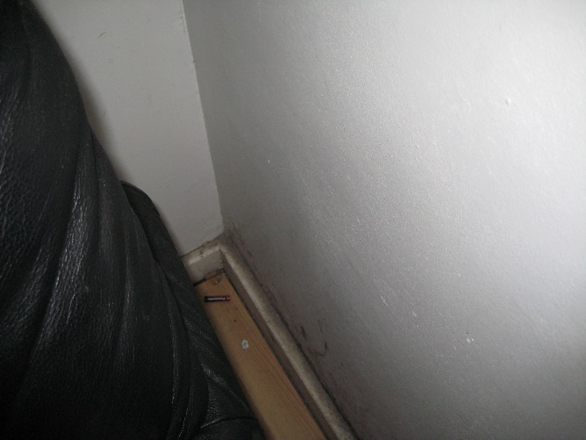
 | Enfield Civic Centre. EN1 3XA | - EXHIBIT E14  - This EXHIBIT E14 referrers to photographic evidence made on behalf of the Now Claimant a Mr. S. P. Cordell  - This Date 06/10/2022 |  | 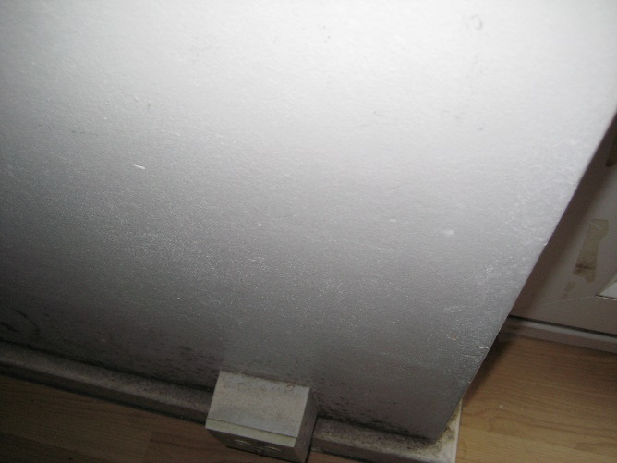
 | Enfield Civic Centre. EN1 3XA | - EXHIBIT E15  - This EXHIBIT E15 referrers to photographic evidence made on behalf of the Now Claimant a Mr. S. P. Cordell  - This Date 06/10/2022 |  | 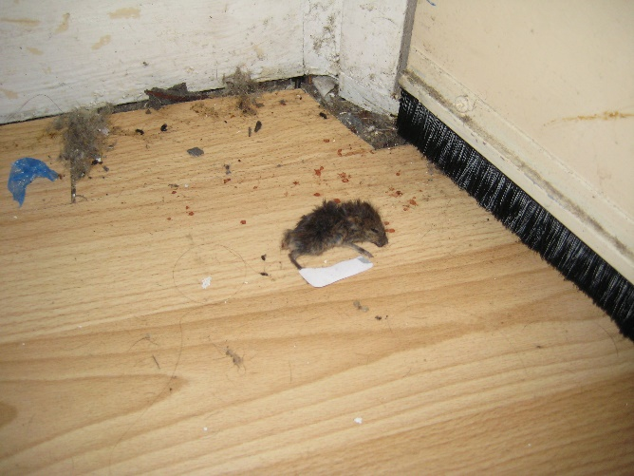
 | Enfield Civic Centre. EN1 3XA | - EXHIBIT E16  - This EXHIBIT E16 referrers to photographic evidence made on behalf of the Now Claimant a Mr. S. P. Cordell  - This Date 06/10/2022 |  | 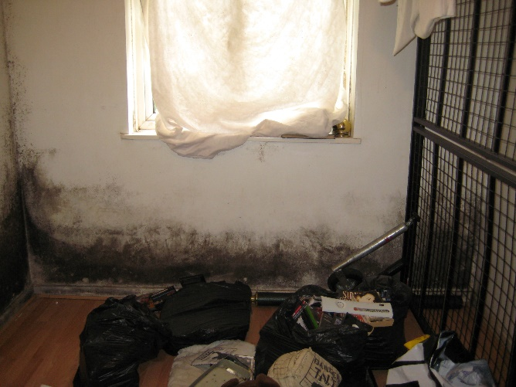
 | Enfield Civic Centre. EN1 3XA | - EXHIBIT E17  - This EXHIBIT E17 referrers to photographic evidence made on behalf of the Now Claimant a Mr. S. P. Cordell  - This Date 06/10/2022 |  | 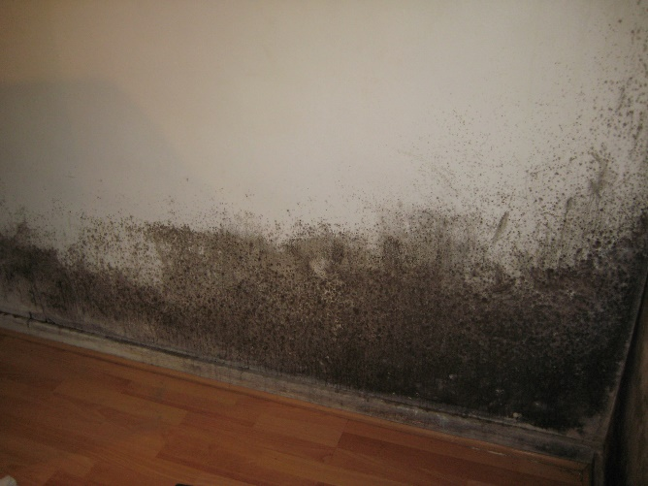
 | Enfield Civic Centre. EN1 3XA | - EXHIBIT E18  - This EXHIBIT E18 referrers to photographic evidence made on behalf of the Now Claimant a Mr. S. P. Cordell  - This Date 06/10/2022 |  | 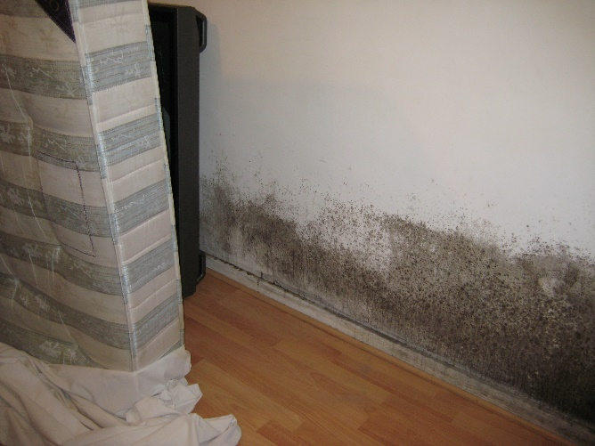
 | Enfield Civic Centre. EN1 3XA | - EXHIBIT E19  - This EXHIBIT E19 referrers to photographic evidence made on behalf of the Now Claimant a Mr. S. P. Cordell  - This Date 06/10/2022 |  | 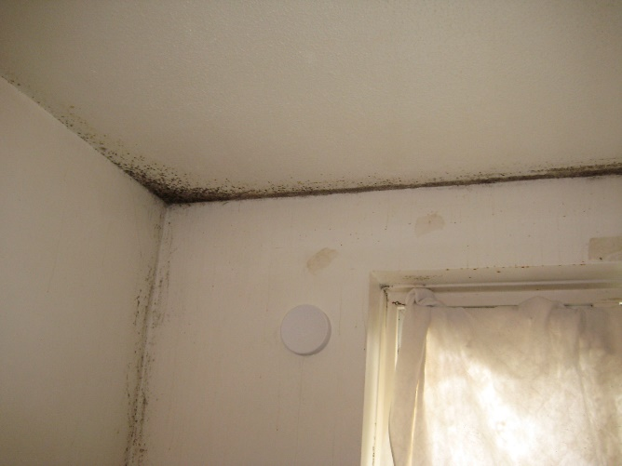
 | Enfield Civic Centre. EN1 3XA | - EXHIBIT E20  - This EXHIBIT E20 referrers to photographic evidence made on behalf of the Now Claimant a Mr. S. P. Cordell  - This Date 06/10/2022 |  | 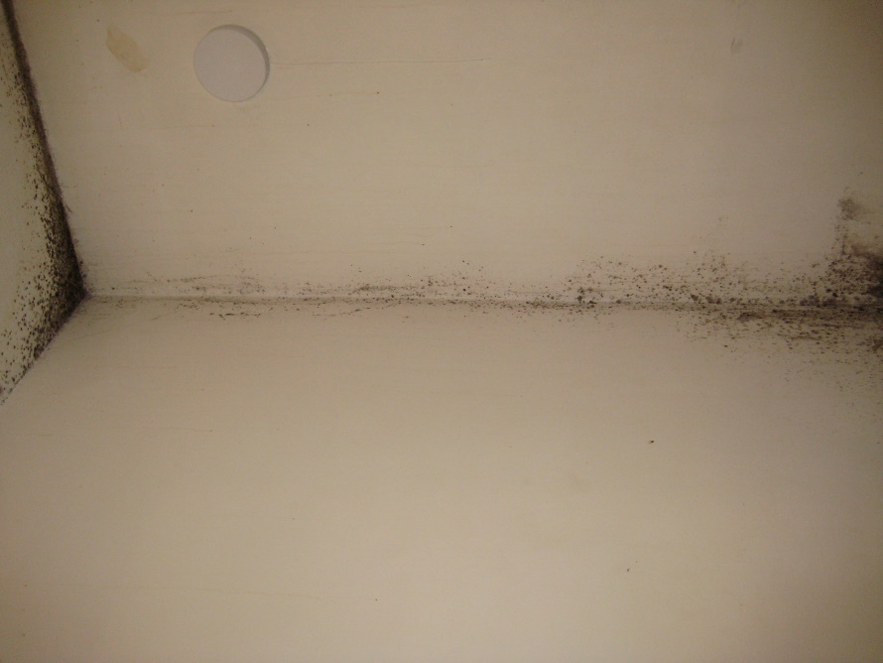
 | Enfield Civic Centre. EN1 3XA | - EXHIBIT E21  - This EXHIBIT E21 referrers to photographic evidence made on behalf of the Now Claimant a Mr. S. P. Cordell  - This Date 06/10/2022 |  | 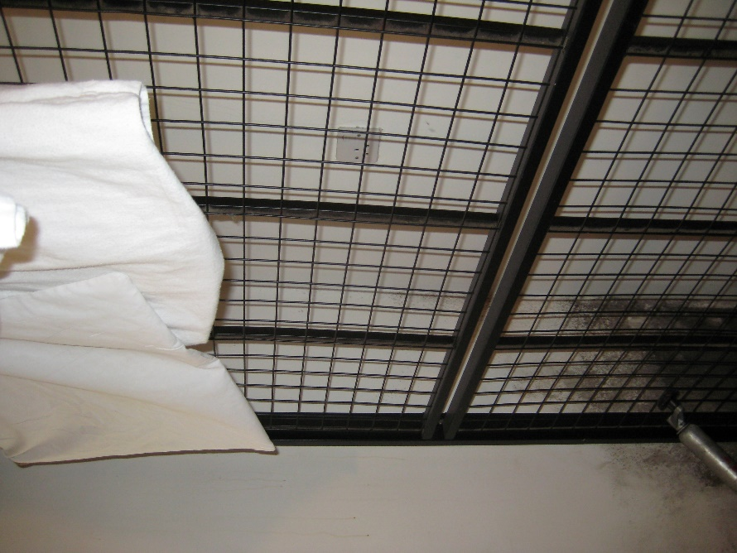
 | Enfield Civic Centre. EN1 3XA | - EXHIBIT E22  - This EXHIBIT E22 referrers to photographic evidence made on behalf of the Now Claimant a Mr. S. P. Cordell  - This Date 06/10/2022 |  | 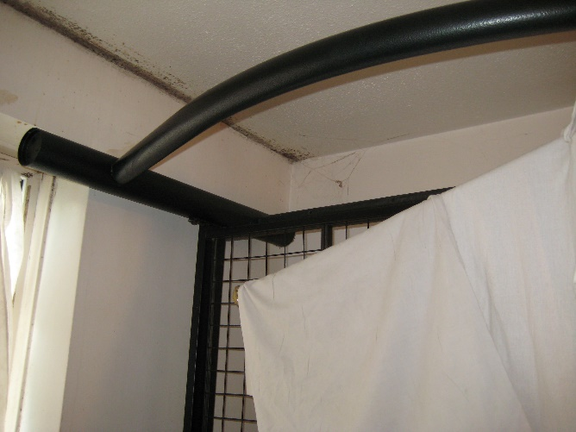
 | Enfield Civic Centre. EN1 3XA | - EXHIBIT E23  - This EXHIBIT E23 referrers to photographic evidence made on behalf of the Now Claimant a Mr. S. P. Cordell  - This Date 06/10/2022 |  | 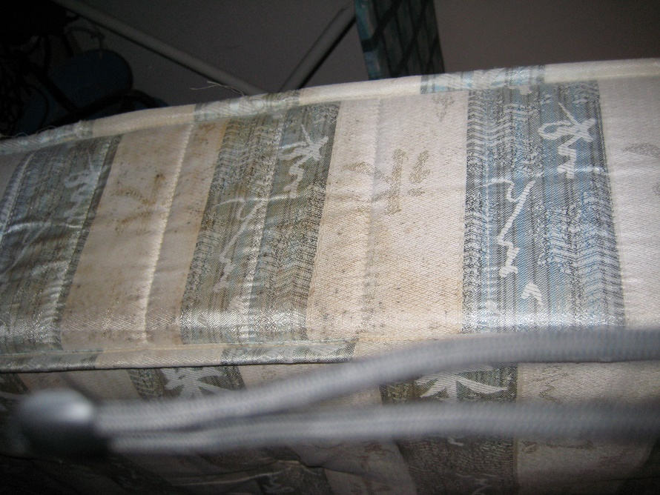
 | Enfield Civic Centre. EN1 3XA | - EXHIBIT E24  - This EXHIBIT E24 referrers to photographic evidence made on behalf of the Now Claimant a Mr. S. P. Cordell  - This Date 06/10/2022 |  | 
 | Enfield Civic Centre. EN1 3XA | - EXHIBIT E25  - This EXHIBIT E25 referrers to photographic evidence made on behalf of the Now Claimant a Mr. S. P. Cordell  - This Date 06/10/2022
End

Disrepair Issues and Bad Management by My Housing Team 117 Burncroft Avenue Flat and Block Pictures!
[EXHIBIT F]

- File Temp Link Location
- https://horrific-corruption-files.webhop.me/Temp/Disrepair%20109%20Burncroft%20Avenue/

Numb | Details of Responsible Authority / Landlords | Exhibits |  | Photographic Evidence
 | Enfield Civic Centre. Enfield Civic Centre. Silver Street, Enfield, London, EN1 3XA | - EXHIBIT F27  - This EXHIBIT F27 referrers to photographic evidence made on behalf of the Now Claimant a Mr. S. P. Cordell  - This Date 06/10/2022 | This just come out of 117 Burncroft Avenue.  ‎25 ‎May ‎2022?  set of tennants in 2 years or more | 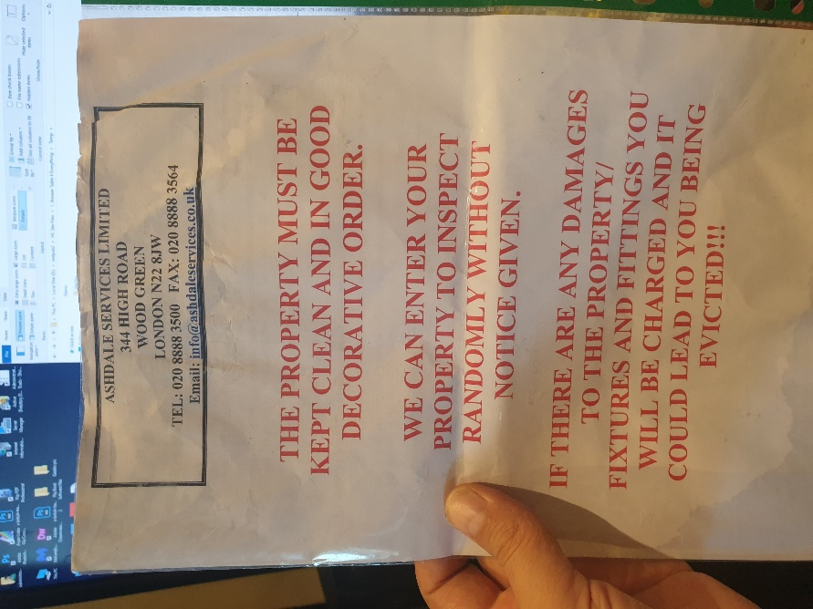
 | Enfield Civic Centre. Enfield Civic Centre. Silver Street, Enfield, London, EN1 3XA | - EXHIBIT F28  - This EXHIBIT F28 referrers to photographic evidence made on behalf of the Now Claimant a Mr. S. P. Cordell  - This Date 06/10/2022 |  | 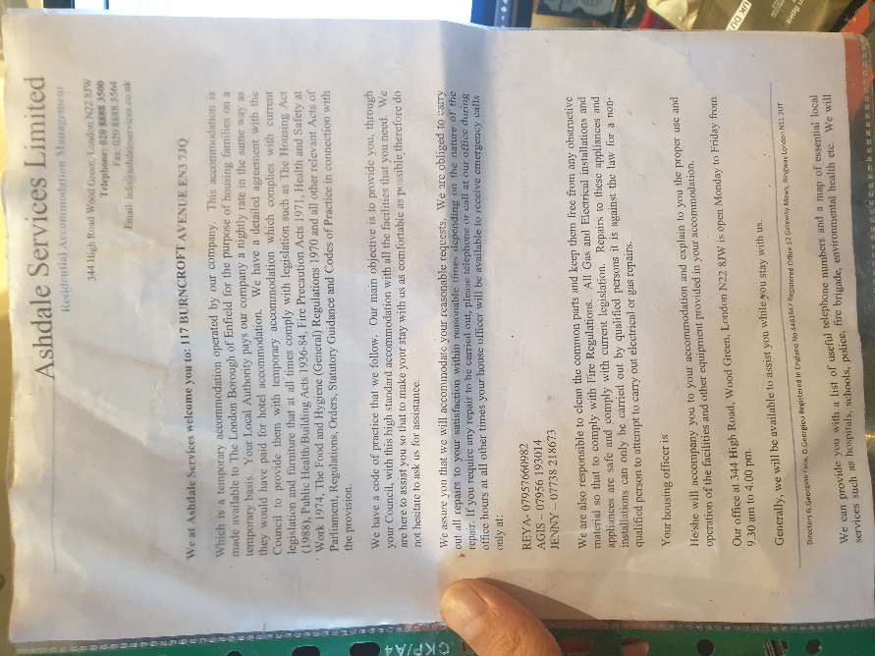
 | Enfield Civic Centre. Enfield Civic Centre. Silver Street, Enfield, London, EN1 3XA | - EXHIBIT F29  - This EXHIBIT F29 referrers to photographic evidence made on behalf of the Now Claimant a Mr. S. P. Cordell  - This Date 06/10/2022 |  | 
 | Enfield Civic Centre. Enfield Civic Centre. Silver Street, Enfield, London, EN1 3XA | - EXHIBIT F30  - This EXHIBIT F30 referrers to photographic evidence made on behalf of the Now Claimant a Mr. S. P. Cordell  - This Date 06/10/2022 |  | 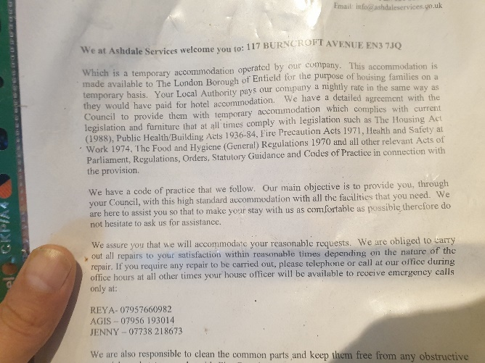
 | Enfield Civic Centre. Enfield Civic Centre. Silver Street, Enfield, London, EN1 3XA | - EXHIBIT F31  - This EXHIBIT F31 referrers to photographic evidence made on behalf of the Now Claimant a Mr. S. P. Cordell  - This Date 06/10/2022 |  | Video Link  https://horrific-corruption-files.webhop.me/Temp/Disrepair%20109%20Burncroft%20Avenue/1%20This%20just%20come%20out%20of%20117%203rd%20set%20of%20tennants%20in%202%20years%20or%20more/20220525_175017.mp4
 | Enfield Civic Centre. Enfield Civic Centre. Silver Street, Enfield, London, EN1 3XA | - EXHIBIT F32  - This EXHIBIT F32 referrers to photographic evidence made on behalf of the Now Claimant a Mr. S. P. Cordell  - This Date 06/10/2022 |  | Video Link  https://horrific-corruption-files.webhop.me/Temp/Disrepair%20109%20Burncroft%20Avenue/1%20This%20just%20come%20out%20of%20117%203rd%20set%20of%20tennants%20in%202%20years%20or%20more/20220525_175620.mp4
 | Enfield Civic Centre. Enfield Civic Centre. Silver Street, Enfield, London, EN1 3XA | - EXHIBIT F33  - This EXHIBIT F33 referrers to photographic evidence made on behalf of the Now Claimant a Mr. S. P. Cordell  - This Date 06/10/2022 | Video Link Pictures | 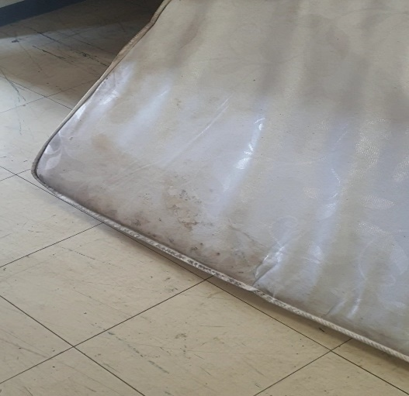
 | Enfield Civic Centre. Enfield Civic Centre. Silver Street, Enfield, London, EN1 3XA | - EXHIBIT F34  - This EXHIBIT F34 referrers to photographic evidence made on behalf of the Now Claimant a Mr. S. P. Cordell  - This Date 06/10/2022 |  | 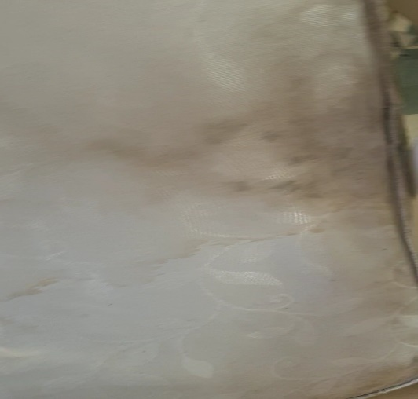
 | Enfield Civic Centre. Enfield Civic Centre. Silver Street, Enfield, London, EN1 3XA | - EXHIBIT F35  - This EXHIBIT F35 referrers to photographic evidence made on behalf of the Now Claimant a Mr. S. P. Cordell  - This Date 06/10/2022 |  | 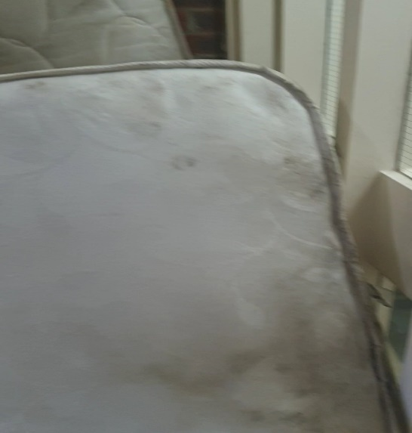
 | Enfield Civic Centre. Enfield Civic Centre. Silver Street, Enfield, London, EN1 3XA | - EXHIBIT F36  - This EXHIBIT F36 referrers to photographic evidence made on behalf of the Now Claimant a Mr. S. P. Cordell  - This Date 06/10/2022 |  | 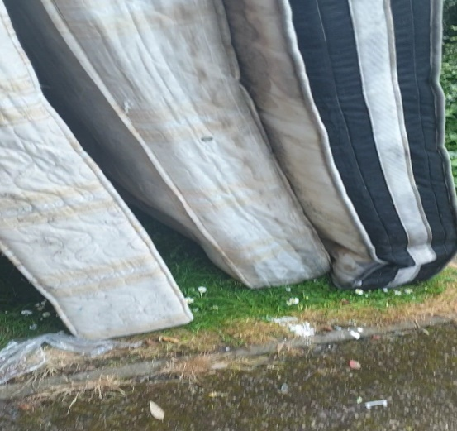
 | Enfield Civic Centre. Enfield Civic Centre. Silver Street, Enfield, London, EN1 3XA | - EXHIBIT F37  - This EXHIBIT F37 referrers to photographic evidence made on behalf of the Now Claimant a Mr. S. P. Cordell  - This Date 06/10/2022 |  | 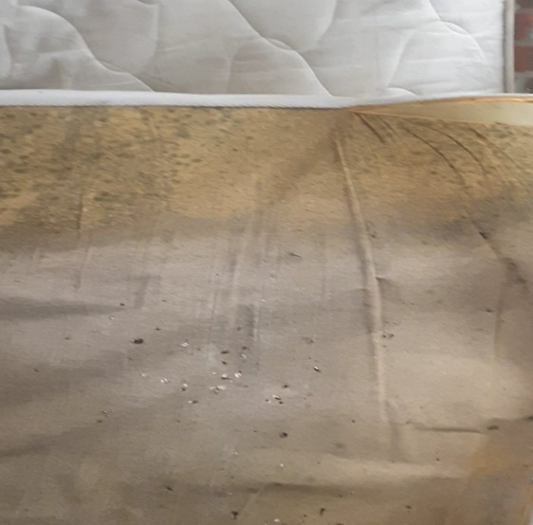
 | Enfield Civic Centre. Enfield Civic Centre. Silver Street, Enfield, London, EN1 3XA | - EXHIBIT F38  - This EXHIBIT F38 referrers to photographic evidence made on behalf of the Now Claimant a Mr. S. P. Cordell  - This Date 06/10/2022 |  | 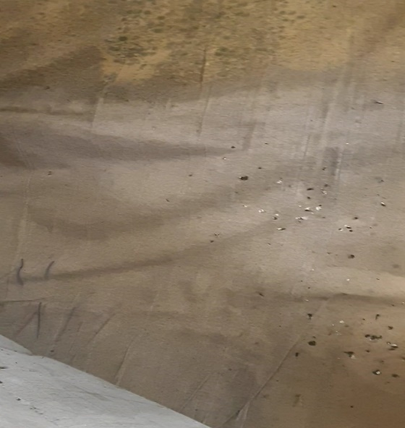
 | Enfield Civic Centre. Enfield Civic Centre. Silver Street, Enfield, London, EN1 3XA | - EXHIBIT F39  - This EXHIBIT F39 referrers to photographic evidence made on behalf of the Now Claimant a Mr. S. P. Cordell  - This Date 06/10/2022 |  | 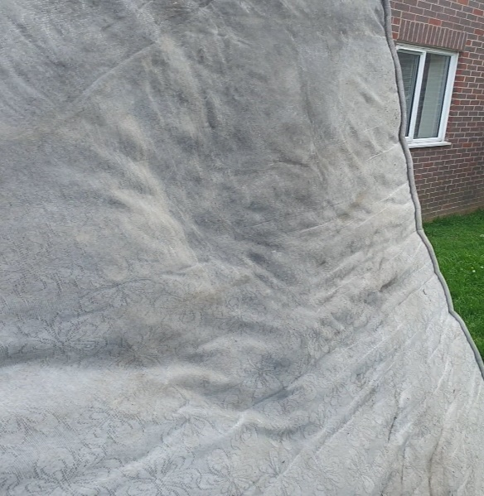
 | Enfield Civic Centre. Enfield Civic Centre. Silver Street, Enfield, London, EN1 3XA | - EXHIBIT F40  - This EXHIBIT F40 referrers to photographic evidence made on behalf of the Now Claimant a Mr. S. P. Cordell  - This Date 06/10/2022 |  | 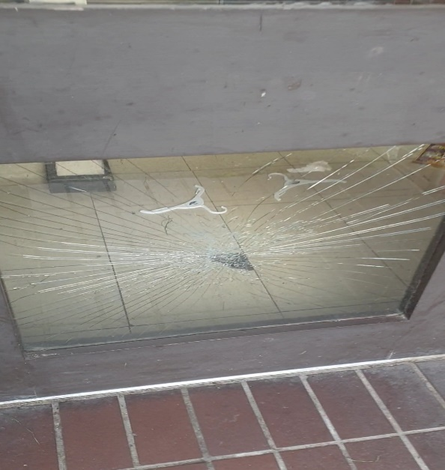
 | Enfield Civic Centre. Enfield Civic Centre. Silver Street, Enfield, London, EN1 3XA | - EXHIBIT F41  - This EXHIBIT F41 referrers to photographic evidence made on behalf of the Now Claimant a Mr. S. P. Cordell  - This Date 06/10/2022
END

Disrepair Issues and Bad Management by My Housing Team Pictures the Second Set 109!
EXHIBIT G

- File Temp Link Location
- https://horrific-corruption-files.webhop.me/Temp/Disrepair%20109%20Burncroft%20Avenue/

Numb | Details of Responsible Authority / Landlords | Exhibits |  | Photographic Evidence
 | Enfield Civic Centre. Enfield Civic Centre. Silver Street, Enfield, London, EN1 3XA | - EXHIBIT G42  - This EXHIBIT G42 referrers to photographic evidence made on behalf of the Now Claimant a Mr. S. P. Cordell  - This Date 06/10/2022 | Upto date of the 06/10/2022 | 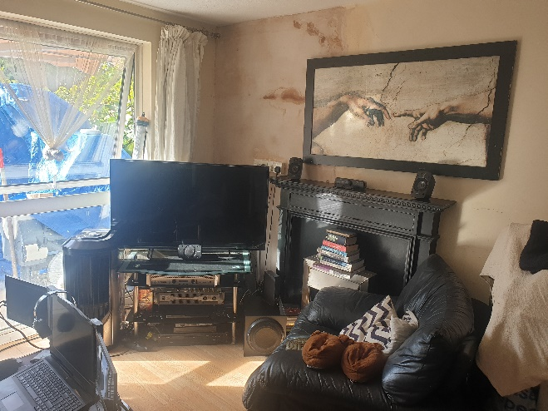
 | Enfield Civic Centre. Enfield Civic Centre. Silver Street, Enfield, London, EN1 3XA | - EXHIBIT G43  - This EXHIBIT G43 referrers to photographic evidence made on behalf of the Now Claimant a Mr. S. P. Cordell  - This Date 06/10/2022 | Upto date of the 06/10/2022 | 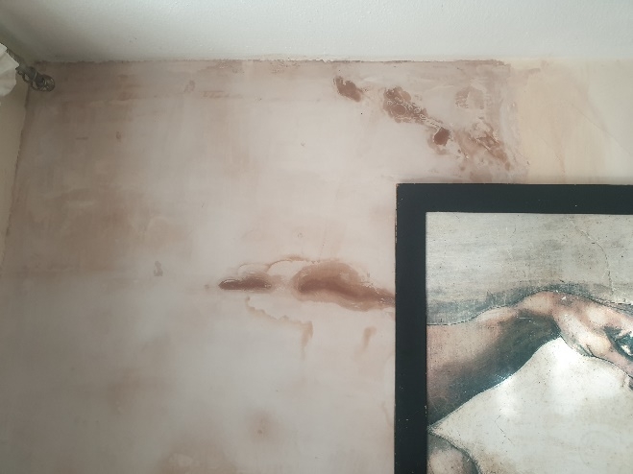
 | Enfield Civic Centre. Enfield Civic Centre. Silver Street, Enfield, London, EN1 3XA | - EXHIBIT G44  - This EXHIBIT G44 referrers to photographic evidence made on behalf of the Now Claimant a Mr. S. P. Cordell  - This Date 06/10/2022 | Upto date of the 06/10/2022 | 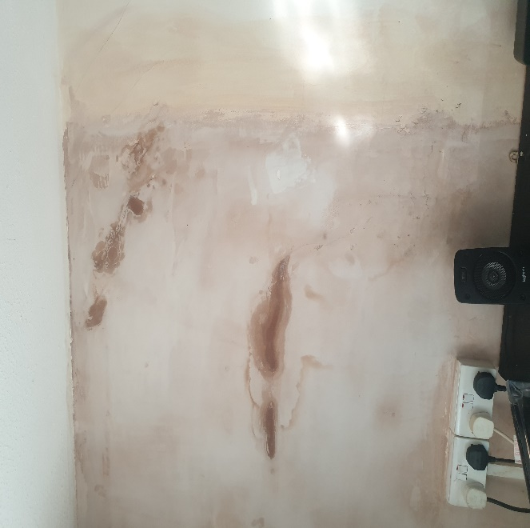
 | Enfield Civic Centre. Enfield Civic Centre. Silver Street, Enfield, London, EN1 3XA | - EXHIBIT G45  - This EXHIBIT G45 referrers to photographic evidence made on behalf of the Now Claimant a Mr. S. P. Cordell  - This Date 06/10/2022 | Upto date of the 06/10/2022 | 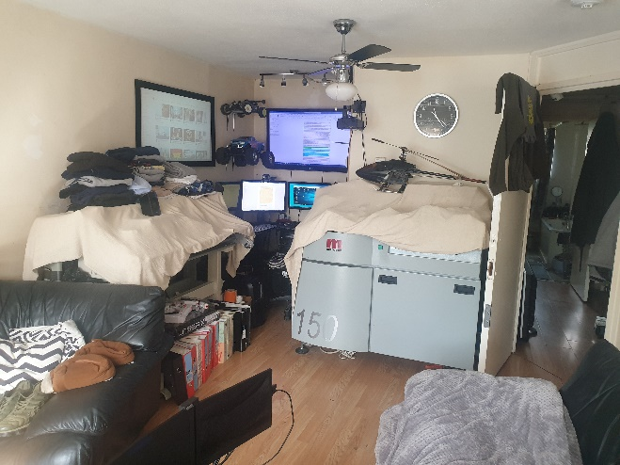
 | Enfield Civic Centre. Enfield Civic Centre. Silver Street, Enfield, London, EN1 3XA | - EXHIBIT G46  - This EXHIBIT G46 referrers to photographic evidence made on behalf of the Now Claimant a Mr. S. P. Cordell  - This Date 06/10/2022 | Upto date of the 06/10/2022 | 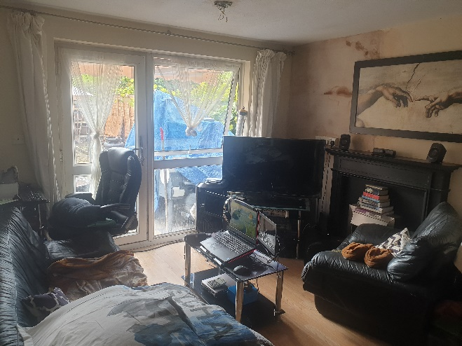
 | Enfield Civic Centre. Enfield Civic Centre. Silver Street, Enfield, London, EN1 3XA | - EXHIBIT G47  - This EXHIBIT G47 referrers to photographic evidence made on behalf of the Now Claimant a Mr. S. P. Cordell  - This Date 06/10/2022 | Upto date of the 06/10/2022 | 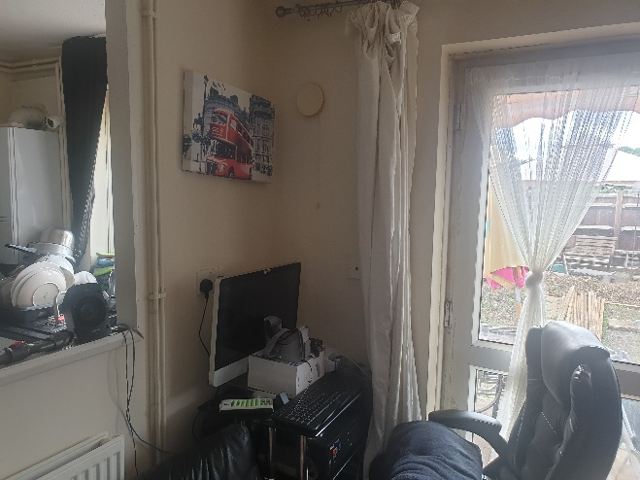
 | Enfield Civic Centre. Enfield Civic Centre. Silver Street, Enfield, London, EN1 3XA | - EXHIBIT G48  - This EXHIBIT G48 referrers to photographic evidence made on behalf of the Now Claimant a Mr. S. P. Cordell  - This Date 06/10/2022 | Upto date of the 06/10/2022 | 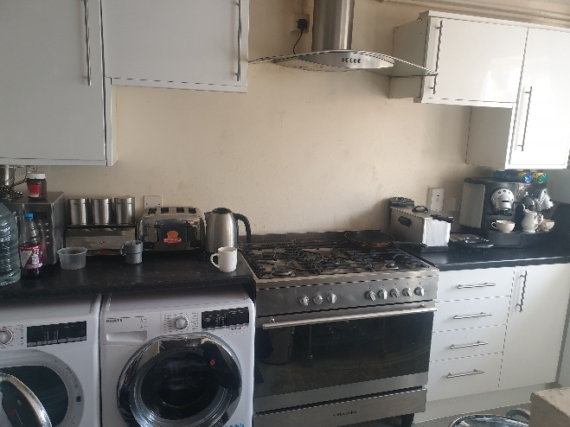
 | Enfield Civic Centre. Enfield Civic Centre. Silver Street, Enfield, London, EN1 3XA | - EXHIBIT G49  - This EXHIBIT G49 referrers to photographic evidence made on behalf of the Now Claimant a Mr. S. P. Cordell  - This Date 06/10/2022 | Upto date of the 06/10/2022 | 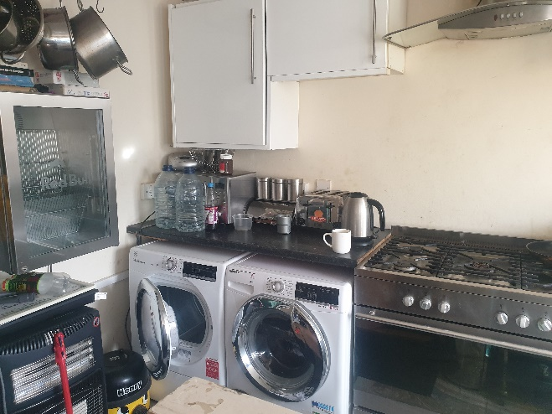
 | Enfield Civic Centre. Enfield Civic Centre. Silver Street, Enfield, London, EN1 3XA | - EXHIBIT G50  - This EXHIBIT G50 referrers to photographic evidence made on behalf of the Now Claimant a Mr. S. P. Cordell  - This Date 06/10/2022 | Upto date of the 06/10/2022 | 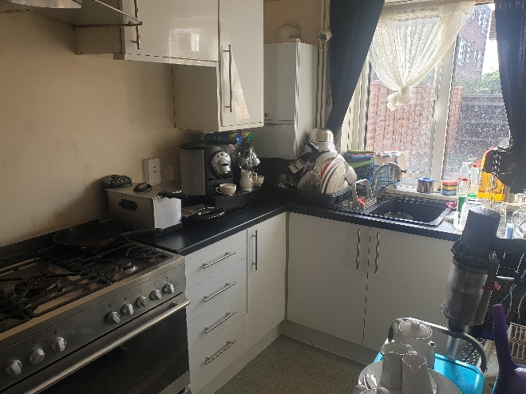
 | Enfield Civic Centre. Enfield Civic Centre. Silver Street, Enfield, London, EN1 3XA | - EXHIBIT G51  - This EXHIBIT G51 referrers to photographic evidence made on behalf of the Now Claimant a Mr. S. P. Cordell  - This Date 06/10/2022 | Upto date of the 06/10/2022 | 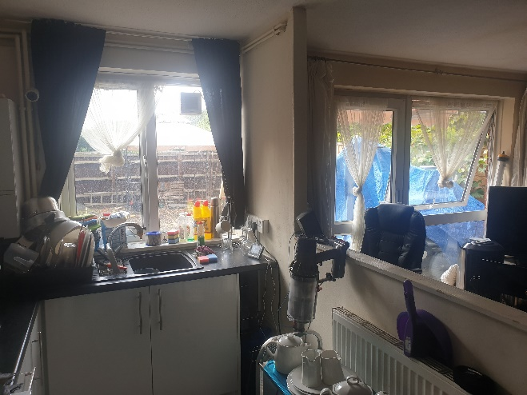
 | Enfield Civic Centre. Enfield Civic Centre. Silver Street, Enfield, London, EN1 3XA | - EXHIBIT G52  - This EXHIBIT G52 referrers to photographic evidence made on behalf of the Now Claimant a Mr. S. P. Cordell  - This Date 06/10/2022 | Upto date of the 06/10/2022 | 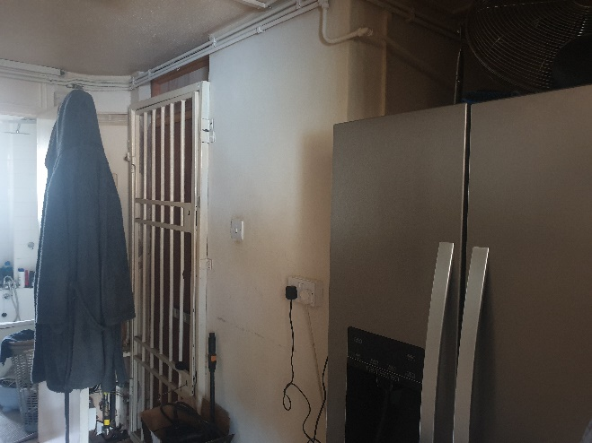
 | Enfield Civic Centre. Enfield Civic Centre. Silver Street, Enfield, London, EN1 3XA | - EXHIBIT G53  - This EXHIBIT G53 referrers to photographic evidence made on behalf of the Now Claimant a Mr. S. P. Cordell  - This Date 06/10/2022 | Upto date of the 06/10/2022 | 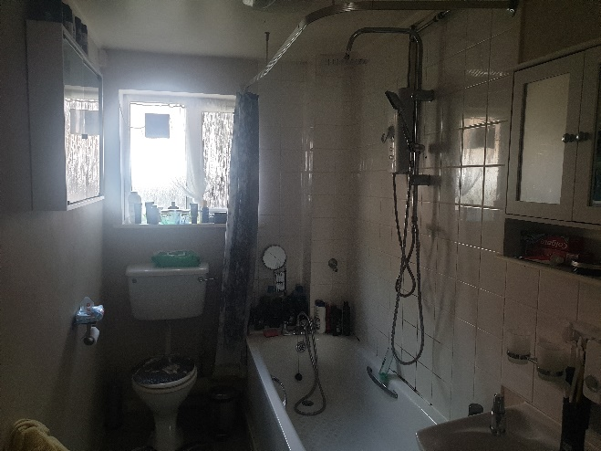
 | Enfield Civic Centre. Enfield Civic Centre. Silver Street, Enfield, London, EN1 3XA | - EXHIBIT G54  - This EXHIBIT G54 referrers to photographic evidence made on behalf of the Now Claimant a Mr. S. P. Cordell  - This Date 06/10/2022 | Upto date of the 06/10/2022 | 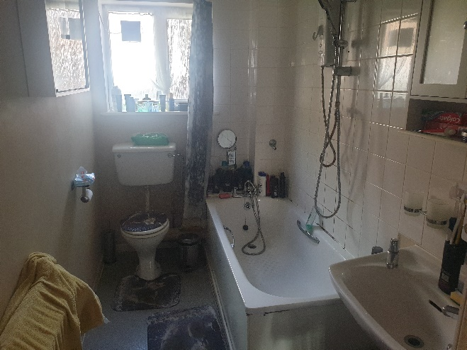
 | Enfield Civic Centre. Enfield Civic Centre. Silver Street, Enfield, London, EN1 3XA | - EXHIBIT G55  - This EXHIBIT G55 referrers to photographic evidence made on behalf of the Now Claimant a Mr. S. P. Cordell  - This Date 06/10/2022 | Upto date of the 06/10/2022 | 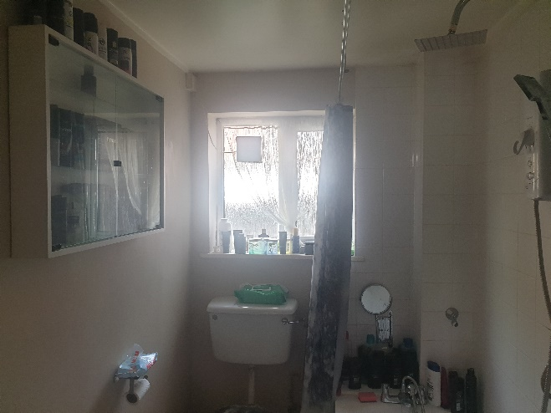
 | Enfield Civic Centre. Enfield Civic Centre. Silver Street, Enfield, London, EN1 3XA | - EXHIBIT G56  - This EXHIBIT G56 referrers to photographic evidence made on behalf of the Now Claimant a Mr. S. P. Cordell  - This Date 06/10/2022 | Upto date of the 06/10/2022 | 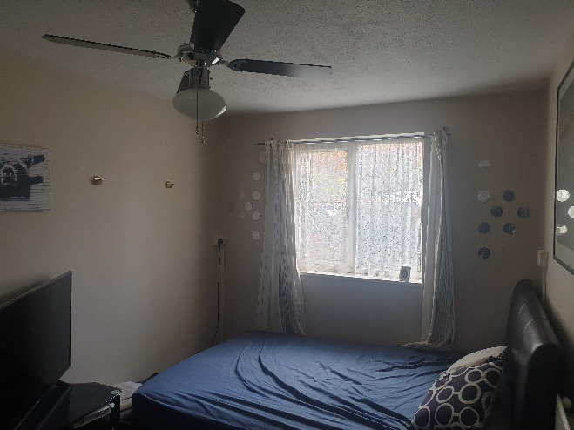
 | Enfield Civic Centre. Enfield Civic Centre. Silver Street, Enfield, London, EN1 3XA | - EXHIBIT G57  - This EXHIBIT G57 referrers to photographic evidence made on behalf of the Now Claimant a Mr. S. P. Cordell  - This Date 06/10/2022 | Upto date of the 06/10/2022 | 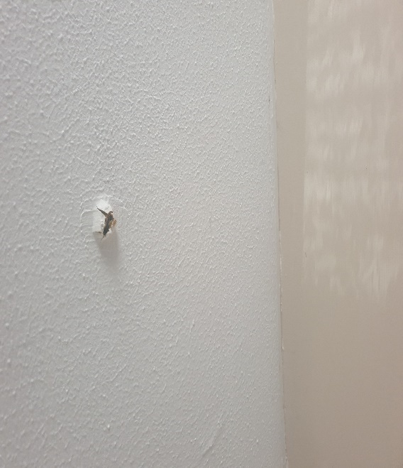
 | Enfield Civic Centre. Enfield Civic Centre. Silver Street, Enfield, London, EN1 3XA | - EXHIBIT G58  - This EXHIBIT G58 referrers to photographic evidence made on behalf of the Now Claimant a Mr. S. P. Cordell  - This Date 06/10/2022 | Upto date of the 06/10/2022 | 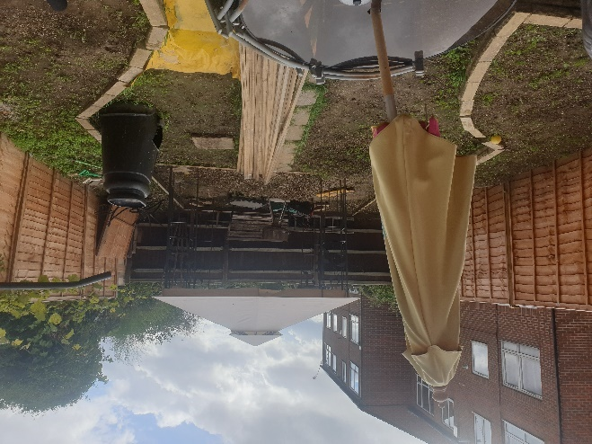
 | Enfield Civic Centre. Enfield Civic Centre. Silver Street, Enfield, London, EN1 3XA | - EXHIBIT G59  - This EXHIBIT G59 referrers to photographic evidence made on behalf of the Now Claimant a Mr. S. P. Cordell  - This Date 06/10/2022 | Upto date of the 06/10/2022 | 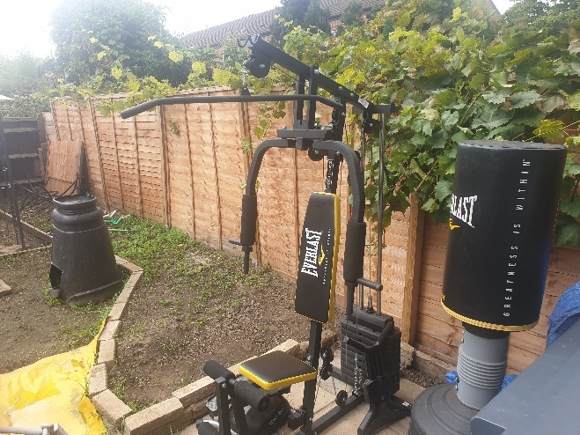
 | Enfield Civic Centre. Enfield Civic Centre. Silver Street, Enfield, London, EN1 3XA | - EXHIBIT G60  - This EXHIBIT G60 referrers to photographic evidence made on behalf of the Now Claimant a Mr. S. P. Cordell  - This Date 06/10/2022 | Upto date of the 06/10/2022 | 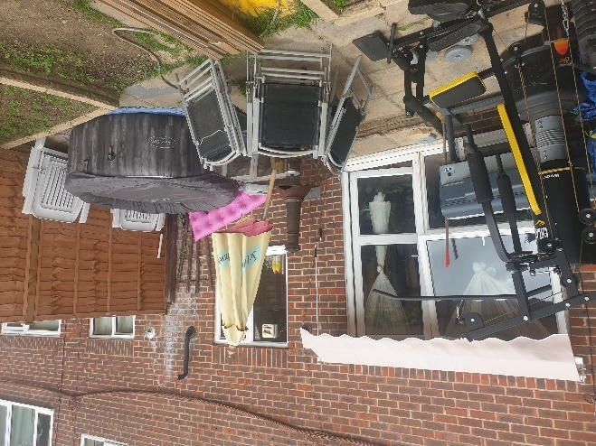
 | Enfield Civic Centre. Enfield Civic Centre. Silver Street, Enfield, London, EN1 3XA | - EXHIBIT G61  - This EXHIBIT G61 referrers to photographic evidence made on behalf of the Now Claimant a Mr. S. P. Cordell  - This Date 06/10/2022 | Upto date of the 06/10/2022 | 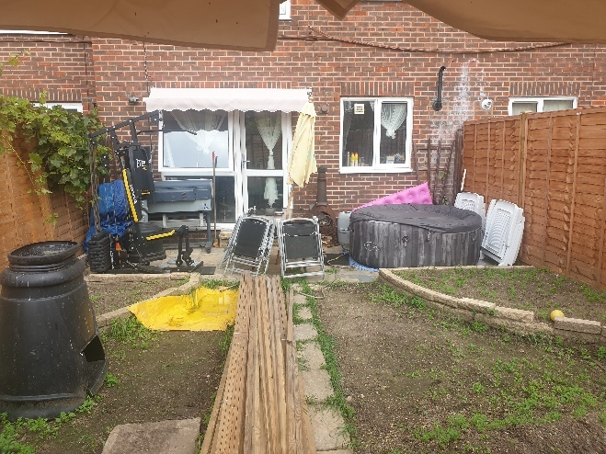
 | Enfield Civic Centre. Enfield Civic Centre. Silver Street, Enfield, London, EN1 3XA | - EXHIBIT G62  - This EXHIBIT G62 referrers to photographic evidence made on behalf of the Now Claimant a Mr. S. P. Cordell  - This Date 06/10/2022 | Upto date of the 06/10/2022 | 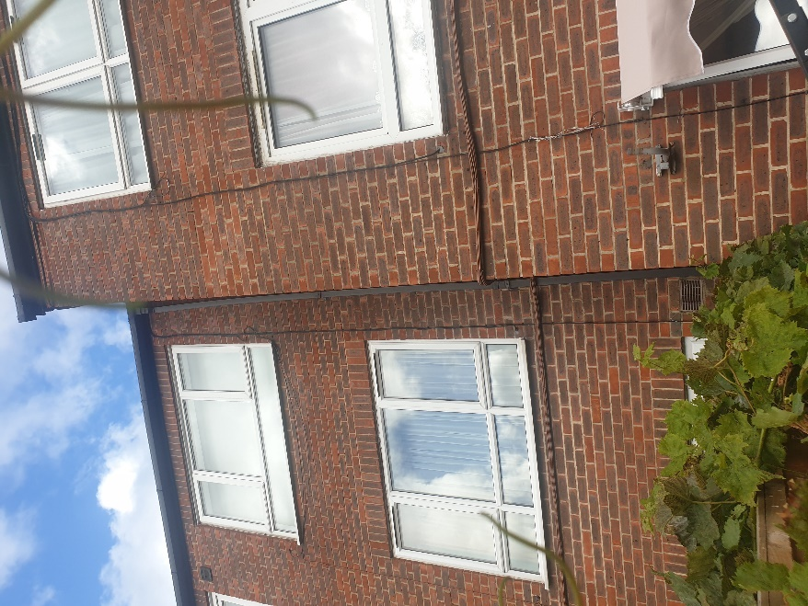
 | Enfield Civic Centre. Enfield Civic Centre. Silver Street, Enfield, London, EN1 3XA | - EXHIBIT G63  - This EXHIBIT G63 referrers to photographic evidence made on behalf of the Now Claimant a Mr. S. P. Cordell  - This Date 06/10/2022 | Upto date of the 06/10/2022

