- The Neighbours
- The Neighbours
- Start Date 12/09/2014
- End Date 14/11/2022

- The Enfield Councils teams took for granted that it is a Penalties for concealing offences or giving false information under the Criminal Law Act 1967 – “Concealing an arrestable offence.” Mr. S. P. Cordell and other persons repeatedly reported the Tort of nuisance Act 1893 Christie v Davey and other civil and criminal wrongdoing what members of his Neighbours vigorously was doing to him with contemporary relevance to no evade of justice.
- The tremendous while yet mortifying attack that Mr. S. P. Cordell reclaims his next-door Neighbours taking apart in panned out to be more than just a punishment and without any fair law or reason. More than thirty different members of Neighbours through different duration of years and times set out on him in an evil frenzy fuelled attack that would be illegal to take place throughout majority of the lands in the world that are in a governed state of control.
- Mr. S. P. Cordell stays scared till date of reprisals as the Neighbours and local authorities left him quaking when applying for justice. Floorboards & windows used as Weapons and not to forget doors the Neighbours used it all to hurt Mr. Cordell and more to any extent, objects banged aloud to disgrace and petrify him and even when they involved knew that he had done nothing wrong. An innocent person tortured such as Mr. S P. Cordell took place and is not acceptable to accept in today’s modern society. The neighbour’s intended to cause considerable damage to Mr. S P. Cordell or any other fair-minded person who choose to act in redemption to save Mr Cordell from stopping the cruel Neighbours’ illegal wrong doings.
- The different illegal scenarios that Mr. S. P. Cordell suffered forcefully put him in fear of losing his life or well-being and has had negative life changing effects on him.
- The Now Claimant’s mother wrote at my request to the authorities for protection, “Enfield Neighbourhood Team & Enfield Council” while I made phone calls to the police.
- The Enfield Council and Metropolitan Police Force blanked the Now Claimant and his mother for months with no replies to and from emails that we sent and while we waited in reply from them they both allowed the Now Claimant Neighbours to continue to attacked him in the hope of evading justice, and once the Now Claimant and his mother burst their bubble for not replying to official Correspondences they involved continued their spree of hate against the Now Claimant by trying to create him a Mental Health History rather than deal with factual claims addressed to themselves. The Enfield Council and Metropolitan Police Force refused the Now Claimant the right to justice by avoiding any fair investigation.
- “In the Table at The Bottom of This Document Below is Exhibit *****.”
And Here is Relevant Laws
- The Criminal Justice Act 2003
- Criminal Law Act 1967
- Tort of nuisance Act 1893 Christie v Davey
- Offences against the Person Act 1861 s.18
- Housing Act 1988

The Neighbours Names Table
[Exhibit B]

- File Temp Link Location
- https://horrific-corruption-files.webhop.me/Temp/Neighbours%20Only/Neighbours%20Only/

Numb | Details | History | Laws & Regs / Info | Exhibit Numb
 | Number 97 Burncroft Avenue | - Neighbours Name  - Known as Ozzie  - Real Name Hassan Ozman | - Ozzie normally rents his Council Flat out to loggers.  - Ozzie loggers are and stays a big problem.  - Hassan Ozman has committed crimes against the Now Claimant and these crimes the Now Claimant has documented in his diary, and also, recorded by Audio, Recorded by Video and other persons witnessed Ozzie in the middle of his illegal frenzied escapade.  - The Crimes that Hassan Ozman has committed the police and the Enfield Council refused to fairly investigate.  - His address is 97 Burncroft Avenue, and this is in the next Block of Flats.  - Hassan Ozman front room and bedroom walls are side to side with the Now Claimants.  - Ozzie is a: - “Secure Council Tenants”  - To the Now Claimants understanding Ozzie has lived in the block of flats Burncroft Ave since the year of 2004 and this is up until Date of the 05/10/2022.  - Ozzie = one person + another.  - Ozzie = one person + 2 more sub-renters.  - A | [Exhibit B1]  Hassan Ozman or Ozzie
 | Number 95 Burncroft Avenue | - Neighbours Name  - Known as Christine Smith | - “Secure Council Tenants”  - Still the Current Occupier dated 07/11/2022.  - The Now Claimants has a large magnitude of evidence that has amounted over the years against Christine Smith.  - Christine Smith made sure she rooted herself as the main cause to a wide-ranging of the illegal activities that took a place against the Now Claimant because none of the court order applications or documents on the government computer systems would not exist without her and her companion co-defendants.  - X 1 person + others  - A | [Exhibit B2]  Christine Smith
 | Number 99 Burncroft Avenue | - Neighbours Name  - Known as Karen Dunno  - Real Name Karen Becky | - “Unsecure Tenants”  - “Left Premisses”  - Number 99 Burncroft Avenue.  - This is in the next Block of Flats to Mr S. P. Cordell’s  - Number 99 Burncroft Avenue does not run alongside 109 Burncroft Avenue internal rooms.  - The flat is above number 95 and on the second floor.  - Karen Dunno joined in with Christine Smith and Stain Curtis alongside with other Neighbours in the year of  - X 1 person  - A | [Exhibit B3]  Karen Dunno or Karen Becky
 | Number 111 Burncroft Avenue | - Neighbours Name  - Was Known as Stain Curtis  - Real Name Was Stain Fisher | - “Was a Secure Council Tenants”  - 111 Burncroft Avenue is in the same block of flats as my rented home and is on the ground floor, 111 is the only flat that faces 109 as the front doors face each other in a small separate communal landing to the main building and the kitchens in both flats run aside to each other. Both these flats have back gardens that also, run a join.  - X 1 person  - Stain is sadly deceased as of the date 17/04/2020.  - A | [Exhibit B4]  Stain Curtis or Stain Fisher
 | Number 111 Burncroft Avenue | - Neighbours Name  - Known as Janice Barton | - “Secure Council Tenants”  - Give up her tenancy  - The flat of 111 Burncroft Avenue is empty at the current date of 05/10/2021 and has stayed that way for months prior. | [Exhibit B5]  Janice Barton
 | Number 111 Burncroft Avenue | - Neighbours Name  Known as | - Re Occupied 30/09/2022  - A | [Exhibit B6]
 | Number 113 Burncroft Avenue | - Neighbours Name  - Known as Debra Andrews | - “Secure Council Tenants”  - X 1 person  - A | [Exhibit B7]  Debra Andrews
 | Number 113 Burncroft Avenue | - Neighbours Name  - Known as Ambrose Tariq  - Real Name Ambrose Atoro | - “Secure Council Tenants”  - X 1 person  - A | [Exhibit B8]  Ambrose Tariq or  Ambrose Atoro
 | Number 113 Burncroft Avenue | - Neighbours Name  - Known as George Quinton | - “Secure Council Tenants”  - X 4 people  - A | [Exhibit B9]  George Quinton
 | Number 113 Burncroft Avenue | - Neighbours Name  - Known as Richard Edward Skinner | - “Secure Council Tenants”  - X 1 person  - A | [Exhibit B10]  Richard Edward Skinner
 | Number 115 Burncroft Avenue | - Young White Couple Real name: Young White Couple  - “Unsecure Tenants”  - X 2 people | N/a. | [Exhibit B11]  N/a.
 | Number 115 Burncroft Avenue | - Neighbours Name  - Known as Turkish Looking Woman | - X 1 person.  - “Unsecure Tenants”  - A | [Exhibit B12]  Turkish Looking Woman
 | Number 115Burncroft Avenue | - Neighbours Name  - Known as Turkish Looking Woman | - Light skin Girl Rebecca O  - Still the Current Occupier  - X 2 people  - “Unsecure Tenants”  - A | [Exhibit B13]  Rebecca O
 | Number 117 Burncroft Avenue | - Neighbours Name  - Known as Mathiyalagan Family  - Real Name Markandu Mathiyalagan  - Real Name Ravathy Mathiyalagan  - Real Name Ravathy Thambirasa  - Real Name Kajenthiran Thevarasa | - 1ST The Mathiyalagan Family & Kanathran the Logger  - “Unsecure Tenants”  - X 3 people  - A | [Exhibit B14]  Markandu Mathiyalagan,  Ravathy Mathiyalagan.  Ravathy Thambirasa.  Kajenthiran Thevarasa.
 | Number 117 Burncroft Avenue | - Neighbours Name  - Known as the 2nd Turkish lot 2x Adults 1 male and 1 female + 3x young children and 1x one new-born. | - “Secure Council Tenants”  - X 3 people  - A | [Exhibit B15]  Known as the 2nd Turkish lot 2x Adults 1 male and 1 female + 3x young children and 1x one new-born.
 | Number 117 Burncroft Avenue | - Neighbours Name  - Known as Rasheedah Lynch  - And Mica Cowan | - The 3rd Set of occupiers  - Black Woman & Man and young child Black family  - Rasheedah Lynch & Mica Cowan  - “Unsecure Tenants”  - X 2 people  - A | [Exhibit B16]  Rasheedah Lynch  And  Mica Cowan
 | Number 117 Burncroft Avenue | - Neighbours Name  - Known as Ryhnna Daniels | - The fourth occupier  - X 1 person  - N/a | [Exhibit B17]  N/a
 | Number 117 Burncroft Avenue | - Neighbours Name  - Known as Louisse Miller | - The 5th Set of occupiers  - A | [Exhibit B18]  Louisse Miller
 | Number 117 Burncroft Avenue | - Neighbours Name  - Known as Dakoto Dunn | - The 6th Set of occupiers  - “Secure Council Tenants”  - X 1 person  - A | [Exhibit B19]  Dakoto Dunn
 | Number 117 Burncroft Avenue | - Neighbours Name  - Known as John Irving | - The Homeowner | [Exhibit B20]  N/a
 | Number 119 Burncroft Avenue | - Neighbours Name  - Known as N/a | - Re Occupied Around the 07/11/2022  - Still the Current Occupier | [Exhibit B21]  N/a
End

The Asbo Stages & Members of my Neighbour’s getting involved!
Exhibit K

- Within the 1st Asbo I have induced Letters Emails and statements inclusive of Video and Audio recoding’s of evidence in relation towards my truthful claims.
- Throughout the case the government manipulated the truth in front of the public and endangered mine and my loved one’s life’s and by them official persons achieving my dissatisfaction Members of my Neighbours also started to illegal attack me!
- Members of my neighbour’s that at I classed as close friends / Family started to attack me for no apparent reason other than that of these wrongful rumours getting spread about me and my loved ones, when those people involved got asked to stop their miss-placed behaviour towards me they continued to victimise me, even low I provided them with good reasons to why not and included strong evidence to them!
- A couple of years past by with me getting degraded and tortured by others no matter what official routes I and others tried to take to get these issues resolved, with no change!
- This wrongful behaviour case me to lose out on a fair decision from a Judge about the first Asbo case on top of degrading my name and reputation this also cause me physical and mental harm of my well-being.
- Members of my Neighbours who are in this report just simply banged away my legal process any a huge amount of respect from other people wrongfully, partly because of the lies they spread.

END

In Ruff.
The Neighbours
Exhibit BB.”

- The Neighbours
- Like a circle is a rotation along a circular path, they involved become “Afro-Caribbean-Killers.”
- Towards the lead up and through the Asbo timeline and then UpToDate of this official document, we have and will continue to display an overwhelming amount of evidence that surly shows how Members of the Enfield Council and Metropolitan Police Force tag teamed up with members of the NHS and Crown Prosecution to fake profile build and use forged official documentation that they fabricated and this includes a forged Mental Health history to aid in themselves violating Article 2: of the Now Claimants Human Rights of the 1998 Act.
- Within this document we have exhibited the named offenders and we will evident how the named offenders attempted to take away the Now Claimants Right to Life.
- The Right to life is an absolute must and this must mean that no person including Government officials had or have the Legal Right to try and end any person’s life inclusively of the Now Claimant life as mutable different people can easily prove they have attempted to.
- Article 2 is a stationary obligation and the Article means that all Government officials are to take the appropriate measurements to safeguard life by simply upkeeping the existing law while implementing any Bills Of Legal Rights to protect persons of the United Kingdom in a fair an informal manner but members of the Enfield Council and Metropolitan Police Force who tag teamed up with members of the NHS and Crown Prosecution failed the Now Claimant by not taking the appropriate steps to protect his life in a non-bias way and as a result they involved have all now endangered his life while torturing him and this has caused him trauma for the rest of his life and all due to curl and evil crimes they committed.
- All Public authority members are made fully aware at the start of their interval for the company of their stationery duties to the public and that of their requirements when handling sensitive or non-sensitive case enquires pertaining to company ongoings and that their decisions must mandatorily consider all person’s legal rights, and this clearly includes the Right to life.
- All Government representatives are to take the correct Government protocols so, that they as staff do not affect or endanger the expectancy of any person’s life but yet again Members of the Enfield Council and Metropolitan Police Force when and before tag teamed up with members of the NHS and Crown Prosecution deliberately tried to shorten the Now Claimant life expectancy by trying to murder him while allowing members of the public to try and murder him as well.
- Members of the Enfield Council and Metropolitan Police Force that were tag teamed up with members of the NHS and Crown Prosecution refused to arrest any person for any of the criminal offences he as the Now Claimant and his Support Network reported and those Government staff representatives used the reported Criminal offenders to fraudulently negative profile build against him to aid in themselves diminishing any responsibility for trying to take away his life and/or at minimal well-being.
- There are more infringements that Members of the Enfield Council and the Metropolitan Police Force with their allied members of the NHS and Crown Prosecution all together allowed on purpose and took a part in on purpose to happen and these incidents are legal and Civil wrongs that had staff done their jobs correctly would not have taken a place against the Now Claimant and they are in short text as follows.
- Article 3: Freedom from Torture and Inhuman or Degrading Treatment.
- Article 5: Right to Liberty and Security.
- Article 6: Right to A Fair Trial.
- Article 7: No Punishment Without Law.
- Article 8: Respect for Your Private and Family Life, Home, And Correspondence.
- Article 12: Right to Marry and Start a Family.
- Article 14: Protection from Discrimination in Respect of These Rights and Freedoms.
- Protocol one, Article 1: Right to Peaceful Enjoyment of Your Property.
- Protocol thirteen, Article 1: Abolition of The Death Penalty.

- The Neighbours
- Hazzan Ozman
- Number: His address is 97 Burncroft Avenue, and this is in the next Block of Flats.
- Neighbours Name: Known as Ozzie
- Real Name: Hassan Ozman
- Housing: Secure Council Tenants
- Present Occupation: Still the Current Occupier dated 07/11/2022.
- Ozzie normally rents his Council Flat out to loggers.
- Ozzie loggers are and stays a big problem.
- Hassan Ozman has committed crimes against the Now Claimant and these crimes the Now Claimant has documented in his diary, and also, recorded by Audio, Recorded by Video and other persons witnessed Ozzie in the middle of his illegal frenzied escapade.
- The Crimes that Hassan Ozman has committed the police and the Enfield Council refused to fairly investigate.
- Hassan Ozman front room and bedroom walls are side to side with the Now Claimants.
- To the Now Claimants understanding Ozzie has lived in the block of flats Burncroft Ave since the year of 2004 and this is up until Date of the 05/10/2022.
- Ozzie = one person + another.
- Ozzie = one person + 2 more sub-renters.

- The Neighbours
- Christine Smith
- Number: 95 Burncroft Avenue
- Neighbours Name: Known as Christine Smith
- Housing: Secure Council Tenants
- Present Occupation: Still the Current Occupier dated 07/11/2022.
- The Now Claimants has a large magnitude of evidence that has amounted over the years against Christine Smith.
- Christine Smith made sure she rooted herself as the main cause to a wide-ranging of the illegal activities that took a place against the Now Claimant because none of the court order applications or documents on the government computer systems would not exist without her and her companion co-defendants.
- X 1 person + others

- The Neighbours
- Karen Dunno
- Number: 99 Burncroft Avenue This is in the next Block of Flats to Mr S. P. Cordell’s the Now Claimant.
- Neighbours Name: Known as Karen Dunno
- Real Name: Karen Becky
- Housing: Unsecure Tenants
- Present Occupation: Moved out of premises
- Number 99 Burncroft Avenue does not run alongside 109 Burncroft Avenue internal rooms.
- The flat is above number 95 and on the second floor.
- Karen Dunno joined in with Christine Smith and Stain Curtis alongside with other Neighbours in the year of
- X 1 person

- The Neighbours
- Stain Curtis
- Number: 111 Burncroft Avenue
- Neighbours Name: Was Known as Stain Curtis
- Real Name: Was Stain Fisher
- Housing: Was a Secure Council Tenants
- Present Occupation: premises reclaimed by Enfield Council
- 111 Burncroft Avenue is in the same block of flats as my rented home and is on the ground floor,
- 111 is the only flat that faces 109 as the front doors face each other in a small separate communal landing to the main building and the kitchens in both flats run aside to each other. Both these flats have back gardens that also, run a join.
- X 1 person
- Stain is now deceased as of the date 17/04/2020.

- The Neighbours
- Janice Barton
- Number: 111 Burncroft Avenue
- Neighbours Name: Known as Janice Barton
- Real Name:
- Housing: Secure Council Tenants
- Present Occupation: Moved out of premises gave up her tenancy.
- The flat of 111 Burncroft Avenue is empty at the current date of 05/10/2021 and has stayed that way for months prior.

- The Neighbours
- New Man
- Number: 111 Burncroft Avenue
- Neighbours Name: New Man
- Real Name: New Man
- Housing: Secure Council Tenants
- Present Occupation: Still the Current Occupier dated 07/11/2022.
- Re Occupied 30/09/2022

- The Neighbours
- Debra Andrews
- Number: 113 Burncroft Avenue
- Neighbours Name: Known as Debra Andrews
- Real Name:
- Housing: Secure Council Tenants
- Present Occupation: Moved out of premises
- X 1 person
- was one of the Now Claimants’ Neighbours who lived directly above him
- Debra Andrews became a friend of the Now Claimant when she moved into 113 Burncroft Avenue in the year of 0000
- Her details are here within Exhibited as ****.
- Through the years of **** till **** the Now Claimant
- Debra had been seeing an Eardley man named Stain Curtis Exhibited as *****
after his wife passed away who lived on the same floor as me before he deceased.
Both Debra and Stain were heavy alcoholics and together they should not have been.
the local Authority’s understood this of Debra but not of Stain as he had not been an acholic for years prior to his wife passing away in the year of 2010.

- The Neighbours
- George Quinton
- Number: 113 Burncroft Avenue
- Neighbours Name: Known as George Quinton
- Real Name:
- Housing: Secure Council Tenants
- Present Occupation: Moved out of premises
- X 4 people

- The Neighbours
- Ambrose Tariq
- Number: 113 Burncroft Avenue
- Neighbours Name: Known as Ambrose Tariq
- Real Name: Ambrose Atoro
- Housing: Secure Council Tenants
- Present Occupation: Moved out of premises
- X 1 person

- The Neighbours
- Richard Edward Skinner
- Number: 113 Burncroft Avenue
- Neighbours Name: Known as Richard Edward Skinner
- Real Name:
- Housing: Secure Council Tenants
- Present Occupation: Still the Current Occupier dated 07/11/2022.
- X 1 person

- The Neighbours
- Young White Couple
- Number: 115 Burncroft Avenue
- Neighbours Name: Young White Couple
- Real Name: Young White Couple
- Housing: Unsecure Tenants
- Present Occupation: Moved out of premises
- X 2 people
- N/a.

- The Neighbours
- Turkish Looking Woman
- Number: 115 Burncroft Avenue
- Neighbours Name: Known as Turkish Looking Woman
- Real Name:
- Housing: May be a homeowner
- Present Occupation: Moved out of premises
- X 1 person

- The Neighbours
- Light skin Girl Rebecca O
- Number: 115 Burncroft Avenue
- Neighbours Name: Light skin Girl Rebecca O
- Real Name:
- Housing: Unsecure Tenants
- Present Occupation: Still the Current Occupier dated 07/11/2022.
- X 2 person

- The Neighbours
- Mathiyalagan family
- Number: 117 Burncroft Avenue
- Neighbours Name: Known as Mathiyalagan Family
- Real Name:
1/ Real Name Markandu Mathiyalagan
2/ Real Name Ravathy Mathiyalagan
3/ Real Name Ravathy Thambirasa
4/ Real Name Kajenthiran Thevarasa
- Housing: Unsecure Tenants
- Present Occupation: Moved out of premises
- The Mathiyalagan Family & Kanathran the Logger
- X 3 people
- Above Debra Andrews flat, lived the Mathiyalagan family
- who were unsecure tenants that the Enfield Council accommodated
- their information we Exhibited as *****
- The history based around the Now Claimant had the Mathiyalagan family is that he helped a Mr. Markandu Mathiyalagan when he got himself into trouble.
- The trouble started when the family first moved onto the Burncroft Avenue Estate.
- They had a logger who lived with them called Kanathran. I believed Kanathran lived in the flat opposite to
was a heavy acholic and had her light skin children taken away from her got scared as I walked behind her as I was coming into the block of flats, I live in

- The Neighbours
- The 2nd Turkish family
- Number: 117 Burncroft Avenue
- Neighbours Name: Known as the 2nd Turkish lot 2x Adults 1 male and 1 female + 3x young children and 1x one new-born.
- Real Name:
- Housing: Unsecure Tenants
- Present Occupation: Moved out of premises
- X 3 people

- The Neighbours
- Rasheedah Lynch And Mica Cowan
- Number: 117 Burncroft Avenue
- Neighbours Name:
Known as Rasheedah Lynch
And Mica Cowan
- Real Name: Rasheedah Lynch & Mica Cowan
- Housing: Unsecure Tenants
- Present Occupation: Moved out of premises
- The 3rd Set of occupiers
- Black Woman & Man and young child Black family
- X 2 people

- The Neighbours
- Ryhnna Daniels
- Number: 117 Burncroft Avenue
- Neighbours Name: Known as Ryhnna Daniels
- Real Name:
- Housing: Unsecure Tenants
- Present Occupation: Moved out of premises
- The fourth occupier
- X 1 person
- N/a Problems

- The Neighbours
- Louisse Miller
- Number: 117 Burncroft Avenue
- Neighbours Name: Known as Louisse Miller
- Real Name:
- Housing: Unsecure Tenants
- Present Occupation: Moved out of premises
- The 5th Set of occupiers

- The Neighbours
- Dakoto Dunn
- Number: 117 Burncroft Avenue
- Neighbours Name: Known as Dakoto Dunn
- Real Name:
- Housing: Unsecure Tenants
- Present Occupation: Moved out of premises
- The 6th Set of occupiers
- X 1 person

- The Neighbours
- John Irving
- Number: 117 Burncroft Avenue
- Neighbours Name: Known as John Irving
- Real Name: The Homeowner
- Housing: The Homeowner
- Present Occupation: Still the Current the Homeowner dated 07/11/2022.
- Re

- The Neighbours
- N/a
- Number: 119 Burncroft Avenue
- Neighbours Name: N/a
- Real Name:
- Housing:
- Present Occupation: Still the Current Occupier dated 07/11/2022.
- Re Occupied Around the 07/11/2022

Overt Act
Malice
Libel

Hosted in:

NUMB | RESPONSIBLE PERSONS | DATE | EXHIBIT
2006, 2007, 2008, 2009, 2010, 2011

 | - Responsible Doctors & Enfield Council for Debra Andrews  - The reason that we have adduced this exhibit into these proceedings is because | 00/00/2006  Till  2011 | Evidence: Exhibit BB5 – 1 / 00/00/2006:  - We contain the Evidence in the Now Claimants Diary!  Evidence: Exhibit BB5 – 2 / 00/00/2006:  - This is a picture of the front layout of Burncroft Avenue  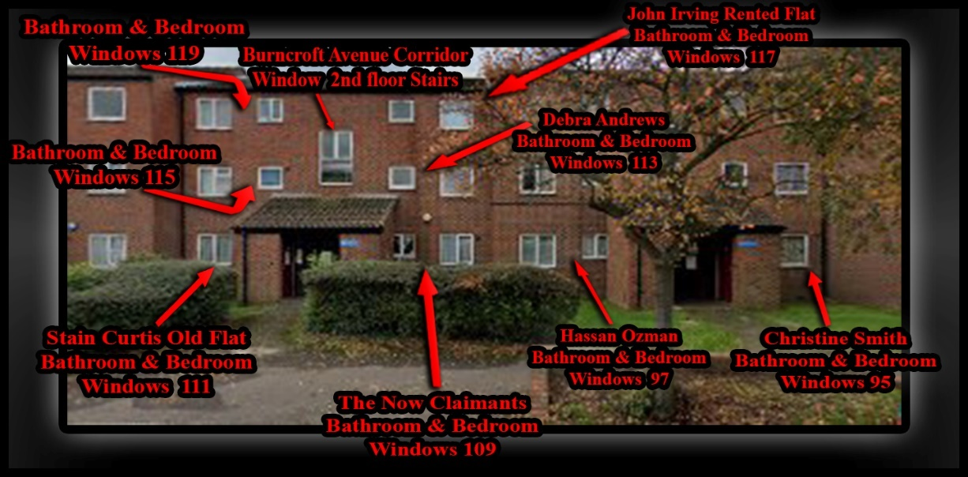  Evidence: Exhibit BB5 – 3 / 00/00/2006:  - This is a picture of the front layout of Burncroft Avenue  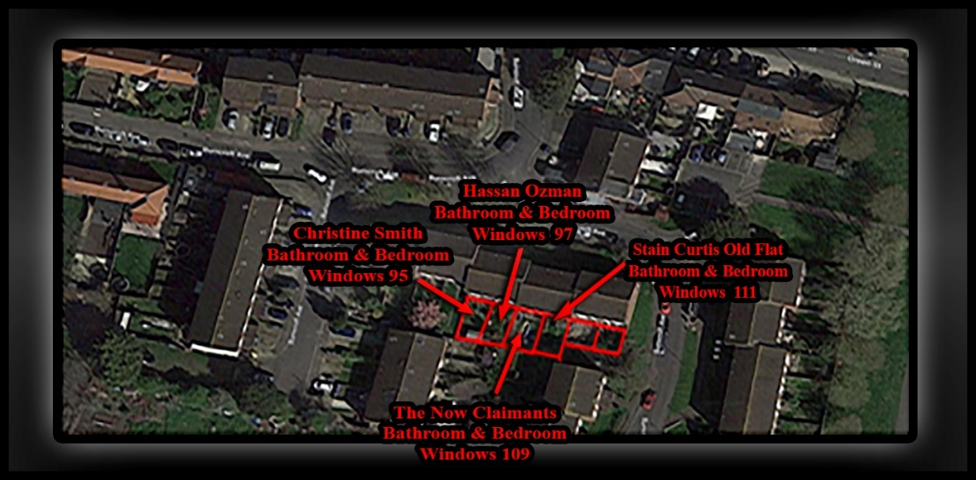  Evidence: Exhibit BB5 – 2 / 00/00/2006:  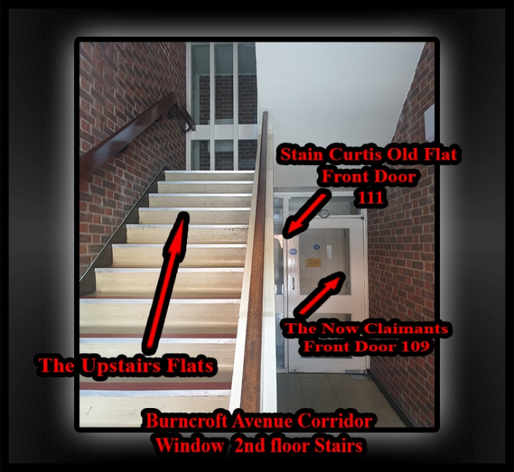  Evidence: Exhibit BB5 – 2 / 00/00/2006:  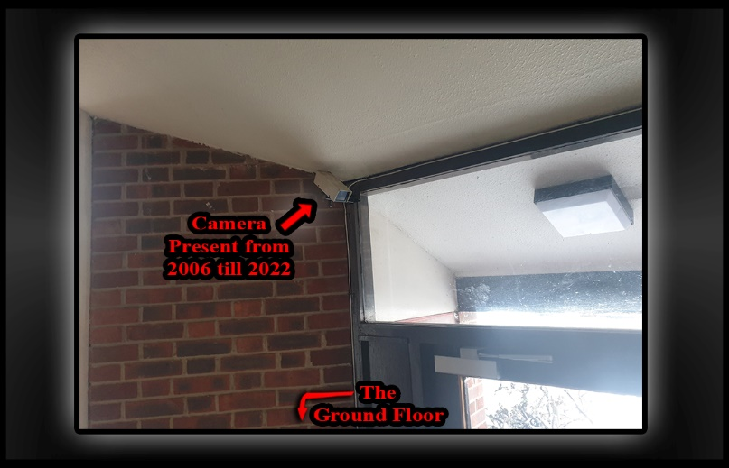  Evidence: Exhibit BB5 – 2 / 00/00/2006:  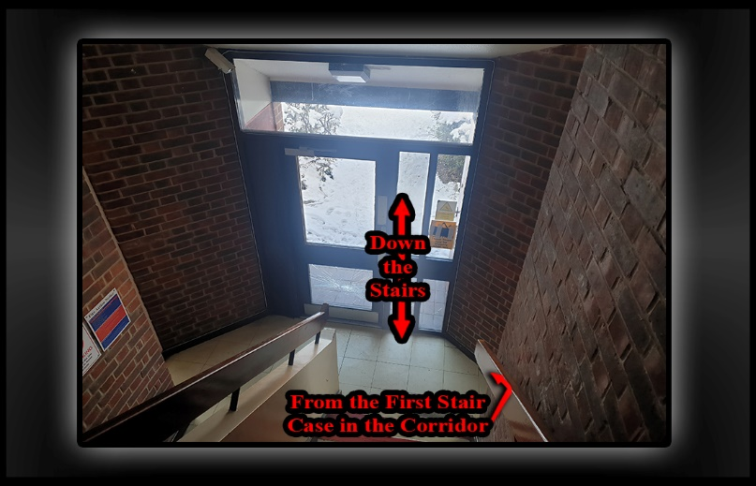  Evidence: Exhibit BB5 – 2 / 00/00/2006:  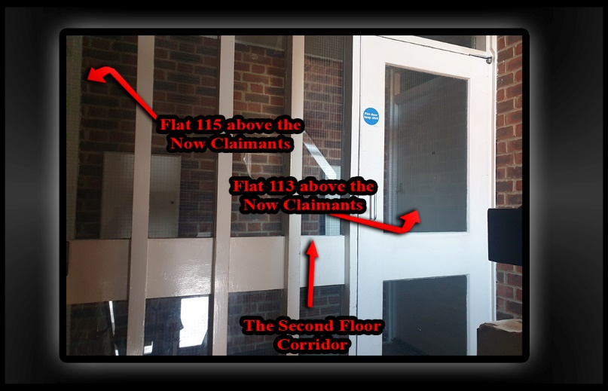  Evidence: Exhibit BB5 – 2 / 00/00/2006:  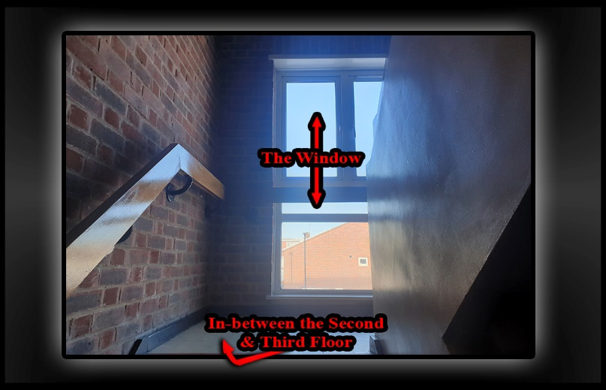  Evidence: Exhibit BB5 – 2 / 00/00/2006:  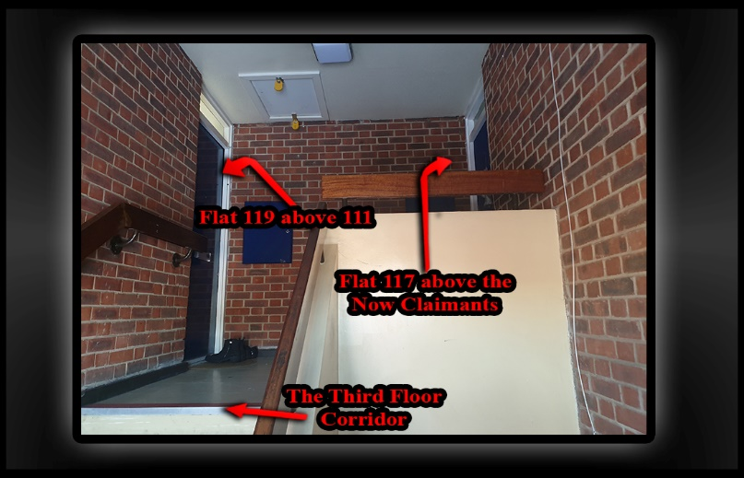  Evidence: Exhibit BB5 – 4 / 00/00/2007:  - We contain the Evidence in the Now Claimants Diary!  Evidence: Exhibit BB5 – 5 / 00/00/2008:  - We contain the Evidence in the Now Claimants Diary!  Evidence: Exhibit BB5 – 6 / 00/00/2009:  - We contain the Evidence in the Now Claimants Diary!  Evidence: Exhibit BB5 – 7 / 00/00/2010:  - We contain the Evidence in the Now Claimants Diary!  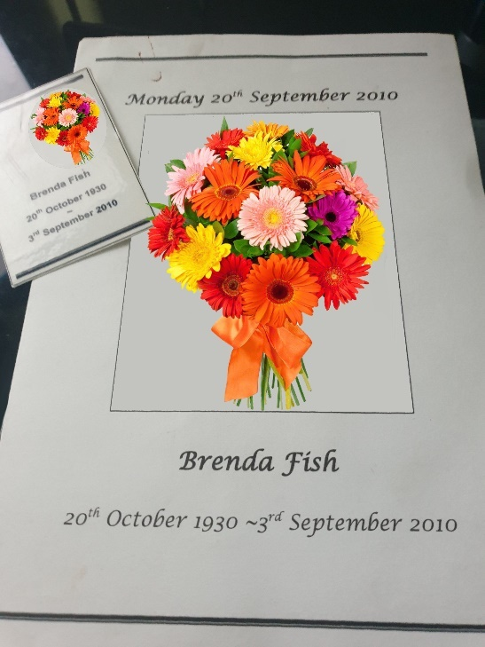  Evidence: Exhibit BB5 – 8 / 00/00/2011:  - We contain the Evidence in the Now Claimants Diary!
INFO | Statement Exhibit BB0 – 1 / 00/00/2006  - When the Now Claimant moved into 109 Burncroft Avenue he met his new neighbours and what he can remember of them is some of the following:  - The First on Now Claimants list is Stain Curtis and his partner Brenda Fisher as they lived the closest and shared a hallway together.  - In the years of 2006 is when they first all met and throughout the years of 2007, 08, 09, 2010, they stayed friends but not of the closest sort.  - A simple hello and a quick chat would happen when their paths crossed whenever, or wherever that may be but always when on their ways out or in their front doors and at these moments in time is where their friendship mostly developed and showed aloe they keep the commonly other known morals and resect between themselves as neighbours, should always keep, the Now Claimant can remember that most of their intervals would tend to be over the back garden fence or in the Corridor of the block of flats.  - The short interviews between the Now Claimant and Stain Curtis and his partner Brenda Fisher stayed short due to stain always being happy as he stayed preoccupied with Brenda.  - A fond memory of the Now Claimants is of Stain being happy as he went on his journeys with his wife. Stains partner Breda would be in her wheelchair as Stain pushed her along their merry way and what else the Now Claimant can remember about these occasions is that when they both see him they would holt the wheelchair for a quick chat then afterwards speeds of again back along their route.  - The Flat of 111 Burncroft Avenue were Stain and Brenda lived inside of belonged to Brenda and is the second flat out of two flats that are based on the ground floor facing each other.  - There was also at first a young female that lived inside of 117 Burncroft Avenue which is the top floor flat out of two above the Now Claimants.  - A  - The middle flat directly above the now Claimants is 113 Burncroft Avenue and there was a tall white man who lived inside of it when the Now Claimant moved into his rented flat.  - The Now claimant thought the man was around 35 to 40 years of age and as the days passed the now Claimant realised that the man would stand at his bedroom window facing the street and dive behind his bed like a bomb went off when he could hear noise and this became worse whenever the Now Claimant went into his back garden, due to this issue the Now Claimants spoke to his mother and his mother spoke to the gentleman to make sure everything was ok with him and he explained to her that he was Scared of noise due to being in the war.  - The Now Claimant never had any issues with this man in the time that they lived next to each other.  - The Two flats above Brenda’s flat are 115 and 118.  - The now claimant can remember a young couple that seemed as if they were studying in collage together living inside of 115 and they all just said hello to each other when their paths crossed each other polity  - As for the flat of 118 Burncroft Avenue the Now Claimant can remember an oldish gentleman who was Indian and very polite also.  - The Now Claimant also met Ozzie Hassan due to being his neighbour as their flats and gardens run alongside each other but are in separate blocks of flats.  - Ozzie’s nationality is Greek and he lived with his logger who was also Greek.  - Ozzy had his bed set up in his front room and sleeps in there and this was up and till the year of 2019 as he rents out the Bedroom.  - When a person first walks into the flats of 95, 97, 109, or 111 Burncroft Avenue they would notice that these are all ground floor flats adjoined but separated by two blocks of flats, with 95, 97 in one block and 109, 111 in the next block.  - All four premises have back gardens and once inside the front door of one you will be in the hallway. With three doors of choice to go through. If a person takes the door to the right they will enter the bathroom and if they enter the door in front of them they will go into the bedroom and the third door to the left will take them into the front room.  - Once in the front room there are two more doors one to the left which is the kitchen and the last door is at the end of the front room and enters into the back garden.  - Ozzie’s logger became incredibly good friends with the Now Claimant as they always went out together to night clubs, raves, and on raving holidays together.  - Ozzy’s logger is slightly older than the Now Claimant and Ozzy is the oldest of all three.  - The Now Claimant drove before he moved into Burncroft Avenue and so did Ozzy but his logger did not.  - Ozzy’s logger  - Fake pills  - From Night Clubs to festivals  - Board of old fragilistic tricks  - Not Cheating on his partner then at the time.  - Giving something back on stead of always taking meant that the Now Claimant would provide a service of balloons  - Noise in the Bedroom  - Going outside of the block of flats  - On the 19/11/2014 the problems with Ozzy exploded as he phoned the police on the Now Claimant and they called the Metal Health Team to do an assessment on him.  A Bit of History About the Now Claimant.  The Now Claimant went to Turkey in the years of 1990 with a friend of his and his friend’s family, while on holiday abroad for the first time he noticed how hot it was when they were on the beach and he also noticed how busy it was and that there was a high demand for cold & hot beverages and this gave him the idea of creating his own establishment within the catering industry.  After the holiday and when back at home the Now Claimant started to do research on how he could get involved in earning an honest living selling hot and cold Beverages.  By the year of 1996  No One Is Perfect and Some People Are a Lot Worse Than Others.  Statement Exhibit BB0 – 2 / 00/00/2007  - 2007,  - Door number 95 in the Second block of flats the Enfield Council rent to Christine Smith.  - The Now Claimant moved into Burncroft Avenue after Christine Smith did and Christine Smith met the Now Claimant because of an incident the Now Claimant caused in: - “Chapter 18” of his diary.  - Si Note: In the events of my past occurrences while living on my estate! -- “I can remember making my first ever mistake, while living on my housing estate, what acutely happened on this occasion did take place on a hot sunny day, that then took place in the middle of summer, I was driving back home when I made an error and clipped another car wing mirror, this was unfortunate to happen, I think that I did put a note with my details on their window and that is how we latter chatted about it. The car that got involved, had got parked down my hometown street, I soon later found out the owner of this car was to be a Ms Christine, who is a close friend to Stan Curtis.”  Statement Exhibit BB0 – 3 / 00/00/2008  - 2008,  - Debra Andrews Moved into the Block of flats of 113 Burncroft Avenue in the year of 2008.  - The flat Debra moved into is the flat above the Now Claimants.  - Unknowingly to the Now Claimant and his Family they were the perfect candidates for the local Authorities to move Debra Andrews above due to their reputable good nature when helping people that were in needle of support, as their ambitions in life was to provide a public service such as a festival that would mandatorily provide these services Debra Andrews desperately needed at this time within society so, badly.  - Deborah Andrews is well known to the North London Authorities since her early adolescence as she raised High-Risk concerns to those alerted to her such as the Police, Social Services, Mental Health Care, and other services.  - What is Known to be True by the Now Claimant about Debra Andrews is: -  - Identity: -  - Debra Andrews is a mixed-race woman IC3. In the year of 2008, the Now Claimant thought she was around the same age group as himself but later found out that she was much older by about 10 years.  - Description of character: -  - Debra Andrews makes it apparent to all that she is an Acholic that is still drinking out of control.  - Debra Andrews Speech stays slurred in any conversation and her face slops downwards but only on one side as her eyes showed a life of misery.  - Debra Andrews has a distinctive presence about her that seem as if she is born with a brain deficiency causing her to stay within a well advance 13 years old of an age Group and she also tends to be dribbling down one side of her mouth.  - Friends and family of alike also find that when they are speaking to Debra that she carries a tendency to suck up her dribble, straight back into her mouth for herself to be able to speak aloud again.  - It advised that when speaking to Debra Andrews that all persons are to stay contusions and careful of more than just a wind fill and in more than just one aspect as her words trend not to make sense and her breath is as if she has a free ticket to unlimited alcohol.  - Her stance is lurched but to the eyes of the beholder they will find that no matter how intoxicated Debra gets she does not sway as if in tipsy.  Statement Exhibit BB0 – 4 / 00/00/2009  - 2009,  - A  Statement Exhibit BB0 – 5 / 00/00/2010  - 2010,  - Stains Wife Sadly Passed Away!  Stains Neighbours across his road supported him.  Stain Told the Now Claimant that he used to be an Acholic  Stain Told the Now Claimant that he used to be a Lorry Driver  Statement Exhibit BB0 – 6 / 00/00/2011  - 2011  - Stain and Debra become drinking partners and more, the Now Claimant started to hear his dog bark as someone opened and then entered into the separated corridor of the flats of 109 and 111 Burncroft Avenue and because he carried extremely about his and his fellow neighbour’s welfare
2012

 | Exhibit BB1  - Responsible Doctors & Enfield Council  - The reason that we have adduced this exhibit into these proceedings is because  - Enfield Council Case History Deborah Andrews / The 1st Injunction Order: | 12/03/2012 | Evidence: Exhibit BB1 – 1 / 01/03/2012:  From Enfield Councils Databases: - History Forged Against the Now Claimant and Illegally Detained.  - https://horrific-corruption-files.webhop.me/Original-Files-Folder/All%20Case%20Original%20Court%20Application%20Case%20Files/All%20Case%20Original%20Court%20Application%20Case%20Files/18_01_2019%20FOI%20Folder/FOI%20%20from%20Council%20Split/Attachment%205_105..pdf  - Page 7  --  Referral Details  23/09/2015: Organisation making referral Housing Anti-Social Behaviour Response Team  History  23/09/2015: Agree an Action Plan with the Complainant ACTION PLAN PROVIDED TO THE VICTIM AND A COPY FORWARDED TO HER CPN BOLA QUADRI  - Dated the 23/09/2015  - “March 12 - 1st contact with MH services following arrest after a: - “Bad Trip of Taking LSD & Alcohol,” mental state assessed remained in custody of police - no MH input”  --  - March 14 - 2nd contact, assessed by team psychiatrist, presented with anxiety & suicidal thoughts in context of social stressors due to pending court case leading to stress. Discharged form MH services, suicidal thoughts are longstanding from early childhood and present at times of high stress, not 'A typical' of other forms of suicide as relates to thoughts as opposed to wish to die, and usually found in context of those presenting with early childhood trauma as a way of expressing emotions.  - Nov l4 - Mental Health Act assessment, not detained in hospital, discharged from mental health services.  Presented highly volatile, angry & paranoid about motives of others, presented in context of social stressors due to on-going issues with police & court process –  mother reported he has been targeted by police causing him stress??  He has a medical history of Crohn's disease which may impact on mood stability particularly if not compliant with treatment and monitoring of symptoms.  All assessments completed by mental health services have found no evidence of serious mental illness,  “He appears to be a very angry young man who has had an extremely difficult and traumatic early childhood which is likely to explain his distrust of people in authority (e.g., police) and being angry at others and at the world....”  Regards Debbie  --  - 23/09/2015 Classification: PROTECT  Good afternoon, Debbie,  Hope you are doing well?  could you kindly advise if the above tenant is known to your service and if he is, does he have a CPN and does he engage?  Thank you for your assistance  Mr Simon Cordell,  109 Burncroft Avenue,  Enfield,  EN3 7JQ  DOB=25 (34 yrs.)  Phone=020 8  Dolly Ogunseye Anti-Social Behaviour Officer Housing Anti-Social Behaviour Team Tenancy Manager  Enfield Council  Evidence: Exhibit BB1 – 2 / 13/08/2012: = March 12 - 1st contact  HERTFORDSHIRE CONSTABULARY)  - Police Came to mine and arrested me “for an accused shop robbery & a separate car case, I got held then bailed for the robbery then while in custody the next day I got re arrested, straight away.  Arrest  Arrest/Summons Ref:  Name Charged: CORDELL, SIMON PAUL.  Date of Birth:  Fingerprint Status: CONFIRMED 41 ID  15/08/2012  NOT TAKEN ARRESTED ON  13/08/2012  10:30 41 HQ 13/08/12.  DNA Status: COYLE/PC/8  Process Stage: 41 (HERTFORDSHIRE CONSTABULARY) CPS (CROWN PROSECUTION SERVICE) 13/09/13.  Arresting Officer:  Report Owner:  Prosecuting Agent: CROWN PROSECUTION SERVICE (CPS.)  Description: REMANDED ON POLICE BAIL ON 14/08/12  At: 41K1  To Appear At: NEXT APPEARING ON 18/09/12 AT 41K1  Owner: 41 (HERTFORDSHIRE CONSTABULARY)  14/08/12.  Condition 1: NOT TO CONTACT DIRECTLY OR INDIRECTLY ANY WITNESS CONNECTED TO THIS INVESTIGATION.  Condition 2: NOT TO ENTER HERTFORDSHIRE EXCEPT TO ANSWER POLICE BAIL.  Condition 3: RES EDMONTON N9.  Dates Held in the Police Station: 13/08/2012.  Dates Held in the Police Station: 14/08/2012.  Bailed to the: 18/09/2012.  Final Result: “Case Won by Si”  Re Arrested on the: 14/08/2012  Transported to: West Midlands “Birmingham”  Accused Car Case!  14/08/2012: “Arrested from; (41 HERTFORDSHIRE CONSTABULARY) the Police Station.”  15/08/2012: “Released on Bail”  Bail till the: 12/09/2012  Final Result: “Case Won by Si”  Evidence: Exhibit BB1 – 3 / 13/08/2012: = March 12 - 1st contact  The Doctor’s Folder / pub Book Issue: five!  Stage 5  Folder five  Originator Details: 13 Aug 2012  Last Amended by Details: 13 Aug 2012  Mohammad Fohim Nursing  Page Numbers:106  Originator Details: 13 Aug 2012 18:58  Mohammad Fohim  Nursing Originally Entered by Details: 13 Aug 2012 19:13  Mohammad Fohim Last Amended by Details: 13 Aug 2012 19:13  Mohammad Fohim Validated by Details: 13 Aug 2012 19:13  Mohammad Fohim Significant: No Added to Risk  History: No  Contains Third Party Info: No Conceal  From Client: Not Concealed Enfield AAC  - Faxed referral received from CFH A&E Dr Smith  - Reported SC was under police arrest (for? crime related offence) and four police officers brought him to CFH A&E due to: - “Effects of LSD” he took over the weekend. He had about 2 x paper LSD last Saturday and ?5mcg liquid LSD on Sunday, also had about one bottle of rum yesterday.  - Had been partying over the weekend at a festival. Was under care of medics (? had first aid) at the festival.  - Was agitated on arrival, but calm down later.? hallucinating, seeing assorted colours.  - No other risk or symptoms identified. Dr Smith reported that these LSD effects might last for about 48hours.  - Referral triaged and advised that he did not need an emergency mental health assessment at present.  - Advised for him to see his GP. Likely would be arrested by police.
INFO | - Exhibit BB1 we have split into five sections A, B, C, D, E.  --  - The First incident: BB1 – 1 – A/  - Is the creation date of the Enfield Councils history against The Now Claimant, dated 23/09/2015.  - We will not be explaining this date yet as we are going to be tackling incidents in a chronological order through this tabled document.  - The Second Incident: BB1 – 1 – B  - Is a wrongful arrest for a robbery backdating over 10 years.  - Evidence: Exhibit BB1 – 2 / 13/08/2012:  - is a printed-out section of the Now Claimants Criminal record held on the Metropolitans police National Computer Systems named as ACRO.  - This Proves that the date of the No Further Actioned Incident was transferred between Government systems by employees inaccurately.  - Evidence: Exhibit BB1 – 3 / 13/08/2012:  - This piece of evidence is a printout of the NHS Computer Systems named as RIO.  - This also proves the date is wrong and first imputed report  - The key word of LSD proves that the  - 00/03/2012 is really the 13/08/2012  - The 13/08/2012 is the correct date of the arrest that the Now Claimant was detained by police wrongfully to the hospital and then taken to the police station for Criminal Offences that he did not commit.  - Evidence Exhibit: BB1 – 2 / 13/08/2012 as above proves the police had no evidence to charge the Now Claimant and the case was latter no further actioned.  - The information held on the Enfield Councils Computer system pursuing this date is wrong in its context as the date is inaccurately wrong by displaying: - “March 12.”  - The Evidence Exhibit: BB1 – 1 / 01/03/2012 is information that is held on the Enfield Councils Computer wrongly and also is set out in such a way that the information describes the Now Claimants as a criminal for facts not proved tarnishing his true good character in an unfair way.  - The purposes of the Enfield Councils staff obtaining this personal data against the Now Claimant was to avoid Justice and clearly would have been a breach of the data act 1998 knowingly to them as official persons.  - The timeline as opposed to what you are reading now and exhibited as BB clearly shows that the facts mentioned on this day are factual evidence once read.  Police went to the Now Claimants home and arrested him for an offence he did not commit that they said happened 10 years prior to the date of arrest.  Came to mine and arrested me “for an accused shop robbery & a separate car case, I got held then bailed for the robbery then while in custody the next day I got re arrested, straight away.  The police came to my home / front door to arrest me. I explained that I had gotten drunk the nights and days before at an event on acholic drink and it had made me ill by causing me to hallucinate. I said to the attending police officers that I had been lying down since contemplating on calling an ambulance until they had arrived at my home address, and this happened soon after they told me that I was getting arrested for an Armed Robbery. I went to the hospital with the police simply because I believed I had been spiked.  - The Third Incident: BB1 – 1 – C  - Is the Gazebo Case  - Evidence: Exhibit BB1 – 4 / 02/03/2014  - Due to the Bail Conditions getting extended and while the Prosecution team was withholding evidence that proved the Now Claimants innocence.  - The Now Claimant heard in Court talks of his Mental stability in question by the Prosecution team and Judge trying to get out of trouble for what the Now Claimant and his support network could prove they had done wrong through the Court Case and investigation and decided to get their first.  - As the Gazebo Case come to an end the Second that the Now Claimant went back out his front door the Enfield Council and Metropolitan Police Set him straight away by building a fraudulent Asbo behind his back.  - We will not be explaining this date yet as we are going to be tackling incidents in a chronological order through this tabled document.  - The Fourth Incident: BB1 – 1 – D  - Nov l4 – “Mental Health Act assessment,” not detained in hospital.  - Discharged from mental health services.  - We will not be explaining this date yet as we are going to be tackling incidents in a chronological order through this tabled document.
 | - Responsible Burncroft Avenue Street Party  - The reason that we have adduced this exhibit into these proceedings is because | 03/06/2012 | Evidence: Exhibit BB5 – 1 / 03/06/2012:  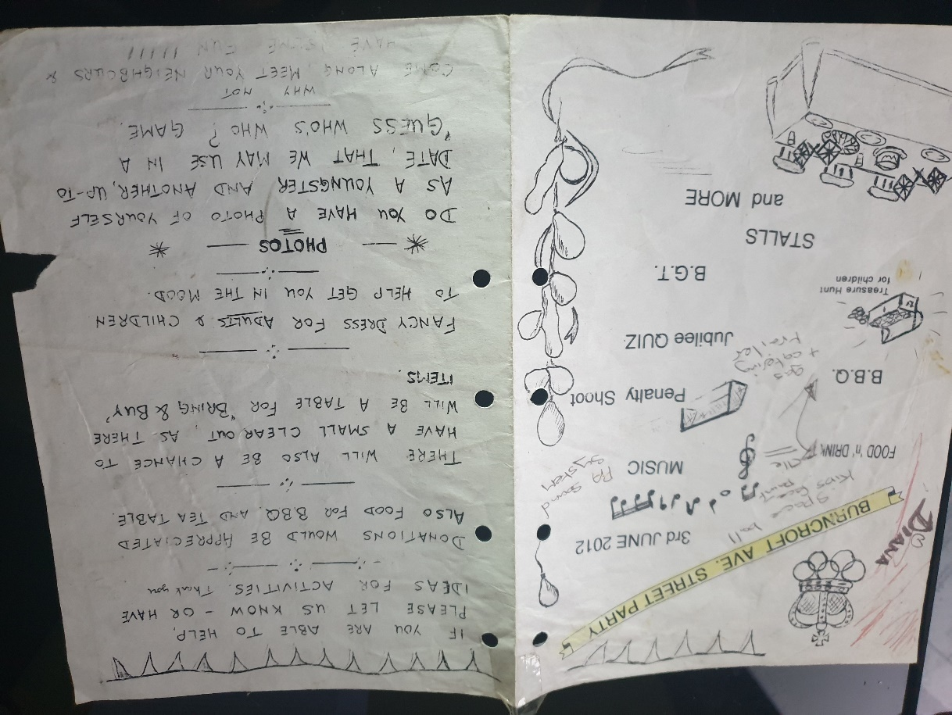
INFO | Statement Exhibit BB0 – 1 / 03/06/2012:  - The Now Claimant Found Himself Taking Part in His Estates Local Street Party: —  - In the day, month, and year of 3rd of June 2012; I started to hire out my entertainment equipment and was still attending the Local civic centre regarding creating my own dreams and making them a reality.  - By this time in my life my dreams included developing other people’s dreams within my own.  - Just before the 03rd of June 2012: I got approached by another resident off Burncroft Avenue, in aid of supporting my estate in a local street party, it was happy that I got invited, for it to get agreed so for me to get involved in supporting my fellow members of neighbour’s, I got the job of supplying entertainment equipment and I done this at a no chargeable rate.  - To me, and I believe others, the event was a success and to my own recollection the day went down with the tents and their friends very well.  - There were no other issues of concern between any of the other Burncroft Avenue residents, in me explaining: apart from the already mentioned, this was for the time period of around the first eleven years of my presence, while residing at my home.  - Debra Andrews 113: --  - 03/06/2012: Debbie Came to my flat asking to borrow money in the sum of £10, when intoxicated with drink and her vocabulary was that off slurred speech, she stayed polite and the money got granted to her that she asked for.  - At the Time: 09:49 pm
 | - Responsible Doctors & Enfield Council for Debra Andrews  - The reason that we have adduced this exhibit into these proceedings is because | 00/00/2012 | Evidence: Exhibit BB5 – 1 / 00/00/2012:  The Now Claimants Diary
INFO | Statement Exhibit BB0 – 1 / 00/00/2012:  - O
 | - Responsible Doctors  - The reason that we have adduced this exhibit into these proceedings is because | 00/00/2012 | Evidence: Exhibit BB5 – 1 / 00/00/2012:
INFO | Statement Exhibit BB0 – 1 / 00/00/2012:  - O
 | - Responsible Debra Andrews  - The reason that we have adduced this exhibit into these proceedings is because | 00/00/2012 | Evidence: Exhibit BB5 – 1 / 00/00/2012:  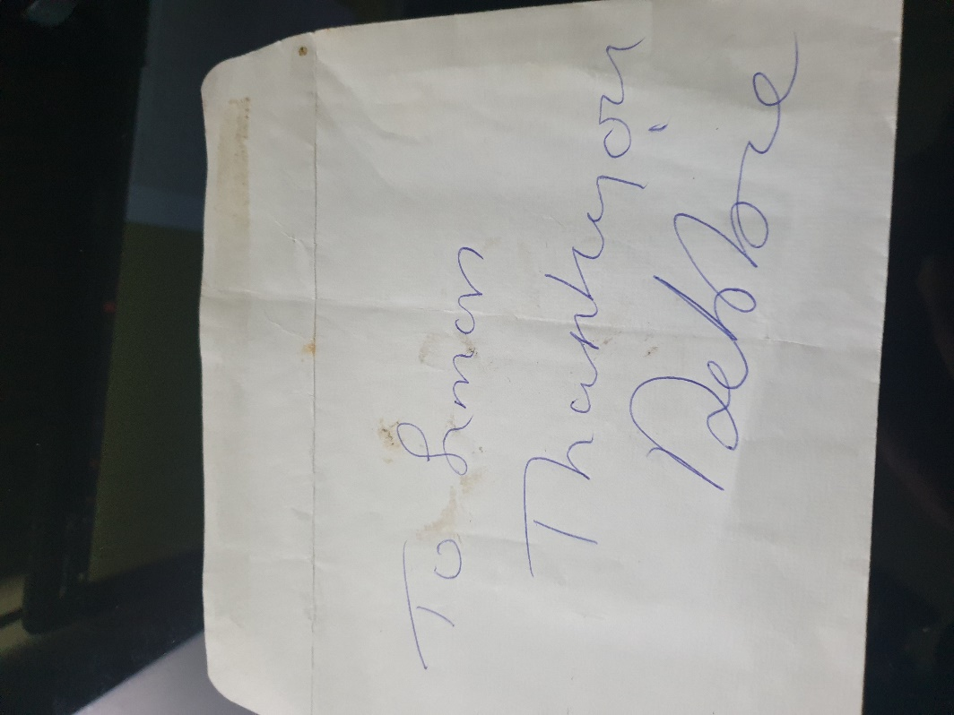
INFO | Statement Exhibit BB0 – 1 / 00/00/2012:  - O
 | - Responsible Debra Andrews  - The reason that we have adduced this exhibit into these proceedings is because | 11/12/2012 | Evidence Exhibit: BB5 – 1 / 11/12/2012:  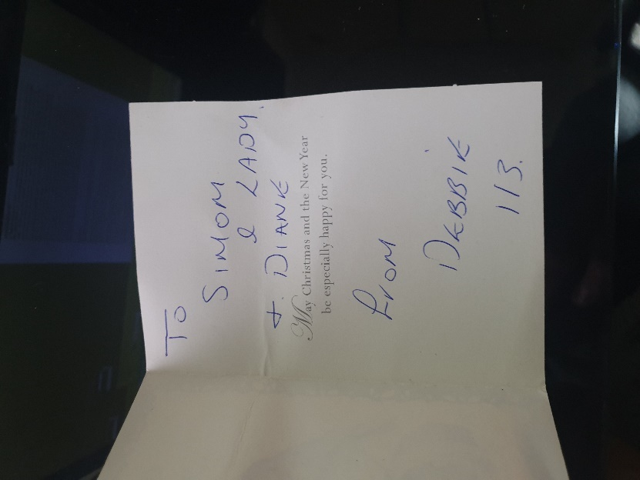
INFO | Statement Exhibit BB0 – 1 / 11/12/2012:  - O
 | - Responsible Doctors  - The reason that we have adduced this exhibit into these proceedings is because | 00/00/2012 | Evidence: Exhibit BB5 – 1 / 00/00/2012:
INFO | Statement Exhibit BB0 – 1 / 00/00/2012:  - O
2013

 | - Responsible Doctors  - The reason that we have adduced this exhibit into these proceedings is because | 00/00/2013 | Evidence: Exhibit BB5 – 1 / 00/00/2013:
INFO | Statement Exhibit BB0 – 1 / 00/00/2013:  - O
 | - Responsible Doctors  - The reason that we have adduced this exhibit into these proceedings is because | 00/00/2013 | Evidence: Exhibit BB5 – 1 / 00/00/2013:  07/06/2013 Debbie wrote me a letter!  12/06/2013 I received another letter off Debbie today!  17/06/2013 Debbie kept on writing me letters!  20/06/2013 Debbie kept writing me letters!  22/06/2013 Debbie kept writing me letters!  24/06/2013 Debbie kept writing me letters I have them all in my position still to date!  28/06/2013 Another letter wrote to me from Debbie!  16/07/2013 I then found another letter of Debra Andrews that got posted through my letterbox of my front door!
INFO | Statement Exhibit BB0 – 1 / 00/00/2013:  - O
 | - Responsible Debra Andrews  - The reason that we have adduced this exhibit into these proceedings is because | 11/07/2013 | Evidence: Exhibit BB5 – 1 / 11/07/2013:  - Contained in the Now Claimants Diary  Evidence Exhibit: - BB5 – 1 / 00/00/2015:  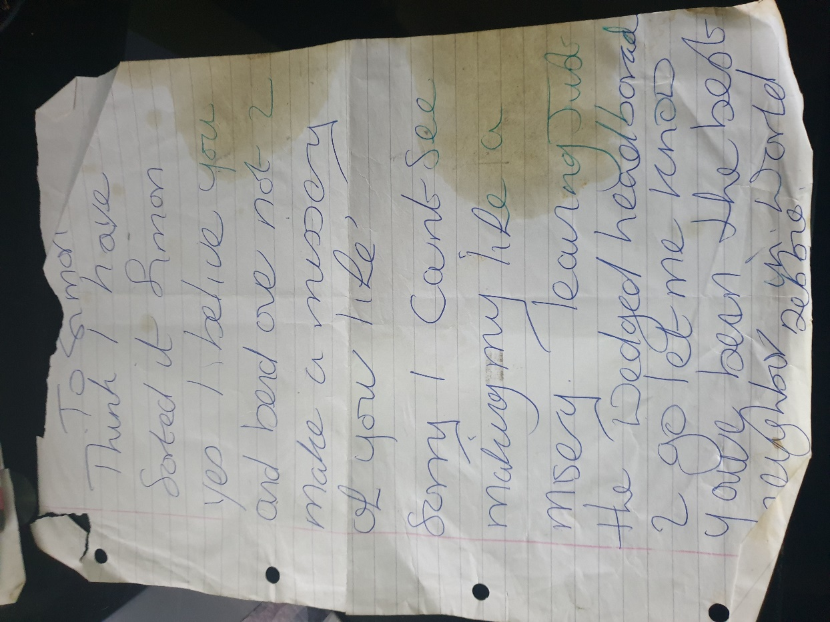  14  Stage 5  The Enfield Councils History FOI Indexed  Stage 5  Deborah Andrews / Enfield Council Case History  Page Number: 1,2,3,4,5,6,7,8,9,10,11,12,13,14,15,16,17,18,19,20,21,  DATE(S).  G.1.1) 18/01/2016  H.1) 18/01/2016  I.1) 18/01/2016  J.1) 26/01/2016  Page 14 of 21  26/01/2016: from customer services re Simon Cordell  From: Laura Goodson  Sent: 26 January 2016 14:10  To: Louise Brown •  Cc: Jackie Gubby  Subject: Simon Cordell 0208 245 7454  109 Burncroft Ave [SEC=PROTECT: INVESTIGATION]  Classification: PROTECT – INVESTIGATION  Hi Louise, Jackie,  Mr Cordell called this afternoon requesting to speak with yourselves in regard to his case against his neighbour.  I am sure you know the details; however, he did say that his neighbour is making noise when he undresses. He did go on to mention an incident that resulted in both himself and his neighbour in an awkward position when he attempted to help her move her bed.  Mr Cordell is expecting a call back this afternoon.  Kind Regards  Simon Cordell’s MP3’S Indexed  Stage 1  Home MHA assessment Recording!  Page Number: Update Page Number 1,  A Home MHA assessment got completed and Simon got assessed as to be not detainable.  This is the wrong date in the report?  On the 02/02/2016 is when they used the section 135 warrant to come to my home with police. On this date I been at home and had no visit of the medical team, as for this was the date when the section 135 of the Mental Health Act  THIS IS PART OF THE RERCORDING  Simon: Eventually, anyway I broke up with my partner and this woman wrote me letters suddenly, this shows how drunk she was and her mental state of mind in the letters.  Simon: She is like dear Simon I thank you for your support through alcoholism.  Simon: So, she is admitting that she is always drunk.  Simon: I was a where that I knocked on your door and borrowed money approximate £7 around 8 times.  Simon: So, you can see that I am always giving her money.  Simon: I am always giving her money.  Katie: That is because she is asking for it.  Simon: Yes, she is knocking on the door.  Simon: And then she is like I do not have the way or the means of stalking you.  Simon: So, she clearly, understands that she is stalking me and I am saying to her please can you stop what you are doing to me, she keeps writing it when she is drunk, it is my life.  Simon: Now because of the case I am spending 24 hours a day in my home, do you know what she does, sir she comes here and she gets the tap in her flat that the manufacture intended it to get built for a purpose and that is not in the way she uses it, what she is doing is sitting there at the tap and I mean she sleeps at the tap " Description of her using the tap" going bang, bang, bang what it was like is someone, had turned the pressure up by the stop cock.  Doctor: Can I stop you there please.  Simon: What it is I cannot even take my clothes off in my own home as she will stamp and follow me bang, bang, bang, bang on the floor all the way into the bathroom.  Mother: He has so many witnesses I been trying to get the council to help with no luck.  Sam: Have you raped I mean, surely, the housing officers know that the.  Mother: I have been I have been.  Simon: the police will do nothing.  Mother: I have been trying to deal with it, I have gotten emails upon emails upon emails that I have sent begging the council to deal with lady upstairs.  Mother: Even when I am here, she follows me into the bathroom.  Simon: There are loads of them here she writes me so many letters so many letters.  Simon: Yes, and none of my friends can take their clothes off in this house or nothing `because of what she has been doing.  Mother: It feels like she is continuing on top of your banging.  Simon: What she does every time she hears a computer keyboard; what she does is she will stand there and she will; (Mr Simon Cordell makes a loud banging sound.)  Sam: And it sounds like there is no sound proofing here at all low.  Mother: No there is not.  Simon: I cannot even work in this house because of her I mean I have been sitting down in this house for the last year still just waiting for her to stop banning and this can cause my sleep pattern to mess up a bit from time to time still.  Sam: No, I am fine, I am fine.  Mother: And I got emails upon emails asking the council to address it because it is not fair on him, he feels as if he has no privacy in `his own home.  Simon: Look Simon, thank you I think I have sorted it and I believe you and would bend over not to make an emissary of your life sorry I cannot see leaving just the wedged headboard.  Katie: There are plenty of people who have been here she has done it too me.  Simon: This is how drunk she is when she wrote this.  Katie: You can hear her.  Louise Brown: Do you live in this block too?  Katie: No but I am always here I am, here a lot and I am also here a lot when mum is not here, I mean a lot of things have happened.  Louise Brown: yes.  Katie: So, it is not like he is making things up as it has gotten seen by a lot of other people and no one does anything as it is a council place for him.  Katie: I even told him that he should move away from here.  Louise Brown: Hmm.  Simon: But do you know what she means by the wedged head board yes like I said a Christmas last Christmas I brought her a box of chocolates yes and I gave everyone in the block a present yes times where hard for me as this time because I had not been up too much because I had been on curfew for two years all ready at that stage yes in this house Simon so I brought t them their boxes of chocolates then In a couple of months later in February she did all this banging on the tap on purpose and stamping bang, bang, banging but just before that she knocked on my door one day and asked me to go upstairs into her flat and help move her bed out this was the first time I had been into her flat I have not been in that flat for years since she has lived there but I still went up there as a gentleman I went up there and I went in to her house and the house smelled right it was clean but it did not just smell clean so I felt funny as I am one of them people that as if "She is lazy why is her house not clean" how could she invite me In to her house like that so I quickly moved the bed fast and UN-done it and got it out of the house and got out and got straight back to my own house yes and that is why she wrote that funny bit about the head board .  Simon: You are being the best neighbour in the world Debbie and this is the sort off letters she keeps putting into my front door.  Mother: Even the council `has turned around and said that she has a fashion-nation with my son, but they’re not doing nothing and it's driving him, he cannot even go into the toilet and have a  bath as she is on top of him banging continued.  Louise Brown: Hmm OK.  Mother: Even when I am sitting here and I go to the toilet and she does not even know that it is me and she does the same too me, and It makes you feel and the council are really not doing nothing about it what so ever.  Louise Brown: Hmm.  Mother: He knows that she has got problems.  Louise Brown: And this has been going on for how long a long time.  Mother: A year.  Louise Brown: Oh right.  Mother: And I put a complaint in because Dawn Alena is his council officer.  Louise Brown: Yes.  Mother: I was making phone calls and saying to Dawn Alena, please try to address this you know please it's going to far now.  Louise Brown: Yes.  Mother: And she wouldn't come out she wouldn't deal with it and wanted Simon to come up and visit her and basically, I put a complaint in and the they said that they’re going to put it over to the anti-social team and they wouldn't do anything then a Louise brown took up the case after months of not doing any think and I am writing emails upon emails and then they come out she did not take one note and he has video tapes recordings and every think and you can hear it and you can hear the taps were she was using the taps and they had the pressure up so high the noise that come into his flat was terrible the noise she was just turning it on and off on and off on and off.  Mother: He could not even sleep propel.  Louise Brown: How old is she Simon?  Simon: She is four years old now.  Mother: How old is Debbie.  Simon: Oh, she is about 12 years older than me I would say.  Louise Brown: 12.  Katie: Oh, what the dog.  Simon: Oh no the dog is four, four years of age.  Louise Brown: Arr.  "Muttering" 45:14 till 45:34  Katie: She might be older than that.  Mother: And like I put a complaint in because the Anti-Social Behaviour team was not dealing with it and they was not taking the issue seriously, and that got put in October of last year and we have not heard a thing, so I keep asking them when are we going to get a response from the formal complaint that got put in because you are not addressing thing correctly.  Louise Brown: And nothing.  Mother: nothing she phoned because I think she made a mistake, because he phoned Louise, and it now I mean Debbie was going off constant banging and he could not work or any think and it is annoying to him so he phoned Louise up and he always gives out my number so she phoned me by mistake and I turned round and said to Louis I said I said She said is Simon Cordell there I said no who is it she said it Louise Brown.  Louise Brown: I am Louise brown.  Mother: Oh, so you are Louise brown can you tell me why you have not responded to my formal complaint I sure you have and I know.  "Muttering" and I have not deleted them err, yet in another email you will have a response fast and directly, but it is still going on now and it is now February and sill nothing.  Marry: No response.  Louise Brown: It can take up to four months later.  Mother: Yes, I Know.  Louise Brown: Any way.  Mother: And I have even been up because he has knocked on her door a few times when she was bad and really banging the council has  "Muttering" So that you do not hear it so badly, so bad when she is constantly, banging.  Mother: I mean, even the other day he had his entire bathroom ceiling flooded, and it knocked his entire electric out and he had to call the Emergency.
INFO | Statement Exhibit BB0 – 1 / 11/07/2013:  - Debra / Moving Her Bed!  - Debbie asked me to go into her bedroom: --  - In the days to follow I noticed that outside of my flat, I could hear the wind howling through the streets, as the sun was trying to come out to play, while I was still trying to stay safe inside of my home.  - By this time Debra’s fire was nearly out, in this instance, Debra Andrews had knocked on my front door but instead of asking the normal question “like can she borrow some money” she had asked the question of whether I can help her by moving her bed out of her flat, I remember having to agree to help her, so I went upstairs to her flat for the first time and only time.  - When I entered, I noticed that she had been finding life hard, she had not managed to keep her flat to a high level of standard of hygiene and I could smell the odour of cider that she had been consuming, I politely hurried to complete the job that I had agreed to do for her then in hand and quickly made my way back home.  - After that day, I did always feel like she took an offence for not spending more of my time with her, as she knew I was a single man by then.  - Date: 11/07/2013  - At Time: 05:30 pm.
 | - Responsible Doctors  - The reason that we have adduced this exhibit into these proceedings is because | 05/09/2013 | Evidence: Exhibit BB5 – 1 / 05/09/2013:  - Contained in the Now Claimants Diary  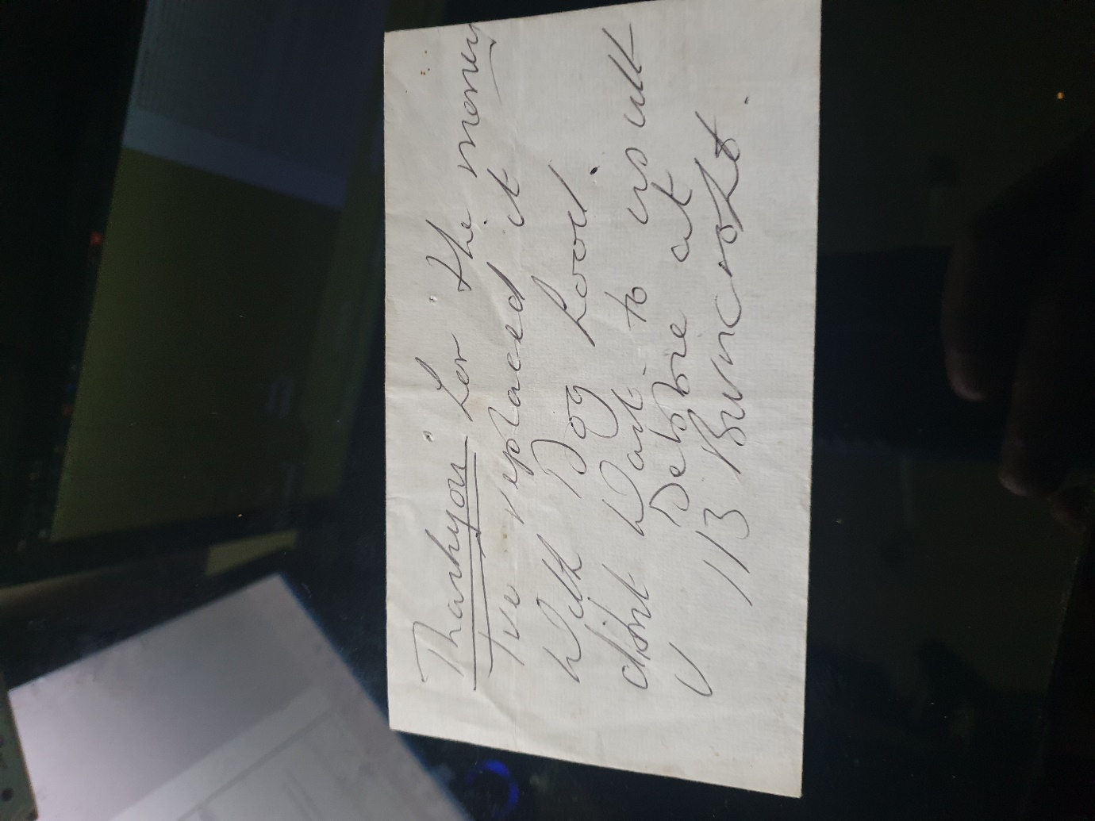
INFO | Statement Exhibit BB0 – 1 / 05/09/2013:  - I like to be able to explain to everyone that it is a powerful reed, when you write like this: -  - Before this Debra had continually attended mine and Ozzie s addresses, she endeavoured us with her so-called love.  - By this stage she has become an occupier of her premises for about five years, in turn living with us as a resident in Burncroft Avenue. Prior to any problems between us all I and Ozzie had both decided not to allow Debra Andrews access into our own flats, as we could understand she has special needs. We managed to look after her, while treating her like a sister, in a short explanation, as much as she attempted to gain access into our homes, we both discretely presided in both politely declining her entry and stayed adamant in our decision. But to our surprise Debra Andrews had found something that would mean to her that she'd not be bored or lonely again, “Stain.” Thought most of the years that Debra Andrews did live above me, Debra never did knock on Stan’s front door, while stains wife was present with us all. The reason for this to me was because I believe, she knew of Brenda's presence. Debra simply knocked on mine and Ozzy’s front doors. Eventually, my own civil partner also raised a large concern about Debra always knocking on our front door, the reason for this was because of the persistent knocking on the front door, which in turn caused my partner weirdly to question me in regard to my personal relationship with Debbie. Whenever I needed to, I would go to my front door and look through the spy hole, this was whenever I heard a person at the front doors, that is to mean the front doors of my or Stan’s, as his front door is opposite to mine and the other reason was partly as my guard dog always makes me aware of anyone else's presence. Henceforth, as a sense of natural instincts, I will confirm who is there for our safety. Because of security I had noticed Debra had started to knock at the front door of Stan on a daily basis a shot while after his wife had passed away, I would notice that he would always grant her access and that she would be carrying a shopping bag full of alcoholic drinks. I could easily tell what she had in her plastic bags as they would always make the clinging sound that glass and plastic bottles do and or metal cans will make. At around the same time, I asked Stan if he would help me, what I asked him was for him to help me to help everybody by reading a proposal that I had prepared for the community event that I had started to build, to which he did agree to read. In the following days, I approached Stan as agreed for an update, as to any amendments that he may advise me to make within the document, when speaking to him, he explained to me that he was grateful that I had asked him to go over the proposal and that he enjoyed reading it very much so, I can remember that his words made me feel very happy, me being me, I questioned him a little more whether there is anything else’s that he recommends being updated or changed for the better of the event being created, I received a reply of no it is perfect just how it was alongside with the advice of to send it off, even low I still understood that I was not quite ready at this stage! The slowdown and closing of talking to Stan, at this period was just after I said to him that I treat my work seriously, so because of this reason, I will be indoors working hard, so if he ever needs any help of me just tell me and I will be there for him.
 | - Responsible Doctors  - The reason that we have adduced this exhibit into these proceedings is because | 28/09/2013 | Evidence: Exhibit BB5 – 1 / 28/09/2013:
INFO | Statement Exhibit BB0 – 1 / 28/09/2013:  - Consequences: --  - Neighbours Stain – Debra & Co  - There will be consequences for their actions, thinking this is what made me carry on staying alive: -  - I did find myself helping Stan, at his own requests, this got achieved in helping to complete some following: -  - A Simple task, like pushing the chair that Stan sits down the road for him, into his house.  - Taking Stan to the doctors, after he had fallen over, when closing his curtains.  - My mother and I shared with Stan, at his house, our boxing day.  - I hand delivered Stan and Debra their Christmas presents early and in time, even low I was finding life hard, as of the police bail conditions and the separate Anti-Social Behaviour Order proceedings.  - Up to date, I have never asked of anything of any other person that lives on my estate, other than respect.  - Shortly after the trial, I got released to be free from police bail conditions and was then single due to the burglary case. It took me a long time to get better, after being kept on curfew and for what I had suffered wrongly, because of the damage that the court case and other on goings had caused me.
 | - Responsible Doctors  - The reason that we have adduced this exhibit into these proceedings is because | 17/12/2013 | Evidence: Exhibit BB5 – 1 / 17/12/2013:
INFO | Statement Exhibit BB0 – 1 / 17/12/2013:  - O  Who stole the Christmas tree?  Thought, the rest of the months in  2013  off the summer faded away into the winter and the question to ask was, “Who stole the Christmas tree?  While still living in my flat, I remember when stain took his time to place a Christmas tree in the corridor for the entire tenant’s pleasure. But little was he to know that this good deed of his was soon after to get disheartened. In the years prior to stain placing the Christmas tree in the corridor the council had never changed the entrance codes, to the front door of the flats, so in layman terms, the entrance code to the front door had never got updated and because of this, the past users' fingerprints, to the door locks, could get seen. The faded ID could get seen by any person’s naked eyes, this is due to the wear and tear, making the door entrances vulnerable to prowling eyes. Because of this reason people had started to loaf within side the corridors for shelter or other reasons and so forth. On one of the cold winter nights after stain had done his good deed, the tenants of the block must have got occupied with their own responsibilities. I cannot clearly remember what I personally was doing, but I could bet a pound coin that I was working hard on a good project. On awakening one morning, I went outside into my communal corridor, on doing so, I noticed stain and said to him the usual, “hello and how are you doing.” His voice was full of upsets as I heard his reply, he asked me the question of; do I know where his Christmas tree has disappeared too. At first, I took a full glance to see the spot to where he had placed it and continued to notice that it was in fact missing. I had known stain for so long by this time, in my life, so I took it that he personally would already understand the truth and that would be that I never would have been that person what did move the Christmas tree, in sense to any stake, I and my first civil partner already had our own Christmas tree. After talking for some time and doing our own investigation, we never did find out who actually did steal, “the tree.” So, the question still is who stole, The Christmas Tree?
 | - Responsible Doctors  - The reason that we have adduced this exhibit into these proceedings is because | 00/00/2013 | Evidence: Exhibit BB5 – 1 / 00/00/2013:
INFO | Statement Exhibit BB0 – 1 / 00/00/2013:  - O
 | - Responsible Stain Curtis  - The reason that we have adduced this exhibit into these proceedings is because | 29/12/2013 | Evidence: Exhibit BB5 – 1 / 29/12/2013:  Bank Statement to be Added  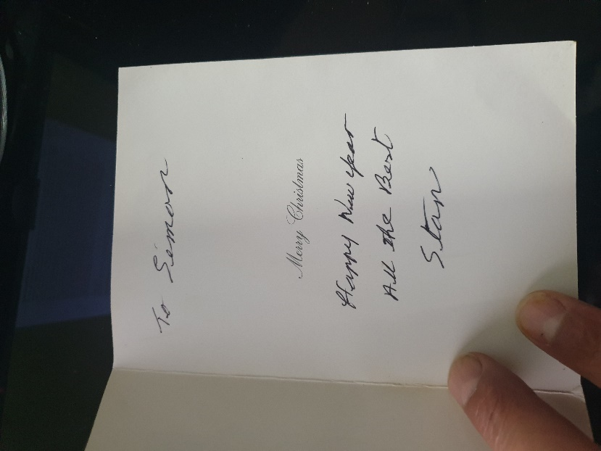
INFO | Statement Exhibit BB0 – 1 / 29/12/2013:  - O  - I had got stain and Debra  A Christmas present each!
 | - Responsible Doctors  - The reason that we have adduced this exhibit into these proceedings is because | 00/00/2013 | Evidence: Exhibit BB5 – 1 / 00/00/2013:
INFO | Statement Exhibit BB0 – 1 / 00/00/2013:  - O
 | - Responsible Doctors  - The reason that we have adduced this exhibit into these proceedings is because | 00/00/2013 | Evidence: Exhibit BB5 – 1 / 00/00/2013:
INFO | Statement Exhibit BB0 – 1 / 00/00/2013:  - O
2014

 | - Responsible Doctors  - The reason that we have adduced this exhibit into these proceedings is because | 00/00/2014 | Evidence: Exhibit BB5 – 1 / 00/00/2014:
INFO | Statement Exhibit BB0 – 1 / 00/00/2014:  - O
 | - Responsible Doctors  - The reason that we have adduced this exhibit into these proceedings is because | 00/00/2014 | Evidence: Exhibit BB5 – 1 / 00/00/2014:
INFO | Statement Exhibit BB0 – 1 / 00/00/2014:  - O
 | - Responsible Doctors  - The reason that we have adduced this exhibit into these proceedings is because | 00/00/2014 | Evidence: Exhibit BB5 – 1 / 00/00/2014:  Evidence: Exhibit BB5 – 2 / 00/00/2014:  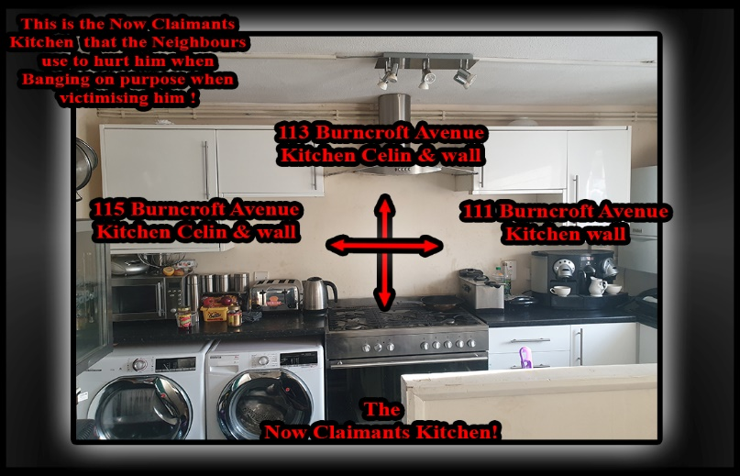  Evidence: Exhibit BB5 – 2 / 00/00/2006:  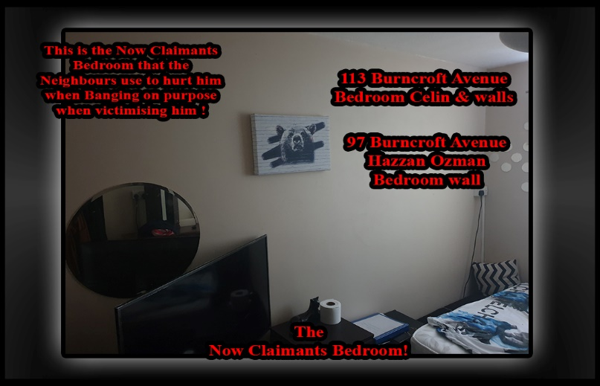  Evidence: Exhibit BB5 – 2 / 00/00/2014:
INFO | Statement Exhibit BB0 – 1 / 00/00/2014:  - O
 | - Responsible Debra Andrews  - The reason that we have adduced this exhibit into these proceedings is because | 26/01/2014 | Evidence: Exhibit BB5 – 1 / 26/01/2014:  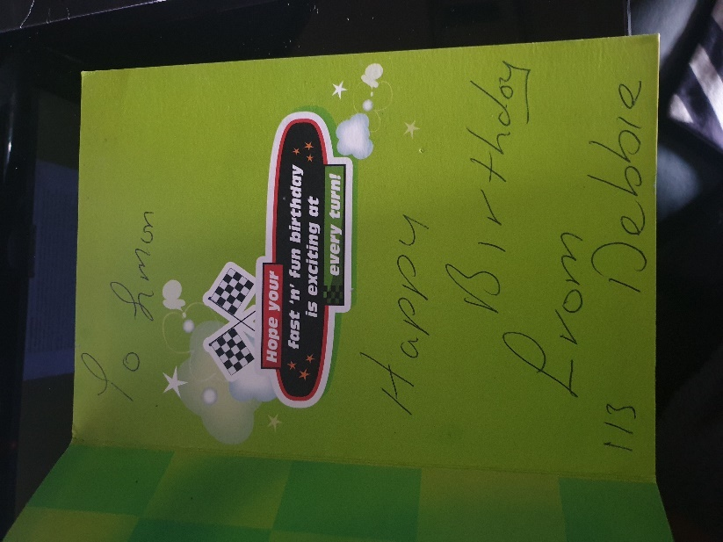
INFO | Statement Exhibit BB0 – 1 / 26/01/2014:  - O  - Wrong? INFO +  1  - My birthday - Neighbours: --  In the flat getting tortured this is the last time I spoke on Facebook to any of my friends because what they stain and Debbie inclusive of the Mathiyalagan!  1  My birthday - Neighbours: --  I could not get the Woolwich case to get dropped, in accordance to the law and my legal rights re obtained: --  The start of  2014  a new year for everyone; it was January and this special day was my birthday. I can reminisce about the day being depressing as I could not get the Woolwich case to get dropped, in accordance to the law and my legal rights re got, which meant that I got bail condition subjected towards my person still, so I found myself stuck in my home, all alone getting attacked by my neighbours. I placed my sound system in my lock up at another address to where I live, earlier in the last year on  June 2013  and took a look online at Facebook. In doing so I noticed that I received a lot of nice birthday messages, which in fact cheered me up, but my smile was not to last for too long, as I realised how far Stain and Debbie and the Mathiyalagan Markandu family members and guests, managed to damaged my life. Typing on the keyboard of my computer doing my work would mean they would hear me and bang above where it would have the worst effect on me, by hitting the floorboards and dropping objects above my head for hours at a time. I kept video diaries and audio recordings so to prove what kept going on.
 | - Responsible Doctors  - The reason that we have adduced this exhibit into these proceedings is because | 11/03/2014 | Evidence: Exhibit BB5 – 1 / 11/03/2014:  From Enfield Councils Databases: - History Forged Against the Now Claimant and Illegally Detained.  - https://horrific-corruption-files.webhop.me/Original-Files-Folder/All%20Case%20Original%20Court%20Application%20Case%20Files/All%20Case%20Original%20Court%20Application%20Case%20Files/18_01_2019%20FOI%20Folder/FOI%20%20from%20Council%20Split/Attachment%205_105..pdf  - Page 7  --  Referral Details  23/09/2015: Organisation making referral Housing Anti-Social Behaviour Response Team  History  23/09/2015: Agree an Action Plan with the Complainant ACTION PLAN PROVIDED TO THE VICTIM AND A COPY FORWARDED TO HER CPN BOLA QUADRI  - Dated the 23/09/2015  - March 12 - 1st contact with MH services following arrest after a: - “Bad Trip of Taking LSD & Alcohol,” mental state assessed remained in custody of police - no MH input  --  - “March 14 - 2nd contact, assessed by team psychiatrist, presented with anxiety & suicidal thoughts in context of social stressors due to pending court case leading to stress. Discharged form MH services, suicidal thoughts are longstanding from early childhood and present at times of high stress, not 'A typical' of other forms of suicide as relates to thoughts as opposed to wish to die, and usually found in context of those presenting with early childhood trauma as a way of expressing emotions.”  --  - Nov l4 - Mental Health Act assessment, not detained in hospital, discharged from mental health services.  Presented highly volatile, angry & paranoid about motives of others, presented in context of social stressors due to on-going issues with police & court process –  mother reported he has been targeted by police causing him stress??  He has a medical history of Crohn's disease which may impact on mood stability particularly if not compliant with treatment and monitoring of symptoms.  All assessments completed by mental health services have found no evidence of serious mental illness,  “He appears to be a very angry young man who has had an extremely difficult and traumatic early childhood which is likely to explain his distrust of people in authority (e.g., police) and being angry at others and at the world....”  Regards Debbie  --  - 23/09/2015 Classification: PROTECT  Good afternoon, Debbie,  Hope you are doing well?  could you kindly advise if the above tenant is known to your service and if he is, does he have a CPN and does he engage?  Thank you for your assistance  Mr Simon Cordell,  109 Burncroft Avenue,  Enfield,  EN3 7JQ  DOB=25 (34 yrs.)  Phone=020 8  Dolly Ogunseye Anti-Social Behaviour Officer Housing Anti-Social Behaviour Team Tenancy Manager  Enfield Council  Evidence: Exhibit BB5 – 1 / 11/03/2014:  The Doctor’s Folder / pub Book Issue: 1!  Notes From the: 09/02.2016  Date of initial referral: 21/01.2016  Date of assessment: 03/02.2016  Place of assessment: Patient’s Home  London Borough of Enfield  Approved Mental Health Professional Assessment Form. For use when compulsory powers are being considered  Assessing AMHP: Sam Curtis.  Hospital Not applicable Dr Kripalani, Consultant Psychiatrist, Lucas House, 305 - 309 Fore Street, Edmonton, London, N9 OPD Tel 020 8702 3100 GP Nightingale House Surgery, 1 Nightingale Road, N9 8AJ Tel 020 88059997 /cmhn / Goodie Adama, Care Coordinator and Community Mental Health Nurse, Lucas House, cmht 305 - 309 Fore Street, Edmonton, London, N9 OPD Tel 020 8702 3100  Page Numbers: 32,33,34,35,36,37  “Not Relevant!”  33,  “Not Relevant!”  34,  “Not Relevant!”  35,  On 11/03/2014 due concerns about suicidal thoughts and anxiety. He was prescribed Sertraline anti-depressant. He was stressed about a pending court case as he was accused of burglary. He described experiencing poor sleep and weight loss.  36,  “Not Relevant!”  37  “Not Relevant!”  Evidence: Exhibit BB1 – 4 / 02/03/2014: = March 14 - 2nd contact, assessed by team psychiatrist  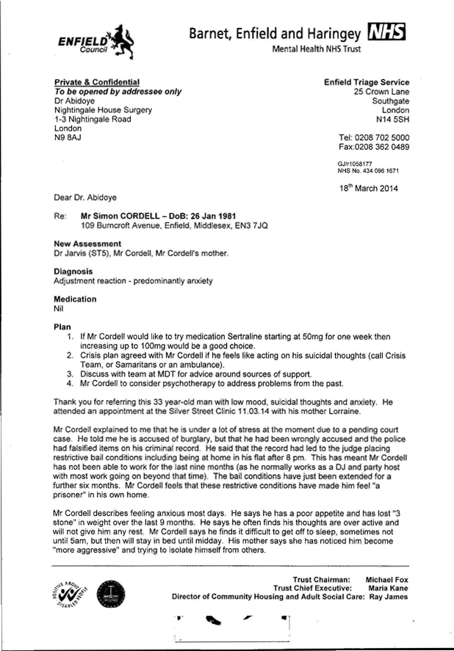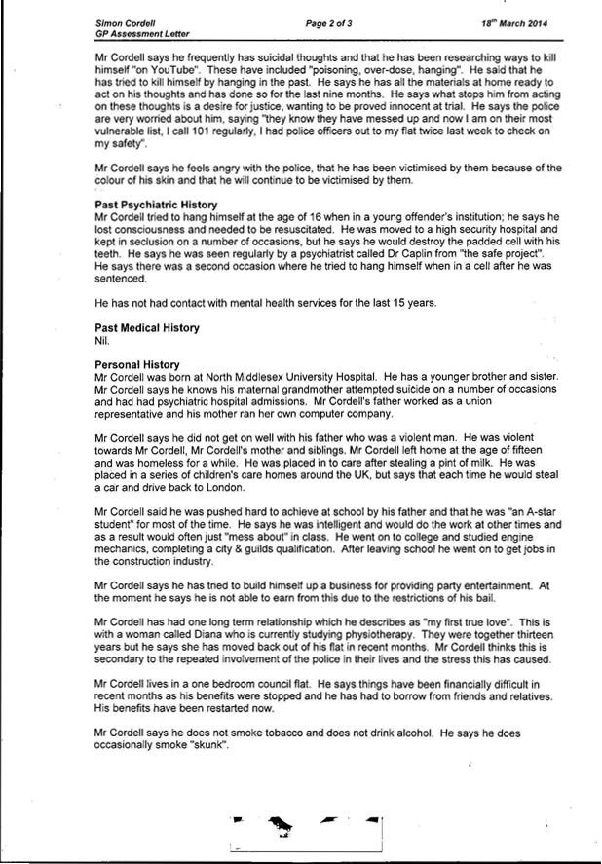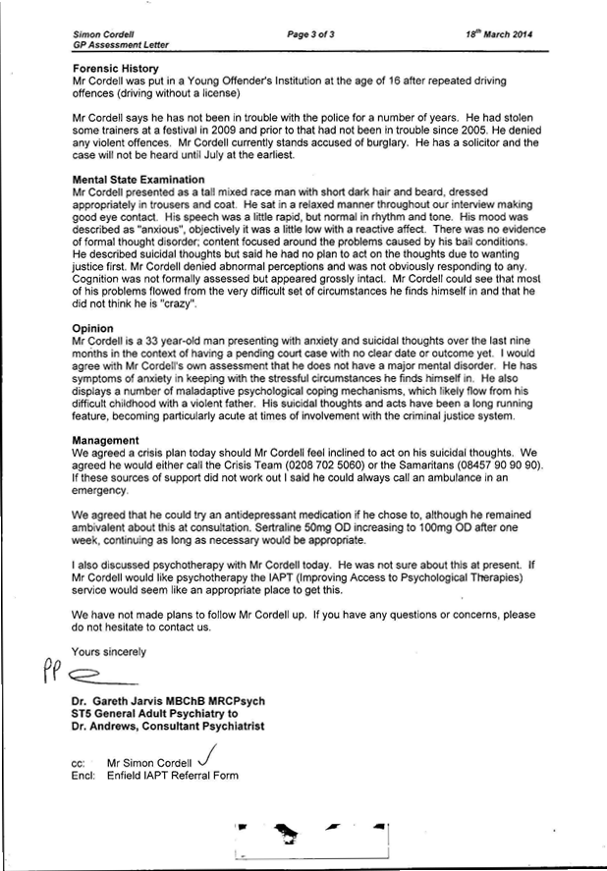
INFO | Statement Exhibit BB5 – 1 / 11/03/2014:  - On the 11/03/2014. I Mr Cordell got assessed by Dr Jarvis from the Enfield triage team, this should be on the 02/03/2014 and not the 11/03/2014.
 | - Responsible Doctors  - The reason that we have adduced this exhibit into these proceedings is because | 00/00/2014 | Evidence: Exhibit BB5 – 1 / 00/00/2014:  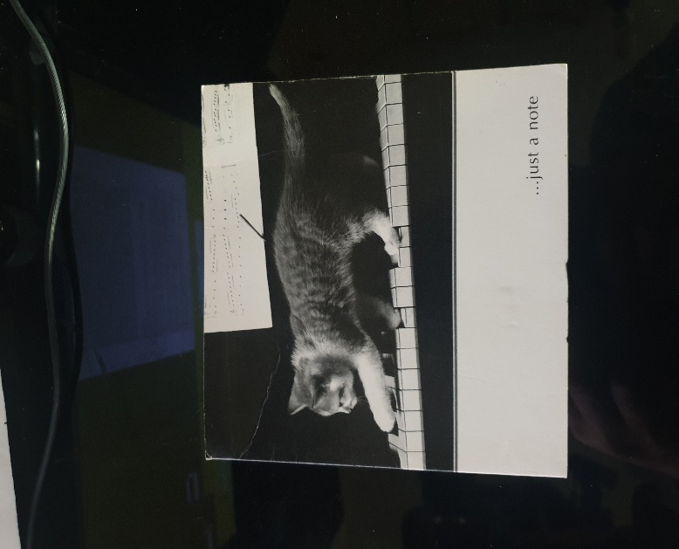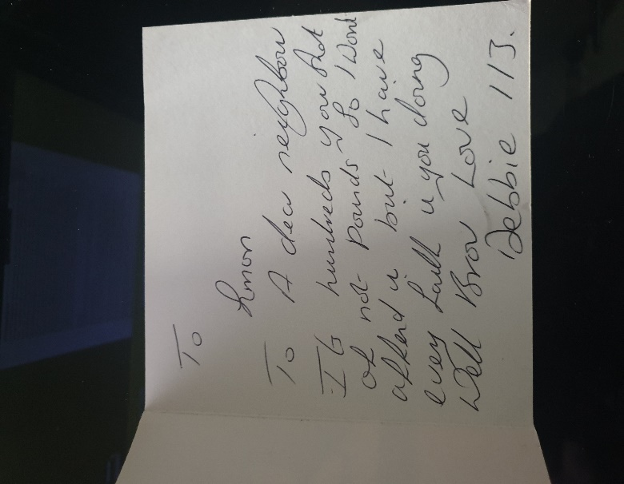  07/06/2013 Debbie wrote me a letter!  12/06/2013 I received another letter off Debbie today!  17/06/2013 Debbie kept on writing me letters!  20/06/2013 Debbie kept writing me letters!  22/06/2013 Debbie kept writing me letters!  24/06/2013 Debbie kept writing me letters I have them all in my position still to date!  28/06/2013 Another letter wrote to me from Debbie!  16/07/2013 I then found another letter of Debra Andrews that got posted through my letterbox of my front door!
INFO | Statement Exhibit BB0 – 1 / 00/00/2014:  - O
 | - Neighbours  - The reason that we have adduced this exhibit into these proceedings is because | 30/08/2014 | Evidence: Exhibit 1 / 30/08/2014:
INFO | Statement Exhibit 1 / 30/08/2014:  - P
 | - Neighbours  - The reason that we have adduced this exhibit into these proceedings is because | 28/08/2014 | Evidence: Exhibit 1 / 28/08/2014:
INFO | Statement Exhibit 1 / 28/08/2014:  - P  My Nan got rushed into hospital!
 | - Neighbours  - The reason that we have adduced this exhibit into these proceedings is because | 30/08/2014 | Evidence: Exhibit 1 / 30/08/2014:
INFO | Statement Exhibit 1 / 30/08/2014:  - P  My Nan passed away!
 | - Neighbours  - The reason that we have adduced this exhibit into these proceedings is because | 09/09/2014 | Evidence: Exhibit 1 / 09/09/2014:
INFO | Statement Exhibit 1 / 09/09/2014:  - P  117 Burncroft Avenue: The London Borough of Enfield / The 2nd Injunction Order Indexed / Statement of Markandu Mathiyalagan - “I have been housed to this Property with my family on 9TH September 2014 by Waltham Forest District Council.  The Property was given to me as a temporary accommodation.
 | - Asbo  - The reason that we have adduced this exhibit into these proceedings is because | 12/09/2014 | Evidence: Exhibit 1 / 12/09/2014:  The Asbo dates  PC Sophie Theodoulou  Police Officer Who Lied and said that she Served me the First Asbo Folder!  Page Numbers: 57,58  12/09/2014
INFO | Statement Exhibit 1 / 12/09/2014:  - PC Sophie Theodoulou is already exhibited in  - [Exhibit A4] Name list  - [EXHIBIT J8] Failed Service of Court Order  - [EXHIBIT J37] Caught More Than Three Times Sir Bernard Hogan Howe  - The Judge wrongfully Granted the Asbo needlessly of the true facts of evidence on the 04/08/2015 and the End of Asbo Court Order was the 04/08/2020.  - The Forged Asbo conditions placed upon me finished but I could never go out ever again to a party in case I got set up again by the police and the Council!
 | - Neighbours  - The reason that we have adduced this exhibit into these proceedings is because | 13/09/2014 | Evidence: Exhibit 1 / 13/09/2014:
INFO | Statement Exhibit 1 / 13/09/2014:  - P  The Asbo folder got left in the hallway!
 | - Neighbours  - The reason that we have adduced this exhibit into these proceedings is because | 06/10/2014 | Evidence: Exhibit 1 / 06/10/2014:  The day had turned into the day of the Asbo?
INFO | Statement Exhibit 1 / 06/10/2014:  - P  I have heard people say their hair is falling out and now so is mine!
 | - Neighbours  - The reason that we have adduced this exhibit into these proceedings is because | 21/10/2014 | Evidence: Exhibit 1 / 21/10/2014:
INFO | Statement Exhibit 1 / 21/10/2014:  - P  The older Nephew or son, the dark secret - “Meeting Mathiyalagan Markandu family including the older Nephew / son, the dark secret
 | - Neighbours  - The reason that we have adduced this exhibit into these proceedings is because | 04/11/2014 | Evidence: Exhibit 1 / 04/11/2014:
INFO | Statement Exhibit 1 / 04/11/2014:  - P  I Started to be sick again - “And I was up all night but needed to go to court the next day, so I got out of the Hospital! A different part of a continuation: --  Also, Going to the clinic!
 | - Neighbours  - The reason that we have adduced this exhibit into these proceedings is because | 06/11/2014 | Evidence: Exhibit 1 / 06/11/2014:  Simon Cordell’s MP3’S Indexed  Stage 1  1x Recording  1st POLICE CALL Recording!  01m. 1st POLICE CALL Recording 06_11_2014  Page Number: Update Page Number 1,  The first recording between me and  The Metropolitan Police that I recorded!  And now this is a true copy of the first recording between me and the Metropolitan Police; --
INFO | Statement Exhibit 1 / 06/11/2014:  - P
 | - Neighbours  - The reason that we have adduced this exhibit into these proceedings is because | 07/11/2014 | Evidence: Exhibit 1 / 07/11/2014:
INFO | Statement Exhibit 1 / 07/11/2014:  - P  I noticed an assault of banging at me: --  I got shocked after coming back home from helping out at the community hall the reason for this is that when I am sitting down in my front room working on establishing a new model constitution for the community hall. Debra Andrews of 113 Burncroft Avenue has started to bang above my head to wherever I sit this continued for over three hours at the time of 9:00 Pm till 12:00Am.
 | - Neighbours  - The reason that we have adduced this exhibit into these proceedings is because | 09/11/2014 | Evidence: Exhibit 1 / 09/11/2014:
INFO | Statement Exhibit 1 / 09/11/2014:  - P  Debbie’s front door: -- Also the Mathiyalagan Markandu family’s front door - “I knocked on Debbie’s front door for the first time, then the Mathiyalagan Markandu family’s front door for the first Time! The banging got worse and worse as the families and Stan Curtis banged on the taps and pipes and floorboards so I could not sleep or study while developing my company, their actions towards me made it so that I could not even work on my own website without being assaulted. One day a few months after the occupiers of the flats I complain about in this report had continued to take place in victimizing me, that is to explain in their assault against me on a continual daily basis, with no remorse for their actions. I knocked on Debbie’s door and ask why she was doing this to me, she blames the Mathiyalagan Markandu family, I then headed upstairs and asked the Mathiyalagan family the same question with the reply of them blaming Debbie Andrews 113, I knew it to be both addresses including Stan Curtis, I believe that no person can question me about what I state as being false or misleading in any deceiving way, the reason for this is that I recorded the ongoing on camera and by way of an audio dictator recorder and I also had numerous friends stay over at my home who were also violated by the people living in all of the addresses, who are also willing to be witnesses and victims with their statements of truth.”
 | - Neighbours  - The reason that we have adduced this exhibit into these proceedings is because | 10/11/2014 | Evidence: Exhibit 1 / 10/11/2014:
INFO | Statement Exhibit 1 / 10/11/2014:  - P  The banging at me / Handshake 1 - “After going up stairs to Debra and then the Mathiyalagan Markandu family flat after, to speak to the people treating me in such a way: they all blamed each other: -- The first handshake with Mr. Mathiyalagan Markandu was in 2014, the day after when I went upstairs to Deborah’s and the Matthew flats, as them and Stan Curtis started to viciously, attack me, so after a few weeks passed with no change I decided to go upstairs and knock on the Mathiyalagan Markandu family flat front doors to speak with them about my questions to why this was happening to me, and if they would help me make it stop if not for me to do it for their child, I spoke to them about Deborah as they accused her themselves, of doing the banging at me, that I got subjected towards in me believing in the Mathiyalagan Markandu family; as I had only helped them in a nice way in the past and I didn't know them or their names, other than that. We spoke politely, to each other and they maintained that it was Deborah Andrews who was doing the assaults against me, when I spoke with them, I asked Mr. Mathiyalagan Markandu whether he would write a letter in regards about Deborah Andrews negative actions and the concern for him having his new born child in the flat around her because of the continuing loud banging noises that got left to happen 24 hours a day, he agreed to write a letter and hand deliver it to my front door, I then asked him whether he would shake my hand in an agreement given his word, he held his hand out and we shock hands, afterwards we both went along in our own days, ways.”
 | - Neighbours  - The reason that we have adduced this exhibit into these proceedings is because | 11/11/2014 | Evidence: Exhibit 1 / 11/11/2014:
INFO | Statement Exhibit 1 / 11/11/2014:  - P  Asking Stain if he would? - “Go upstairs to help me or Debra by taking control in a positive aspect! On this day I asked Stan if he would go upstairs to debris and try to resolve the problems he said: no. When I asked why he explained to me, that one day not so long ago at this time of relevance, he had been in his own back garden when Debra had been upstairs drunk in her flat.”
 | - Neighbours  - The reason that we have adduced this exhibit into these proceedings is because | 12/11/2014 | Evidence: Exhibit 1 / 12/11/2014:
INFO | Statement Exhibit 1 / 12/11/2014:  - P  Do you ever question yourself when you think?  Because I do and I keep thinking, personally, that I was better of writing all of the documents for a festival than this report: -  Contacting the council and MP’s; - Obviously, the banging never stopped it continued and got much, much, much, worse than ever before. Between the different contacts that I had with the MP’s, Enfield council and the police nothing changed for me the banging continued as I explain and got much, much, much, worse. I asked my mother if she could help me in emailing and or calling Enfield Council, so to get the problems addressed, as towards what was being done to me, by members of my neighbours, which my mother and I both did on a numerous number of different occasions, many emails got sent to the official departments, I even called them by phone on top of sending emails as did my mother. At the first chance I and my mother had we then after continually, sent the correct correspondence addressed to the relevant complaint departments who would have any relevance in these situations and this got done by us with no correct follow up taking place of them sent correspondents thus so far, this is a serious concern to me: - “the victim” and any others it may affect, indirectly. Nothing was being done by the council I told them I got CCTV of what was going on but they never asked to see it, in the one and only meeting I got with them, they did not even ask to see all the evidence that I have, I offered more than once in the meeting to show them, the lady did not even write anything down throughout, I said to her that Debbie even attacked me outside the flat all of this got told to the council.  Also  A Subject access request got made  To the Local council Enfield: --  A Subject access request got made to the Local council Enfield, chasing up answers, I re-submitted a subject access request in to the local council again, so that I could find out more information as to what was truly, being addressed by them and why and also what was being done about it.  In the request that I sent I asked for some of: -  Any information, as to any complaints made by my neighbours or any other person about me or my personal visiting guests, in any of the times, that they been and visited me, this was to get answers for the time period, of Enfield Council being my landlords; this was to include any anti-social complaints.  The reply that I received back, that was in acceptance off my Subject access request and was an answer of no there has been no complaints that got made to them, regarding myself or any of my other visiting guest, this got agreed for the time of the first eleven years, which I had lived in my home.  Also  Seeing Debra and Stain  Coming into the Block of Flats from after I asked stain to speak to Debra.
 | - Neighbours  - The reason that we have adduced this exhibit into these proceedings is because | 13/11/2014 | Evidence: Exhibit 1 / 13/11/2014:
INFO | Statement Exhibit 1 / 13/11/2014:  - P  Assaulted with battery and negligence: --  Every day I get assaulted with battery and negligence towards my human right Article 2 the right to life and article 13 the right to a private family life this continues with article 5 the right to freedom and security alongside most of my other human rights that have gotten breached now towards me I can feel the damage that Stain, Debra and the Mathiyalagan Markandu do to me, by banging on the floor and walls inclusive of slamming on and off when abusing the water tap on and off at a compulsive fast rate, they bang so hard and, compulsively, that it causes all the other fixtures in the building to come loose and so that every other close by person within a half mile radios can hear them assaulting me. I believe is easy for others to see that this is having a negative effect on me, I had done nothing wrong to them all and because the two flats above my flats, main water feed runs through my flat, I cannot get away from hearing them while they assault me with tortures acts and endanger my life, while I try to stay strong. Stain, Debra and the Mathiyalagan Markandu’s kept doing the things that I mention about so that other person's children might come into the block and try to also victimise me, while they cause me mental sufferings. On this day this got left to happen to me, by the police and local council once I contacted them about my safety concerns.  Also  I Received a Phone Call - “On this day I received a phone call of my new living partner  Also  One off the times that I enjoyed - “One off the times, that I enjoyed with my new living partner was w
 | - Neighbours  - The reason that we have adduced this exhibit into these proceedings is because | 14/11/2014 | Evidence: Exhibit 1 / 14/11/2014:
INFO | Statement Exhibit 1 / 14/11/2014:  - P  117 Burncroft Avenue: He said it was not her fault! - “The Mathiyalagan Markandu family’s nephew or son said.”
 | - Neighbours  - The reason that we have adduced this exhibit into these proceedings is because | 15/11/2014 | Evidence: Exhibit 1 / 15/11/2014:
INFO | Statement Exhibit 1 / 15/11/2014:  - P  The banging at Me Continued: Mathiyalagan Markandu family - “The Mathiyalagan Markandu family; wife played with her pressure pot release the value on and off for hours at a time with her cooker, while slamming her window opened and closed so that I could hear the banging sound and the sound also from the pressure pot, she placed more pressure on me and my partner who sadly, had a miscarriage because of what them members of neighbours were doing to us, with their wrongful intent of criminal action’s.”
 | - Government Issue  - The reason that we have adduced this exhibit into these proceedings is because | 17/11/2014 | Evidence: Exhibit BB5 – 1 / 17/11/2014:  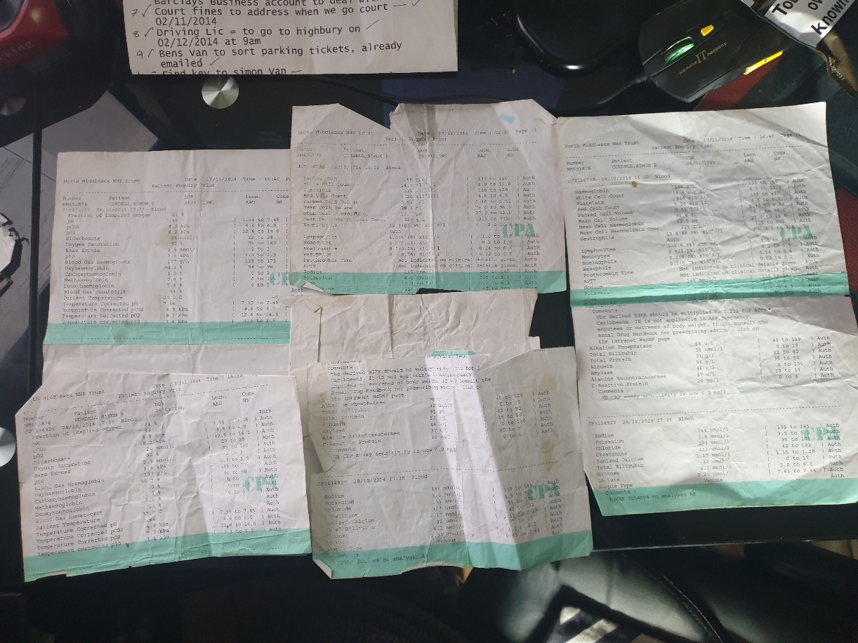
INFO | Statement Exhibit BB0 – 1 / 17/11/2014:  - O  My blood test results - “To the hospital:
 | - Neighbours  - The reason that we have adduced this exhibit into these proceedings is because | 18/11/2014 | Evidence: Exhibit 1 / 18/11/2014:
INFO | Statement Exhibit 1 / 18/11/2014:  - P  I received a phone call from the Clinic Evergreen - “At the same time, I had already been to the clinic and requested to have my blood test taken
 | - Responsible Doctors  - The reason that we have adduced this exhibit into these proceedings is because | 19/11/2014 | Evidence: Exhibit BB1 – 1 / 19/11/2014:  From Enfield Councils Databases: - History Forged Against the Now Claimant and Illegally Detained.  - https://horrific-corruption-files.webhop.me/Original-Files-Folder/All%20Case%20Original%20Court%20Application%20Case%20Files/All%20Case%20Original%20Court%20Application%20Case%20Files/18_01_2019%20FOI%20Folder/FOI%20%20from%20Council%20Split/Attachment%205_105..pdf  - Page 7  --  Referral Details  23/09/2015: Organisation making referral Housing Anti-Social Behaviour Response Team  History  23/09/2015: Agree an Action Plan with the Complainant ACTION PLAN PROVIDED TO THE VICTIM AND A COPY FORWARDED TO HER CPN BOLA QUADRI  - Dated the 23/09/2015  - March 12 - 1st contact with MH services following arrest after a: - “Bad Trip of Taking LSD & Alcohol,” mental state assessed remained in custody of police - no MH input  - March 14 - 2nd contact, assessed by team psychiatrist, presented with anxiety & suicidal thoughts in context of social stressors due to pending court case leading to stress. Discharged form MH services, suicidal thoughts are longstanding from early childhood and present at times of high stress, not 'A typical' of other forms of suicide as relates to thoughts as opposed to wish to die, and usually found in context of those presenting with early childhood trauma as a way of expressing emotions.  --  - “Nov l4 - Mental Health Act assessment, not detained in hospital, discharged from mental health services.  Presented highly volatile, angry & paranoid about motives of others, presented in context of social stressors due to on-going issues with police & court process –  mother reported he has been targeted by police causing him stress??  He has a medical history of Crohn's disease which may impact on mood stability particularly if not compliant with treatment and monitoring of symptoms.  All assessments completed by mental health services have found no evidence of serious mental illness,  “He appears to be a very angry young man who has had an extremely difficult and traumatic early childhood which is likely to explain his distrust of people in authority (e.g., police) and being angry at others and at the world....”  Regards Debbie”  - “Classification: PROTECT  Good afternoon, Debbie,  Hope you are doing well?  could you kindly advise if the above tenant is known to your service and if he is, does he have a CPN and does he engage?  Thank you for your assistance  Mr Simon Cordell,  109 Burncroft Avenue,  Enfield,  EN3 7JQ  DOB=25 (34 yrs.)  Phone=020 8  Dolly Ogunseye Anti-Social Behaviour Officer Housing Anti-Social Behaviour Team Tenancy Manager  Enfield Council”  Evidence Exhibit: 1 / 19/11/2014:  - Mr Cordell’s mother phoned the hub (triage team) and reported that he was paranoid towards her and towards the police.  - In response the home treatment visited the same day.  - When home treatment workers arrived the same day, the police were present and reported that Mr Cordell had been screaming in distress.  - The police said that they had found Mr Cordell using a gas canister and thought that he was using nitrous oxide.  - “He was referred for a Mental Health Act assessment.”  Evidence: Exhibit 2 / 19/11/2014:  - NHS: Colin Clancy Nursing / CRHT / Time 19:12 - “Mother, Lorraine: 020. Father, Ben: 0741. We spoke initially with mother on phone. She reiterated that Simon has suffered years of harassment by the police for past offences. Not all true. She has spoken with him today and he has been extremely angry with her and the father. We stated to mother that we will be tactful and say only that the family were concerned. We attended the flat around 17.30. There were police outside. They had been attempting to enter as they had received complaints from neighbours due to Simon screaming out in distress. We spoke with the officers and explained that we were from the mental health services. They stated that they had not properly spoken with him and observed him to be holding a small gas cannister, possibly sniffing nitrous oxide for recreational purposes. We all jointly spoke with his mother, and she requested that CRHT do not attempt to see him following this as it will antagonise the situation.19.30: Spoke with Lorraine. She stated that a friend is currently with him, and he is calmer. The coincidental timing of the police attending has caused him to blame Lorraine for calling police. He is convinced that she is also conspiring against her. he has stated to her that he is feeling persecuted, he is paranoid and suffering ideas of reference from the TV constantly. “Lorraine explained that he has had an ASBO put on him due to being aggressive when in court, he has been bailed to his own address c/o a burglary accusation in June 2014.” “Lorraine spoke of her own mother who has been treated for BPAD and was prescribed Clozaril with good effect.” Mother is now deceased c/o cancer complications.  - “Lorraine states that Simon has suffered sexual abuse as part of a paedophile ring when younger.” This is the source of his anger and subsequent treatment under CAMHS. He has refused to talk about it for years and has declined any therapy / counselling for this so far. “Lorraine states that she does not want him to be asked about any sexual abuse.” “I informed mother of the remit of HTT and that he may be potentially prescribed an antipsychotic for his emerging paranoid psychosis.” “She reiterates that he will most likely refuse all medicine interventions.” “He has been prescribed medicine for Crohn's disease.” He does not take. We have mutually agreed to plan CRHT to call mother tomorrow am to negotiate another visit to assess
INFO | Statement Exhibit 1 / 19/11/2014:  - On the 19/11/2014 It is said that the now Claimants mother telephoned the Mental Health hub (triage team) in regard to her son a Mr. Simon Paul Cordell not being well and stated to them: - “That He Was Paranoid Towards Her and Towards the Police.” this information is not correct to its statement as this is not what really happened.  - What did in fact happen is  “Mr Cordell’s mother phoned the hub (triage team) and reported  In response the home treatment visited the same day  Mr Cordell had been screaming in distress.  using a gas canister and thought that he was using nitrous oxide. He was referred for a Mental Health Act assessment.  Statement Exhibit 2 / 19/11/2014:  - On the 19/11/2014 I Mr Cordell  Doctors say that they spoke initially with mother on phone.  She reiterated that Simon has suffered years of harassment by the police for past offences. Not all true.  She has spoken with him today and he has been extremely angry with her and the father.  We stated to mother that we will be tactful and say only that the family were concerned.  We attended the flat around 17.30.  There were police outside.  They had been attempting to enter as they had received complaints from neighbours due to Simon screaming out in distress.  We spoke with the officers and explained that we were from the mental health services.  They stated that they had not properly spoken with him and observed him to be holding a small gas cannister, “possibly sniffing nitrous oxide for recreational purposes.”
 | - Responsible Doctors  - The reason that we have adduced this exhibit into these proceedings is because | 21/11/2014 | Evidence: Exhibit 1 / 21/11/2014:  - “The duty AMHP made contact with Mr Cordell’s mother and father.”  - The duty AMHP was told that Mr Cordell was subject to an anti-social behaviour order and that he is on the police at risk register for suicide. The duty AMHP advised that he broke up with his girlfriend and grandmother died. He had stopped taking his medication for chromes disease four weeks and had been admitted to the North Middlesex Hospital.
INFO | Statement Exhibit 1 / 21/11/2014:  - On the 21/11/2014 I Mr Cordell
2015

 | - Housing Disrepair  - The reason that we have adduced this exhibit into these proceedings is because | 02/03/2015 | Evidence: Exhibit 1 / 02/03/2015:  The Enfield Gov / Email’s Issue:  495. Lorraine Cordell _Re_ Complaint Simon Cordell  / Page Numbers: 1769,1770,  From: Lorraine Cordell [lorraine32@blueyonder.co.uk]  Sent: 02 March 2015 14:05  To: feedback@enfieldhomes.org  Cc: housing.repairs@enfieldhomes.org  Subject: Re: Complaint Simon Cordell  To Whom It May Concern:  Complaint.  - “I am writing this email to many issues with my address of 109 Burncroft Avenue, Enfield, EN3 7JQ, over many years now I have had big issues with damp to my flat, I believe there is a wide area of concern being that.”  - There are leaks to pipe work in other flats above and beside me.  - This is causing the conditions I am living in and the flat is very dump.  - “I have had large amounts of work done to try and stop this to my flat but believe due to other flats having issues this is causing my flat to suffer and this is causing my heath to suffer.”  - “My flat has been unliveable due to the damp and the issues just being covered up and not repaired in the way in which they should.”  - Since some major work was carried out in my flat for damp, they had to remove the radiators in my flat also due to leaks in pipe work under the floors.  - “These were never replaced once the work was completed, so I have had to live for years now with no heating.”  - “When they come to do a lot of work to my flat, they had to take the flooring up in my bedroom, and bathroom, they had to replace part of it, due to the leaking pipes the floor and joist have very badly bowing and rioting.”  - “But due to them not fixing the leaks the rest of my floor in my bedroom has now started to sink, so I know the problem has not been fixed, also the smell of damp as soon as you enter the bedroom is very bad and this is also still ruining my belongings, I have already had to replace everything, and I am not willing to keep replacing due to things not being done, correctly.”  - “I have had around twelve surveyors to my flat each time them saying they would sort heating out for my flat and other things which has never happened therefore I have been living at my flat with no heating since the large amount of work was done.”  - “I have made many phones calls each time they just say they would send a surveyor again to look what needed doing but how can they keep doing this and not correct the problems, until around Jan of 2015 all the information was on their system about all the problems this now seems to be missing, I am told people will call me back, but the calls never come.”  - “The last set of surveyors sent was around Nov 2014 and all work was planned to be done, the person came to see how much pipe work was needed, but no one has come to do the work, and when I call all, I get told it is being looked into.”  - “When work was also carried on my flat re doing the electric,” they wired in fire alarms and a Carbon Monoxide alarm, I made many calls to say these had not been fitted correctly, and due to this got carbon monoxide poisoning due to a faulty boiler and the Carbon Monoxide alarm not working.  - “When they did come out in Nov 2014 I was left with no boiler for weeks until parts could be ordered, work was also meant to be done to rewire the incorrect rewiring of the alarms this has again not been done and I feel very unsafe.”  - They also repaired a new dump section to my wall, but due to them not fitting the under-laying problems with other flats this has again come back.  - “I believe to leaking pipe work. I have told the council many times about the other flats, but nothing has been done and this is causing my heath to suffer badly this is now just not good enough.”  - They were also meant to repair my back-door window this is not just a back door it has windows each side to it.  - That has a large hole around the window frame where you can see outside. this was also meant to be fixed and has not been.  - The other day I got up to a large amount of water on the floor due to the hole around the frame of the window and it had been raining this has happened more than once due to this and the rain and also, the window in my bedroom does not lock and needs a new hinge.  - Also, where the police kicked of my front door, I give the CAD number to get this address as my front door is not safe nothing again has been done to sort this.  - Also, the new toilet wish was fitting is not secure I have had this repaired once already but it still is moving around, and I feel unsafe.  - I just want a home to live in and to be warm and not have all these problems and for them to be addressed but I am getting nowhere, so the only option I have left is to put this complaint in.  - If I did not pay my rent, you would soon get me out of the flat but when it is repairs that need done nothing gets done. I am paying full rent for a flat I cannot use right; I have to sit there with covers on just to try and keep warm this is no way to live and I had enough of nothing being done.  - I would like a reply to this complaint within the next 14 days as I feel I have waited long enough for work to be carried out on my flat. could you please reply via this email, and also confirm you have my email?  Regards  Simon Cordell  The Enfield Gov / Email’s Issue:  Jo O'Brien MR SIMON CORDELL  / Page Numbers: 1775,1776,  From: Jo O'Brien  Jo.O'Brien@enfieldhomes.org  Sent: 04 March 2015 16:20  To: Lorraine Cordell  Subject: 109 Burncroft Avenue, Enfield, Middlesex, EN3 7JQ MR SIMON CORDELL [SEC=UNCLASSIFIED]  Classification: UNCLASSIFIED  Good afternoon, Ms Cordell,  Following your e-mail to EH Feedback I have been asked by the Customer Services Manager to raise a repair order to our contractor Wates Living Space for an operative to attend to carry out necessary works to the front door. EH Feedback will be in touch with you shortly in response to your e-mail. An appointment has been booked for a Wates operative to attend on Tuesday 10th March between 8.00am- 10.30am. Order Number 1509056/1. If this appointment is not convenient, please do not hesitate to contact me so that we can agree a mutual appointment.  Many thanks  Jo O'Brien Customer Services Enfield Homes  ★ ★  Direct 0800 40 80 160* The Edmonton Centre  Fax 020 8375 8016 36-44 South Mall  * This is a freephone number, so there is no charge if you use a landline.  Edmonton Green N9 0TN  If you  1776,  Enfield Council is committed to serving the whole borough fairly, delivering excellent services and building strong communities. Opinions expressed in this email are those of the individual and not necessarily those of the London Borough of Enfield. This email and any attachments or files transmitted with it are strictly confidential and intended solely for the named addressee. It may contain privileged and confidential information and if you are not the intended recipient and receive it in error you must not copy, distribute, or use the communication in any other way. All traffic handled by the Government Connect Secure Extranet may be subject to recording/and or monitoring in accordance with relevant legislation. This email has been scanned for viruses, but we cannot guarantee that it will be free of viruses or malware. The recipient should perform their own virus checks.  The Enfield Gov / Email’s Issue:  499. Lorraine Cordell _Re_ 109 Burncroft Avenue, Enfield, Middlesex, EN3 7JQ MR SIMON CORDELL [SEC=UN3  / Page Numbers: 1782,1783,  From: Lorraine Cordell [lorraine32@blueyonder.co.uk]  Sent: 04 March 2015 19:27  To: 'Jo O'Brien'  Subject: RE: 109 Burncroft Avenue, Enfield, Middlesex, EN3 7JQ MR SIMON CORDELL [SEC=UNCLASSIFIED]  Dear Jo O’Brien  “I am sorry but the 10th or the 11th and maybe the 12th of March 2015 cannot be done due to having appointments already arranged could this please be re booked.”  Regards  Lorraine Cordell  The Enfield Gov / Email’s Issue: 02  Jo O'Brien MR SIMON CORDELL  / Page Numbers: 1784,1785,1786,  1785,  My Flat Front Door Disrepair Case Enfield Homes!  From: Jo O'Brien [Jo.O'Brien@enfieldhomes.org]  Sent: 05 March 2015 10:10  To: Lorraine Cordell  Subject: RE: 109 Burncroft Avenue, Enfield, Middlesex, EN3 7JQ MR SIMON CORDELL [SEC=UNCLASSIFIED]  Classification: UNCLASSIFIED  Good morning, Ms Cordell,  Thank you for your response, I have cancelled the appointment for 10th March as requested. A new appointment has been booked with our contractor Wates Living Space for attendance on Friday 13th March between 10.30-2.00pm. Would you be so kind as to advise Mr Cordell that if the front door needs to be renewed, he is responsible to pay for the replacement but we can arrange for him to pay by instalments but if Mr Cordell can provide a Crime Reference Number and not a Cad Number, we can carry out the repair.  Kind regards  Jo O'Brien Customer Services  From: Jo O'Brien [Jo.O'Brien@enfieldhomes.org]  Sent: 06 March 2015 09:38  To: Lorraine Cordell  Subject: RE: 109 Burncroft Avenue, Enfield, Middlesex, EN3 7JQ MR SIMON CORDELL [SEC=UNCLASSIFIED]  Classification: UNCLASSIFIED  Dear Lorraine,  The police provide a CAD number as a call logging only. When a crime/incident has taken place, they will provide a full crime reference number. Enfield Homes Procedure is that we require this reference number to enables us to carry out repairs/renewals without recharging the tenant.  Kind regards Jo  Jo O'Brien Customer Services  From: Lorraine Cordell [Mail To:lorraine32@blueyonder.co.uk]  Sent: 06 March 2015 10:22  To: Jo O'Brien  Subject: RE: 109 Burncroft Avenue, Enfield, Middlesex, EN3 7JQ MR SIMON CORDELL [SEC=UNCLASSI FI ED]  Dear Jo O’Brien  Could you please send me the CAD number my son gave you I will call the police station and get the reference number you need.  Regards  Lorraine  The Enfield Gov / Email’s Issue: 02  Jo O'Brien MR SIMON CORDELL  / Page Numbers: 1794,1795,1796,1797,1798,1799,  From: Jo O'Brien [Jo.O'Brien@enfieldhomes.org]  Sent: 06 March 2015 11:25  To: Lorraine Cordell  Subject: RE: 109 Burncroft Avenue, Enfield, Middlesex, EN3 7JQ MR SIMON CORDELL [SEC=UNCLASSIFIED]  Classification: UNCLASSIFIED  Dear Lorraine,  I have checked our records and can confirm your son did not provide us with a CAD number.  Kind regards Jo  Jo O'Brien Customer Services  From: Lorraine Cordell [Mail To:lorraine32@blueyonder.co.uk]  Sent: 06 March 2015 00:20  To: Jo O'Brien  Subject: RE: 109 Burncroft Avenue, Enfield, Middlesex, EN3 7JQ MR SIMON CORDELL [SEC=UNCLASSI FI ED]  Dear Jo O’Brien  My son has already provided a Crime Reference Number crime ref is called a CAD as this is what gives the police the ref, they need to call up any information the police have on file.  Regards  Lorraine
INFO | Statement Exhibit 1 / 02/03/2015:  - M
 | - Responsible Debra Andrews  - The reason that we have adduced this exhibit into these proceedings is because | 00/00/2015
INFO | Statement Exhibit BB0 – 1 / 00/00/2015:  - O
 | - Responsible Doctors  - The reason that we have adduced this exhibit into these proceedings is because | 00/00/2015 | Evidence: Exhibit BB5 – 1 / 00/00/2015:  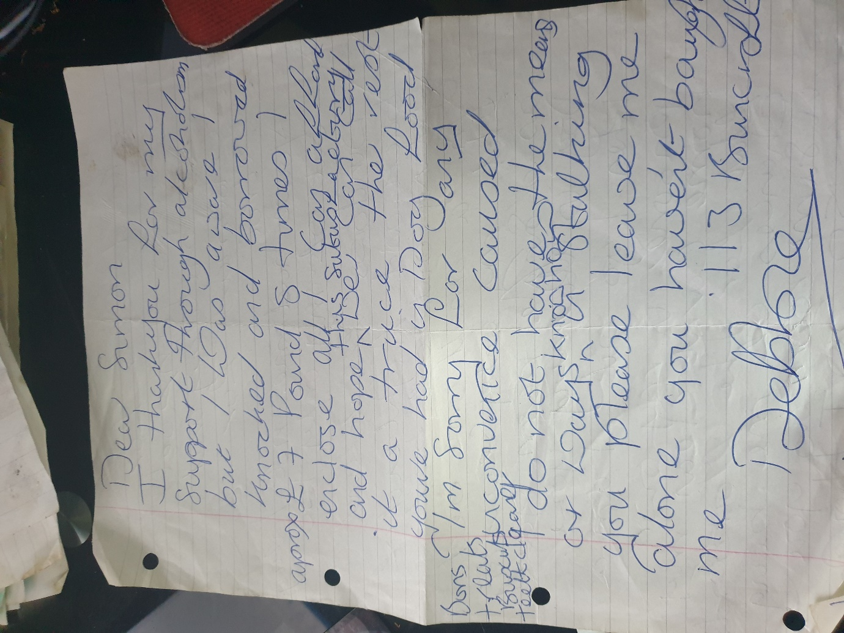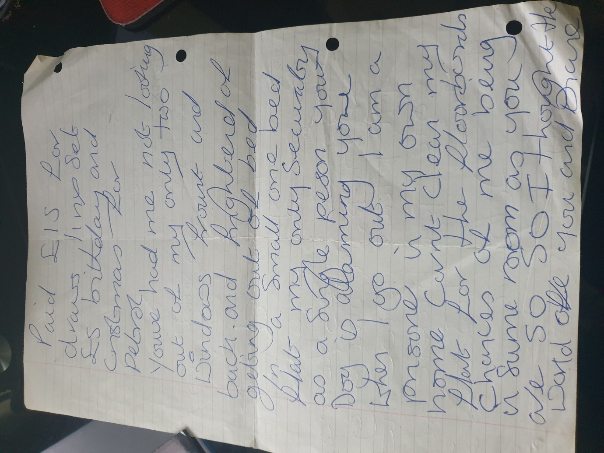  07/06/2013 Debbie wrote me a letter!  12/06/2013 I received another letter off Debbie today!  17/06/2013 Debbie kept on writing me letters!  20/06/2013 Debbie kept writing me letters!  22/06/2013 Debbie kept writing me letters!  24/06/2013 Debbie kept writing me letters I have them all in my position still to date!  28/06/2013 Another letter wrote to me from Debbie!  16/07/2013 I then found another letter of Debra Andrews that got posted through my letterbox of my front door!
INFO | Statement Exhibit BB0 – 1 / 00/00/2012:  - O
 | - Responsible Doctors  - The reason that we have adduced this exhibit into these proceedings is because | 19/03/2015 | Evidence: Exhibit 1 / 19/03/2015:  The Enfield Gov / Email’s Issue:  523. Lorraine Cordell _Re_ Can you please help  / Page Numbers: 1910,  1x Email Dawn Allen First Email complaint about my Neighbour’s!  19 March 2015 16:37  To: Dawn Allen  Subject: RE: Can you please help  Mr Simon Cordell Burncroft Ave  Enfield  Middlesex  EN3 7JQ  Dear Dawn Allen  - My son has had an issue with his neighbours who live above him, this has been going on a while and it is making my son's health go downhill he is not sleeping due to what is going on.  - We would like to put a report into the issue and therefore would it please be possible for you to make a date when you could come to my son's home to do this, if you can let me know via this email with dates this can get done so we can get this issue addressed as soon as possible I would be grateful.  Regards  Mother  Simon Cordell
INFO | Statement Exhibit 1 / 19/03/2015:  - On the 19/03/2015 the 1st email got sent by the Now Claimants Mother to Dawn Allan who works or worked for thew Enfield Council.  - Dawn Alan is or was the Now Claimants Tenancy Manager and based at the Neighbourhood watch department at Edmonton Green.  - The Emails that got sent to Dawn Allen she never replied to, and this occurred no matter how high their importance and this left the Now Claimant to get attacked by mutable Members of his Neighbours.  - Logic says that by two people complaining that the same thing is happening that the likelihood of it being the truth is remarkably high.  - Likelihood also proves that it would be very unlikely that by two different people saying the same thing is happening or happened, as they have both witnessed the incident or both been subjected to the incident would prove that their complaint it is not a Mental Health Issue.  - Dawn Allen cannot say that she never received the Emails because eventually she answered to the Now Claimant and his mother from the same email address, but Dawn Alan only done this when she thought that she had something negative about the Now Claimant and that it would be him that was in trouble.  - The Email sent by the Now claimant’s mother raised issues such as: - “  - My son has had an issue with his neighbours  Time Duration: - “this has been going on a while”  Inhuman Effect: - “it is making my son's health go downhill he is not sleeping due to what is going on”  Breach Of the Procedure: - “We would like to put a report into the issue.”  Meeting Arranged: – “therefore would it please be possible for you to make a date when you could come to my son's home to do this.” “If you can let me know via this email with dates this can get done so we can get this issue addressed as soon as possible”  - There was no reply to Evidence Exhibit: 1 / 19/03/2015: (RE: Can you please help.)
 | - Asbo  - The reason that we have adduced this exhibit into these proceedings is because | 20/03/2015 | Evidence: Exhibit 1 / 20/03/2015:  - 15 FW RE FOI 06/03/2015 13:42 1008  - The Enfield Gov / Email’s Issue: 02  FW RE FOI  / Page Numbers: 1800,1801,1802,1803,  From: Lorraine Cordell  To: "Micheal McKee"  Cc: "JOSEPHINE WARD"  Subject: FW: RE FOI 11845 [SEC=UNCLASSIFIED]  Date: 06 March 2015 13:42:00  From: Ned Johnson [Mail To: Ned.Johnson@enfield.gov.uk]  Sent: 05 March 2015 16:39  To: lorraine32@blueyonder.co.uk  Cc: Esg Complaints  Subject: RE FOI 11845 [SEC=UNCLASSIFIED]  Classification: UNCLASSIFIED  Dear Ms Cordell,  FREEDOM OF INFORMATION ACT 2000 - INFORMATION REQUEST  Thank you for your email received on February 10th, 2015, where you requested information regarding illegal raves/parties. In response to your questions:  All dates and times and addresses to any illegal rave/parties where the Noise and Nuisance Team attended:  8/6/14, no time recorded, Progress Way, Enfield.  Any paperwork was served to any person/persons and if need known. copies of any paperwork served:  No paperwork served.  All the calls that were made on any dates to the Noise and Nuisance Team to make them aware that illegal rave/parties were taking place: -  - Progress Way:  - 13/6/14: 1 call  - 12/6/14: 2 calls after event  - 09/6/14: 2 calls after event  - 08/6/14: 6 calls  - 07/6/14: 8 calls  - Leeside Road:  - 15/7/13: 1 call after event  - 46 Crown Road:  - 18/5/14: 3 calls after event  - 19/5/14: 6 calls after event  - 21/5/14: 1 call after event  - 31/5/14: 2 calls  - 01/6/14: 6 calls  - 02/6/14: 4 calls after event  - 04/6/14: 1 call after event  - 06/6/14: 1 call  - 08/6/14: 3 calls  - 09/6/14: 1 call after event  - 13/6/14: 2 calls  --  Any noise abatement orders that was put on any addresses where an illegal rave/party was taking place.  This would include any noise abatement that were put in place before an illegal rave/parties took place.  This would include dates and times the noise abatement, orders were served on an address and to whom and to forward copies of any such noise abatement orders within this request: No noise abatement notices served.  Personal names who attended the address and times and dates of any person attending from the Noise and Nuisance Team and any police officer names or IDs that attended with the Noise and Nuisance Team:  Progress way: 2 Enforcement Officers attended form the Out of Hours Noise Team, 08/6/2014, no times noted.  Any reports made up for any of the addresses in full for the dates listed above for any illegal rave/parties. No reports made.  If you are dissatisfied with the handling of your request, you have the right to ask for an internal review.  Internal review requests should be submitted within two months of the date of receipt of the response to your original letter and should be addressed to:  Theresa Dodd  Correspondence & Complaints Manager  Environment & Street Scene Department  PO Box 52  Civic Centre  Silver Street  Enfield EN1 3XE  020 8379 3540  Email – theresa.dodd@enfield.gov.uk  Please remember to quote the reference number above in any future communications. If you are not content with the outcome of the internal review, you have the right to apply  1802,1803,  - 16 FW RE FOI 06/03/2015 15:36 1008  - 17 FW RE FOI 06/03/2015 17:16 1008
INFO | Statement Exhibit 1 / 20/03/2015:  - Mother and I were contacting the Enfield Council about the ongoing ASBO case that I was dealing with since the 12/09/2014 that the met police along with Enfield Council had submitted to the court,  - I had been subjected to an interim order on the 05/11/2014 by the court, which breached my Human Rights and was unlawful.  - Enfield Council state they were not involved in the ASBO case but if they were not involved why is Enfield Council name on the ASBO files which were in front of the court why are there statements from Enfield Council in the ASBO files which can be proven.  - There are reasons I was never helped by Enfield Council with the issues with the neighbours the above is one of them.  46 Crown Road:  - 18/5/14: 3 calls after event  - 19/5/14: 6 calls after event  - 21/5/14: 1 call after event  - 31/5/14: 2 calls  - 01/6/14: 6 calls  - 02/6/14: 4 calls after event  - 04/6/14: 1 call after event  - 06/6/14: 1 call  - 08/6/14: 3 calls  - 09/6/14: 1 call after event  - 13/6/14: 2 calls
 | - Enfield Council Dawn Allen & Co About Debra Andrews  - The reason that we have adduced this exhibit into these proceedings is because | 31/03/2015 | Evidence: Exhibit 1 / 31/03/2015:  The Enfield Gov / Email’s Issue:  533. Lorraine Cordell _Re_ Issue I am having  / Page Numbers: 1958,  From: Lorraine Cordell  lorraine32@blueyonder.co.uk  Sent: 31 March 2015 15:34  To: Dawn Allen  Subject: RE: Issue I am having  Mr Simon Cordell  109 Burncroft Ave  Enfield  Middlesex  EN3 7JQ  Dear Dawn Allen,  - I am writing this email due to not having a reply to my email dated 19/03/2015 I am having a great deal of problems with my neighbours who live above me, they are not letting me sleep and this is having an effect on my health I have asked before if someone could come and speak to me to address these problems and no one has.  - I and my mother have made phone calls about the neighbours above my flat, yet nothing is being done.  - Please can you get back to me as soon as possible in order to setup a meeting at my home so we can address the issues with the neighbours as soon as possible as I cannot live the way I am any longer.  - There are also still issues with repairs that have not been addressed.  Regards  Simon Cordell  Lorraine Cordell
INFO | Statement Exhibit 1 / 31/03/2015:  - On the 31/03/2015 a second email got sent to Dawn Allan by the Now Claimants mother about flat repairs and neighbours no reply to this email (RE: Issue I am having) Email name.  - A total of 12 days passed by and without a reply to the Now Claimants and his mother’s request for emergency help of the Enfield Council and their neighbourhood watch teams. Members of the Now Claimants neighbours were left to brutally attacking him due to this failure.
 | - Enfield Council Dawn Allen & Co About Debra Andrews  - The reason that we have adduced this exhibit into these proceedings is because | 11/04/2015  Till the  17/04/2015 | Evidence: Exhibit 1 / 11/04/2015:  I was still being victimised by the already mentioned: --  - On the 11th of April, a 24-hour assault of cruel inhuman treatment took place against me because I was still being victimised by the already mentioned.  - Stan Curtis and Debra Andrews with the Mathiyalagan family had been left to breach my human rights on a day to day and night to night basis this was while Stain and Debra were always both drunk together, this got done to an extent off an attempted manslaughter charge that would be in accordance to section 18 of that Act and also includes proof of their intent and purpose such as 1. Cruel Inhuman treatment. 2. sport and fun.  - I know this as I had rapidly, told them all involved that I had not been tricked by their evil banging on the floorboards and walls, even with or without foreign objects being used at separate times by them; on numerous instances this contained the use of their feet and hands inclusive of other objects and fixtures.  - Together they would work in collaboration to maintain a 24-hour assault on myself to get overseen and managed, I continued to defend myself even more and with any extra time of peace that I got given I read into the Anti-Social Behaviour Order Case files I noticed, that these people that created the application were not good police officer’s, they were criminals.  - I needed to safeguard myself from their actions and after contemplating on what would be the best way forward for me and anyone involved, I called the Metropolitan police 999 call centre again to ask for more advice and security and this is a copy of that conversation that got recorded then transcribed.  Evidence: Exhibit 2 / 17/04/2015:  Tape recording two Z0000011: --  Intro: Welcome to the Metropolitan police introduction: --  - Police Officer: Hello, police officer, what is the reason for calling us.  - Simon: hello I would like to put a complaint in, and I was just wondering if you could help me do this, please.  - Police Officer; yes, is it a complaint against police?  - Simon: yes, that is correct.  - Police Officer: yes, I can take the complaint.  - Simon: I would like to; can you forward an email to Jane Johnson please?  - Police Officer; Jane Johnson.  - Simon; yes, superintendent for Edmonton police station the commissioner.  - Police Officer; let me just have a look, just one second.  - Police Officer; Jane Johnson yep supper chief superintendent  - Simon: yes, that is correct.  - Police Officer: yes, that is ok, is this complaint that has already got made or is it that you need to make a first one?  - Simon: this is just a fresh email to herself it is more of a request than a complaint at the  - present time but it may turn into an official complaint depending on how she decides to discipline her officers that she represents.  - Police Officer; ok.  - Police Officer: and that is too Jane Johnson ok go ahead with the continence and I will get the email sent to you.  - Simon: my name is a Mr Simon Paul Cordell.  - Police Officer; Paul Cordell  - Police Officer; Cordell  - Simon: yes, that is correct madam.  - Simon; and.  - Police Officer; and your contact number 0208-245.  - Simon: yes, that is correct.  - Police Officer; right go ahead.  - Simon; and the issue is of concern is that I have her signature at the bottom of an Asbo Order a standalone Asbo Order and there has been a lot of corruption represented in side of it, that she has instructed, a Steve Elsmore too complete an application for an Anti-Social Behaviour Order for the organisation of illegal raves and in that application there are lots of police corruption and foul play where the evidence has gotten manufactured, now I am asking her to oversee her officers that she has instructed to make such an application and then to cheek the time stamps relating to the Cad’s and to check the Urn numbers that run consecutively, over an annual year period when they should not, I am asking her to oversee this and to inform me of my case being manufactured and for this it will get dropped or I am calling her, herself to the court as a witness and I will investigate myself against her also for her actions and decisions.  - Police Officer; OK.  - Simon; to what is allowed to happen, she is basically, the boss of all the police and she is charge of Steve Elsmore, she has told Steve Elsmore to create an application and either she told Steve Elsmore to manufacture the application in such a way and or to falsify information contained within it or she does not know that Steve Elsmore has done that and I would like her to know that Stave has done that and I would like her to decide to whether she is going to suspended him right now and give the case to somebody else to handle or what she will do and I would like her to contact me back at Re_wired@ymail.com as soon as practically, possible.  - Simon: I know I was going fast, but did you manage to get the full gist of what I am explaining to you, madam.  - Police Officer: yes, I got the jest I made the points for you.  - Simon: so, she will contact me back at Re_wired@ymail.com as soon as practically, possible regarding how she will represent this case, because at the present time I am being held captive within my own home because she is not doing her job correctly.  - Simon; I have handed in an article six twice now sine this case started in the courts with a complete copy, if she would like to get a copy of the court case she can and contained within this is a copy of the Article six with all the drafted corruption inside it and also, I have handed in three complaints, three official complaints that get issued in the police PNC computer this will also show this information.  - Police Officer; OK.  - Simon: and if she would like to hold a meeting with me, I would be happy to come to the police station and show her the evidence I have.  - Simon: either she is a part of the corruption, or she is separate from the corruption and  - for her to be separate she must do her job correctly, and this must mean that I am not being held captive in my own home.  - Police Officer; ok.  - Simon: to laws that do not even exist.  - Police Officer; right ok.  - Police Officer: what I will do for you right now Simon is getting this email sent over to her right now, please can you confirm your email address again Re_wired@ymail.com.  - Simon; thank you.  - Police Officer; ok good buy.  - Simon: you have a good day.  Evidence: Exhibit 3 / 17/04/2015:  The banging Started!  - Debbie Andrews (responsible)  - Stain Curtis (responsible)  - Mathiyalagan (Responsible)  Time: All-Day and All-Night whenever they knew that I was indoors!  - I tried to defend myself from them attacking me in a dignified manner with no submission towards justice getting accomplished!  - The Enfield Council and the Enfield Homes employees aloud the occupiers of 117 and 113 and 111 Continued to victimize me by: --  - 117 Burncroft Avenue and 113 keep on continually, reiterating to flushing the toilet when I am in the bathtub!  - Eavesdropping, / Heedfully aurally perceiving where I am in my abode and then chasing me around into each room as listed, while banging on the floor with objects!  - 113 and 117 woke me up by assailing me intentionally by stamping and dropping articles above my head in my front room and all other living rooms!  - Slamming the main, communal ingress door closed!  - Victimizing me with intent of utilizing the same reiterated items of the building fixtures to have tortures effects on me within my rented habitation is inequitable living circumstances!  Evidence: Exhibit 4 / 17/04/2015:  Disrepair!  - I stay in the freezing conditions within my home because all of the complaints I make get pushed aside after I report them to the Enfield council employed staff!  Evidence: Exhibit 5 / 17/04/2015:  Time Spent Building.  - In the background of everything going I continued creating a new and up to date event Electrical Systems Policy and I continued to Study and finish at the Time Start: 07:00 Am and Time End: 03:30 Pm!  - My mother also continues to build my company website for me with others at the Time Start: 09:00 and Time End: 14:00!  Evidence: Exhibit 6 / 17/04/2015:  Working at Home doing Court Case Defence Work!  - “I spent time and resources costing expenditure with my mother also building my defence case, against the allegations getting put against me at the Time Start: 12:00 Am and Time End: 06:00 Am!”
INFO | Statement Exhibit 1 / 11/04/2015:  - On the 11/04/2015 is an exhibit taken from the Now Claimants diary.  - The Now Claimant explained to Members of the Enfield Council and Metropolitan Police Force that an incident report form that he had been given by them to complete was not designed to manage more than a couple of words and that he had followed their advice due to this fact and continued to document incidents down on a bit of paper but no member of staff would since accept the incident logs or have a meeting with him in regards to the issues raised with it.  - The Evidence Exhibit: 1 / 11/04/2015: would have clearly show the Official staff the torture the Now Claimant was continually being put through by members of his neighbour’s aloe he did say they were committing an attempted manslaughter charge when he should have said an attempted murder charge.  - The Now Claimant also explained that his neighbours were taking out Cruel & Inhuman treatment against him while explain that this was done to him by those involved as if it were a sport for them to have fun, but yet the Government authorities refused to act in accordance with the law and even with his mother saying the same.  - Neighbours of the Now Claimant were left evilly banging on the floorboards and walls, and even with objects at him and no arrests of interviews took place in respect of these matter.  Statement Exhibit 2 / 11/04/2015:  - On the 17/04/2015  Is a Tape recording to the Metropolitan police Services  Statement Exhibit 3 / 11/04/2015:  - On the 17/04/2015  Diary Exhibit of the banging at the Now Claimant  Statement Exhibit 4 / 11/04/2015:  - On the 17/04/2015  Disrepair!  Statement Exhibit 5 / 11/04/2015:  - On the 17/04/2015  Time Spent Building.  Statement Exhibit 6 / 11/04/2015:  - On the 17/04/2015  Working at Home doing Court Case Defence Work!
 | - Enfield Council Dawn Allen & Co About Debra Andrews  - The reason that we have adduced this exhibit into these proceedings is because | 17/04/2015 | Evidence: Exhibit 1 / 17/04/2015:  The Enfield Gov / Email’s Issue:  546. x2 Lorraine Cordell _Fwd._ Issue I am having  / Page Numbers: 2014,  From: Lorraine Cordell [lorraine32@blueyonder.co.uk]  Sent: 17th April 2015 17:57  To: Dawn Allen  Subject: FW: Issue I am having  Dear Dawn Allen  - “I still have not had a reply to the below email please can you get back to me via this email address my son is really suffering due to what the neighbours are doing.”  - “A report needs to be made as this is making my son's health go downhill, he is not being able to sleep due to what is going on and other things. Please can you get back to me?”  Regards  Lorraine Cordell
INFO | Statement Exhibit 1 / 17/04/2015:  - On the 17/04/2015 The 3rd email got sent to Dawn Allan by my mother about flat repairs and neighbours due to no reply to past emails and the exhibited email as **** also did not get replied to headed as (FW: Issue I am having.)  The First Email sent about Neighbours asking for protection from being victimised was sent on the 19/03/2015 and the Second Email was 31/03/2015.  = 14 days March  = 17 days April  Totalling a total of: -  31 Days  son is really suffering due to what the neighbours are doing.”  A report needs to be made as this is making my son's health go downhill  he is not being able to sleep due to what is going on and other things.  Please can you get back to me?”
 | - Enfield Council Dawn Allen & Co About Debra Andrews  - The reason that we have adduced this exhibit into these proceedings is because | 04/05/2015 | Evidence: Exhibit 1 / 04/05/2015:  The Enfield Gov / Email’s Issue:  550. x2 Lorraine Cordell _Re_ Issue I am having with neighbours  / Page Numbers: 2031,  04th May 2015 13:22  Sent: To: Dawn Allen  Subject: RE: Issue I am having with neighbours  Mr Simon Cordell  Burncroft Ave  Enfield  Middlesex  EN3 7JQ  Dear Dawn Allen  - I have been sending you so many emails, yet I am getting no reply nothing is being done,  - my son is having so many issues with the neighbours he has asked for help, yet nothing is being done.  - My son went up to the neighbours and asked if they would please stop banging all the time,  - and about the water issues with the pipes banging, very, badly, in his flat, but they are still doing it and will not stop,  - people who also have been in my son's flat have also heard what is going on, and they are even saying they do not know how he is coping with this.  - On the top floor, they have wooden flooring this does not help and can something please get done.  - lady that lives at 113 is also causing a great deal of problems and she keeps coming to my front door asking for money to buy a drink, she is also banging very, badly, and  - my son's health is suffering due to this,  - I do not know why you have not replied to my emails and are just leaving things when we are asking for help,  - you are the council officer for my son's area please can this get addressed.  Regards
INFO | Statement Exhibit 1 / 04/05/2015:  - On the 04/05/2015 The 4th email got sent to Dawn Allan by my mother about flat repairs and neighbours no reply to this email (RE: Issue I am having with neighbours) Email name.  = 14 days March  = 30 days April  = 4 Days May  Totalling a total of: -  48 Days
 | - Enfield Council Dawn Allen & Co About Debra Andrews  - The reason that we have adduced this exhibit into these proceedings is because | 28/05/2015 | Evidence: Exhibit 1 / 28/05/2015:  The Enfield Gov / Email’s Issue: 02  FW Issue I am having with neighbours  / Page Numbers: 2045,  28 May 2015 15:16  Sent: To: Dawn Allen  Subject: FW: Issue I am having with neighbours.  Dear Dawn Allen  - “Could you please reply to all my emails as too, what can get done with the issues that is going on, you have not replied to one email, and this is not fair.”  - “I don’t know what is going on and why my son is being treated like this by Enfield Council is it due to what the police did to him?”  Regards
INFO | Statement Exhibit 1 / 28/05/2015:  - On the 28/05/2015 The 5th email got sent to Dawn Allan by my mother about flat repairs and neighbours no reply to this email (FW: Issue I am having with neighbours) Email name.  = 14 days March  = 30 days April  = 28 Days May  Totalling a total of: -  72 Days
 | - Enfield Council Dawn Allen & Co About Debra Andrews  - The reason that we have adduced this exhibit into these proceedings is because | 01/06/2015 | Evidence: Exhibit 1 / 01/06/2015:  The Enfield Gov / Email’s Issue:  561. Lorraine Cordell _Fwd._ Issue I am having with neighbours_ (2)  / Page Numbers: 2048,2049,  From: Mother [Mother!32@blueyonder.co.uk]  Sent: 01/06/2015 - 14:38  To: Dawn Allen  Subject: FW: Issue I am having with neighbours  Dear Dawn Allen  Complain  - I have sent a number of emails regarding the issues my son is having with his neighbours, which you have failed to reply to and have not addressed the issues which has been ongoing.  - I have given you enough time to reply and address the issues, yet you have failed to do anything.  2049,  - I would like it looked into why you do not reply to my emails.  - I would like it looked into why you have done nothing in regard to the issues that having been ongoing for son for some time and have done nothing.  - I would like it looked into why you have allowed a person to suffer and have not done anything about it.  - I would like a reply to this co1nplaint and if you cannot deal with this, please pass it over to a person that can.  - I would like a reply to this co1nplaint and if you cannot deal with this, please pass it over to a person that can.  Mother
INFO | Statement Exhibit 1 / 01/06/2015:  - On the 01/06/2015 Issue I am having with neighbours  = 14 days March  = 30 days April  = 31 Days May  = 01 Days June  Totalling a total of: -  76 Days
 | - Enfield Council Dawn Allen & Co About Debra Andrews  - The reason that we have adduced this exhibit into these proceedings is because | 10/06/2015 | Evidence: Exhibit 1 / 01/06/2015:  The Enfield Gov / Email’s Issue: 02  RE Please Can You Help This Cannot Carry On!  Page Number: 2063,  From: Mother [Mail To: Mother!32@blueyonder.co.uk]  Sent: 10/06/2015 - 21: 13  To: Dawn Allen  Subject: RE: Please Can You Help This Cannot Carry On!  Mr Simon Cordell  109 Burncroft Ave  Enfield  Middlesex  EN3 7JQ  Dear Dawn Allen  - I do not understand why all my phone calls and emails are not getting addressed.  - I have really tried and so has my son.  - we have been making calls all the time to try and get something done and I have sent a lot of emails including a complaint email dated 01/07/2015.  - I still have had no reply to my son and also, I have tried to talk to the neighbours which have done nothing they still keep on.  - My son health is st1ffering due to what has been ongoing for a long time.  - We have tried to get help from the council as if the council speaks to them maybe they will stop what they are doing.  - I also went to 117 but they were not at home so did not speak to them about the issues.  - I went to Debbie at 113 to try and talk to her but she just started to shout at me through the door.  - I did try and say to her through the door could she let me speak but she was just screaming at me so I went back down to my son flat the banging is unbelievably bad and you can clearly hear they are doing this is not just so1neone living their life as no1mal people would.  - You can even hear her following my son around in his flat banging; he does not even want to take a bath because he can hear her above him banging on the floor.  - Yet she still keeps coming down to my son door asking him for money to buy drinks my son has told her could she please leave him alone and stop coming to his door and to please stop following him around and banging on the floor and pipes, but this has not helped she just acts like nothing is going on.  - Debbie has now started to go to my other neighbours at 111 and they are drinking and now 111 is also banging.  - I do not know if it is due to Debbie liking my son and when he and his partner ended in Mid-2013.  - “She was hoping something would come of this, as this is the time when she started to come to my son flat door a lot more.”  - when my son was with his partner, she used to co1ne to his door maybe once a week for money but after they ended, she was coming down more and more she even was trying to give my son drink, he does not drink so would not accept it.  - She was also writing my son letters and putting them through his door, the letters are not really readable.  - The main problem with Debbie seemed to start when she came to 1ny son's front door and saw a girl in his flat she saw the girl on more than once and this upset her.  - Since this time things have got worse and worse, and my son's health is really suffering.  - Please cam something be done as we really do not know what to do any longer, if you cannot do anything about the neighbours in the block can you please see if you can move my son as he cannot take any 1nore, he needs to be able to rest and sleep which at this time it is impossible, this is unfair what is going on to my son's health. Please can you reply to this email as you have not done to any of my other emails or calls or the calls my son has made regarding this issue which I do not understand why.  Regards  Mother
INFO | Statement Exhibit 1 / 10/06/2015:  - On the 10/06/2015 RE Please can you help this cannot carry on  - Demonstrates how the Enfield  = 14 days March  = 30 days April  = 31 Days May  = 10 Days June  Totalling a total of: -  85 Days
 | - Enfield Council Dawn Allen & Co About Debra Andrews  - The reason that we have adduced this exhibit into these proceedings is because | 20/06/2015 | Evidence: Exhibit 1 / 20/06/2015:  The Enfield Gov / Email’s Issue: 02  FW Issue I am having with neighbours  / Page Numbers: 2067,2068,  20th June 2015 19:12  Sent: To: Dawn Allen  Subject: FW: Issue I am having with neighbours  Dear Dawn Allen  - “Seeing as you are not addressing the emails that are being sent, I have no option but to take this higher.”  Regards  Mother  Evidence: Exhibit 2 / 20/06/2015:  The banging Started!  - Debbie Andrews (responsible)  - Stain Curtis (responsible)  - Mathiyalagan (Responsible)  Time: All Morning: -- Mid-Day: -- In the Evening and of the Night!  - The Enfield Council and the Enfield Homes employees aloud the occupiers of 117 and 113 and 111 Continued to victimize me by: --  - 117 Burncroft Avenue and 113 keep on continually, repeating to flushing the toilet when I am in the bathtub!  - And follow me to the toilet when I am being sick and start banging above my head  - Debbie bangs when she is drunk with the occupiers of 117 the Mathiyalagan family and also Stain Curtis off 111 Burncroft Avenue and continue to Slam the water tap on and off, causing damage to my health and the buildings fixtures at an unacceptable rate!  - Stain playing with pots or pans on his kitchen wall like the devil that has surmounted his sole I cannot believe that I had so much love for him, and reverence and he treats me this way in my life and my dotted ones!  - The occupiers of 117 keep on assailing me and then Slamming their own living room, door closed repentantly!  - Debra when drunk 113 and Mathiyalagan 117 keep slamming the dihydrogen monoxide tap on and off at an unacceptable rate, while stain 111 additionally joins in from his flats kitchen dihydrogen monoxide supply to daunt me into moving home and this is causing earnest damage to my health, while everyone else on the estate can auricularly discern and does nothing to forfend me from them!
INFO | Statement Exhibit 1 / 20/06/2015:  - On the 20/06/2015 The 6th email got sent to Dawn Allan by my mother about flat repairs and neighbours no reply to this email (FW: Issue I am having with neighbours) Email name.  = 14 days March  = 30 days April  = 31 Days May  = 20 Days June  Totalling a total of: -  95 Days  Statement Exhibit 2 / 20/06/2015:  - On the 20/06/2015 The
 | - Enfield Council Dawn Allen & Co About Debra Andrews  - The reason that we have adduced this exhibit into these proceedings is because | 01/07/2015 | Evidence: Exhibit 1 / 01/07/2015:  The funfair being present: --  - July 2014 is around the time of the funfair being present in the local park attached to our housing estate, date.  - I had gotten locked in my flat wrongly, for one year for the gazebo case and an additional six months for the interim order by this stage of my life and thought that time I got assaulted by my neighbours, Stain Debra and the Mathiyalagan Markandu and friends, they together mentioned had been banging so loud at me, that it seemed as if in they were trying to get other involved who live on my estate, by way of making them believe that they were better than me and that I am the worst of society.  - Luckily, other people than the ones already involved on my estate did not get involved neither did their loved ones, so when the funfair arrived in the local park ajar from our housing estate it seemed as if in, they would bang louder hoping for them to get involved by coming to my home address, I believe that it is lucky that this did not happen, I had prevented any bad misfortunes from happening and brought the welder for my security gate and then reinstated the gate commission of use.  Evidence: Exhibit 2 / 01/07/2015:  1 x Email!  Sent: 01 July 2015 14:38  To: Dawn Allen  Subject: FW: Issue I am having with neighbours  Dear Dawn Allen  Complaint: --  - I sent a number of emails regarding the issues my son's is having with his neighbours, which you failed to reply to and have not addressed the issues which has been ongoing.  - I have given you enough time to reply and address the issues, yet you have failed to do anything,  - I would like it looked into why you do not reply to my emails.  - I would like it to look into why you done nothing regarding the issues that having been ongoing for some time and have done nothing.  - I would like it to look into why you allowed a person to suffer and done nothing about it,  - I would like a reply to this complaint and if you cannot deal with this, please pass it over to a person who can.  Regards Simon’s Mother
INFO | Statement Exhibit 1 / 01/07/2015:  - On the 01/07/2015 The 7th email mum got sent to Dawn Allan by my mother about flat repairs and neighbours no reply to this email (FW: Issue I am having with neighbours) Email name.  Statement Exhibit 2 / 01/07/2015:  - On the 01/07/2015  = 14 days March  = 30 days April  = 31 Days May  = 30 Days June  = 01 Days July  Totalling a total of: -  105 Days
 | - Enfield Council Dawn Allen & Co About Debra Andrews  - The reason that we have adduced this exhibit into these proceedings is because | 10/07/2015 | Evidence: Exhibit 1 / 10/07/2015:  The Enfield Gov / Email’s Issue: 02  RE “Please Can You Help This Cannot Carry On”  / Page Numbers: 2069,  10th July 2015 21:13  Sent to: Dawn Allen  Subject: RE: “Please can you help this cannot carry on Mr Simon Cordell”  Burncroft Ave  Enfield Middlesex  EN3 7JQ  Dear Dawn Allen  - I do not understand why all my phone calls and emails are not getting addressed, I tried and so has my son, we have been making calls all the time to get something done and I have sent a lot of emails including a complaint email dated 01/07/2015 which I still have had no reply to my son and I also tried to talk to the neighbours which have done nothing they still keep on.  - My son health is suffering due to what has been ongoing for a long time. We tried to get help from the council as if the council speaks to them, maybe they will stop what they are doing,  - I also attended to 117 but I believe they were not at home so did not speak to them about the issues.  - I attended to Debbie at 113 to talk to her, but she shouted at me through the door. I tried to say to her through the door could she let me speak, but she was just screaming at me so I went back down to my son flat the banging is terrible and you can clearly hear they are doing this is not just someone living their life as normal people would.  - You can even hear her following my son around in his flat banging;  - If he does not even want to take a bath because he can hear her above, him banging on the floor.  - Yet she still keeps coming down to my son door asking him for money to buy drinks my son has told her could she please leave him alone and stop coming to his door and to please stop following him around and banging on the floor and pipes, but this has not helped she acts like nothing is going on.  - Debbie has now gone to my other neighbours at 111 and they are drinking and now 111 is also banging.  - I do not know if it is due to Debbie liking my son and when he and his partner ended in Mid-2013 she was hoping something would come of this as she came to my son’s flat door a lot more. when my son was with his partner, she used to come to his door maybe once a week for money, but after they ended, she was coming down more and more she even was trying to give my son drink, he does not drink so would not accept it.  - She was also writing my son letters and putting them through his door, the letters are not readable.  - The main problem with Debbie seemed to start when she came to my son's front door and saw a girl in his flat, she saw the girl on more than once and this upset her. Since this time things got worse and worse, and my son's health is suffering.  - Please cam something gets done as we really, do not know what to do any longer, if you can do nothing about the neighbours in the block can you please see if you can move my son as he cannot take any more, he needs to rest and sleep which is impossible, this is unfair what is going on to my son's health.  - Please can you reply to this email as you have not done to any of my other emails or calls or the calls my son has made regarding this issue which I do not understand why.  Regards
INFO | Statement Exhibit 1 / 10/07/2015:  - On the 10/07/2015 The 8th email got sent to Dawn Allan by my mother about flat repairs and neighbours no reply to this email (RE: Please can you help this cannot carry on) email name.  = 14 days March  = 30 days April  = 31 Days May  = 30 Days June  = 10 Days July  Totalling a total of: -  114 Days
 | - Asbo  - The reason that we have adduced this exhibit into these proceedings is because | 03/08/2015 | Evidence: Exhibit 1 / 03/08/2015:  7 Out of 20 of 20 court dates the 7 of 7 appearance towards the 1st Asbo got held at Highbury Court and the judges was  Date: 03/08/2015 & 04/08/2015  Defendants Name: Mr Simon Cordell  Case Handler: Ms Sally Gilchrist Legal Executive Director Met Police and she was Present!  Court House: Highbury Corner Magistrates  Reason: Mention Hearing  Case Number: 1402490741  Judges Name: Defendant Judge Pigot  Contra’s Name: Robert Talalay  My Barrister Name: Mr. Andrew Locke  Note 1: (Full Hearing)  Note 2:
INFO | Statement Exhibit 1 / 03/08/2015:  - On the 03/08/2015 This is the Day at Court for the trial of the Anti-Social Behaviour Order Case and the Verdict got made Guilty against me on the 04/08/2015, Spelling Mistakes.  - On the 03 & 04/08/2015 at the Highbury Corner Court the Asbo trial case, got said to be part proven on the 04th 08/2015.  - On this date of trial, I never got found guilty in my opinion, and others, such as my mother and barrister under true and fair Acts of law under the grounds of the application that the prosecution had brought into motion, but somehow, I seemed to have received a punishment, so I travelled home and looked into the case files even more than I had beforehand as I knew that I had not committed the crimes that I was being accused of.  - I noticed the following to be wrong and in clear error: -  - They got all the law’s and do not use them right: -  - I had noticed the governing officials as explained thought growing up, but this finally, became a growing concern when reading the Anti-Social Behaviour Order application that got said to get served on me under the law, to which I disputed from the start of the proceedings, at first, in the Anti-Social Behaviour Order case I had not noticed a lot of fraudulent inconsistencies contained, in its folder, right until I had noticed the time stamps were in error and this was because I understood that I had never committed the crimes or public offence I was being questioned and accused of on the days that the police brought proceedings in motion towards.
 | - Asbo  - The reason that we have adduced this exhibit into these proceedings is because | 04/08/2015 | Evidence: Exhibit 3 / 04/08/2015:  The 1st Injunction Order / Lemmy / pub Book Issue: one!  D + E + F + G: Lemmy Statement 1st Injunction order /  Page Numbers: 105,106,107,108,109,110,111,112,113,114  105,  Simon Cordell’s  The 1st Injunction Order Dated: 00/00/2014  INDEX  “Not Relevant!”  106,  Simon Cordell’s  The 1st Injunction Order Dated: 00/00/2014  INDEX  5. The Defendant was I previously known to the Claimant and an anti-social behaviour order was made on  G.  04 August 2015  by the Magistrates Court to prevent him from knowingly using or supplying property personal or otherwise, for the use in a rave as defined in s.63(1) o: f the Criminal Justice Order Act 1994. The order· was made for a duration of 5 years. A copy of the Order is at page 27 of the  exhibit bundle.  Evidence: Exhibit 4 / 04/08/2015:  LEMMYS, Index I received on the 25/06/2018  Claim form, application for an injunction and statements / New 2 Injunction / Indexed  / Page Numbers:  196,197,198,199,200,201,202,203,204,205,  206,207,208,209,210,211,212,213,214,215,  216,217,218,219,220,221,222,223,224,225,  226,227,228,229,230,231,232,233,234,235,  236,237,238,239,240,241,242,243,244,245,  246,247,248,249,250,251,252,253,254,255,  256,257,258,259,260.261,262,263,264,265,  266,267,268,269,270,271,272,273,274,275,  276,277,278,279,280,281,282,283,284,285,  286,287,288,289,290,291,292,293,294,295,  296,297,298,299,300,301,302.  --  219  07th day of August 2017  CLAIM NUMBER: D02EDO73  IN THE EDMONTON COUNTY COURT  BETWEEN:  {CLAIMANT}  THE MAYOR AND BURGESSES OF THE LONDON BOROUGH OF ENFIELD  -AND-  (DEFENDANT)  MR SIMON CORDELL  DIRECTIONS ORDER  Dated this 07th day of August 2017  220  Dated 07th August 2017  I have held this employment since August 2016  CLAIM NUMBER: D02EDO73  IN THE EDMONTON COUNTY COURT  BETWEEN:  {CLAIMANT}  THE MAYOR AND BURGESSES OF THE LONDON BOROUGH OF ENFIELD  -AND-  (DEFENDANT)  MR SIMON CORDELL  DIRECTIONS ORDER  - Made on behalf of the Claimant  - Witness Statement of Lemmy Nwabuisi  - Statement No. 1  - Exhibit No LN1  - Dated 7 August 2017  IN THE EDMONTON COUNTY COURT  CLAIM, NO:  BETWEEN:  THE MAYOR AND BURGESSES OF THE LONDON BOROUGH OF ENFIELD  Claimant  -and-  MR SIMON CORDELL  Defendant  WITNESS STATEMENT OF MR LEMMY NWABUISI  I, Mr Lemmy Nwabuisi, of PO BOX 50, Civic Centre, Enfield, EN1 3XA make this statement believing it to be true and understand that it may be placed before court.  As far as the content of this witness statement is within my own personal knowledge it is true and insofar as it is not within my personal knowledge it is true to the best of my knowledge.  I WILL SAY AS FOLLOWS  - I am employed by the London Borough of Enfield as an Anti-Social Behaviour Coordinator in the Community Safety Unit.  I have held this employment since August 2016. My role as an Anti-Social Coordinator consists of investigating and dealing with reports of anti-social behaviour involving council and non-council tenants. My involvement with the Defendant was due to allegations of verbal abuse, threats, harassment, and intimidation made against him by some of his neighbours.  221  14th August 2006  October 2016  05th October 2016  17th November 2016  04th August 2015  CLAIM NUMBER: D02EDO73  IN THE EDMONTON COUNTY COURT  BETWEEN:  {CLAIMANT}  THE MAYOR AND BURGESSES OF THE LONDON BOROUGH OF ENFIELD  -AND-  (DEFENDANT)  MR SIMON CORDELL  DIRECTIONS ORDER  The Defendant was previously known to the Claimant and an anti-social behaviour order was made on 4 August 2015 by the Magistrates Court to prevent him from knowingly using or supplying property, personal or otherwise, for the use in a rave as defined in s.63(1) of the Criminal Justice Order Act 1994. The order was made for a duration of 5 years. A copy of the Order is at page 27 of the exhibit bundle.  Evidence: Exhibit 5 / 04/08/2015:  LEMMYS, Index I received on the 25/06/2018  Claim form, application for an injunction and statements / New 2 Injunction / Indexed  / Page Numbers:  196,197,198,199,200,201,202,203,204,205,206,  207,208,209,210,211,212,213,214,215,216,217,  218,219,220,221,222,223,224,225,226,227,228,  229,230,231,232,233,234,235,236,237,238,239,  240,241,242,243,244,245,246,247,248,249,250,  251,252,253,254,255,256,257,258,259,260.261,  262,263,264,265,266,267,268,269,270,271,272,  273,274,275,276,277,278,279,280,281,282,283,  284,285,286,287,288,289,290,291,292,293,294,  295,296,297,298,299,300,301,302  256  07th October 2016  05th October 2016  17/11/2016  CLAIM NUMBER: D02EDO73  IN THE EDMONTON COUNTY COURT  BETWEEN:  {CLAIMANT}  THE MAYOR AND BURGESSES OF THE LONDON BOROUGH OF ENFIELD  -AND-  (DEFENDANT)  MR SIMON CORDELL  DIRECTIONS ORDER  CRIMINAL JUSTICE SYSTEM  Prosecution Team  Witness Care Unit Holborn 10 Lambs Conduit Street Holborn Police Station  London WC1N3NR  0208 247 7530 10am - 2pm Mon-Fri  7th October 2016  Dear Mr ****  Case Against Simon Cordell  Unique Reference Number 01YE0355816:  I am writing to confirm that you are required to attend court to give your evidence.  At the hearing on 5th October 2016 at Highbury Comer Magistrates Court, Simon Corded pleaded “not guilty" to the following offences:  - Use threatening / abusive / insulting words / behaviour with intent to cause fear to of / provoke unlawful violence  - Criminal damage-to property valued under £5000  The defendant Is on ball with the following conditions: not to contact you or attend your address and to reside at a designated address known to police. If you witness the defendant breaking these conditions, call 101 or in an emergency, 999 immediately.  A trial has been arranged to take place at HIGHBURY CORNER MAGISTRATES COURT at 13:30 p.m. on 17/11/2016.  On arrival, please make your way to WITNESS SERVICE and you wait in their suite which is separate from the public and read your statement. Please collect a blue victim form to claim any expenses of loss of earnings.  If you do not attend a WITNESS SUMMONS may be issued to enforce your attendance.  EN3 7JQ  i1venue  257  17/11/2016  CLAIM NUMBER: D02EDO73  IN THE EDMONTON COUNTY COURT  BETWEEN:  {CLAIMANT}  THE MAYOR AND BURGESSES OF THE LONDON BOROUGH OF ENFIELD  -AND-  (DEFENDANT)  MR SIMON CORDELL  DIRECTIONS ORDER  Please confirm if you wish for your contact details to be passed onto the Witness Service. They offer support to victims; and witnesses, on the day you attend court, and they can arrange for you to visit the court, before the day of the trial, so that you can have a look around. If you would like to visit the court, please contact the Witness Service ·on 0300 332 1000  “Thank you for your assistance as a witness, as giving evidence is very important and your help is greatly appreciated.”  Yours sincerely  Thomas Jones  Witness Care Officer.  - Please call WITNESS CARE to confirm that you will be attending.  - Please attend HIGHBURY CORNER MAGISTRATES court at 13:30 p.m. on 17/11/2016  - For further information about being a witness, visit: http://www.iustice.QOV.uk/victims-and-witnesses/workinQ-with-victims- witnesses  258  Date: 04th August 2015  Date: 04th August 2015  CLAIM NUMBER: D02EDO73  IN THE EDMONTON COUNTY COURT  BETWEEN:  {CLAIMANT}  THE MAYOR AND BURGESSES OF THE LONDON BOROUGH OF ENFIELD  -AND-  (DEFENDANT)  MR SIMON CORDELL  DIRECTIONS ORDER  Highbury Corner Magistrates' Court  Code 2572  North London Admin Centre POBOX52 N7 1AF  Telephone 020 7506 310  Fax 0870 739 5768  Mr Simon CORDELL 109 Bancroft Avenue Enfield Middlesex EN37JQ  Case number: 011402490741  Bom:  Anti-social behaviour order on application  Order  You must not  - Attended a rave as defined by s.63(1) of the Criminal Justice and Public Order Act 1994.  - Be concerned in the organisation of a rave as defined by s.63(1) of the Criminal Justice and Public Order Act 1994  - Knowingly using or supplying property, personal or otherwise, for the use in a rave as defined in s.63(1) of the Criminal Justice and Public Order Act 1994.  - Enter or remain in any dis/us/ed or abandoned building unless invited to do so in writing by a registered charitable organisation or Local Authority  - Enter or re man on non-residential private property on an industrial estate between the hours of 10pm and 7am Without written permission from the owner and/or leaseholder of the property; and  - Engage in any licensable activity in an unlicensed premise  - For the sake of clarity, nothing in this order prevents the Defendant from assisting, preparing for or engaging in licensed licensable activities  - This order lasts for 5 years.  Warning  - If you do not obey any part of this order, you will commit an offence and may be fined or sent to prison for up to five years.  - J. Vantyghem  - Date: 4 August 2015  - Justices' Clerk  - Mr Simon CORDELL  - 04 August 2015/ASBOJ6_0/1584095/1  Evidence: Exhibit 6 / 04/08/2015:  Stage 4  The Enfield Councils History FOI Indexed  Stage 4  Please reply to: Geoffrey Mann  Geoffrey Mann Neighbourhood Manager  Page Number: 27,28,29,30,  22/12/2016  27,  22nd December 2016  24th November 2016  24th November 2016  05th December 2016  08th December 2016  04th August 2015  18th November 2016  25th November 2016  29th November 2016  The Enfield Councils History  FOI Indexed  ENFIELD  Connected  Please reply to Geoffrey Mann  Ms Lorraine Cordell Sent via Email  E-mail: geoffrey.mann@enfield.gov.uk  My Ref: COM 1885  Your Ref:  Date: 22nd December 2016  Dear Ms Cordell,  Re: Mr Simon Cordell -109 Burncroft Avenue - COM 1885.  I write with reference to your letters of complaint dated 24th November 2016 copies of which were received via email on 24th November 2016, 5th December 2016, and 8th December 2016.  I will respond to the issues you raised as follows.  1. Anti-Social Behaviour Order  We are aware that the police applied for an Anti-Social Behaviour Order (ASBO) which was granted on 04th August 2015 against your son in relation to activities that cations away from Burncroft Avenue. We are aware that your son is appealing against the ASBO, and we are therefore unable to comment further.  EQUALITY  Environment  Enfield Council  Civic Centre, Silver Street  FRAMEWORK FOR LOCAL  GOVERNMENT  Enfield EN13XY  EXCELLENT  Website: www.enfield.gov.uk  28,  04th August 2015  20th August 2015  26th January 2016  04th August 2015  04th October 2016  14th August 2016  The Enfield Councils History  FOI Indexed  concerns a breach of tenancy conditions and will be addressed separately from this complaint.  3. Allegations of Anti-Social Behaviour  You referred to alleged issues that your son was having with his neighbours; however, you' did not specify which neighbours and or provide a specific time frame when these complaints were made. We have checked our records since 4h August 2015 and found two records of telephone complaints received from your son.  29,  29th November 2016  21st November 2016  November 2016  The Enfield Councils History  FOI Indexed  30,  03rd January 2017  The Enfield Councils History  FOI Indexed  Yours Sincerely  Geoffrey Mann Neighbourhood Manager
INFO | Statement Exhibit 1 / 04/08/2015:  - Asbo Court Date  Statement Exhibit 2 / 18/01/2016.  This shows  Anti-social Behaviour order on application, Threats Made out of my Asbo Condition’s in page 18 2nd Asbo Folder by Police! Page Numbers: eighteen  10/03/2015  Mother  Called the typo spelling mistakes!  Highbury Corner Magistrates' Court  North London Admin Centre  Case number: 011402490741  - Enter or remaining any disused or abandoned building unless invited to do so in writing by a  - registered charitable organisation or Local Authority -  - Enter or remain on non-residential private property or on an industrial estate between the hours of  Date: 4 August 2015  Mr. Simon CORDELL  Justices' Clerk  04 August 2015  ASB0_sixteen_0/1584095/1  J. V an ty g hem  Statement Exhibit 3 / 18/01/2016.  Lemmy Statement 1st Injunction order  “The Defendant was I previously known to the Claimant and an anti-social behaviour order was made on 04 August 2015 by the Magistrates Court to prevent him from knowingly using or supplying property personal or otherwise, for the use in a rave as defined in s.63(1) o: f the Criminal Justice Order Act 1994. The order· was made for a duration of 5 years. A copy of the Order is at page 27 of the exhibit bundle.”  - On the 04/08/2015. This Information about the Asbo is also in Lemmy’s 1st Injunction Order for the Enfield Council dated 09 January 2018 which means that Lemmy and the Enfield Council had a copy of the Asbo files all the way through the proceedings that were given to them by Sally Gilcrest or her legal team. Page 256 or 254  - This is also in Lemmy’s 1st Injunction Order for the Enfield Council Page 256 or 254 Which means that Lemmy and the Enfield Council had a copy of the files all the way through the proceedings given to them by Sally Gilcrest or her legal team.  Statement Exhibit 4 / 18/01/2016.  “Same as above”  Statement Exhibit 5 / 18/01/2016.  - Section One of The Document Lemmy’s, Index I Received on the 25/06/2018 George & Endfield Council Case Against Simon Cordell. Prosecution Team Witness Care Unit Holborn 10 Lambs Conduit Street Holborn Police Station  - Section one of the document Highbury Corner Magistrates' Court  - Enter or remain in any dis/us/ed or abandoned building unless invited to do so in writing by a registered charitable organisation or Local Authority  - Enter or re man on non-residential private property on an industrial estate between the hours of 10pm and 7am Without written permission from the owner and/or leaseholder of the property; and  Statement Exhibit 6 / 18/01/2016.  - Geoffrey Mann in reference to mothers’ complaint dated 24th November 2016  - When Geoffrey Mann responded to some of the issues raised, he mentions about the Asbo and what he states is that the Enfield Council and Neighbourhood team  - Anti-Social Behaviour Order We are aware that the police applied for an Anti-Social Behaviour Order (ASBO) which was granted on 4th August 2015 against your son in relation to activities that cations away from Burncroft Avenue. We are aware that your son is appealing against the ASBO, and we are therefore unable to comment further.  - Allegations of Anti-Social Behaviour You referred to alleged issues that your son was having with his neighbours; however, you' did not specify which neighbours and or provide a specific time frame when these complaints were made. We have checked our records since 4h August 2015 and found two records of telephone complaints received from your son.
 | - Asbo  - The reason that we have adduced this exhibit into these proceedings is because | 14/08/2015 | Evidence: Exhibit 1 / 14/08/2015:  The Asbo’s wrong Verdict  - Got advertised in the News Papers While I awaited my appeal!  - The newspapers.  - Mutable Newspaper Articles were published with wrongful claims that I got given an Asbo under the applicant's case, stating Man given ASBO for organising illegal raves (From Enfield Independent.) Do you hate things in life?  - In any analogous way, to what I do?  - When do people refuse to say sorry?  - In return for this happening to me, I ended up feeling like a leprechaun which had got robbed and was therefore without his pot of gold.  - While looking into the court case paperwork, when at my home address one day, trying to study, so that I could defend myself, I remember a different occasion, when I was looking at the local newspaper, while trying to get my head around all the banging that I got induced towards from members of my neighbours.  - When reading the paper, I noticed a copy of an article that got contained in my local newspaper.  - What I read was about my person and was unjustified to get printed as a true and fair description of the truth events.  - In fact, it got worse than unjustified as it was incorrect information that slandered my character.  - The published articles in the newspapers that had gotten copied from the metropolitan police website and were in regard to the Anti-Social Behaviour Order application that the police had been pursuing in court against me, they stated that I got given an Anti-Social Behaviour Order for organizing illegal raves.  - The case against me for the Anti-Social Behaviour Order regarding “the organization of illegal raves” never got proven, correctly, and this is because the judge could not find any illegal accept, that I the defendant was guilty of, as the application claimed to be for, but somehow, some way even low wrong in law the district judge sitting the court found me guilty of acting in an antisocial way.  - In the newspapers it stated the following also: — “Cordell is well-known for organizing illegal raves in Enfield and across London.”  - I have never got arrested for anything that nature mentioned, so find this to be untrue and in other words, this would be a lie inclusive as since I had never arrested, I got so upset that my address got put into the metropolitan police website as I had requested and received a copy of the court transcripts of the day of the trail which prove that I am right, so had set the wheels in motion for the appeal proceedings.  - This led to the real problems I had to get worse and get out of control; I understood that members of my neighbours and members of the police made me suffer towards.  - My life got turned upside down as a figure of speech, by my name getting darkened and put into all the local newspapers stating that I had got found guilty of illegal raves when the judge clearly stated that no illegality got proved.  - A full assault took place against me by members of my neighbours, and I was looking for a solution to the problems.  - The stress that has accumulated because of the problems in this document that I highlighted in any readers' vision are Unfair to have taken place against me and the problems being of such an important level of importance is of even further relevance to how this case should not have got dealt with.
INFO | Statement Exhibit 1 / 14/08/2015:  - On the 14/08/2015 The Asbo’s wrong verdict got advertised in the newspapers while I awaited my appeal.
 | - Asbo  - The reason that we have adduced this exhibit into these proceedings is because | 16/08/2015 | Evidence: Exhibit 1 / 16/08/2015:  The Newspaper articles: --  - After the Newspaper articles got wrongly, published I noticed that Debbie’s attitude and Stains had really, changed against me for the worst, and this includes the Mati lagan family and this reminded me of the stories I had heard before of wild tales of evil witches and evil sources, but I never felt as if they were true till the adults around me turned evil towards me, the weird thing is that I had just met people who made them characters seem so real to me and it was them named neighbours.  - Soon after the Anti-Social Behaviour Order case; got said to have got proven against me at court; I noticed after the newspaper articles that had got published about me and from the letters that I had received from Debbie that her attitude and Stains had changed in a negative factor towards me.  - Other neighbour’s had now also at this moment in time banged on the floor board and walls with Stan and Debra to my further surprise at my person, this was now happening, they were using the floor as if it was an offence weapon or a belt being wrongfully; used to hit a person, this is Clear tortious acts of crime that no one should ever have to go through, this happened to me, in every room I walk into in my own home, “I could not go anywhere and be safe” I found that any place I stand in my flat she or others was above me, taking furious assaults upon me.  - I could always notice the other family above her flat joining in I could not even get in the bath or take my close off, I felt as if I was Debbie's children that have got taken away from her by social services, I was being abused in a sense of a clear insight, like she had gone mad hitting me, this could happen over 70 times a day and continued on for over a 1000 days, this still happens up to date were the Mathiyalagan family, who still live above me, who are not secure tenants as I am would not see reason to the issues and still to date have not changed their characters, as they always continue with the same actions and mind frame of making me a victim to their actions, together them mentioned neighbour’s all achieved this by way of using the floorboards and other house fixtures as weapons, they continued to find ways to have a negative effect on my life.  Evidence: Exhibit 2 / 16/08/2015:  The banging!  - Debbie Andrews (responsible)  - Stain Curtis (responsible)  - Mathiyalagan (Responsible)  Time: All-Day and All-Night!  - The Enfield Homes and the Enfield Council staff aloud the tenants of 117 and 113 and 111 Continued to victimize me by: --  - Banging with objects onto the internal main buildings walls and floors, so to intimidate surely me and maybe others living close by whom may be present to an extent only worthwhile for the perpetrators selfless glory, In them perpetrators knowing that their behaviour would only leave all those getting victimized towards getting left by their wrongful actions as to being put into a state of a mental health patient and not rightfully with this occurring within mine and their rented or paid for homes!  - I am Keen to get these problems rectified in my flat, but nothing gets rectified on the Enfield council's and the Enfield homes behalf.  - Ever Email I send to the complaint department that never got addressed fairly and in a timely manner makes my sole understands the failures for humanity and puts diversity down!  - The Enfield Council employees managed a Breach of duty towards me!  - These problems not getting addressed causes me Disturbance to my personal relationship with my partner!  Evidence: Exhibit 3 / 16/08/2015:  Summary!  - My Heart has really started to hurt me every day, I am having an early aged mild heart attacks because of what the Mathiyalagan family stain and Debra with the police and local council members are getting away with each day holding me hostage with no first hand witness and the estate members flushing the toilet attacking me when I am in the bathtub and getting undressed all so playing with the water taps and banging above my head damaging my work studies and private family life and making me a Vulnerable person!  - I have also had a lot of problems with eating because of what they keep all doing to me!  - My dog has eaten its paws because of what 113 – 117 and 111 are getting away with I have taken pictures of the damage this is doing to us in this flat!  Evidence: Exhibit 4 / 16/08/2015:  Disrepair!  - It must be forbidden for the Enfield Council's tents to suffer for the Enfield homes staff’s mistakes or similar mistakes of neglect by their team leaders, as I do!  Evidence: Exhibit 5 / 16/08/2015:  Time Spent Building.  - In the background of everything going I continued working on Creating a new and up to date event Traffic Management policy and I continued to Study and finish at the Time Start: 00:00 and Time End: 00:00 and this included creating a new and up to date event On Site Road Traffic Plan policy!  - My mother also continues to work on building my company website for me with others at the Time Start: 09:00 and Time End: 14:00!  Evidence: Exhibit 6 / 16/08/2015:  Working at Home doing Court Case Defense Work!  - I spent time and resources costing expenditure with my mother also building my defense case, against the allegations getting put against me at the Time Start: 12:00 Am and Time End: 06:00 Am!
INFO | Statement Exhibit 1 / 16/08/2015:  - On the 16/08/2015  Newspaper articles Asbo starting Neighbours of at me.  Statement Exhibit 2 / 16/08/2015:  - On the 16/08/2015  The banging  Statement Exhibit 3 / 16/08/2015:  - On the 16/08/2015  Summary  Statement Exhibit 4 / 16/08/2015:  - On the 16/08/2015  Disrepair!  Statement Exhibit 5 / 16/08/2015:  - On the 16/08/2015  Time Spent Building my company  Statement Exhibit 6 / 16/08/2015:  - On the 16/08/2015  Working at Home doing Court Case Défense Work
 | - Enfield Council Dawn Allen & Co About Debra Andrews  - The reason that we have adduced this exhibit into these proceedings is because | 18/08/2015 | Evidence: Exhibit 1 / 18/08/2015:  The Enfield Gov / Email’s Issue: 02  Mother FW Please can you help this cannot carry on  / Page Numbers: 2086,2087,  18 August 2015 11:19  Sent: To: Dawn Allen  Subject: Forward: Please can you help this cannot carry on?  Dear Dawn Allen  - Can you please give me a person name and email address that can address this issue, as you seem to not want to reply I can call and checked?  - I am sending these emails to the correct email address which I am Dawn.Allen@Enfield.gov.uk  Regards  Simon’s Mother
INFO | Statement Exhibit 1 / 18/08/2015:  - On the 18/08/2015 The 9th email mum sent to Dawn Allan about flat repairs and neighbours no reply to this email (FW: Please can you help this cannot carry on) email name.  = 14 Days March  = 30 Days April  = 31 Days May  = 30 Days June  = 31 Days July  = 18 Days August  Totalling a total of: -  153 Days
 | - Enfield Council Dawn Allen & Co About Debra Andrews  - The reason that we have adduced this exhibit into these proceedings is because | 20/08/2015 | Evidence: Exhibit 1 / 20/08/2015:  The Enfield Councils History FOI Indexed  Stage 4  Please reply to: Geoffrey Mann  Geoffrey Mann Neighbourhood Manager  Page Number: 27,28,29,30,  22/12/2016  27,  22nd December 2016  24th November 2016  24th November 2016  05th December 2016  08th December 2016  04th August 2015  18th November 2016  25th November 2016  29th November 2016  The Enfield Councils History  FOI Indexed  ENFIELD  Connected  Please reply to Geoffrey Mann  Ms Lorraine Cordell Sent via Email  E-mail: geoffrey.mann@enfield.gov.uk  My Ref: COM 1885  Your Ref:  Date: 22nd December 2016  Dear Ms Cordell,  Re: Mr Simon Cordell -109 Burncroft Avenue - COM 1885.  I write with reference to your letters of complaint dated 24th November 2016 copies of which were received via email on 24th November 2016, 5th December 2016, and 8th December 2016.  I will respond to the issues you raised as follows.  28,  04th August 2015  20th August 2015  26th January 2016  04th August 2015  04th October 2016  14th August 2016  The Enfield Councils History  FOI Indexed  3. Allegations of Anti-Social Behaviour  You referred to alleged issues that your son was having with his neighbours; however, you' did not specify which neighbours and or provide a specific time frame when these complaints were made.  We have checked our records since 04th August 2015 and found two records of telephone complaints received from your son.  One on 20th August 2015 and again on 26th January 2016 which related to noise and the issues he was having with a neighbour. These concerns were dealt with at the time by relevant officers.  29,  29th November 2016  21st November 2016  November 2016  The Enfield Councils History  FOI Indexed  30,  03rd January 2017  The Enfield Councils History  FOI Indexed  www.homeswapper.co.uk.  https://www.enfield.Gov.uk/forms/form/203/fresh start scheme.  Yours Sincerely  Geoffrey Mann Neighbourhood Manager  Evidence: Exhibit 2 / 20/08/2015:  The banging Started!  - Debbie Andrews (responsible)  - Stain Curtis (responsible)  - Mathiyalagan (Responsible)  Time: All-Day and All-Night whenever they knew that I was indoors!  - The occupiers of 117 and 113 and 111 Continued to victimize me by: --  - Continually, repeating to flushing the toilet when I am in the bathroom being sick in my toilet because they made me ill!  - Victimizing me by Banging above the Barth to which I get into, once they understand that I have stopped running the water for my bath to be ready, this is after they wait for any other tail, tail signs that I have gotten undressed and soaked within the water, creating a brutal attack against my person in their wrongful self-gains!  - The continual intimidation of the kitchen draw being slammed shut or opened either way it got effectually, closed, to then soon after hearing the sharpening of the kitchen utilities knifes to an unrealistic extent to make a constructive sense of logic and reason, visible for explanation of any good character of themselves with the time need to look after an Adelson in today’s word safely!  - 117 Slamming the main, communal entrance door closed!
INFO | Statement Exhibit 1 / 20/08/2015:  - On the 20/08/2015 Geoffrey Mann Neighbourhood Manager said that they had checked their records since 04th August 2015 and found two records of telephone complaints received from Mr. Simon Cordell. One on 20th August 2015 and again on 26th January 2016 which related to noise and the issues he was having with a neighbour. Geoffrey Mann said that these concerns were dealt with at the time by relevant officers, but Mr. Cordell was never informed of any outcome.  Statement Exhibit 1 / 20/08/2015:  - On the 20/08/2015
 | - Responsible the Police & Council  - The reason that we have adduced this exhibit into these proceedings is because | 28/08/2015 | Evidence: Exhibit 1 / 28/08/2015:  I put a police complaint in, and it got cancelled: --  - I put a police complaint in, and it got cancelled.  - I have the letter to prove this I then revived a letter dated the 30^{th of} August 2015 stating the complaint was being addressed again as it should have been with no further contact after.
INFO | Statement Exhibit 1 / 28/08/2015:  - On the 28/08/2015 I put a police complaint in, and it got cancelled. I then revived a letter dated the 30th of August 2015 stating the complaint was being addressed again.
 | - Enfield Council Dawn Allen & Co About Debra Andrews  - The reason that we have adduced this exhibit into these proceedings is because | 29/08/2015 | Evidence: Exhibit 1 / 29/08/2015: E
INFO | Statement Exhibit 1 / 29/08/2015:  - On the 29/08/2015 The Police attended my address Six days after I phoned them about my life being in danger because of their wrong actions, I have a video of their wrong doings. I have a police video regards an Emergency 999 call I made when I fell victim to the police advertising wrongful claims on their website about the forged Asbo and printed their gain from the guilty conviction for the Asbo into the newspapers. I got attacked with a gun outside of my flat because their forged Intel. Police pulled the Asbo information about me out of their website shortly afterwards.
 | - Enfield Council Dawn Allen & Co About Debra Andrews  - The reason that we have adduced this exhibit into these proceedings is because | 30/08/2015 | Evidence: Exhibit 1 / 30/08/2015: E
INFO | Statement Exhibit 1 / 30/08/2015:  - On the 30/08/2015 I Received a letter of the police regarding a complaint that I had made to the Police on the 28/8/2015 about the Asbo the police said it will get investigated.  - Information gained from a data subject access requested of my personal information from Enfield Councils Computer systems. Dated 04/01/2017 On the 18/09/2015 Doctors went to Debra Andrews flat 113 Burncroft Avenue  - Is what Debra Andrews History should start with but on stead it starts with the 23/09/2015  - The reason for this that on the 18/09/2021 the doctors that look after Debra Andres alongside Enfield Council at attended her home of 113 Burncroft Avenue and she would not let them in her front door on stead she just talked to them through her letter box, and she had been acting this way for some time, so the doctors contacted Dawn Allen  - The 23/09/2016 was put in first to cover up this fact. Because my mother had also been contacting Dawn Allen for months prior and without any reply back or update in Debra Andrews Mental Health Records or Enfield Council History even aloe, she was considerable risk and had her children taken away from her.  - Debra Andrews who lived in the flat above mine as a secure Enfield Council Tenant made a complaint regarding myself, while she and other neighbours were attacking me.  - I and my mother had complained about them for months prior and without any fair investigation taking place by the police and council inclusive of the Enfield Mental Health Teams.  - After months of no emergency contact when requested of the Enfield Council and Neighbourhood watch team.  - In fact, I got my claims disbelieved and so did that of my family and friends who are also witness and some made into victims due to what we got forced to undergo.  - The Enfield Council and that of their sub partner company the neighbourhood watch team of the Enfield Borough.  - and it gets addressed right away with you going to her home and switching the blame.  - By this date I and others had made umpteen complaints about the neighbours spanning backwards in the last 6 months which you can see from the emails, this is not including the numerous amounts of phone calls being made still up to date 17/04/2022  - (Which were made and noted in emails sent)  - Why does the involved government authority’s feel it lawful to ignore me and not address my issues?  - And when a neighbour of mine has an issue with me,  - The speed and number of times the government officers have acted within is wrong and done in such a way that it is obvious that staff willingly disadvantage me  - The government official’s behaviours who delt with my ongoings was more than an unmoral and unfair. The staff’s actions were to help themselves only and endangered my life while tarnishing any future prospects of a fair standard of life.  - This disregard shows a lack of responsibility for stationary duty’s and shows you wanted to victimise me and make me suffer the way I have been for all this time. Also, this shows a complete lack of due care towards Mr Cordell.  - Why is it that Enfield Council received in their words lots of complaints from Debra Andrews but when we received the SAR, they only start on the 23/09/2021?
 | - Enfield Council Dawn Allen & Co About Debra Andrews  - The reason that we have adduced this exhibit into these proceedings is because | 18/09/2015 | Evidence: Exhibit 1 / 18/09/2015:  Weblink https://serverone.hopto.org/Index%2011/  Name Debra Andrews  Address 113 Burncroft Avenue Enfield London EN3  Dates of living in residence  Page Number and Title Page Numbers: 53,54,55,56,57,58  Date Incident Logs Facts Si Note:  E. 18/09/2015 E. From: Mark.Tilley2@met.pnn.police.uk mailto:Mark.Tilley2@met.pnn.police.uk Sent: 18 September 2015 17:23 To: Dolly Ogunseye Subject: 113 Burncroft Avenue, Enfield, Middlesex, EN3 7JQ Ms Debra Andrew [SEC=PROTECT] Hi Dolly, Nick and I attended while ago and spoke to the lady a while ago when she originally called Police. “At the time she did not want us to speak to her neighbour as things had got better. “The lady handed us a letter about what had happened but none of it made any sense.” “We believe she was suffering from mental health issues.” “On another occasion we popped round to see her, and she would not come and speak to us so instead she spoke through her letterbox to us.” The male at 109 - Simon Cordell who is causing the problems is very well known to Police and is also very anti Police. I know some Officers went around and spoke to him and things seemed to get better “After that we have had no further calls from the lady.” We will try and get around to see her when were back on duty on Monday. Kind Regards Classification: PROTECT Good afternoon, Mark, Could you kindly assist with this query please. “Following reports of ASB by the above tenant, my colleague and I visited her this morning and were alarmed by the nature of her complaints.” “She has in the past few months being constantly harassed, intimidated, bullied, stalked, and threatened to be kill by her neighbour at 109.” As a result of his behaviour, she has become too scared to leave her flat for fear of what may happen to her. She is a vulnerable tenant who requires support from services. However, the unsettling behaviour exhibited by number 109, has hindered her from attending her appointments and exacerbated her condition. At the moment, she feels very disorientated / agitated and will like the harassment to stop. She advised that she had reported this to the police a few times but, was not taken seriously. I will appreciate if you could stop over at to reassure her that the matter is being dealt with and to stop by 109 and advise him that you are aware of what is going on and the repercussions should it continue. Thank you for your support and assistance Doliy Ogunseye Anti-Social Behaviour Officer 58, In light of the above, h a s been identified as one of many cases involved in this process. You will shortly hear from an office with the community Safety Unit advising you of the name of the officer that will be dealing with case. Page 6 of 32 Housing Anti-Social Behaviour Team Tenancy Management Enfield Council Referral Details: This was the real first date that was known about Debra to the Enfield Council and their Neighbourhood watch team.
INFO | Statement Exhibit 1 / 18/09/2015:  - The 18/09/2015 is a date that is contained inside of a copy of an SRA that my mother requested from the Enfield Council and received on the 24/02/2017  - My neighbour makes a complaint regarding my neighbours attacking me on this and without any fair investigation taking place in fact I got my claims disbelieved and so did that of my family and friends who are also witness and some victims to what I was forced to undergo.  - The Enfield Council and that of their sub partner company the neighbourhood watch team of the Enfield Borough.  - Date and it gets addressed right away with you going to her home and switching the blame.  - By this date I and others had made umpteen complaints about the neighbours spanning backwards in the last 6 months which you can see from the emails, this is not including the numerous amounts of phone calls being made. (Which were made and noted in emails sent)  - Why does the involved government authority’s feel it lawful to ignore me and not address my issues?  - And when a neighbour of mine has an issue with me,  - The speed and number of times the government officers have acted within is wrong and done in such a way that it is obvious that staff willingly disadvantage me  - The government official’s behaviours who delt with my ongoings was more than an unmoral and unfair. The staff’s actions were to help themselves only and endangered my life while tarnishing any future prospects of a fair standard of life.  - This disregard shows a lack of responsibility for stationary duty’s and shows you wanted to victimise me and make me suffer the way I have been for all this time. Also, this shows a complete lack of due care towards Mr Cordell.  - Why is it that Enfield Council received in their words lots of complaints from Debra Andrews but when we received the SAR, they only start on the 23/09/2021?
 | - Enfield Council Dawn Allen & Co About Debra Andrews  - The reason that we have adduced this exhibit into these proceedings is because | 21/09/2015 | Evidence: Exhibit 1 / 21/09/2015:  The Enfield Gov / Email’s Issue: 02  Re Complaint /  Neighbours  Page Numbers: 2137,  From: Lorraine Cordell [lorraine32@blueyonder.co.uk]  Sent: 21st September 2015 13:59  To: 'dawn.allen@enfield.gov.uk'  Subject: Re: Complaint  Mr Simon Cordell  109 Burncroft Ave  Enfield  Middlesex  EN3 7JQ  Dear Dawn Allen,  - “I am writing this email after phone calls and emails have been sent to Enfield council about my neighbour who lives above me.”  - “I have made calls myself and my mother Ms Lorraine Cordell has also sent emails and made phone calls.”  - “No one has been to my address to see me, and I am asking for you to come out to see me and take a full report of what has been going on as my heath is being made worse by nothing being done.”  - “There is also still repair issues I would like to talk about that has not been done.”  - “Could you please email this email address a date and time when you can come out to see me to take a report?”  Regards  Mr Simon Cordell  Evidence: Exhibit 2 / 21/09/2015:  The Enfield Gov / Email’s Issue: 02  Dawn Allen RE Complaint /  Neighbours  Page Numbers: 2138,2139,  From: Dawn Allen [DAWN.ALLEN@Enfield.gov.uk]  Sent: 21 September 2015 14:17  To: Lorraine Cordell  Cc: Feedback Council Housing  Subject: RE: Complaint [SEC=UNCLASSIFIED]  Classification: UNCLASSIFIED  Dear Mr Cordell  - In terms of your neighbour, you will need to attend this office for us to discuss the neighbour concerns face to face in a neutral environment.  - For repairs, please speak to customer services on 0208 3791327 for any outstanding issues you have.  - Our office is open Monday to Friday 08.30 am – 05.00 PM where you can attend this office to speak to us directly.  Regards  Dawn Allen  Tenancy Management Officer  Council Housing  The Edmonton Centre  3644  South Mall  Edmonton  N9 0TN  Email: Dawn.allen@enfield.gov.uk  Freephone 0800 40 80 160  "Enfield Council is committed to serving the whole borough fairly, delivering excellent services and building strong communities".  Evidence: Exhibit 3 / 21/09/2015:  The Enfield Gov / Email’s Issue: 02  RE Complaint /  Neighbours  Page Numbers: 2141,2142,  From: Lorraine Cordell [lorraine32@blueyonder.co.uk]  Sent: 21 September 2015 15:35  To: 'Dawn Allen'  Subject: RE: Complaint [SEC=UNCLASSIFIED]  Dear Dawn Allen  - I no longer go out of my home due to my heath that is why I cannot come to the office.  - “Also, why would it need to be a in a neutral environment you would have to come to my flat at some point to hear for yourself what is going on as you can clearly hear it and see what the neighbour is doing.”  - “I have also put in reports also about the repairs this has been going on for years and things still have not been done.”  - You are my housing officers can you please tell me what your job description is?  - “I am asking for help and have been for some time and you do not seem to be willing to give me any help.”  - Is there a problem with you coming to my flat?  - My Mother will be there with me, and you can be someone with you if you feel there is a need to.  - “I have on going issues which does need to be addressed by someone and you are my housing office and I have been told you would need to address these issues.”  Regards  Simon Cordell  Evidence: Exhibit 4 / 21/09/2015:  The Enfield Gov / Email’s Issue: 02  Dawn Allen RE Complaint /  Neighbours  Page Numbers: 2143,2144,2145,  From: Dawn Allen [DAWN.ALLEN@Enfield.gov.uk]  Sent: 21 September 2015 15:43  To: Lorraine Cordell  Subject: RE: Complaint [SEC=UNCLASSIFIED]  Classification: UNCLASSIFIED  Dear Mr Cordell  - “Can you be a bit more specific about your repairs so I can forward to the correct person.”  - “The Nuisance complaint will be forwarded to the Antisocial Behaviour Team for them to contact you it is likely log sheets may be issued.”  - “If you can answer the first question it would be greatly appreciated.”  Kind regards  Dawn Allen  Tenancy Management Officer  Council Housing  The Edmonton Centre  3644  South Mall  Edmonton  N9 0TN  Email  dawn.allen@enfield.gov.uk  Freephone 0800 40 80 160  "Enfield Council is committed to serving the whole borough fairly, delivering excellent services and building strong communities".  Evidence: Exhibit 5 / 21/09/2015:  The Enfield Gov / Email’s Issue: 02  Mother RE Complaint /  Neighbours  Page Numbers: 2146,2147,2148,  From: Lorraine Cordell [lorraine32@blueyonder.co.uk]  Sent: 21 September 2015 16:14  To: 'Dawn Allen'  Subject: RE: Complaint [SEC=UNCLASSIFIED]  Dear Dawn Allen  - My Mother has sent emails in of complaints about the repairs more than once and made lots of phone calls.  - There does seem to be an issue of things not being logged on the system and reports going missing.  - But I sure if you looked you could find them.  - But I am tired of getting the run about and waiting for years for things to be done.  - And a call was made to the Antisocial Behaviour Team today and they again gave me your details, so once again it seems nothing will get done about the neighbour.  - My mother has now made a call to the Assistant Director Community Housing Services and they have taken a lot of notes, and your name and I should be getting a call back and she has now booked to see the MP and will being all the information that has been gathered along to the MP to see what they can do.  Regards  Evidence: Exhibit 6 / 21/09/2015:  The Enfield Gov / Email’s Issue: 02  Dawn Allen RE_ Complaint /  Neighbours  Page Numbers: 2149,2150,2151,2152,  From: Dawn Allen [DAWN.ALLEN@Enfield.gov.uk]  Sent: 21 September 2015 16:29  To: Lorraine Cordell  Cc: Dolly Ogunseye  Subject: RE: Complaint [SEC=UNCLASSIFIED]  Classification: UNCLASSIFIED  Dear Mr Cordell  - Thank you for the update but unless you are specific with the repair, I cannot refer you to the correct person.  - In terms of the complaint with your neighbour the Anti ‐ Social Team will be in touch with you at home.  Regards  Dawn Allen  Tenancy Management Officer  Council Housing  The Edmonton Centre  3644  South Mall  Edmonton  N9 0TN  Email  Dawn.allen@enfield.gov.uk  Freephone 0800 40 80 160  "Enfield Council is committed to serving the whole borough fairly, delivering excellent services and building strong communities".  Evidence: Exhibit 7 / 21/09/2015:  The Enfield Gov / Email’s Issue: 02  Mother RE Complaint /  Neighbours  Page Numbers: 2153,2154,2155,2156,2157,  From: Lorraine Cordell [lorraine32@blueyonder.co.uk]  Sent: 21 September 2015 17:03  To: 'Dawn Allen'  Subject: RE: Complaint [SEC=UNCLASSIFIED]  Dear Dawn Allen  - Was meant to be sending a surveyor out to see how the pipes have been laid for my heating system, this has not been done.  - When work was carried on my flat re doing the electric, they wired in fire alarms and a Carbon Monoxide alarm, I made many calls to say these had not been fitted correctly, and due to this got carbon monoxide poisoning and ended up in hospital due to a faulty boiler and the Carbon Monoxide alarm not working. when they did come out in Nov 2014 I was left with no boiler for weeks until parts could be ordered as they had to cap the boiler off, work was also meant to be done to rewired the incorrect rewiring of the alarms this has not been done and I feel very unsafe as I feel if my boiler went wrong again the Carbon Monoxide alarm would not go off.  - Window in my bedroom does not lock and needs a new hinge.  - The new toilet wish was fitting is not secure I have had this repaired once already but it still is moving around, and I feel unsafe.  - The Sink has come away from the wall in bathroom.  - After major works being done to my flat for damp the smell of damp as soon as you enter the bedroom is awfully bad.  - They fixed damp in my front room, and this is still not died out due to them not fixing the reason for the damp.  - I was told that the guttering was causing the damp in my flat and needed doing someone came around months ago and told me the works was due to be done this has never been done.  - The pipes bang in the flat really bad I was told it was the main stop cock that needed replacing the pipes are still banging badly so this cannot have been done. When the man came out to do my heating the council had told them I had removed all the pipes from my home, the man was stocked to see them all still in place and could not understand why he had been told this.  - I have had so many surveyors come to my flat and say work is going to be done but it never is this is most of the list that still needs to be done.  Regards  Evidence: Exhibit 8 / 21/09/2015:  The banging Started!  - Debbie Andrews (responsible)  - Stain Curtis (responsible)  - Mathiyalagan (Responsible)  Time: All-Day and All-Night!  - The Enfield Homes and the Enfield Council staff aloud the tenants of 117 and 113 and 111 Continued to victimize me by: --  - 117 and 113 Continually, repeating to flushing the toilet when I am in the bathroom being sick in my toilet because they make me ill by Victimizing me with intent of using the same repeated items of the building fixtures to have tortures effects on me within my rented home is unfair living circumstances!  - 117 Slamming their own living room, door closed!  - 117 Slamming their own bedroom, door closed!  - 111 Banging on the kitchen wall!  - Whenever I contact the complaints departments, they made my issues of concern invisible!  - A Drastic turn around in the decision that the Enfield council and the Enfield Homes came to since the start of the announcement when I put them into receipt of my Disrepair issues needs to get addressed and then fixed needs to get reanalysed, so in an effect I do not suffer any longer!
INFO | Statement Exhibit 1 / 21/09/2015:  - Mother contacted Dawn Allen on the 21/09/2015 about Debra Andrews and other neighbors.  - This time Dawn Allen did reply to mothers’ emails and there were emails sent back and forth.  31 Re Complaint 21/09/2015 13:59  32 Dawn Allen RE Complaint 21/09/2015 14:17  33 RE Complaint 21/09/2015 15:35  34 Dawn Allen RE Complaint 21/09/2015 15:43  35 Mother RE Complaint 21/09/2015 16:14  36 Dawn Allen RE_ Complaint 21/09/2015 16:29  37 Mother RE Complaint 21/09/2015 17:03  - By the 21/09/2015 my mother had contacted the Enfield Council more than thirty times regarding what my neighbours were doing to me by attacking me in my home illegally, as shown below up to 30  15 FW RE FOI 06/03/2015 13:42  16 FW RE FOI 06/03/2015 15:36  17 FW RE FOI 06/03/2015 17:16  18 RE FW RE FOI 06/03/2015 17:14  19 Read acknowledgement 06/03/2015 17:19  20 Read acknowledgement 09/03/2015 16:21  21 FW RE FOI 20/03/2015 15:33  22 FW Issue I am having 17/04/2015 17:57  23 RE Issue I am having with neighbours 04/05/2015 13:22  24 RE Can you please help 19/05/2015 16:37  25 FW Issue I am having with neighbours 28/05/2015 15:16  26 RE Issue I am having 31/05/2015 15:34  27 FW Issue I am having with neighbours 01/06/2015 14:38  28 RE Please can you help this cannot carry on! 10/06/2015 21:13  29 FW Issue I am having with neighbours 20/06/2015 19:12  30 Mother FW Please can you help this cannot carry on 18/08/2015  - Some dates above are wrong because when I first started putting the emails together, I made the above as an index but due to” OCR-Ing” the emails from images to text a few dates were wrong. I used the index to quickly put this document together and then realised. I have updated everything since. If I remember right, it was the months that went wrong.  - On the 21/09/2015 My mother contacted Dawn Allen again about Debra Andrews and other neighbour’s illegal actions against Mr. Simon Paul Cordell.  - On this day Dawn Allen did actually reply to mothers’ emails for the first time.  - After this day emails got sent back and forth.  - The Emails prove that by the 21/09/2015 my mother had contacted the Enfield Council more than thirty times regarding what my neighbours were doing to me by attacking me in my home illegally.  = 14 Days March  = 30 Days April  = 31 Days May  = 30 Days June  = 31 Days July  = 31 Days August  = 21 Days September  Totalling a total of: -  188 Days  Statement Exhibit 2 / 21/09/2015:  - On the 21/09/2015  Statement Exhibit 3 / 21/09/2015:  - On the 21/09/2015  Statement Exhibit 4 / 21/09/2015:  - On the 21/09/2015  Statement Exhibit 5 / 21/09/2015:  - On the 21/09/2015  Statement Exhibit 6 / 21/09/2015:  - On the 21/09/2015
 | - Enfield Council Dawn Allen & Co About Debra Andrews  - The reason that we have adduced this exhibit into these proceedings is because | 23/09/2015 | Evidence: Exhibit 1 / 23/09/2015:  - Home visit to flat. Attended? Dawn Allen TMO and CRN Sola Quadri. Home visit to advised that her neighbour at number 109 has for the past few months harassed, intimidated, stalked her, and made a life a complete misery. He continuously plays loud music, bangs on her ceiling and door alleging that she is monitoring his movements in his flat. She feels petrified by his presence and as a result refused to leave her flat for fear bumping into him on her way out. She has missed a few appointments with her social worker as a result, she has now been subjected to making home appointments pending the time this matter is resolved. She explained that they use to be acquaintances. Ms also recalled an incident when the perp spat in her face. It has been one issue after the other she advised.  Evidence: Exhibit 1 / 23/09/2015:  Weblink https://serverone.hopto.org/Index%2011/  Name Debra Andrews  Address 113 Burncroft Avenue Enfield London EN3  Dates of living in residence  Page Number and Title Page Numbers: 53,54,55,56,57,58  Date Incident Logs Facts Si Note:  05/10/2016  Debra Andrews  Council History  53,  N/a 24/01/2017  54,  A. 03/09/2015 +  A1. 23 September 2015 15:07 23/09/2015  B. https://ecaseworks.net/ENFIELD/ViewSelected.asp7sViewData-747403.750084.747... 08/08/2017  55,  A2. 23/09/2015  A3. 23/09/2015  A4. 23/09/2015  A5. 23/09/2015  C. https://ecaseworks.net/ENFIELD/ViewSelected.asp7sViewData-747403.750084.747... 08/08/2017  56,  A6. 23/09/2015  D. https://ecaseworks.net/ENFIELD/ViewSelected.asp7sViewData-747403.750084.747... 08/08/2017  57,  E. 18 September 2015 18/09/2015  F. https://ecaseworks.net/ENFIELD/ViewSelected.asp7sViewData-747403.750084.747... 08/08/2017  58  A7. 23/09/2015  A8. 23/09/2015  A9. 23/09/2015  A10. 23/09/2015  A11. 23/09/2015  A12. 23/09/2015  A13. 23/09/2015  A14. 23/09/2015  A15. 23/09/2015  G. 24/09/2015  H. 28th September 2015 28/09/2015  I. https://ecaseworks.net/ENFIELD/ViewSelected.asp7sViewData—747403.750084.747... 08/08/2017  Weblink https://serverone.hopto.org/Index%2011/  Name Debra Andrews  Address 113 Burncroft Avenue Enfield London EN3  Dates of living in residence  Page Number and Title Page Numbers: 53,54,55,56,57,58  Date Incident Logs Facts Si Note:  24/01/2017 Out of Com Mothers FOI  03/09/2015 + A1. 23/09/2015 A. 03/09/2015: Sent: A1. 23 September 2015 15:07 To: Carmel Naessens; Loretta Walsh Cc: Charles Elkington; Dawn Allen Subject: Bancroft Annum Importance: High Classification: PROTECT New case VICTIM: Ms Bancroft Avenue ENFIELD EN3 7JQ 297 07/ 1973 02083500628 Perpetrator Simone Cordell 109 Burncroft Avenue ENFIELD EN3 7JQ Home visit to flat. Attended? Dawn Allen TMO and CRN Sola Quadri Home visit to advised that her neighbour at number 109 has for the past few months harassed, intimidated, stalked her, and made a life a complete misery. He continuously plays loud music, bangs on her ceiling and door alleging that she is monitoring his movements in his flat. She feels petrified by his presence and as a result refused to leave her flat for fear bumping into him on her way out. She has missed a few appointments with her social worker as a result, she has now been subjected to making home appointments pending the time this matter is resolved. She explained that they use to be acquaintances before the relationship went sour. She believes the whole problem started when he claimed the decoration in his flat was damaged as a result of a leak coming from her flat. She confirmed that she had a leak from her overflow a few months, ago which has since been repaired but, the damage alleged had occurred. “Ms also recalled an incident when the perp spat in her face. “ It has been one issue after the other she advised 55, “The recent event which took place a week ago. “ “She was on her way out to attend her appointment with her CRN when he apprehended her and threatened to kill her. She was pretty shaken from the incident that instead of attending her appointment, returned home immediately. She advised that she contacted the police but, was not taken seriously as they assumed, she was drunk at the time of the call.” She advised that she was not in the list drunk but, just the way she spoke due to her condition. She still was not taken seriously and had to abandon the call. She found this very frustrating and advised that it was not the first time this would happen to her. Her GPN also confirmed her statement and expressed her dissatisfaction at the way she was treated. I felt completely let down by the police and became frightful for her safety especially, as she knows the perpetrators has shells in his flat. I observed in her flat that her floors were very creaky, I was made aware by Dawn that most of the flats in the block are like that. Unfortunately, the creakiness exacerbates the noise level in the fiats and cause more problems than usual. “I advised that I contact the police to make further enquiries. I will also contact MHT to enquire if Mr Cordell is known to them. “At some point the perpetrator will need to be interviewed and a warning letter issued on him.” “I will contact the repairs team and try to arrange a surveyor to visit her flat and see what assistance can be offered “I further advised that her case will be investigated, and an officer will get back to her to discuss further with her. “Her CPN and TMO will be kept informed of updates” Bola Quadri has already put in place a safeguard alert.”  Evidence: Exhibit 3 / 23/09/2015:
INFO | Statement Exhibit 1 / 23/09/2015:  - This is said in the Enfield Councils History as the first incident dated 23/09/2015  The recent event which took place a week ago.  She was on her way out to attend her appointment with her CRN when he apprehended her and threatened to kill her. She was pretty shaken from the incident that instead of attending her appointment, returned home immediately. She advised that she contacted the police but, was not taken seriously as they assumed, she was drunk at the time of the call.  - For a fact this would not have been able to have occurred due to the simple fact that the accused incident had not happened until the 30/09/2015 / 28/09/2015 and 100% means that the council history was created after this date, to cover up what had really happened and was allowed to continue.  - On the 30/09/2015 / 28/09/2015 my mother and I both sent an email to Dawn Allen explain what had really happened on this date and this was never added to the Enfield Councils History due to information providing a fair account of the true ongoing that situated on the 28/09/2015 that proved my innocence.  - On the 22/12/2016 Debra Andrews made up information was explained in brief to I and my mother by Geoffrey Mann but not in full as he understood that he was Dawn Allen’s Team Leader and he held an obligation of responsibility for what he had allowed to continue to proceed to myself and the way that the Official paperwork had been fabricated behind mine and my mother’s back while we were making Official complaints in respect of the ongoings at the same time.  - Debra Andrews at this stage was a Super bad acholic who had been diagnosed as a Mental Health High Risk Patient suffer, she had also had children in her past and the Government had taken custody and visiting rights away from her.  - I am not too sure of the reasons to why this had happened to her but in the years that I had gotten to know her before she had no intention of ever seeing them again and she just would not give up drinking acholic drinks to get them back  - No Council History was built for Debra Andrews that contained the emails my mother and I had both been sending to the Enfield Council.  - The Enfield Council responded to my mother for the first time 00/00/201  Perpetrator Simone Cordell  - Dawn Allen and her team labelled me a perpetrator without no fair investigating even when the doctors warned her of Debra Andrews behaviour on the 18/09/2015 while my mother was also sending complaints about her and others copying her cruel behaviour towards myself  - Dawn Allen and her careers were not honest when being complacent with Debra’s past Mental Health history and acholic dependences and not to forget the fact that she had her own light skin children taken away from her for their own safety  - Dawn Allen and none of the Government teams had ever met me or spoken to myself.
 | - Enfield Council Dawn Allen & Co About Debra Andrews  - The reason that we have adduced this exhibit into these proceedings is because | 24/09/2015 | Evidence: Exhibit 1 / 24/09/2015:  The 1st Injunction Order / Lemmy / pub Book Issue: one!  Added Information Council History Debra Andrews/  Page Numbers: 53,54,55,56,57,58  58,  G.  24/09/2015: Email - sent,  RE SOVA Alert - D.A - 1009639  Classification: PROTECT  Dear Susan,  - Thank you for your email. Please note that as from Monday 28th September 2015, all high-level cases of antisocial behaviour will be transferred to the Council’s Community Safety Unit.  - In light of the above, Ms Andrews case has been identified as one of many cases involved in this process. You will shortly hear from an officer within the Community Safety Unit advising you of the name of the officer that will be dealing with Ms Andrews case.  Kind regards  Dolly Ogunseye = Anti-Social Behaviour Officer Housing Anti-Social Behaviour Team Tenancy Management Enfield Council  Evidence: Exhibit 2 / 24/09/2015:  Stage 5  The Enfield Councils History FOI Indexed  Stage 5  Deborah Andrews / Enfield Council Case History  Page Number:  1,2,3,4,5,6,7,8,9,10,  11,12,13,14,15,16,  17,18,19,20,21,  --  06  24/09/2015: Email- sent  RE SOVA Alert - D.A -1009639 Classification: PROTECT  Dear Susan,  - Thank you for your email.  - Please note that as from Monday 28th September 2015, all high-level cases of anti-social behaviour will be transferred to the Council's Community Safety Unit.  - In light of the above, Ms Andrews case has been identified as one of many cases involved in this process. You will shortly hear from an officer within the Community Safety Unit advising you of the name of the officer that will be dealing with Ms Andrews case.  Kind regards  Dolly Ogunseye = Anti-Social Behaviour Officer Housing Anti-Social Behaviour Team Tenancy Management Enfield Council  28/09/2015: “Note from above”  24/09/2015: Letter – sent; TRANSFER TO CSU LETTER MS DEBORAH ANDREWS  24/09/2015: Email- sent  Classification: PROTECT  - Good morning, Debbie, Glad you are doing well.  - Thank you for being ever so helpful.  - I know, “we are busy bees"  - I appreciate the detailed information you have provided  - It will assist us in deciding a way forward.  - Have a peaceful weakened  - Warm regard  Dolly Ogunseye Anti-Social Behaviour Officer Housing Anti-Social Behaviour Team Tenancy Management Enfield Council  Hi Dolly,  - I am well thanks; I see your department is busy as ever...  - Re: SC, he is not open to MH services and does not have a MH worker.  - 01/03/2012: March 12- 1st contact with MH services following arrest after a bad trip of taking LSD & alcohol, mental state assessed remained in custody of police - no MH input  - 02/03/2014: March 14 - 2nd contact, assessed by team psychiatrist, presented with anxiety & suicidal thoughts in context of social stressors due to pending court case leading to stress.  - Discharged form MH services, suicidal thoughts are longstanding from early childhood and present at times of high stress, not 'A typical' of other forms of suicide as relates to thoughts as opposed to wish to die, and usually found in context of those presenting with early childhood trauma as a way of expressing emotions.  - 00/11/2014: Nov 14 - Mental Health Act assessment, not detained in hospital, discharged from mental health services.  - “Presented highly volatile, angry & paranoid about motives of others, presented in context of social stressors due to on-going issues with police & court process - mother reported he has been targeted by police causing him stress?”  - He has a medical history of Crohn's disease which may impact on mood stability particularly if not compliant with treatment and monitoring of symptoms.  - All assessments completed by mental health services have found no evidence of serious mental illness, he appears to be a very angry young man who has had an extremely difficult and traumatic early childhood which is likely to explain his distrust of people in authority (e.g., police) and being angry at others and at the world....  Regards,  Debbie  Classification: PROTECT  - Good afternoon, Debbie,  - Hope you are doing well? could you kindly advise if the above tenant is known to your service and if he is, does he have a CPN and does he engage?  - Thank you for your assistance  - Mr Simon Cordell,109 Burncroft Avenue, Enfield, EN3 7JQ  - DOB=26/01/19 (34 yrs.)  - Phone=020 8245  - Dolly Ogunseye Anti-Social Behaviour Officer Housing Anti-Social Behaviour Team Tenancy Management Enfield Council
INFO | Statement Exhibit 1 / 24/09/2015:  - On the 24/09/2015  Statement Exhibit 2 / 24/09/2015:  - On the 24/09/2015 Dawn Allen went to the Mental Health Teams and asked them to check my personal data without my legal consent for any history of any mental health issues about myself rather than doing a fair investigation into what me my mother and the (Doctors 18/09/2015) had said to her about Debra’s Mental Health state. They provided her with my personal data  “Re: SC, he is not open to MH services and doesn't have a MH worker.”  and told Dawn Allan and team that there was no Mental Health History on me.  - Also, Debra’s Enfield Council History had not been made against me by this date.  - As it got built by Dawn Allen and her team after the date of 30/09/2015.  - An RE SOVA Alert got sent out by way of email stating that as from Monday 28th September 2015, all high-level cases of anti-social behaviour will be transferred to the Enfield Council's Community Safety Unit, who forged the Asbo against me and allowed members of my neighbours to attack me and all while not investigating mine or my mother’s claims fairly, in an aid as a cover up for what their team had illegal forged in an official court order set out against myself to deprive me of my way of life and then life itself as the cover up.  - Si Note “CSU Meaning” = https://medical-dictionary.thefreedictionary.com/CSU
 | - Enfield Council Dawn Allen & Co About Debra Andrews  - The reason that we have adduced this exhibit into these proceedings is because | 28/09/2015 | Evidence: Exhibit 1 / 28/09/2015:  The Enfield Gov / Email’s Issue:  597. Lorraine Cordell-RE-109 Burncroft Av  / Page Numbers: 2168,  Debbie screamed: --  Date: 30 September 2015 14:23:00  To: jackie.gubby@enfield.gov.uk  Subject: Re: Burncroft Ave  Dear Jackie Gubby  - Thank you for taking the time to talk to me, on the phone today and explaining why you could not come to the meeting on the 28/09/2014 at 14:30! As said on the phone the surveyors took all the details of repairs and said they will deal with them. I am happy, you will get keep updated as too, what is going on with the repairs and keep me updated.  - As also said to you on the phone we did not hear from the ASB team as yet, and today my son heard the main door keep banging so he walked out to the front and saw no one there so walked out further than he was to see if he could spot anyone else around the flats.  - When he walked back to the main door Debbie, his neighbour was by the bin door and when she turned around and saw my son, she hit him with her shopping bags, there was a lady that was with her, but not standing with her and saw what was going on and run over and told Debbie to stop, my son asked for the lady's name and the lady would not give him it or who she worked for.  - But my son had time to talk to the lady and tell her what Debbie had been doing, Debbie got upset, and kept shouting and telling the lady not to talk to him the lady had to tell Debbie to stop that she wanted to hear what my son was saying and told Debbie to wait.  - She spoke to my son for a little while but said to my son that she was sorry, but she was busy and had to go and she left, and my son goes back into his flat.  - He called me and told me what had happened and asked me to call you to update you as too, what had gone on.  Regards  Evidence: Exhibit 2 / 28/09/2015:  Weblink https://serverone.hopto.org/Index%2011/  Name Debra Andrews  Address 113 Burncroft Avenue Enfield London EN3  Dates of living in residence  Page Number and Title Page Numbers: 53,54,55,56,57,58  Date Incident Logs Facts Si Note:  H. 28/09/2015 H. “28th September 2015, all high-level cases of antisocial behaviour will be transferred to the Council’s Community Safety Unit.”
INFO | Statement Exhibit 1 / 28/09/2015:  - On the 28/09/2015 meeting at my home Jackie Gubby turned up and Dawn Allan and Louise Brown Never.  Statement Exhibit 2 / 28/09/2015:  - On the 28/09/2015 Debra Andrews History was made on or after this date!
 | - Enfield Council Dawn Allen & Co About Debra Andrews  - The reason that we have adduced this exhibit into these proceedings is because | 30/09/2015 | Evidence: Exhibit 1 / 30/09/2015:  The Enfield Gov / Email’s Issue:  597. Lorraine Cordell _RE_ 109 Burncroft Av  / Page Numbers: 2168,  Debbie screamed: --  Date: 30 September 2015 14:23:00  To: jackie.gubby@enfield.gov.uk  Subject: Re: Burncroft Ave  Dear Jackie Gubby  - Thank you for taking the time to talk to me, on the phone today and explaining why you could not come to the meeting on the 28/09/2014 at 14:30!  - As said on the phone the surveyors took all the details of repairs and said they will deal with them.  - I am happy, you will get keep updated as too, what is going on with the repairs and keep me updated.  - As also said to you on the phone we did not hear from the ASB team as yet, and today my son heard the main door keep banging so he walked out to the front and saw no one there so walked out further than he was to see if he could spot anyone else around the flats.  - When he walked back to the main door Debbie, his neighbour was by the bin door and when she turned around and saw my son, she hit him with her shopping bags, there was a lady that was with her, but not standing with her and saw what was going on and run over and told Debbie to stop, my son asked for the lady's name and the lady would not give him it or who she worked for.  - But my son had time to talk to the lady and tell her what Debbie had been doing, Debbie got upset, and kept shouting and telling the lady not to talk to him the lady had to tell Debbie to stop that she wanted to hear what my son was saying and told Debbie to wait.  - She spoke to my son for a little while but said to my son that she was sorry, but she was busy and had to go and she left, and my son goes back into his flat.  - He called me and told me what had happened and asked me to call you to update you as too, what had gone on.  Regards
INFO | Statement Exhibit 1 / 30/09/2015:  - A complaint got sent by my mother and I to Dawn Allen from the Enfield Homes Teams and this is also, the day that Debra Andrews Screamed!
 | - Enfield Council Dawn Allen & Co About Debra Andrews  - The reason that we have adduced this exhibit into these proceedings is because | 01/10/2015 | Evidence: Exhibit 1 / 30/09/2015:  Stage 5  The Enfield Councils History FOI Indexed  Stage 5  Deborah Andrews / Enfield Council Case History  Page Number: 1,2,3,4,5,6,7,8,9,10,11,12,13,14,15,16,17,18,19,20,21,  DATE(S).  X) 24/01/2017  Y) 01/03/2012  Z) 02/03/2014  A.1) 00/11/2014  B.1) 01/10/2015  C.1) 01/10/2015  Page 7 of 21  B.1  01/10/2015: History; Email - sent  Classification: PROTECT  - Good afternoon, Mark,  - “Just received some disturbing news about am incident that took place today.”  - I was made aware that Simon Cordell attempted to strangle the tenant of 113 Burncroft Avenue.  - She managed to escape his grip but extremely shaken by the whole episode.  - She is petrified at the moment and refuses to leave her flat.  - Would it be possible to contact / visit her today ASAP please?  - Thank you  - Dolly Ogunseye Anti-Social Behaviour Officer Housing Anti-Social Behaviour Team Tenancy Management Enfield Council  C.1  01/10/2015: History; Email - sent  Dear Bola,  Page 7 of 21  “Missing Page”
INFO | Statement Exhibit 1 / 30/09/2015:  - When the Anti-Social Behaviour team authored an email to mark saying that
 | - Enfield Council Dawn Allen & Co About Debra Andrews  - The reason that we have adduced this exhibit into these proceedings is because | 06/10/2015 | Evidence: Exhibit 1 / 06/10/2015: E
INFO | Statement Exhibit 1 / 06/10/2015:  - Around this date 06/10/2015 is when Debra Andrews got moved into a Hotel by the Council until the date of the 08/12/2015 as this is when she got moved back into the flat to attack me again.
 | - Enfield Council Dawn Allen & Co About Debra Andrews  - The reason that we have adduced this exhibit into these proceedings is because | 13/10/2015 | Evidence: Exhibit 1 / 13/10/2016:  Stage 5  The Enfield Councils History FOI Indexed  Stage 5  Deborah Andrews / Enfield Council Case History  Page Number: 1,2,3,4,5,6,7,8,9,10,11,12,13,14,15,16,17,18,19,20,21,  DATE(S).  D.1) 24/01/2017  E.1) 13/10/2015  Page 12 of 21  E.1  13/10/2015: History; Email-sent from:  Dolly Ogunseye  Sent: 13 October 2015 14:19  To: Louise Brown (nee Wainwright)  Subject: RE: HUB case 16175 Deborah Andrews [SEC=PROTECT]  Importance: High  Classification: PROTECT  - Also forgot to mention that we are still in the process of locating a suitable TA for Ms Andrew pending the time her case is resolved  Dolly Ogunseye Anti-Social Behaviour Officer Housing Anti-Social Behaviour Team Tenancy Management Enfield Council  From: Dolly Ogunseye  Sent: 13 October 2015 14:14  To: Louise Brown (nee Wainwright)  Subject: RE: HUB case 16175 Deborah Andrews [SEC=PROTECT]  Importance: High  Classification: PROTECT  Good afternoon, Louise,  - Sorry I missed your call; I was at a meeting at the time. Called and left a message on your voice mail.  - “Ms Andrews suffers from a history of mental health; she is currently being supported by Bola Quadri Care-coordinator / CPN / Nurse Prescriber Psychosis Service Line”  - Barnet, Enfield & Haringey Mental Health NHS Trust / 58-60 Silver Street, Enfield EN1 3EP  - She made complains about her neighbour at number 109, harassing, verbally abusing her, intimidating, shouting threatening to kill her.  - “The mean concern here is that the perpetrator in question also suffers from mental health and is known to be very aggressive, violent, and anti-police.”  - “He has on a few occasions threatened to kill her and petrified the life out of her.”  - “It was on this basis that a decision was made to move her out immediately.”  - Hope the above information is useful.  Thank you  Dolly Ogunseye Anti-Social Behaviour Officer Housing Anti-Social Behaviour Team Tenancy Management Enfield Council  Classification: PROTECT Dolly,  Page 13 of 21  - Please can you contact me regarding this case as I would like an update and the full reasons as to her vulnerability and why we have put her up in the hotel?  Thanks, you  Louise Brown  Anti-Social Behaviour officer  Community Safety Unit  Regeneration & Environment Department  London Borough of Enfield  020 8379 4467  louise.brown2@enfield.gov.uk
INFO | Statement Exhibit 1 / 13/10/2016:  - When Dolly Ogunseye Anti-Social Behaviour Officer Housing Anti-Social Behaviour Team Tenancy Management for Enfield Council messaged a Louise Brown Neighbourhood Watch Team, they
 | - Enfield Council Dawn Allen & Co About Debra Andrews  - The reason that we have adduced this exhibit into these proceedings is because | 15/10/2015 | Evidence: Exhibit 1 / 15/10/2015:  - Louise Brown attended my flat with two police officers.
INFO | Statement Exhibit 1 / 15/10/2015:  - A Formal Complaint about Louise Brown got made on the 16/10/2015.  - The complaint dated the 15/10/2015, was about when Louise Brown: attended my flat with two police officers.  - Debra got moved into a Hotel by the Council, I got told this day!  - And in the time that Debra had got moved into the hotel is when
 | - Enfield Council Dawn Allen & Co About Debra Andrews  - The reason that we have adduced this exhibit into these proceedings is because | 16/10/2015 | Evidence: Exhibit 1 / 16/10/2015:  38 Dear Louise Brown, 16/10/2015 N/a 1233  39 Louise Brown Jackie Gubby 16/10/2015 N/a 1233  42 Mother RE Simon Cordell Complaint 16/10/2016 16:49 1325  Evidence: Exhibit 2 / 16/10/2015:  The Enfield Gov / Email’s Issue:  Mother Re Simon Cordell /  Page Numbers: 2209,  Sent: 16 October 2015 15:30  jackie.gubby@enfield.gov.uk  Subject: Re: Simon Cordell  Dear Louise Brown and Jackie Gubby  - Could you please read the attached letter and please reply so I know you have this email?  - Regards  - Mother Simon Cordell  Formal Complaint  - Dear Louise Brown:  - You are the person dealing with the complaints put in due to the behaviour of Debbie who lives at number 113 Burncroft Av EN3 7 JQ.  - My son Simon Cordell is the person who lives at 109 Burncroft Av EN3 7 JQ.  - Yesterday the 15/10/2015 you attended my son Simon Cordell flat with two police officers.  - Why would you turn up at someone flat with two police officers and not even ask or set up a meeting to do this?  - Could I please ask why a meeting was not set up to see him, and you just turned up at his flat with the police?  - I am the person looking after my son and have been in contract with the council and was meant to have been there at the meeting, so this was meant to have been arranged not that you just turn up with police.  - You said you was in the area and had the case file for this so just attended, when was you given the case file for you to address on what date? As it was some time ago, yet we have had no contact from you.  - You asked my son what had been going on, yet you took no notes or a report of anything my son was saying.  - How is this addressing the issue when you did not even take notes at what was meant to be called a meeting, may I ask what was the point of this meeting?  - You did not want to look at any of the videos that my son had recorded re what had been going on and what Debbie had been doing.  - You did not want to look at any of the evidence my son had, the letters Debbie was putting in my son's door in one letter she even put £20 in there which was posted back in her door as my son did not want her money, the videos my son had recorded, nothing so how are you doing your job.  - You did not want to hear about the attack on my son, when Debbie was at the bins and my son walked be hide her to the main door and when she turned around and saw my son she started screaming and attacking my son.  - You said to my son Debbie had not been in her address for the last 2 weeks that she had been in a hotel.  - And asked my son if he knew this how is my son meant to know this?  - You told him this because he said the things had been better the last few weeks, but there were still problems.  - Which if you had looked at the Videos you would have seen things from the last 2 weeks, but you did not do this did you.  - When you left you made my son give his word, he would not hurt Debbie, like Debbie is the victim here and not my son.  - My son has never hurt Debbie so why would you make him give his word he would not hurt her?  - Debbie is the person who attacked my son not the other way around here.  - Which was reported?  - You have given Debbie support moved her to a hotel like she is the victim yet failed to support my son in any way here, yet he is the victim of what Debbie is doing.  - Not took a report does not ask anyone what has been going on, as there is witness as to what Debbie is doing.  - My son's friends and I have heard what is going on and what Debbie is doing.  - I even went up to Debbie's door to try and speak with her, she asked who was at the door and I said I was Simon’s mum and would like to speak to her to try and sort the issue out what was going on, that if we spoke maybe we could sort this out, she just started shouting so many things at me and sounded drunk, I left and went down to my son flat and said she would not speak to me,  - I was there around 3 hours after that and Debbie did not bang once or doing anything, yet the 2 hours I was there before going up to her flat to speak to her the banging was ongoing and was making my son so upset, we could not do the work I was there for that is why I went up to speak to her.  - I believe my son has been to her door 2 times and ask her to stop well he begged her to stop She just started shouting and then called the police, one of these times my son friend Katie was there, and heard what Debbie was doing and spoke to the police when they came to my son door.  - Katie goes to my son's flat a lot along with a friend called Nash and a few other people each of these people have heard what Debbie is doing.  - Debbie has been to my son's door more than once when Katie has been at my son's flat offering my son cans of alcohol which my son refused as he does not drink and asking my son for money and other things.  - So please do not make this out as if it is my son that is causing the problem here as that is how you made him feel yesterday.  - We are the ones who put the reports in from around a year ago, yet you have done nothing to support my son the first time you even went to see him was the 15/10/15 yet you been out to see Debbie and seem to have given her support.  - Yet each time I told the council how ill this is making my son, where is his support?  - Am I of the understand you said to my son that you believe Debbie has feelings for my son and this is the reason you believe Debbie is acting the way in which she is?  - My son has never acted in a way to make Debbie think my son had any interest in her, he has only every helped his neighbours, which is the type of person my son is.  - Has Debbie said she has feeling for my son?  - And as Debbie has already attacked my son unprovoked is, he in any harm from a next attack?  - This is making my son ill, but you do not care about how ill this is making my son do you or you would have addressed the issue when contact was made with the council about this issue.  - You have said you are moving Debbie back in, but what has been done to the so-called feelings you think Debbie has got for my son have they just gone away? We know Debbie has mental health issues and she is an alcoholic, and that she needs help, but I am sorry this is making my son ill, and something does need to be done as it has been going on to long now and you have done nothing.  - My son has lived in his flat even before Debbie moved there, and he has never caused a problem.  - In fact, he has only ever tried to help his neighbours.  - I would like to know what has been done to address this and what is being done to help my son.  - I do not think you have addressed this in the correct manner, and I feel that you feel Debbie needs more support due to her being vulnerable, but have you asked if my son is vulnerable what heath conditions, he has nope you have not and I feel it is due to him being a male and Debbie a female, I feel as if you think males can’t be vulnerable.  Regards  Mother  Simon Cordell
INFO | Statement Exhibit 1 / 16/10/2015:  - A Big complaint “See Archived Files” got sent to Dawn Allen from the Enfield Homes Teams that raised high priority issues of concern.
 | - Enfield Council Dawn Allen & Co About Debra Andrews  - The reason that we have adduced this exhibit into these proceedings is because | 21/10/2015 | Evidence: Exhibit 1 / 21/10/2015:  Debra got moved  - Into a Hotel by the Council!  Evidence: Exhibit 2 / 21/10/2015:  The Enfield Gov / Email’s Issue:  Me to Mother Case Defence Asbo /  Page Numbers: 2220,  Subject: Re: Re: Simon Cordell  From: Rewired (re_wired@ymail.com)  To: lorraine32@blueyonder.co.uk;  Date: Wednesday, 21 October 2015, 13:21  - Thanks  On Wednesday, 21 October 2015, 12:55, Lorraine Cordell <lorraine32@blueyonder.co.uk>  wrote:  - read attached
INFO | Statement Exhibit 1 / 21/10/2015:  - On the 21/10/2015 my mother showed me a copy of her wrote complaint for the first time.  Statement Exhibit 2 / 21/10/2015:  - On the 21/10/2015
 | - Enfield Council Dawn Allen & Co About Debra Andrews  - The reason that we have adduced this exhibit into these proceedings is because | 26/10/2015 | Evidence: Exhibit 1 / 26/10/2015: E
INFO | Statement Exhibit 1 / 26/10/2015:  - On the 26/10/2015 The 1st hearing for the Asbo was at Wood Green Crown Court, to see if the court case was ready for the appeal date.
 | - Enfield Council Dawn Allen & Co About Debra Andrews  - The reason that we have adduced this exhibit into these proceedings is because | 02/11/2015 | Evidence: Exhibit 1 / 26/10/2015:  The Enfield Gov / Email’s Issue:  Re Simon Cordell Complaint /  Page Numbers: 2230,  Sent: 02 November 2015 17:38  To: Louise Brown; Jackie Gubby  Subject: Re: Simon Cordell Complaint  Dear Louise Brown and Jackie Gubby  - It has been over 10 days since I sent the complaint in due to how my son has gotten treated.  - I have not had one reply not even a reply to say you got my email.  - It has also got left voice messages on Louise Brown phone yet had no calls back.  - I spoke to Jackie Gubby and got told I should hear within 10 days about my complaint but have heard nothing: also,  - I would like to take the time to say to Jackie Gubby that jobs are still outstanding on my son's flat.  Regards  Mother Simon Cordell  Evidence: Exhibit 2 / 26/10/2015:  The banging Started!  - Debbie Andrews (responsible)  - Stain Curtis (responsible)  - Mathiyalagan (Responsible)  Time: In the Morning: -- Mid-Day: -- And in the Evening and of the Night!  - The tenants of 117 and 111 Continued to victimize me by: --  - The flats conditions are making it so that I am unable to sleep and continue to make me ill!  - 117 Burncroft Avenue kept continually, repeating to flushing the toilet when I am in the bathroom being sick in my toilet because they initially made me ill then they were Jumping up and down on the floorboards above wherever they can tell that I am present below!  - Stain 111 Burncroft Avenue on my life also attacked me by hitting the kitchen wall with metal objects I can tell they are metal because of the noise it makes when he does it to have the negative effect he desires to create and I keep on washing all of my clothes so that they do not smell of the damp but the smell continues to linger on and become noticeable on all of my garments!
INFO | Statement Exhibit 1 / 26/10/2015:  - On the 02/11/2015 About the Big complaint “See Archived Files” got sent to Dawn Allen from the Enfield Homes Teams!
 | - Enfield Council Dawn Allen & Co About Debra Andrews  - The reason that we have adduced this exhibit into these proceedings is because | 03/11/2015 | Evidence: Exhibit 1 / 03/11/2015:  40 Louise Brown RE Simon Cordell 03/11/2015 11:16 1251  41 Jackie Gubby RE Simon Cordell 03/11/2015 13:03 1251  Evidence: Exhibit 2 / 03/11/2015:  The Enfield Gov / Email’s Issue:  Louise Brown RE Simon Cordell /  Page Numbers: 2232,2233,  From: Jackie Gubby [Jackie.Gubby@enfield.gov.uk]  Sent: 03 November 2015 13:03  To: Louise Brown.  Lorraine Cordell  Subject: RE: Simon Cordell Complaint [SEC=PROTECT]  Classification: PROTECT  Dear Ms Cordell  - I am not aware of any outstanding repairs to your son’s property.  - The surveyors who attended the inspection reported back that the heating was fully operational, and the detectors are also working.  - Mr Cordell can report any new repairs to telephone 0800 40 80 160 - option one  Yours sincerely  Jackie Gubby Housing Manager  Tenancy Management the Edmonton Centre 36-44 South Mall Edmonton Green N9 0TN  Tel: 0800 40 80 160*  Fax: 020 8375 8016  e-mail: jackie.gubby@enfield.gov.uk  * This is a free phone number, so there is no charge if you use a landline. If you are using a mobile, you may find it cheaper to call our landline number 020 8379 1327  "Enfield Council is committed to serving the whole borough fairly, delivering excellent services and building strong communities."  Evidence: Exhibit 3 / 03/11/2015:  The Enfield Gov / Email’s Issue:  609. x2 Louise Brown _RE_ Simon Cordell Complaint [SEC=PROTECT]  / Page Numbers: 2236,2237,  From: Louise Brown [Louise.Brown2@Enfield.gov.uk]  Sent: 03 November 2015 11:16  To: Lorraine Cordell; Jackie Gubby  Subject: RE: Simon Cordell Complaint [SEC=PROTECT]  Classification: PROTECT  Dear Ms Cordell,  - Thank you for your email and enquiry regarding your son Simon Cordell tenancy  - A full response clearly outlining actions to‐date will be sent to your son Simon Cordell.  Yours sincerely  Louise Brown  Anti-Social Behaviour officer  Community Safety Unit  Regeneration & Environment Department  London Borough of Enfield  020 8379 4467  Evidence: Exhibit 4 / 03/11/2015:  The Enfield Gov / Email’s Issue:  611. Lorraine Cordell _Re_ Simon Cordell Complaint [SEC=PROTECT] _ (3)  / Page Numbers: 2240,2241,2242  From: Lorraine Cordell [lorraine32@blueyonder.co.uk]  Sent: 03 November 2015 14:39  To: 'Jackie Gubby'  Subject: RE: Simon Cordell Complaint [SEC=PROTECT]  Dear Jackie Gubby  - When the surveyors came around there was a list of jobs that they said needed to be done.  - The electrics needed sorting and the detectors (this has now been done they sent someone out nearly right away after the surveyors came and done the report)  - Bathroom sink (repaired now)  - Bathroom toilet (repaired now)  - Heating pipes not been covered that are running all round the walls and down the walls. (Now it is winter my son has his heating on but has burned himself more than once walking past the pipes as they are so hot, this is bad being left like this as it is a danger due to how hot the pipes get. (Not done)  - Bedroom floor (not done)  - Bedroom window (not done)  - Front room window/door frame (surveyors said that the water was still coming in due to the outside step and this needed to be sorted) (Not  - done)  - Pipes banging all the time (the surveyors saw this when they came out) (Not done)  - Wall still wet in front room (we have been told this is due to the guttering needs to be renewed which was meant to be done,  - 111 has guttering in his back garden that has fallen off the roof some time ago, but now what also has been noticed is that in the main hallway water is dripping down the walls leaving puddles of water on the stairway which people have to walk up and down this is a danger for people they could have an accident, believe this is due to the guttering needs to be replaced or the roof. (Not Done)  - I am sure there was also some other jobs that needed to be done the surveyors that came the day you were meant to have come took a full list and wrote everything down.  - So how is none of these jobs on the system that have not been done? It seems once again things have not been put on the system.  - Why should we have to keep calling for jobs to be done when they were already meant to have been done, and surveyors and inspectors have been out more than once over the years why are they not on the system, as it seems someone is not doing their job.  Regards  Lorraine Cordell  Simon Cordell
INFO | Statement Exhibit 1 / 03/11/2015:  - On the 03/11/2015  Statement Exhibit 2 / 03/11/2015:  - On the 03/11/2015 Regarding Simon Cordell tenancy. “Disrepair & Neighbours.”  - I am not aware of any outstanding repairs to your son’s property.  - The surveyors who attended the inspection reported back that the heating was fully operational, and the detectors are also working.  - Mr Cordell can report any new repairs to telephone 0800 40 80 160 - option one  Statement Exhibit 3 / 03/11/2015:  - On the 03/11/2015  Statement Exhibit 4 / 03/11/2015:  - On the 03/11/2015
 | - Asbo  - The reason that we have adduced this exhibit into these proceedings is because | 05/11/2015 | Evidence: Exhibit 1 / 05/11/2015:  INTERIM CONDITIONS GOT GRANTED on the 05/11/2014.  Date: 5 November 2014  Defendant: Simon Cordell  DOB: two  Address: 109 Burncroft Avenue, Enfield, Middlesex, EN3 7JQ  ON THE COMPLAINT  of PC Steve Elsmore  on behalf of the  Commissioner  of  Police of the Metropolis.  THE REASONS for making the Order are that it is said:  - That the defendant has acted on dates between 01ST January 2013 to date in the London Borough of Enfield and elsewhere in an anti-social manner, that is to say, in a manner that caused or was likely to cause harassment, alarm, or distress to one or more persons not of the same household as himself; and  - That an anti-social behaviour order is necessary to protect persons in the  - London Borough of Enfield local government area and elsewhere in which the harassment, alarm or distress was caused, or was likely to be caused from further anti-social acts by him.
INFO | Statement Exhibit 1 / 05/11/2015:  - On the 05/11/2015 The Asbo interim conditions got granted against my person with forged paperwork for the Enfield Council, Neighbourhood watch team and Met police force.
 | - Enfield Council Dawn Allen & Co About Debra Andrews  - The reason that we have adduced this exhibit into these proceedings is because | 12/11/2015 | Evidence: Exhibit 1 / 12/11/2015:  The Enfield Gov / Email’s Issue:  612. Lorraine Cordell _Re_ Simon Cordell Complaint [SEC=PROTECT] _ (2)  / Page Numbers: 2283,2284,2285,  From: Lorraine Cordell [lorraine32@blueyonder.co.uk]  Sent: 12 November 2015 12:07  To: 'Jackie Gubby'  Subject: RE: Simon Cordell Complaint [SEC=PROTECT]  Dear Jackie Gubby  - “I still have had no reply to the below email and to what is going on.”  - “Are we expected to again contact the repairs again and again put these jobs in again is that what you are telling us to do?”  Regards  Lorraine Cordell  Simon Cordell
INFO | Statement Exhibit 1 / 12/11/2015:  - On 12/11/2015 Complaint about disrepair.
 | - Responsible Doctors  - The reason that we have adduced this exhibit into these proceedings is because | 24/11/2015 | Evidence: Exhibit 1 / 24/11/2015:  - Mr Cordell was assessed under the MHA act, but he was not detained. Record of interview with patient (Include where it was conducted who was present and use of police if required during process) Mr Cordell was assessed under the Mental Health Act at around 10:40hrs
INFO | Statement Exhibit 1 / 24/11/2015:  - On the 24/11/2015
 | - Responsible Doctors  - The reason that we have adduced this exhibit into these proceedings is because | 27/11/2015 | Evidence: Exhibit 1 / 27/11/2015:  - She reported that Mr Cordell was not eating, not sleeping and that he was experiencing persecutory ideas, thinking that people are laughing at him and talking about him. His mother said that Mr Cordell believed that the government were advertising information about him, and that the television was talking about him or to him. She stated that Mr Cordell was smoking significant amounts of cannabis and he was not taking the anti-depressant medication that as prescribed in March 2014.
INFO | Statement Exhibit 1 / 27/11/2015:  - On the 27/11/2015 Reports that my mother contacted the Enfield HUB, mental health referral centre.
 | - Responsible Doctors  - The reason that we have adduced this exhibit into these proceedings is because | 01/12/2015 | Evidence: Exhibit 1 / 01/12/2015:  - Mr Cordell’s mother again contacted the Enfield assessment mental health team and reported that Mr Cordell had locked himself in his room and believed that his television was talking to him. She reported that Mr Cordell was eating but not as regularly as previously. She said that Mr Cordell sometimes believes that his mother’s body language is sending him messages. She reported that he had not had any recent contact with his friends but does go out on a scramble bike and had injured his hands. a worker from the Enfield assessment team phoned Dawn Allan, estate officer, who reported that he had threatened to strangle his neighbour who had been moved as a result. Mr Cordell had accused his neighbour of deliberately causing noise disturbance. An assessment team worker phoned Mr Cordell and reported that she had received text messages from Mr Cordell saying that he will commit suicide once a court case is finished. Mr Cordell was assessed by Dr Cushion, psychiatrist based at the Home Treatment Team.
INFO | Statement Exhibit 1 / 01/12/2015:  - On the 01/12/2015 Reports that my mother contacted the Enfield HUB, mental health referral centre.
 | - Responsible Doctors  - The reason that we have adduced this exhibit into these proceedings is because | 08/12/2015 | Evidence: Exhibit 1 / 05/11/2015: Sam Curtis  - There were no concerns identified concerning his personal care.  - He said that he has not gone out for months and his mother does all the shopping.  - He spoke about a conspiracy to destroy his good name and send subliminal messages to him via the television.  - Mr Cordell said that the woman in the flat upstairs had been “stalking him” he elaborated and said that she stamps on the floor when she hears him moving around his flat or taking off his clothes.  - He spoke about his plans to start a global business for children.  - He said that he had about having thoughts of killing himself when he eventually clears his name.  - He did not accept that he had a mental disorder during the assessment.  Diagnosis:  - Within the Mental Health doctors’ notes made after my assessment on the 08/12/2015 a letter got sent by a Practitioner named as Dr Jane Cushion who is or was a Consultant Psychiatrist who worked for Barnet, Enfield and Haringey NHS Mental Health that got addressed to my GP doctor stating that I had a First Episode of Psychosis with some paranoid and grandiose symptoms, that was based on evidence from history of several months and I had just passed a random mental health assessment at my home.  - She also, left a comment to my doctor labelled as “FH” followed by “major mental illness” at the end of her letter.  Rio Notes  - Joint assessment conducted together with Dr Cushion from the Enfield Assessment Services at patients’ home.  - We could not gain entry to his flat and therefore we had to make a telephone call to his mother who we asked to give us a code for access to communal door of the property.  - Same given as 0123.  - His mother is called Lorraine and her phone number is 02082457454.  - Upon knocking on the door to his flat there was fierce barking of his dog from the flat.  - He was suspicious of people knocking on the door and asked, Dr Cushion Who are you?  - We calmly introduced ourselves and called out purpose for our attendance.  - We then asked him to put his dog away and let us in.  - He complied without any issues.  - The front door was secured with a heavy-duty metal door and as soon as he opened the door, he instantly bombarded us with volumes of information, about who he is, he talked about what the police have done to him, explained what his neighbour is doing to him (following him about) and what he is doing to clear his name regarding his assumed criminal or police records.  - This pattern continued even when we sat down to interview him.  - He would not allow continuous flow of conversation; he had rapid speech; he was disruptive and jumping topics.  - He had many volumes of files to refer to and try to prove his points and assumed mistreatment by the police and misdiagnosis by the medical professionals.  - However, he could be interrupted without him becoming angry.  - He could not facilitate conclusive dialog or interview no matter what method of interviewing we employed.  - We kept going around the circle without end.  - He appeared to be mentally disordered and without understanding of his illness (not insightful).  - We advised and offered him support for his mental disorders which he declined saying that he is not ill and will not take medication.  - His mother reported family history of mental illness.  - His grandmother suffered from schizophrenia.  - This could be the start of his schizophrenia acerbated by drug use.  - Finally, we had to summarise purpose of our home visit.  - We told him that we had attended in order to address his medical as well as social issues:  Medical:  - We told him that after the interview, we felt that he needed support/treatment for his mental disorders.  - We explained and offered him home treatment which he declined.  - I do not think that he would engage with the HTT.  - If he continues to take drugs he will continue to deteriorate in mental state and being paranoid about harm to him from others including the police and neighbours  Social issues:  - A 34-year male of mixed race, white, black (mother is white, and father is Black).  - He was known to CAMHS as a child.  - He accessed mental health services in 2008, 2012, 2013, 2014 and this year with no records of previous admission.  - He admits to using skunk cannabis daily supplied by people.  - He pays for drug supply with his benefit money and support from his mother.  - A well-known person to police.  Relationships:  - Isolated for more than two years, he said. According to Simon, he is not allowed to go out to certain areas by the police and in particular industrial places.  - He said that he has no friends.  - However, his mother has regular contact with him.  - She does his shopping for him.  - Activity of daily living.  - He told me that he can cook for himself.  - I checked that his kitchen was clean and there was some activity of previous cooking.  - There was food in the fridge.  - Although his flat is full of equipment, computers, industrial printers, speakers, and others, his flat is reasonably clean and orderly.  - His bedroom is not too bad either, has makeshift wall robe he made by himself, and I could see that an attempt had been made to make the bed after night use.  https://rio.beh-mht.cse.thirdparty.nhs.uk/rio/Reports/RiOReports.asp 29/01/2019  - Being appropriately clothed.  - Mr Cordell was casually dressed in a truck suit.  - He was cleanly shaven with no signs of self-neglect  Accommodation.  - Lives in a one bedroomed flat provided by the council and paid through housing benefits.  - Denied any rent arrears.  Finance/employment.  - Unemployed, explained that he is not allowed to venture out by police and hence he cannot go out to look for work.  - He said that he is in receipt of state benefits.  - He told me that he earns around A£70 per week EAS and receives housing benefits on top.  - Mother supports him with money too.  Social inclusion.  - He does not want to work or go for training.  - Said that his grandparents left a lot of money for the family.  - He said, "lam alright"  - Factors having significant impact on Mr Cordell’s wellbeing.  Mental health and emotional wellbeing.  - he continues to deteriorate in mental state as currently not under treatment and using skunk cannabis  Conclusion/impression:  - Mr Cordell is not accepting that he is ill.  - He would not engage with the HTT.  - Mr Cordell need to be referred to the EIS as showing early signs of psychosis.  - A referral for MHA assessment to admit him in hospital for further assessments and treatment would help reduce risk of further deterioration in mental state but Mr Cordell is not deterrable in his current mental state.  - No immediate social work role for now.  - The interview did not determine, and Mr Cordell could not identify social issues having signification impact on his wellbeing.  Plan  - We gave him our 24-hour contact number to phone mental health services if in emergency (02087023800).  Dr Jane Cushion  - A Letter got sent by Dr Jane Cushion to my GP for my GP to see only.  - Mother has crisis number and is in regular contact with Simon.  - She confirmed that he has deteriorated gradually in last year, with no self-harm in last year she is aware of and no known harm to others  - She gave history that that large metal gate has gone up again recently: and that in her view Simon has been deteriorating for the past year.  - Mother is very keen that Simon does not know she made the referral to mental health services.  - Since his father called the HUB, they have had no contact.  - She is Simon's main support at the moment and has concerns that Simon knowing of her involvement would damage this relationship and negatively impact on him.  - EAS Joint HV with me and Jameson Simwanza SW after sending out letter From RIO notes  - Disrupted childhood: CSE in paedophile ring, violent father, adolescence in care, under CAMHS  - 2012 – diagnosed with anxiety related to court case for burglary  - 2014- had MHAA - found not to have major mental illness  - 2015- 05-year ASBO for organising illegal raves- not allowed to enter industrial or disused premises between 10pm and 7 am  - 2015- November - mother made referral via HUB- she reports gradual deterioration in mental health over the last year.  - Simon was angry when his father made contact with the HUB in 2014 and does not want it known she instigated the referral.  - Today  - Simon consented to be seen and let us in.  - He was clean, well nourished, well kempt and dressed casually.  - He put the dog in the back garden.  - One bed council flat  - There was a massive heavy-duty metal door like that of a prison cell (over seven feet tall) behind his own front door, which Simon said he has made and installed recently.  - There were tools lying about on the floor and he has worked in construction in the past.  - He did not give us a reason for making the door.  - He has not gone out for months- mother does all shopping  History from Mr Cordell  - Chaotic historian, jumping about topic to topic, but happy to talk especially about his grievances chiefly with the police and the woman upstairs.  - He said there is a widespread conspiracy to destroy his good name and possibly ultimately to kill him.  - This is organised by the police with a police officer in Essex called Big Bad (unheard) as its source, in league with "Storm" a global agency who manage the UK’s 999 calls.  - The police are putting things about him all over the internet (there has been local reporting of his ASBO) and are putting subliminal messages about him through his own TV and other people's.  - As part of this, he says they have falsified all his records - the proof of which he gave as a list of CADS (relating to one of the illegal raves he had arranged) which as they were not written down in sequence of their numbers, could not be a true record and thus in his view proof of a conspiracy.  - He said he has evidence on tape of the police talking about him and plotting against him, which he offered to show us, although in fact there were no such sound files on his computer.  - He could not really explain how he had heard this material.  - He was keen to show us other written "evidence " from the police, which were all notes Simon had made in files on his computer.  - Simon said the woman in the flat above has been stalking him, is aware of all his movements around the flat, and when he is in the bath, takes off his clothes or on the loo, begins stamping on the floorboards.  - The history we have is that he made threats to her, and she was moved for her own safety: he still feels she is upstairs.  - Said he had CCTV footage from cameras in his flat of her stalking him - he could not show us any cameras.  - Simon got out several boxes of papers which he said related to the conspiracy together with his plan for his own business and his plans for a global charity for children.  - The flat was full of equipment for printing and other things.  - Simon said he had spent" a quarter of a million" on his businesses including 20 000 on each of two printers.  - Has thoughts of killing himself "when I eventually clear my name."  - FH of Bipolar Disorder /Schizophrenia- grandmother PPH  From previous notes  - Tried to hang himself at the age of sixteen when in a young offender’s institution and needed to be resuscitated.  - He was moved to a high security hospital and kept in seclusion on several occasions. He says he was seen regularly by a psychiatrist called Dr Caplin from "the safe project" (probably CAMHS.  - He says there was a second occasion where he tried to hang himself when in a cell after he was sentenced Said attended NMUH A and E 2014 after drinking liquid nitrous oxide with intent to die  Forensic history  - Long history police contact from juvenile, mostly connected with driving, theft-? in prison on remand in past Smokes 1-2 spliffs most days, no other drugs, alcohol, or tobacco SH  - One bed council flat, no debts, ESA, food in fridge, flat cluttered but clean MSE  - Clean, open manner, engaged well, incongruently cheerful, very polite  - Appeared euthymic- did not appear particularly elated: idea of harming self "when name is eventually cleared" but currently has no thoughts of self-harm or harming anyone else  - Pressure of speech but able to repeatedly interrupt without irritability  Thought disordered:  - Tangential, circumstantial, preoccupied  - Paranoid delusions relating mainly to police and woman upstairs: delusions of reference  - His comments about hearing having police talking about him on tapes may be elaboration of auditory hallucinations No evidence commands or passivity  Insight: articulate:  - does not think he has a mental health problem: Said he had had all these problems for the last year, especially in the last few months, but felt they were getting worse.  - He has withdrawn from all social contact except with his mother.  - Impression  - FEP, possibly with mood element history at least several months  Strengths:  - Significant part of personality intact at present, was willing to engage with us today Maternal support  Risks:  - isolation, self-neglect if mother withdraws support, potential risk harm to self but trigger factors not clear (past self-harm attempts as teenager appear to have related to court appearances)  Plan  - Declined medication and engagement with CRHTT (as he did not want to give his story again)  - We talked about referral to EIS and my view that he would find seeing someone regularly helpful: he said if I made the referral he would engage- saying he would be too polite to refuse.  - He seemed to find our conversation today a relief and thanked us for coming.  - I did not feel he would meet criteria for detention today under the MHA and that I would refer for assertive approach from EIS as a more proportionate response.  - Referral via email to Simon Clark  - Mr. Jameson Simwanza Social Worker  - Joint assessment conducted together with Dr Cushion from the Enfield Assessment Services at patients’ home.  - We could not gain entry to his flat and therefore we had to make a telephone call to his mother who we asked to give us a code for access to communal door of the property.  - Same given as 0123.  - His mother is called Lorraine and her phone number is 02082457454.  - Upon knocking on the door to his flat there was fierce barking of his dog from the flat.  - He was suspicious of people knocking on the door and asked, Dr Cushion Who are you?  - We calmly introduced ourselves and called out purpose for our attendance.  - We then asked him to put his dog away and let us in.  - He complied without any issues.  - The front door was secured with a heavy-duty metal door and as soon as he opened the door, he instantly bombarded us with volumes of information, about who he is, he talked about what the police have done to him, explained what his neighbour is doing to him (following him about) and what he is doing to clear his name regarding his assumed criminal or police records.  - This pattern continued even when we sat down to interview him.  - He would not allow continuous flow of conversation; he had rapid speech; he was disruptive and jumping topics.  - He had many volumes of files to refer to and try to prove his points and assumed mistreatment by the police and misdiagnosis by the medical professionals.  - However, he could be interrupted without him becoming angry.  - He could not facilitate conclusive dialog or interview no matter what method of interviewing we employed.  - We kept going around the circle without end.  - He appeared to be mentally disordered and without understanding of his illness (not insightful).  - We advised and offered him support for his mental disorders which he declined saying that he is not ill and will not take medication.  - His mother reported family history of mental illness.  - His grandmother suffered from schizophrenia.  - This could be the start of his schizophrenia acerbated by drug use.  - Finally, we had to summarise purpose of our home visit.  - We told him that we had attended in order to address his medical as well as social issues:  Medical:  - We told him that after the interview, we felt that he needed support/treatment for his mental disorders.  - We explained and offered him home treatment which he declined.  - I do not think that he would engage with the HTT.  - If he continues to take drugs he will continue to deteriorate in mental state and being paranoid about harm to him from others including the police and neighbours  Social issues:  - A 34-year male of mixed race, white, black (mother is white, and father is Black).  - He was known to CAMHS as a child.  - He accessed mental health services in 2008, 2012, 2013, 2014 and this year with no records of previous admission.  - He admits to using skunk cannabis daily supplied by people.  - He pays for drug supply with his benefit money and support from his mother.  - A well-known person to police.  Relationships:  - Isolated for more than two years, he said. According to Simon, he is not allowed to go out to certain areas by the police and in particular industrial places.  - He said that he has no friends.  - However, his mother has regular contact with him.  - She does his shopping for him.  - Activity of daily living.  - He told me that he can cook for himself.  - I checked that his kitchen was clean and there was some activity of previous cooking.  - There was food in the fridge.  - Although his flat is full of equipment, computers, industrial printers, speakers, and others, his flat is reasonably clean and orderly.  - His bedroom is not too bad either, has makeshift wall robe he made by himself, and I could see that an attempt had been made to make the bed after night use.  - Samantha Bernard Administrative  - 24hour notification letter emailed to GP on behalf of Dr Cushion:
INFO | Statement Exhibit 1 / 05/11/2015:  - On the 08/12/2015 Debra Came Back Around Here and started again and the doctors done a section 135 on my home address so that they could assess me for Mental Health reasons.  - In respect of point three of Sam Curtis Report: - “He spoke about a conspiracy to destroy his good name and send subliminal messages to him via the television.”  - In respect of point four of Sam Curtis Report: - “Mr Cordell said that the woman in the flat upstairs had been “stalking him” he elaborated and said that she stamps on the floor when she hears him moving around his flat or taking off his clothes.”
 | - Responsible Doctors  - The reason that we have adduced this exhibit into these proceedings is because | 10/12/2015 | Evidence: Exhibit 1 / 10/12/2015:  - Mr Cordell was contacted by Goodie Adama, early intervention team worker. He said that he was not interested in meeting with mental health services. He spoke about being victimised by the police on 02nd October 2009 and there was no evidence thought disorder or psychotic symptoms on the telephone. He said that he did not feel safe leaving the flat which appeared to be due concerns about police harassment. He said that complaint that he had made about a police officer had led to that police officer being arrested.
INFO | Statement Exhibit 1 / 10/12/2015:  - On the 10/12/2015
 | - Enfield Council Dawn Allen & Co About Debra Andrews  - The reason that we have adduced this exhibit into these proceedings is because | 24/12/2015 | Evidence: Exhibit 1 / 24/12/2015: E
INFO | Statement Exhibit 1 / 24/12/2015:  - On the 24/12/2015 Debra Andrews Came Back around here and started again while Stain Curtis went away!
 | - Enfield Council Dawn Allen & Co About Debra Andrews  - The reason that we have adduced this exhibit into these proceedings is because | 01/01/2016 | Evidence: Exhibit 1 / 01/01/2016:  The Enfield Gov / Email’s Issue: 04  Page Numbers:  Sent: 01 February 2016 14:36  To: Bola Quadri; George Benyure (george.benyure@beh-mht.nhs.uk)  Craig Susan  Subject: FW: Debra Andrews [SEC=PROTECT|  Sensitivity: Confidential  Classification: PROTECT  Dear George & Bola,  Thank you for your email,  - I have only copied you both as there is other information on Mr Cordell that urgently needs to be considered.  - I received an email informing me that a mental health warrant had been granted for Mr Cordell.
INFO | Statement Exhibit 1 / 01/01/2016:  - On the 01/01/2016
 | - Responsible Doctors  - The reason that we have adduced this exhibit into these proceedings is because | 05/01/2016 | Evidence: Exhibit 1 / 05/01/2016: Stain Curtis Came Back!  Evidence: Exhibit 2 / 05/01/2016:  - Goodie Adama Nursing said he was my care coordinator. Originator Details: 05 Jan 2016, Last Amended by Details: 08 Jan 2016. EIS case & referral meeting: I gave feedback on Simon. I reported that he still remained adamant that he did not require mental health services. However, he is happy to speak with me. Team discussed possible actions - cc to speak with GP and find out if they had any concerns. cc to continue telephone contact with Simon. discuss Simon again at next meeting.
INFO | Statement Exhibit 1 / 05/01/2016:  - In reference to Exhibit 1 / 05/01/2016; - Stain Curtis came back  Statement Exhibit 2 / 05/01/2016:  - In reference to Exhibit 2 / 05/01/2016; - Goodie Adama Nursing
 | - Enfield Council Dawn Allen & Co About Debra Andrews  - The reason that we have adduced this exhibit into these proceedings is because | 07/01/2016 | Evidence: Exhibit 1 / 07/01/2016:  Additional Email Attachments & Emails / Issue:  2. 1. 2  LBE Right to buy -07-01-2016 03-00  07/01/2016  / Page Numbers: 2,3,4  --  2,  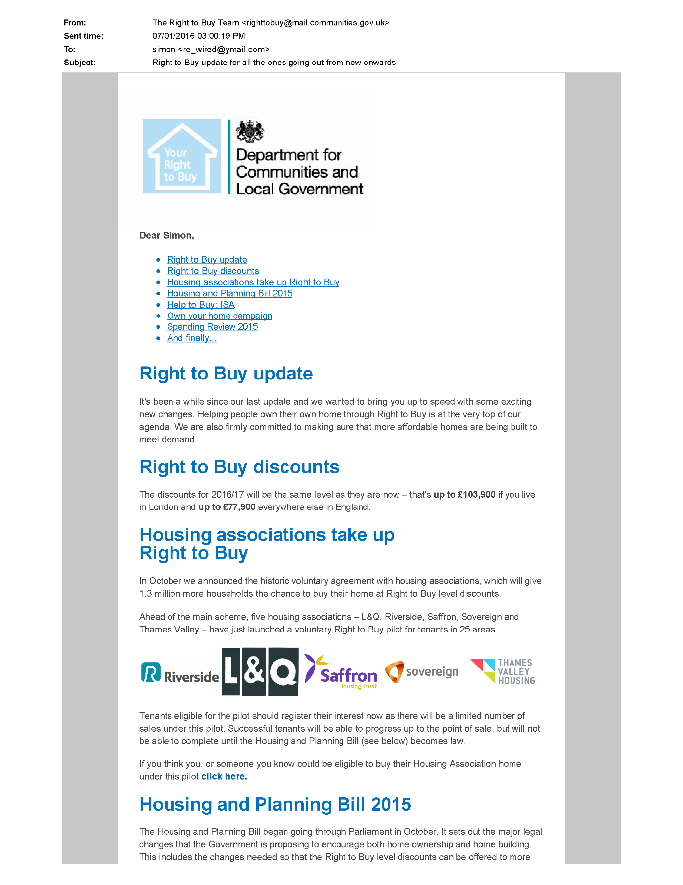  3,  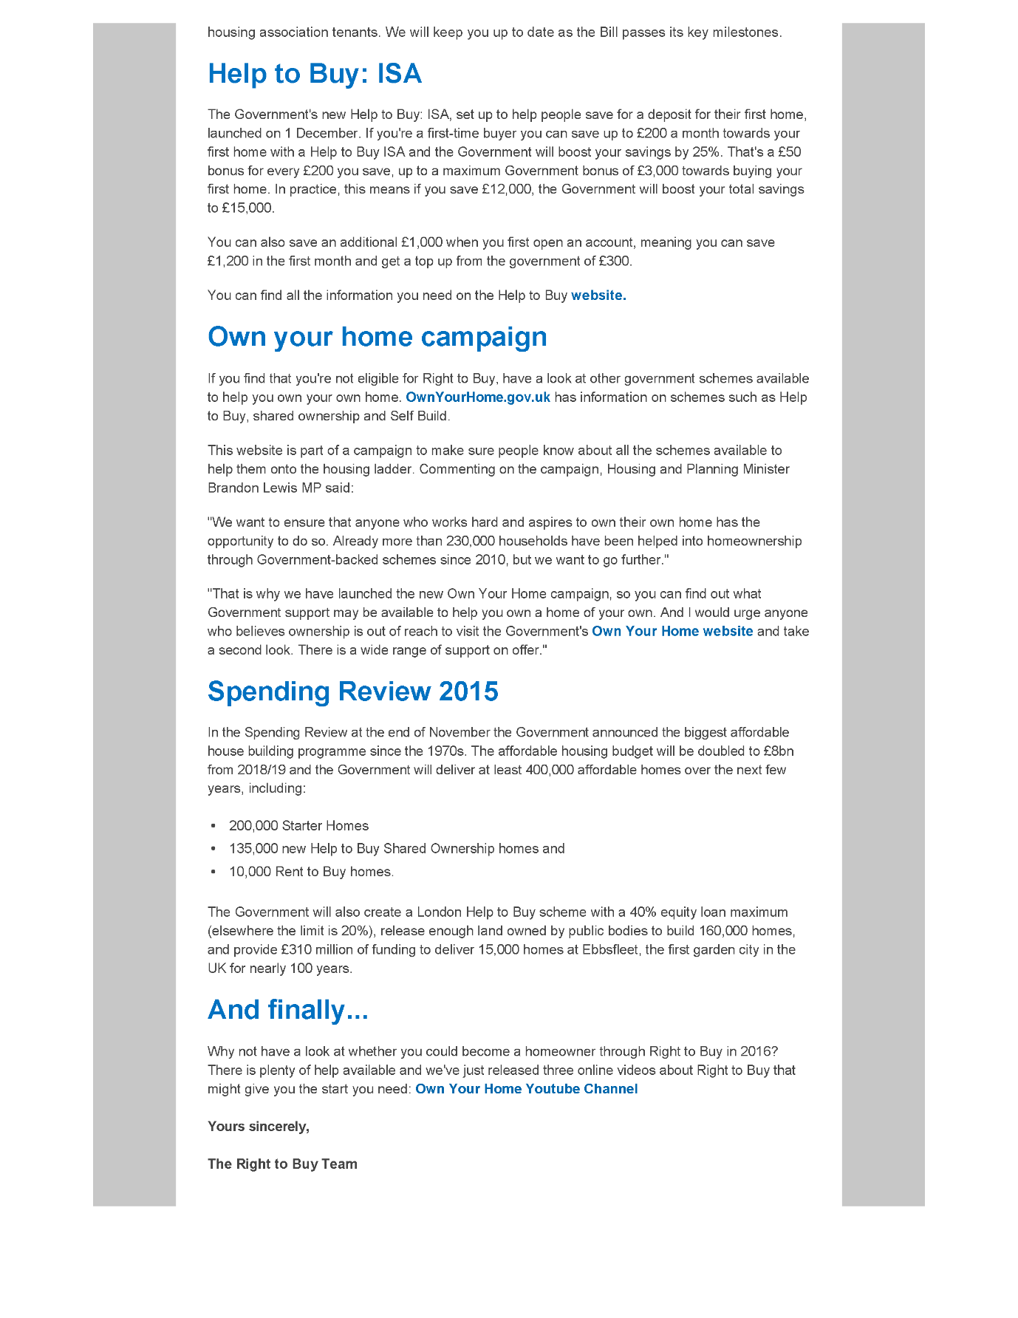  4,    END  Evidence: Exhibit 2 / 07/01/2016:  The banging Started!  - Debbie Andrews (responsible)  - Stain Curtis (responsible)  - Mathiyalagan (Responsible)  Time: All-Day and All-Night whenever they knew that I was indoors!  - They forced me to suffer when I provided the correct evidence, as they wanted me to go through tortures act of criminal intent caused by them self the staff and members of my neighbours for their own self gain with no compliance to legislation!  - The Enfield Homes and the Enfield Council staff aloud the occupiers of 117 and 113 and 111 Continued to victimize me by  - Loud and truculent banging in the bathroom got worse and this got achieved by slamming objects on to the floor with evil intent of malefactor actions!  - Then victimizing me with intent of using the same repeated items of the building fixtures to have tortures effects on me within my rented home is unfair living circumstances!  - Jumping up and down on the floor above wherever they can tell that I am present below!  - Banging with objects onto the internal main buildings walls and floors, so to intimidate surely me and maybe others living close by whom may be present to an extent only worthwhile for the perpetrators selfless glory, In them perpetrators knowing that their behaviour would only leave all those getting victimized towards getting left by their wrongful actions as to being put into a state of a mental health patient and not rightfully with this occurring within mine and their rented or paid for homes!  Evidence: Exhibit 3 / 07/01/2016:  Disrepair!  - All of the Emails I send to the complaints departments do not get processed with the right outcome leaving me to suffer every day of my life!  Evidence: Exhibit 4 / 07/01/2016:  Time Spent Building.  - In the background of everything going I continued working on creating a new and up to date Event Incident Control Centre plan and I continued to Study and finish at the Time Start: 07:00Am and Time End: 03:30 Pm!  - My mother also continues to work on building my company website for me with others at the Time Start: 09:00 and Time End: 14:00!  Evidence: Exhibit 5 / 07/01/2016:  Working at Home doing Court Case Defense Work!  - I spent time and resources costing expenditure with my mother also building my defence case, against the allegations getting put against me at the Time Start: 12:00 Am and Time End: 06:00 Am!
INFO | Statement Exhibit 1 / 07/01/2016:  - On the 07/01/2016 LBE sent me a letter to the Right to buy my rented property which means as I am a council secure tenant, I have the right to a discount when buying my rented flat. My issue is that by the Council and the police allowing my neighbours to bang on the walls at me through the years they have it damaged the reputation to this flat as it showed the vulnerabilities in the property.  Statement Exhibit 2 / 07/01/2016:  - On the 07/01/2016  Statement Exhibit 3 / 07/01/2016:  - On the 07/01/2016  Statement Exhibit 4 / 07/01/2016:  - On the 07/01/2016  Statement Exhibit 5 / 07/01/2016:  - On the 07/01/2016
 | - Responsible Doctors  - The reason that we have adduced this exhibit into these proceedings is because | 08/01/2016 | Evidence: Exhibit 1 / 08/01/2016:  - Goodie received a telephone call from Mr Cordell’s mother. She said that she was concerned about Mr Cordell and said that she had been concerned about him for over a year but would not specify what her concerns were. Goodie phoned Mr Cordell the same day he spoke about conspiracies involving the police and appeared thought disordered and thought about conspiracies.
INFO | Statement Exhibit 1 / 08/01/2016:  - On 08/01/2016
 | - Enfield Council Dawn Allen & Co About Debra Andrews  - The reason that we have adduced this exhibit into these proceedings is because | 11/01/2016 | Evidence: Exhibit 1 / 11/01/2016.  My 1st Asbo Response Bundle/ pub Book Issue: one! / Date+++  UPDATED FREEDOM OF INFORMATION RESULTS FROM ENFIELD COUNCIL/  Page Numbers: 288,289,290,291,292,293,294,295,296  From: Lorraine Cordell  To: "Ned Johnson"  Subject: RE: RE FOI 11845 [SEC=UNCLASSIFIED]  Date: 11 January 2016 15:25:00  Dear Ned Johnson,  - Thank you for the reply email and the update. I have other information due to investigations I have done and due to speaking to people within the area. That it was not just the one date in April 2014 there were events at Crown Road. The dates I have been given that events took place at Crown Road are. A. 12th / 13th April 2014 B. 19th / 20th April 2014 (confirmed) C. 26th / 27th April 2014 D. 03rd / 04th May 2014 E. 17th / 18th May 2014 (confirmed) F. 31st / 01st May and June 2014 (confirmed) G. 06th 07th 08th June 2014 (confirmed) H. 13th / 14th June 2014 (confirmed) Some of these dates have already been given that events took place within the FOI I requested. Also, you say you did not serve a Noise Abatement Notice on the squatters / occupiers, as it would have had no benefit to do so as you would not have been able to take anyone to court, and I do understand that the council was working with the owners of the building to deal with this problem. But I am sure if you had served a Noise Abatement Notice to the squatters / occupiers / Building, it would have covered not just to take someone to court. It would have covered the council to have seized sound equipment and due to this stopped the events far sooner with a Noise Abatement Notice in place on the building then not having served one at all. That is the reason a Noise Abatement Notice can be served on occupiers / Buildings under Environmental Protection Act 1990 section 80  Evidence: Exhibit 2 / 11/01/2016.  My 1st Asbo Response Bundle/ pub Book Issue: one! / Date+++  UPDATED FREEDOM OF INFORMATION RESULTS FROM ENFIELD COUNCIL/  Page Numbers: 288,289,290,291,292,293,294,295,296  From: Ned Johnson  mailto:Ned.Johnson@enfield.gov.uk  Sent: 11 January 2016 12:17  To: Lorraine Cordell  Cc: Andy Higham; Robert Oles.  Theresa Dodd  Subject: RE: RE FOI 11845 [SEC=UNCLASSIFIED]  Classification: UNCLASSIFIED  Dear Ms. Cordell,  - Thank you for your email. I have rechecked our database and indeed, I did make a mistake and missed one complaint which was received by our Residential Noise Team on 20/04/14, it was the only complaint received by the Council prior to the ones listed in the FOI response sent to you. The officer who received the complaint tried to contact the customer who made it on several occasions but was unable to do so and as such we were unable to verify the complaint. The next complaint received was then on 18/05/14 as stated in my original response. We did not receive any further complaints after June 2014 in regard to the Man Building and therefore as far as we were aware the matter had been resolved. A Noise Abatement Notice was not served on the squatters as we would not have been able to verify any names given, if indeed they would have given a name and it would have been unenforceable as it is extremely unlikely that we would have been able to take anybody to court who was squatting. The line taken was to pursue the owners of the building who then needed to evict the squatters and secure the premises, which they did; serving a Noise Abatement Notice would have had no effect on the owners as they were already taking the necessary steps to stop the problem.
INFO | Statement Exhibit 1 / 11/01/2016.  - In reference to Exhibit 1 / 11/01/2016; - Ned to Mother / This date is about the Asbo application brought wrongfully in motion, it is a request of freedom of information that I and my mother had requested to help in proving my innocence.  - The Enfield Council is one of the two companies that took part in building the Asbo application  Statement Exhibit 2 / 11/01/2016.  - In reference to Exhibit 2 / 11/01/2016; - Ned to Mother / Enfield Council gave a reply on this date about the request of data and this information clearly shows that
 | - Responsible Doctors  - The reason that we have adduced this exhibit into these proceedings is because | 13/01/2016 | Evidence: Exhibit 1 / 13/01/2016.  - Goodie spoke to Mr Cordell to see if he would agree to a home visit that day but said that it was not a convenient time, but he was prepared to have a visit at another time.
INFO | Statement Exhibit 1 / 13/01/2016.  - On 13/01/2016
 | - Responsible Doctors  - The reason that we have adduced this exhibit into these proceedings is because | 15/01/2016 | Evidence: Exhibit 1 / 15/01/2016.  - He agreed to have home visit during a further telephone conversation with Goodie.
INFO | Statement Exhibit 1 / 15/01/2016.  - On 15/01/2016
 | - Enfield Council Dawn Allen & Co About Debra Andrews  - The reason that we have adduced this exhibit into these proceedings is because | 18/01/2016 | Evidence: Exhibit 1 / 18/01/2016.  Stage 5  The Enfield Councils History FOI Indexed  Stage 5  Deborah Andrews / Enfield Council Case History  Page Number: 1,2,3,4,5,6,7,8,9,10,11,12,13,14,15,16,17,18,19,20,21,  DATE(S).  F.1) 24/01/2017  G.1) 18/01/2016  15/01/2016  Page 13 of 21  From: James.Flesher@met.pnn.police.uk, Sent: 18 January 2016 08:35. To: Louise Brown. Subject: Cordell.  - “Hi Louise, I hope you are well. Since 15/01/2016 we have had further calls from Debra Andrew relating to the issues she has been having with Simon Cordell. Given the nature of the calls, we visited Debra yesterday for a reassurance visit. She said that there has been a leak in the building causing 'flooding' in both her flat and Cordell's flat, and Cordell has been making accusations relating to it. She said that she believes Cordell is leaving his flat in two weeks, which I had not heard, but said I would look into it - do you know if that is true by any chance? Debra said that if Cordell does not leave, she wants to leave her flat and move somewhere else herself. While at the address we also noticed that Cordell has now installed a CCTV camera which is placed at the top of the internal communal door leading to flats 109 and 111, facing towards the main door of the block. I am unsure as to whether he is allowed to do this and shall look into it, but just wanted to let you know! Best wishes, James PC James Flesher 337YE | Dedicated Ward Officer for Enfield Highway | North Cluster NPT Team B | Enfield Borough OCU | James.flesher@met.police.uk | Ward Mobile Number: 020 8721 2903 Follow @MPS Enfield for updates of what we're doing across the borough!
INFO | Statement Exhibit 1 / 18/01/2016.  - The 18/01/2016 is an email that proves PC James Flesher 337YE is a police officer who is also in the Asbo proceedings and that a conflict of interest
 | - Responsible Doctors’ Involvement & Enfield Council.  - The reason that we have adduced this exhibit into these proceedings is because | 19/01/2016 | Evidence: Exhibit 1 / 19/01/2016.  - He was visited at home by Goodie and Sandra Muschett, senior practitioner.  - He was noted to be paranoid, grandiose, and not eating well. He denied any suicidal thoughts.  Evidence: Exhibit 2 / 19/01/2016.  The Enfield Gov / Email’s Issue:  620. Lorraine Cordell _Re_ Simon Cordell Repair ref_ 1633429  / Page Numbers: 2321,2322,2323,  From: Lorraine Cordell [lorraine32@blueyonder.co.uk]  Sent: 19 January 2016 14:43  To: 'Jackie Gubby'  Subject: RE: Simon Cordell Repair ref: 1633429  - Dear Jackie Gubby, would it please be possible for you to give me a call on 0208? Yesterday I got a call from the repair team in regard to a leak my son had in his flat from the flat above.  - They had to have a repair team out and shut my son lighting of in his bathroom due to the water leaking into the electrics and blowing out all my son's electrics. Today I got a call from the council saying they believe the leak is coming from the flat above 113 which would be 117 which is privacy owned and someone would be coming to see my son today from 117.  - The people from 117 have been to see my son today and have had someone check there flat and they are 100% the leak is not coming from there flat and that they believe it is coming from 113 which is Debbie's flat the person my son has been having trouble with for over a year now and the council have done nothing about this.  - The people from 117 have tried to speak to 113 but she will not open the door to them to see where the problem is coming from. Just a little while ago my son saw Debbie care worker and he spoke to them and told them again what has been going on and he cannot take it any longer, the care worker told my son that Debbie will not even let them into the flat anymore. Something has to be done as this has caused my son heath to go downhill badly and this cannot go on anymore.  - I am getting no replies to any complaints that have gone in and the ASB team are doing nothing.  - I have booked a date to see my son’s local MP also now as this is having a huge effect on my son's heath, and due to the council doing nothing I do not know where else to turn any longer.  - I have just called the repair team and spoke to a lady Linda, who has tried to call 113 Debbie and could not take to her, so she is sending a letter out to113 Debbie, Regards  Lorraine Cordell.
INFO | Statement Exhibit 1 / 19/01/2016.  - The 19/01/2016 was  Statement Exhibit 2 / 19/01/2016.  - The 19/01/2016 could
 | - Responsible Doctors  - The reason that we have adduced this exhibit into these proceedings is because | 21/01/2016 | Evidence: Exhibit 1 / 21/01/2016.  - Sandra Muschet had a telephone conversation with Mr Cordell’s mother. She said that Mr Cordell had been harassed by the police for a number of years and that his preoccupation with the police was based on reality. She reported that Mr Cordell is not eating, not going out and has poor self-care.
INFO | Statement Exhibit 1 / 21/01/2016.  - On 21/01/2016 a Sandra Muschet
 | - Responsible Doctors  - The reason that we have adduced this exhibit into these proceedings is because | 22/01/2016 | Evidence: Exhibit 1 / 22/01/2016.  - An attempt was made to assess Mr Cordell under the Mental Health Act. Mr Cordell was angry that he had an unannounced assessment. He spoke about feeling targeted by the police. He spoke about being arrested numerous times and had a curfew from the police. He refused to give the assessing team access. He initially spoke rapidly but more slowly as the meeting went on. Mr Cordell phoned Amal Pomphrey, early intervention worker covering for Goodie, and said that he had felt threatened by the Mental Health Act assessment that had taken place. He spoke about being arrested over a thousand times by the police and being subject to a curfew.
INFO | Statement Exhibit 1 / 18/01/2016.  - On 22/01/2016
 | - Responsible Doctors’ Involvement & Enfield Council.  - The reason that we have adduced this exhibit into these proceedings is because | 26/01/2016 | Evidence: Exhibit 1 / 26/01/2016.  - My Birthday  Evidence: Exhibit 2 / 26/01/2016.  - Mr Cordell phoned Amal Pomphrey, early intervention worker. He said that he had been contacted by a housing officer who had “threatened to get the mental health team out to see him.”  Evidence: Exhibit 3 / 26/01/2016.  The Enfield Gov / Email’s Issue: 04  Page Numbers: 624,625  - To whom it may concern: I am writing this letter to confirm I do give my mother Ms Mother my authority to speak, write, and email, Enfield Council this would include any department within Enfield Council on my behalf.
INFO | Statement Exhibit 1 / 26/01/2016.  - On 26/01/2016 My Birthday  Statement Exhibit 2 / 26/01/2016.  - On 26/01/2016  Statement Exhibit 3 / 26/01/2016.  - On 26/01/2016
 | - Enfield Council Asbo  - The reason that we have adduced this exhibit into these proceedings is because | 27/01/2016 | Evidence: Statement Exhibit 1 / 27/01/2016.  The Enfield Gov / Email’s Issue: 04  Page Numbers: 626,627,628  From: Mother [lorraine32@blueyonder.co.uk]  Sent: 27/01/2016 - 18:20  To: 'Nicholas.Foster@Enfield.gov.uk.'  Subject: Re: Enfield Council Subject Access Request Simon Cordell.  Attachments: one. Simon_Cordell_authority_Letter_26-01-2016.doc. 2. Data-Protection-Request.doc.  To Whom It May Concern:  - Please see attached letters in regard to my Subject Access Request under the Data Protection Act 1998 Regards Mr Simon Cordell Miss Mother.
INFO | Statement Exhibit 1 / 27/01/2016.  - On 27/01/2016
 | - Responsible Stain Curtis  - The reason that we have adduced this exhibit into these proceedings is because | 31/01/2016 | Evidence Exhibit BB5: – 1 / 31/01/2016:  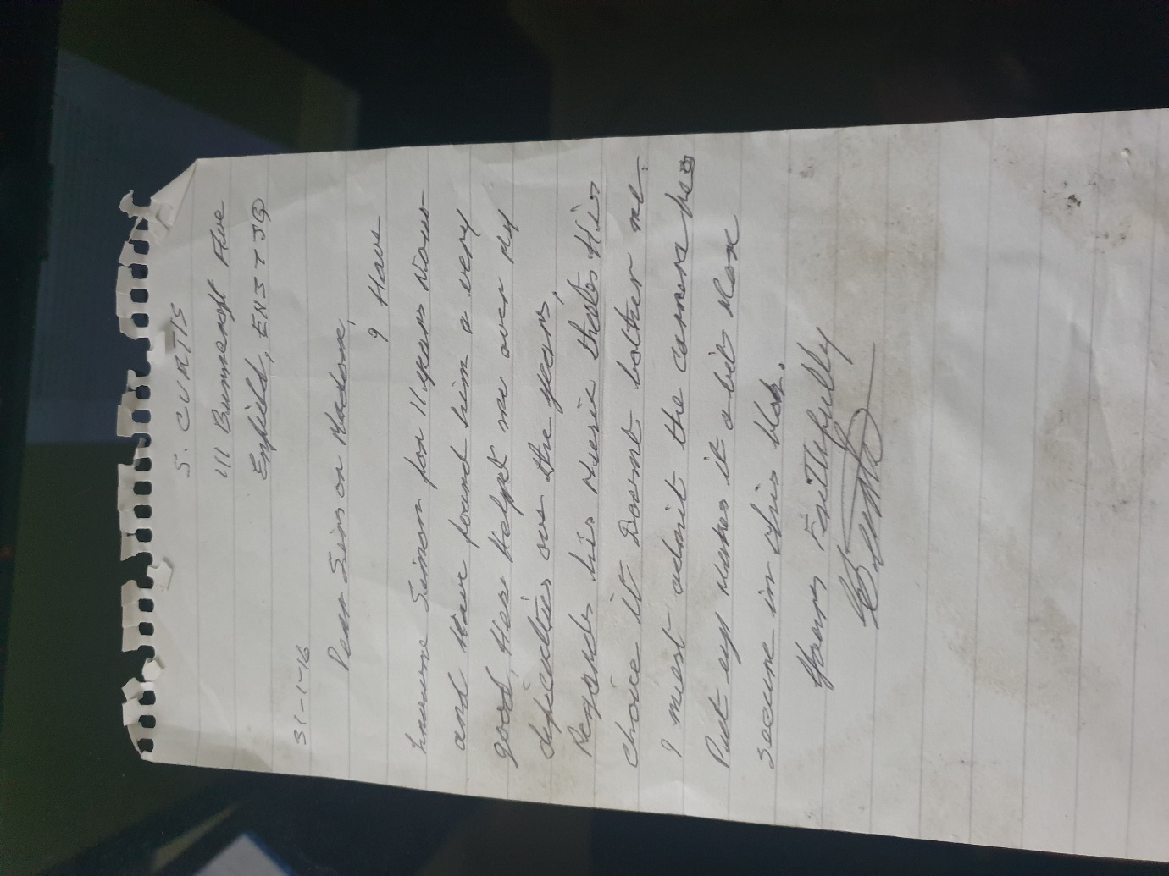
INFO | Statement Exhibit BB0 – 1 / 31/01/2016:  - O
 | - Enfield Council Dawn Allen & Co About Debra Andrews  - The reason that we have adduced this exhibit into these proceedings is because | 01/02/2016 | Evidence: Statement Exhibit 1 / 01/02/2016.  Stage 5  The Enfield Councils History FOI Indexed  Stage 5  Deborah Andrews / Enfield Council Case History  Page Number:  1,2,3,4,5,6,7,8,9,10,11,  12,13,14,15,16,17,18,19,  20,21,  --  18  01/02/2016: communication between CSU & Bola Quadri CPN  From: Louise Brown  Sent: 01 February 2016 14:36  To: bola Quadri; George Benyure (george.benyure@beh-mht.nhs.uk)  Craig Susan  Subject: FW: Debra Andrews [SEC=PROTECT|  Sensitivity: Confidential  Classification: PROTECT  Dear George & Bola,  - Thank you for your email, I have only copied you both as there is other information on Mr Cordell that urgently needs to be considered.  - I received an email informing me that a mental health warrant had been granted for Mr Cordell.  - This will cause a greater issue especially if he is released back into the community.  - My fear is that this will indirectly cause further distress for Deborah.  - A plan needs to be put in place with full considerations.  - Please can an urgent mental health strategy meeting be held regarding Deborah Andrews, given the above information and the urgent need for full consideration in this case due to the complex needs and issues with both clients, who are known to your services and tenants of Enfield Council.  - Deborah is contacting me if not daily every other day these calls are coming through at all different days and times.  - She is informing me that she is not coping with everything and wants to go back into supported accommodation, she feels extremely frightened and vulnerable.  - I must confirm that its Deborah stating that she is not coping as I am not in a position to make these decisions.  - When I speak with Deborah asking if she is attending her appointments, she states that" it is a quick jab, in and out no one speaks with you.  - With regards to the management transfer this is still being prepared and waiting to be heard by panel, I am waiting to hear the next available date for this.  - It was explained when I suggested this action may be a route forward that this is not a quick process, and all elements need to be considered.  - It is not necessary for Ms Andrews to currently go into emergency accommodation either.  - This case will be assisted by moving Ms Andrews; however, this may not resolve all of the concerns or the overall future welfare of Ms Andrews.  - Transferring Ms Andrews into another independent accommodation without fully assessing her current needs and the full support required should be considered before this happens.  - As moving her may not solve all of Deborah Andrews concerns.  - She is only going out when SJOG are visiting, however they are only allocated 3 hours per week.  - More recommendations need to be put forward to provide a comprehensive package to support.
INFO | Statement Exhibit 1 / 01/02/2016.  - On the 01/02/2016: A communication between CSU & Bola Quadri CPN took place
 | - Responsible Doctors’  - The reason that we have adduced this exhibit into these proceedings is because | 02/02/2016 | Evidence: Exhibit 1 / 02/02/2016.  - Mr Cordell phoned Amal Pomphrey and advised that he had been told that a warrant had been granted. He was clearly aware of the planned Mental Health Act assessment.
INFO | Statement Exhibit 1 / 02/02/2016.  - On 02/02/2016
 | - Responsible Doctors’  - The reason that we have adduced this exhibit into these proceedings is because | 03/02/2016 | Evidence: Exhibit 1 / 03/02/2016.  1. Dr Al-Allaq (independents 12 Doctor), 2. Dr Albazaz (independent s12 Doctor), 3. CJ and Nellie (Home Treatment Team workers), 4. Amal Pomphrey (Community Mental Health Nurse based at Enfield Early Intervention Team) 5. All attended. A s135(1) warrant was obtained but not executed as Mr Cordell gave access. 6. A lock smith was present, but their services were not required as Mr Cordell opened the door.7. The police were present but remained outside the property.8. Mr Cordell’s home was somewhat cluttered with a large printer by the door. 9. However, it was clean and organised. 10. He had food in the kitchen.11. His mother and a female friend were present. 12. Mr Cordell was expecting the assessment to take place. 13. He was appropriately groomed and dressed. 14. He had put his dog in the garden. 15. Mr Cordell expressed his unhappiness about the warrant being obtained. 16. He said that if he had been sent an appointment letter, he would give professionals access.17. He mentioned on going issues with the police and that he had a court case in February. 18. His speech was somewhat rapid at the start of the interview, but this appeared to be due to anxiety rather than thought disorder. 19. His speech slowed as the interview went on. 20. Mr Cordell did change topic of conversation a number of times as there was particular information that he wanted to share with the team. 21. He spoke a project to start a community internet site and showed those present a business plan that was on his computer. 22. He showed us documents which he said were related to his court case. 23. He pointed out a line in the document that said that all the suspects were white and said that this was part of his legal challenge to his Anti-Social Behaviour Order. 24. He denied any symptoms of mental illness when asked about a variety of psychotic symptoms. 25. He denied suicidal ideation. 26. He spoke about difficulties he had with his upstairs neighbour relating to noise disturbance. 27. He showed us some letters which said that his neighbour had written to him. 28. He said that his neighbour has an alcohol problem and a learning disability. 29. There was no evidence of distraction, confusion or that he was responding to internal stimuli. 30. It is my view that Mr Cordell’s detention was not in the interests of his health as I did not identify evidence of mental disorder during the visit. 31. I did not believe that Mr Cordell’s detention was necessary for his safety, Mr Cordell denied experiencing any suicidal ideation and could I not identify other risks to safety apart from possible substance misuse which could not be used as the basis of detention without clear evidence of a mental disorder associated with the substance misuse issues. 32. I also did not think that the threshold for detention on the basis of safety was met, he was having conflict with neighbour this conflict did not appear to be driven by any mental disorder. 33. I identified Mr Cordell’s Nearest Relative as his mother Lorraine Cordell. 34. Mr Cordell lives alone and is single. 35. As far as I could ascertain he did not have any children and was not in relationship. 36. His father was the older of his parents but when I phoned his mother. 37. she informed me that he was in regular contact with Mr Cordell and did his shopping for him. 38. I therefore formed the view that she provided care and was the Nearest Relative. 39. I phoned Lorraine at around 09:30hrs
INFO | Statement Exhibit 1 / 03/02/2016.  - In pursuit of the 03/02/2016 1. Dr Al-Allaq (independents 12 Doctor), 2. Dr Albazaz (independent s12 Doctor), 3. CJ and Nellie (Home Treatment Team workers), 4. Amal Pomphrey (Community Mental Health Nurse based at Enfield Early Intervention Team) who all obtained a Mental Health Warrant to assess Mr S. P. Cordell.  1.1 – point 5 a  1.2 – point 6 a
 | - Responsible Doctors’  - The reason that we have adduced this exhibit into these proceedings is because | 09/02/2016 | Evidence: Exhibit 1 / 09/02/2016; -  1. Sam Curtis Report Dated 09/02/2016 - 2. Contact details: North London Forensic Service, Camlet 1, Chase Farm Hospital, The Ridgeway, London EN2 8JL.9. I phoned Lorraine at around 09:30hrs on the 09/02/2016 and she advised that in her view use of a warrant and the Mental Health Act assessment were unnecessary as he would give professionals access if he had received an appointment letter. 10. She said that he had a court case in February but would not elaborate on this. 11. Lorraine said that she thought that the involvement of mental health services was unnecessary as Mr Cordell was not in her view experiencing any mental health difficulties and had not experienced any mental health difficulties for a number of months. 12. I was surprised that Lorraine stated that she did not think that Mr Cordell as the recent referral to mental health services had been triggered by a referral that she had made. Consultation with Assessing Doctors: 14. Both assessing Doctors declined to make medical recommendations and were in agreement that there was no clear evidence of any mental disorder during the assessing.15. 7 Views of others consulted. 16. Prior to the assessment the police present advised me that were aware of conflict between Mr Cordell and his neighbour. 17. They advised that the soundproofing between the two properties was poor. 18. The police officers advised me that they were aware that on one occasion Mr Cordell had threatened to strangle his neighbour. Mental Capacity Act 2005 - 20. No Capacity Act issues identified during the assessment. 21. Reason for decision to make the application (including choice of Section) 22. “Given that Mr Cordell’s diagnosis and treatment plan were not clear at the time of the assessment the assessment was for possible detention on section 2.” 23. It was my view that Mr Cordell did not meet the statutory criteria for detention. 24. It was not clear that he was suffering from a mental disorder of a nature because at the time of the assessment it was unclear if whether or not he had a mental disorder. 25. “He did not meet the criteria for degree as there was no clear evidence that he was experiencing symptoms of mental disorder.” 26. Relevant social and medical history. 27. Information obtained from reports from Mr Cordell and his family to mental health services. 28. Not independently verified. Social: 30. Mr Cordell was the victim of abuse by a paedophile ring, and this led to him having contact with CAMHS Safe project for a number of years, he has not spoken about the abuse for many years. 31. Mr Cordell’s father was violent towards him. 32. “He was placed in care as a teenager.” 33. He separated from his girlfriend in 2014.v34. Mr Cordell’s mother has regular contact with and helps with shopping. 35. Mr Cordell’s grandmother was diagnosed with bipolar affective disorder and schizophrenia; she was treated with Schizophrenia. 36. She died from cancer in August 2014.37. In 2014 he was bailed for burglary. 38. In 2015 he was made subject to a 5-year Anti-Social Behaviour Order for organising illegal raves. 39. He not allowed to enter industrial or disused premises between 10pm and 7 am. 40. He has reported that he has a long history police contact since he was juvenile. 41. His contact with the police mostly related to theft and driving offences.42. He lives in a one-bedroom council flat and is in receipt of Employment Support. Psychiatric History: 44. Mr Cordell tried to hang himself at the age of 16 when in a young offender’s institution and needed to be resuscitated. 45. He was moved to a secure hospital and kept in seclusion on a number of occasions. 46. He has reported that he was regularly by a psychiatrist called Dr Caplin from CAMHS "the safe project". 47. Mr Cordell reports there was a second occasion where he tried to hang himself when in a cell after he was sentenced. 48. He attended the Accident and Emergency Department at the North Middlesex Hospital after drinking liquid nitrous oxide with an intent to die 03 October 2009 hallucinating after taking LSD. 49. He was not followed up by mental health services.50. He was assessed by Dr Jarvis from the Enfield triage team.
INFO | Statement Exhibit 1 / 09/02/2016  - The 09/02/2016 is the date the doctor updated his report after the 135 Mental Health assessment at my home. Below is a list of inaccurate comments; left in the report made on this date.  1.1 – point 2 a  1.2 – point 4 a
 | - Enfield Council Lemmy Backdated Before He Worked for The Council + Dawn Allen & Co About Stain Curtis  - The reason that we have adduced this exhibit into these proceedings is because  - Enfield Council Lemmy Backdated Before He Worked for The Council + Dawn Allen & Co About Stain Curtis | 06/07/2016 | Evidence: Exhibit 1 / 06/07/2016; Stain Curtis Enfield Council History
INFO | Statement Exhibit 1 / 06/07/2016.  - On the 06/07/2016 Stain Curtis Council History  - While I and my mother were complaining for months to the Enfield council about the Asbo, housing repairs and Neighbours attacking me I got treated with negligence by the named companies.  - I and my mother got left without any response to our complaints and this meant that I continued to get assaulted and forced to suffer on top of the probations in accordance with the Asbo.  - The involved companies used their media departments to make my personal information go viral and, in an effect, misleading the public into  - Dawn Alain  - Geoffrey Oman  - Loise Brown  - Jacky Gubby,  - Alongside other team members who all worked in the same department as Steve Elesmore who is the developer of the Forged Asbo application. These staff all clearly knew Steven Elesmore and Co, as they talk about him and Pat in the Enfield Councils History.  Stain Curtis Council History starts with Debra Andrews Council History as the first date.  - Debra Andrews personal data of History held on the Enfield Councils computer systems got vexatiously forged as the 1st illegal cover up by dawn Alan’s and her team the neighbourhood watch rather than getting the true perpetrators persecuted that they had allowed to violate my human rights by banging on my walls and so forth at me and/or getting any of their past or then present team members held liable for the fraud they created that is contained in the Asbo  - All of the dates in Stain Curtis Council history and every other person’s council history all got made at the same time and in a rush because of the need for a cover-up of what had been integrated and allowed to continue against my person illegally and also because of mine and my mother Subject Data Access request  - 111 Burncroft Avenue Enfield En3 7jq - Stain Curtis -  - 113 Burncroft Avenue Enfield En3 7jq  - 115 Burncroft Avenue Enfield En3 7jq  - 117 Burncroft Avenue Enfield En3 7jq  - Lemmy used Dawn Alans information about Debra Andrews on the 11/01/2016 after he met George Quinton for the 1st time and after George had lost the Bike case dated the 04/10/2016 against me on the 17/11/2016 or their after but before my mother’s FOI had to get served to her and me for my personal data held on Enfield Councils computer systems, that had to be given to us on the date of the 24/01/2016.  - Lemmy Used Dawn Alans forged work in his own forgery against me and this is how the information got used for a second time as an illegal cover up.  What Lemmy done was!  - After Debra Andrews Council History got created in 2015  - Lemmy started work for the Enfield Council on the 01/10/2016 and was given the George bike case to manage by his line manager Kanichiwa who had also just started work for the same company on the date of the 00/00/2016  Stains dates after Debra Andrews Date  - I was not living inside of my rented flat 109 Burncroft Avenue for any of the dates in Stain Curtis Council History as I was on bail conditions to reside at my mothers and did as my bail conditions required.  - All Stain Curtis could remember when questioned was an alleged incident that happened in September 2016, Stain Could not remember any dates or the true events that occurred around the days and months of 2016 and this I important for more reasons than one but just as an example I will list 1.  - I f no date was give on the first contact and there on afterwards as noted in the Enfield Council history just a month and year then how does the date of the 06th exist.  - The reason for the date of the 06th is because a date was needed to create a history in the Enfield Council computer system against me and the 06th was given to something in July. The first time any person could see the date of the 06th is in the first Injunction Order dated 00/00/20  --  - On the 31/10/2016 This was the day that Stain became known to the Enfield Council it was not him personal who spoke to the Council bout that of one of his friends.  - His friend tried to explain an incident but could not say any precise dates as Stain could not remember to give anyone that information.  - A new employee of Enfield Councils staff took the telephone call who is named as Kaunchita Maudhub, who is an Anti-Social Behaviour - Team Leader attached to the Community Safety Unit and who was Lemmy’s Line Manager who did work for the Enfield Council.”  - The Reason that I had to stay at my mother on bail conditions was for the following reasons.  - The Christian Carron Case  - The Georges Bike Case  These two-case got me put on bail conditions  - An End decision from the CPS was no further action on the 17/11/2016.  - Bail Dates 05/10/2016 till the 17/11/2016 but I did not go back home until the 04/12/2016  - 03/11/2016 Jean Barton Called Stain Curtis by telephone, she also spoke to Kaunchita Maudhub by email - ASB Victim Support. Jean. Barton @enfield.qov.uk  - 04/11/2016 Lemmy went to stains house to see if it could help him, and his team get away with the Asbo ongoings that Pat and Steve made. They released that I had not been arrested for Stain but for Christine and Caron setting me up for Stain to help him get away with what me and my mother had been complaining about. Lemmy asked stain about the incidents that had been called in on the 31/10/2016 and stain said he could not remember much and that he could not remember the dates. Stain gave sometime in June and or in September!  - 11/11/2016 Sarah flexure went to Stains house to see if she could make things worse by making stain remember some dates.  - Stain still said the same and that he could not remember much about the days and that he could not remember the dates. Stain gave sometime in June and or in September again!  - This is also the day she backdated claims to help the Mathiyalagan’s and her colleagues get away from complaints I and my mother dad mad about them.  - When Lemmy and the Enfield Council team made my neighbours councils History’s on and after the 11/01/2017 after meeting George for the first time.  Lemmy added the day of the  06th  And after meeting the  Mathiyalagan’s  John Irving  George Quinton  Weblink https://serverone.hopto.org/Index%2011/  Name Stain Curtis / Fisher  Address 111 Burncroft Avenue Enfield London EN3  Dates of living in residence  Page Number and Title Page Numbers: 46,47,48,49,50,51,52  Date Incident Logs Si Note:  47, C. 06/07/2016 C1. 06/07/2016 C. 06/07/2016: Making threats, Date reported: C1. 06/07/2016 Making threats Elderly The defendant using threatening/abusive/insulting words and behaviour with intent to cause fear -provoke unlawful violence - directed at the victim.  Weblink https://serverone.hopto.org/Index%2011/  Name Stain Curtis / Fisher  Address 111 Burncroft Avenue Enfield London EN3  Dates of living in residence  Page Number and Title Page Numbers: 46,47,48,49,50,51,52  Date Incident Logs Si Note:  D. 31/10/2016 D1. 31/10/2016 D. 31/10/2016: From: John Duncan [mailto:johnboy0070@virginmedia.com] Sent: D1. 31 October 2016 18:09 To: Kaunchita Maudhub Subject: Contact phone number for Mr Stanley Curtis Hi Kaunchita, This is the contact phone number for Stanley Curtis. 0787-0655010 As stated, he is partially deaf so may not hear the phone sometimes. If I can be of further assistance, please do not hesitate to call me. Thanks for your help. Regards, John Bates  - Took a telephone call in her notes of a person call John Baits or John Duncan  - But Lemmy said in his first 12 allegations sent to my mother on the 10/02/2017 that Complainant C  The Enfield Gov / Email’s Issue: ten  Sent: 10/02/2017 - 16:01  Lemmy Nwabuisi FW Anti-Social Behavior Allegations against Mr. Simon Cordell  / Page Numbers: 2901,2902,2903,2904,2905,  Lemmy’s Incident Number is listed as: 03  2901,  - On 31/10/2016 a telephone call got received from another resident on behalf of Complainant C. He alleged that Complainant C's neighbour, Simon was using threatening, abusive, and insulting words towards Complainant C. He stated that he witnessed an incident that happened in September 2016 outside the block when Simon shouted abuse at Complainant C and made threats towards him.  - Christine
 | - Doctors’ Involvement  - The reason that we have adduced this exhibit into these proceedings is because | 04/08/2016 | Evidence: Exhibit 1 / 04/08/2016; E
INFO | Statement Exhibit 1 / 04/08/2016.  On the 04/08/2016 A Mental Health Risk Assessment took place against me again in targeted malice. Doctors abused their powers against me.
 | - Enfield Council Lemmy Backdated Before He Worked for The Council + Dawn Allen & Co About the Mathiyalagan Family  - The reason that we have adduced this exhibit into these proceedings is because | 05/08/2016 | The Neighbours  - Page 0
INFO | S
 | - Enfield Council Lemmy Backdated Before He Worked for The Council + Dawn Allen & Co About the Mathiyalagan Family  - The reason that we have adduced this exhibit into these proceedings is because | 06/08/2016 | The Neighbours  - Page 0
INFO | S
 | - Enfield Council Lemmy Backdated Before He Worked for The Council + Dawn Allen & Co About Stain Curtis  - The reason that we have adduced this exhibit into these proceedings is because | 14/08/2016 | The Neighbours  - Page 0
INFO | S
 | - Enfield Council Dawn Allen & Co About My Formal Complaint  - The reason that we have adduced this exhibit into these proceedings is because | 24/08/2016 | The Neighbours  - Page 0
INFO | S
 | - Responsible Doctors’  - The reason that we have adduced this exhibit into these proceedings is because | 27/08/2016 | The Neighbours  - Page 0
INFO | S
 | - Responsible Doctors’  - The reason that we have adduced this exhibit into these proceedings is because | 28/08/2016 | The Neighbours  - Page 0
INFO | S
 | - Responsible Doctors’  - The reason that we have adduced this exhibit into these proceedings is because | 29/08/2016 | The Neighbours  - Page 0
INFO | S
 | - R  - The reason that we have adduced this exhibit into these proceedings is because | 00/00/0000 | The Neighbours  - Page 0
INFO | S
 | - R  - The reason that we have adduced this exhibit into these proceedings is because | 00/00/0000 | The Neighbours  - Page 0
INFO | S
 | - R  - The reason that we have adduced this exhibit into these proceedings is because | 00/00/0000 | The Neighbours  - Page 0
INFO | S
 | - R  - The reason that we have adduced this exhibit into these proceedings is because | 00/00/0000 | The Neighbours  - Page 0
INFO | S
 | - Responsible Doctors’  - The reason that we have adduced this exhibit into these proceedings is because | 00/00/0000 | The Neighbours  - Page 0
INFO | S
 | - R  - The reason that we have adduced this exhibit into these proceedings is because | 00/00/0000 | The Neighbours  - Page 0
INFO | S
 | - R  - The reason that we have adduced this exhibit into these proceedings is because | 00/00/0000 | The Neighbours  - Page 0
INFO | S
 | - R  - The reason that we have adduced this exhibit into these proceedings is because | 00/00/0000 | The Neighbours  - Page 0
INFO | S
 | - R  - The reason that we have adduced this exhibit into these proceedings is because | 00/00/0000 | The Neighbours  - Page 0
INFO | S
 | - R  - The reason that we have adduced this exhibit into these proceedings is because | 00/00/0000 | The Neighbours  - Page 0
INFO | S
 | - R  - The reason that we have adduced this exhibit into these proceedings is because | 00/00/0000 | The Neighbours  - Page 0
INFO | S
 | - Responsible Doctors’  - The reason that we have adduced this exhibit into these proceedings is because | 00/00/0000 | The Neighbours  - Page 0
INFO | S
 | - R  - The reason that we have adduced this exhibit into these proceedings is because | 00/00/0000 | The Neighbours  - Page 0
INFO | S
 | - R  - The reason that we have adduced this exhibit into these proceedings is because | 00/00/0000 | The Neighbours  - Page 0
INFO | S
 | - R  - The reason that we have adduced this exhibit into these proceedings is because | 00/00/0000 | The Neighbours  - Page 0
INFO | S
 | - R  - The reason that we have adduced this exhibit into these proceedings is because | 00/00/0000 | The Neighbours  - Page 0
INFO | S
 | - R  - The reason that we have adduced this exhibit into these proceedings is because | 00/00/0000 | The Neighbours  - Page 0
INFO | S
 | - R  - The reason that we have adduced this exhibit into these proceedings is because | 00/00/0000 | The Neighbours  - Page 0
INFO | S

